|  |  |
| --- | --- |
| **F:\3dcoaching_pc_v3\3D Curriculum\3 Dimensional Coaching logo.png**  ***TM*** |  |

**Date Issued**  Monday, October 31, 2016

**Between** 3D Institute, INC

**and**

**Sponsor**  Father Lopez Catholic High School

3918 LPGA Blvd

Daytona Beach, Florida 32124

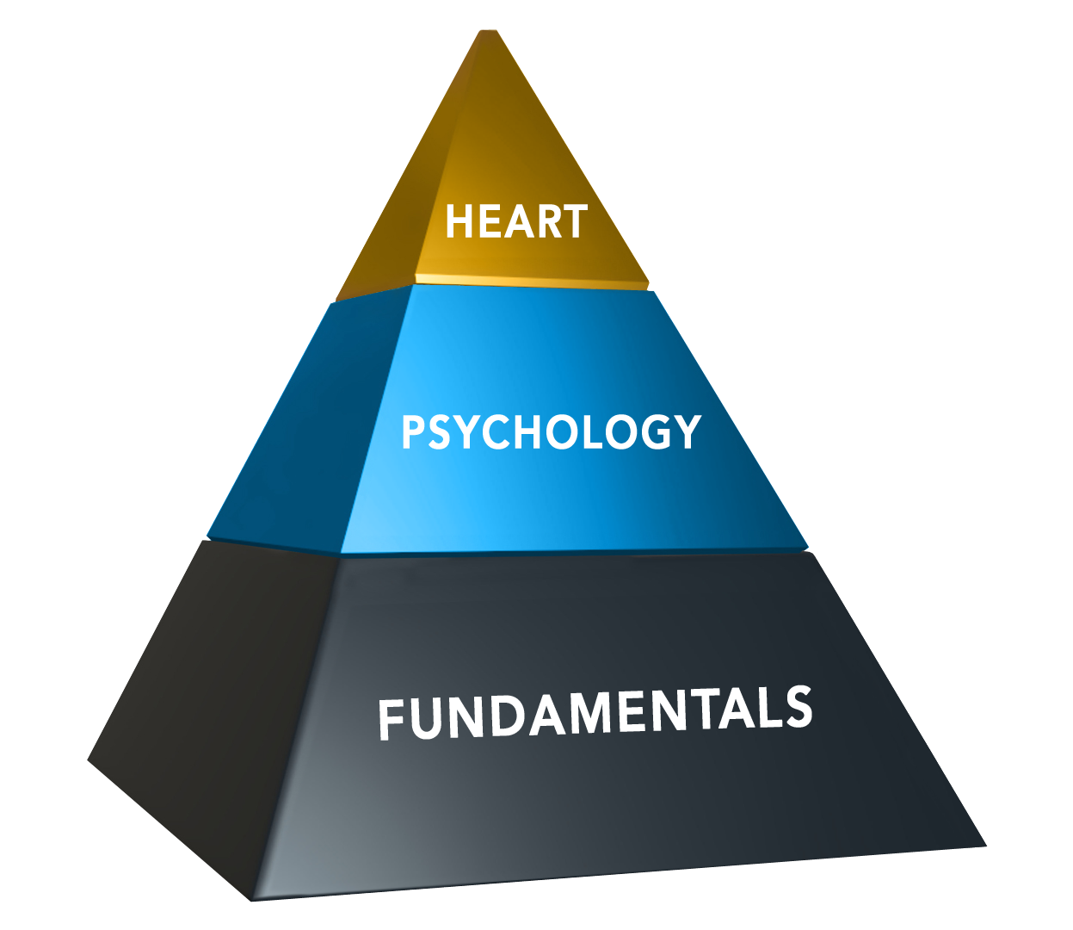

**Presenter** Jeff Duke

**Date of appearance**  7/30/16

**Location** Father Lopez Catholic High School

**Start Time** 1:00 PM

**Length** 3 Hours

**Speaking Fee** $750.00

Resources (50 booklets) $50.00

Mileage Reimbursement (150 miles) $86.25

**Total: $886.25**

**Payment Terms:**

Please make check payable to 3D Institute (**EIN# 47-2053869).**

Mail to 3D Institute 7325 Forestwood Ct., Orlando, FL 32835

Payment should be mailed to arrive 5-7 days before the presentation. Payment can also be given to the presenter on the day of the event.

THIS CONTRACT SERVES AS AN INVOICE. YOU WILL NOT RECEIVE ANOTHER INVOICE UNLESS YOU REQUEST IT.

**Other Terms:**

Sponsor is also responsible for providing projector and sound system compatible with a laptop.

I have read and understand all the information contained herein:

**Signature Date**

