**웹프로그래밍 HW5**

18013189 컴퓨터공학과 차윤범

**소스 코드**

**html 파일 소스 코드**

<!DOCTYPE html>

<html lang="ko">

  <head>

    <meta charset="utf-8" />

    <meta name="viewport" content="width=device-width, initial-scale=1.0,minimum-scale=1.0,maximum-scale=1.0" />

    <meta name="format-detection" content="telephone=no, address=no, email=no" />

    <link

      rel="stylesheet"

      href="https://stackpath.bootstrapcdn.com/bootstrap/4.4.1/css/bootstrap.min.css"

      integrity="sha384-Vkoo8x4CGsO3+Hhxv8T/Q5PaXtkKtu6ug5TOeNV6gBiFeWPGFN9MuhOf23Q9Ifjh"

      crossorigin="anonymous"

    />

    <script

      src="https://stackpath.bootstrapcdn.com/bootstrap/4.4.1/js/bootstrap.min.js"

      integrity="sha384-wfSDF2E50Y2D1uUdj0O3uMBJnjuUD4Ih7YwaYd1iqfktj0Uod8GCExl3Og8ifwB6"

      crossorigin="anonymous"

    ></script>

    <link rel="stylesheet" href="https://maxcdn.bootstrapcdn.com/bootstrap/4.5.2/css/bootstrap.min.css">

  <script src="https://ajax.googleapis.com/ajax/libs/jquery/3.5.1/jquery.min.js"></script>

  <script src="https://cdnjs.cloudflare.com/ajax/libs/popper.js/1.16.0/umd/popper.min.js"></script>

  <script src="https://maxcdn.bootstrapcdn.com/bootstrap/4.5.2/js/bootstrap.min.js"></script>

  <link rel="stylesheet" href="style.css" />

    <title>18013189_HW5_차윤범</title>

  </head>

  <style>

    body{

        background-repeat: no-repeat;

        background-size: cover;

    }

    iframe {

      border-radius: 20px;

      border: 7px solid gold;

    }

    table {

      background-color: beige;

      font-family: "Comic Sans MS", c ursive;

      font-size: 20px;

      text-align: center;

      width: 60%;

      margin: 0 auto;

    }

    .table td,

    .table tr {

      vertical-align: middle;

    }

    .col-lg-3{

        margin-left: 300px;

    }

    body {

      font-family: Arial, Helvetica, sans-serif, 맑은고닥;

      text-shadow:1px 1px 2px rgba(68,68,68,0.4);

  }

  #hi {

      overflow:hidden;

      position:relative;

      width:978px;

      height:300px;

      /*border:1px solid #444;*/

      /*background-color:#fff;*/

       box-sizing:border-box;

      -webkit-box-sizing:border-box;

      -moz-box-sizing:border-box;

  }

  #home {

      position:relative;

      padding:90px 0;

      height:100%;

      border-top:none;

      background-color:#F7F7F7;

      text-align:center;

      font-size : 40px;

      text-align: center;

      padding-top: 250px;

      padding-bottom: 250px;

  }

  #home:after {

      position:absolute;

      z-index:0;

      top:0;

      left:0;

      display:block;

      content:'';

      height:100%;

      width:5px;

      background-color:#444;

      transition:width .45s;

      -webkit-transition:width .45s;

      -moz-transition:width .45s;

  }

  #home:hover:after {

      width:100%;

  }

  #home #hi{

      position:relative;

       z-index:10;

      font-size:45px;

      line-height:35px;

      text-transform:uppercase;

      font-weight:700;

      padding-bottom:20px;

      text-shadow:1px 1px 10px rgba(68,68,68,0.4);

      transition:all .9s;

      -webkit-transition:all .9s;

      -moz-transition:all .9s;

  }

  #home #hi {

      position:relative;

      z-index:10;

      transition:color .9s;

      -webkit-transition:color .9s;

      -moz-transition:color .9s;

  }

  #home:hover #hi {

      color:#fff;

      text-shadow:1px 1px 10px rgba(255,255,255,0.4);

  }

  hr {

      width: 500px;

      background-color: gray;

  }

  #navbar {  /*내비 스타일*/

      overflow : hidden;

      background-color : #FFFFFF;

      padding: 0px 5px;

      transition: 0.7s;

      position:fixed;

      width: 99%;

      top: 0;

      z-index: 99;

      box-shadow: 0px 0px 3px gray;

  }

  #navbar a { /*내비바 링크 스타일*/

      float: left;

      color:black;

      text-align: center;

      padding: 12px;

      text-decoration: none;

      font-size: 15px;

      line-height: 25px;

      border-radius: 4px;

      font-weight: bold;

  }

  #navbar a:hover { /*링크에 마우스 올려놓을때*/

      transition-duration: 0.5s;

      background-color: #7DC3F6;

      color: white;

  }

  #navbar-right { /*내비바 오른쪽정렬*/

      float: right;

      left: 10px;

  }

  #info {

      padding-top: 25px;

      padding-bottom: 70px;

      background-color: #EDECEC;

      width: 100%;

  }

  .infoName, .infoSkill {

      background-color: rgb(214, 214, 214);

  }

  #info-top {

      font-weight: bold;

      font-size : 40px;

      text-align: center;

      color: #F42242;

      /*text-decoration-line: underline;*/

      padding: 5px 0px;

      text-shadow: 0px 10px 10px rgba(68,68,68,0.4);

  }

  #info-table { /*프로필, 학력 테이블*/

      margin: auto;

      margin-top: 25px;

      width: 80%;

      text-align: center;

  }

  #info-table h1 {

      font-size:  25px;

  }

  #info-table h2 {

      font-size: 20px;

  }

  #info-use { /*스킬*/

      /*clear: both;*/ /*float을 제거하기위해 쓴다*/

      margin-top: 30px;

      font-size: 15px;

      padding-top: 50px;

      text-align: center;

  }

  #info-character { /*성격 테이블*/

      margin: auto;

      margin-top: 50px;

      text-align: center;

      width: 100%;

  }

  #info-character h1{

      font-size: 25px;

  }

  #info-character h2{

      font-size: 18px;

  }

  #characterHinghlight {

      background-color: rgb(255, 255, 149);

  }

  #characterExplanation {

      font-weight: bold;

      font-size: 20px;

  }

  #project {

      background-color: white;

      text-align: center;

      padding-bottom: 300px;

  }

  .projectImg, .projectImgGame, .projectImgDiary {

      float: none;

      position: relative;

      height: 261px;

      width: 450px;

      box-shadow: 2px 2px 5px;

  }

  #project-info, #project-Game, #project-Diary {

      margin-bottom: 25px;

      margin-top: 25px;

  }

  .projectImg a, .projectImgGame a, .projectImgDiary a {

      position: absolute;

      left: 50%;

      height: 50%;

      display: block;

  }

  /*.projectImg:hover, .projectImgGame:hover, .projectImgDiary:hover {

      transform:scale(1.3);

      opacity: 0.7;

      transition: 0.5s;

      overflow: hidden;

  }*/

  #project-top {

      text-shadow:0px 10px 10px rgba(68,68,68,0.4);

      font-weight: bold;

      font-size: 40px;

      color: #F42242;

      padding: 40px;

  }

  #project-info, #project-Game, #project-Diary { /*프로젝트 테이블*/

      overflow: hidden;

      text-align: center;

      width: 100%;

      padding-bottom: 100px;

  }

  #project-info h1, #project-Game h1, #project-Diary h1 {

      font-size: 30px;

  }

  #project-info a, #project-Game a, #project-Diary a {

      font-weight: bold;

      font-size: 15px;

  }

  #project-info h2, #project-Game h2, #project-Diary h2 {

      font-size: 20px;

  }

  #project-name {

      font-size: 30px;

      font-weight: bold;

  }

  #project table{ /*프로젝트 파트 경계 붕괴*/

      border-collapse: collapse;

  }

  #info-table a {

      font-weight: bold;

      font-size: 20px;

  }

  .slideWrap{

      position: relative;

  }

  .slideButtonRight, .slideButtonLeft {

      font-size: 20px;

      font-weight: bold;

      text-align: center;

      position: absolute;

      top: 50%;

      left: 50%;

  }

  .slideButtonLeft {

      opacity: 0.5;

      transform: translate(-600%, -50%);

  }

  .slideButtonRight {

      opacity: 0.5;

      transform: translate(500%, -50%);

  }

  .slideButtonRight:hover, .slideButtonLeft:hover {

      opacity: 1.0;

  }

  @media screen and (max-width: 800px) {

      #characterExplanation {

          font-size: 14px;

      }

      .projectImg, .projectImgGame, .projectImgDiary {

          transition: 0.5s;

          height: 180px;

          width: 275px;

      }

      #project p {

          transition: 0.5s;

          font-size: 21px;

      }

      #project a {

          transition: 0.5s;

          font-size: 14px;

      }

      #project h2 {

          transition: 0.5s;

          font-size: 12px;

      }

      .slideButtonLeft {

          opacity: 0.5;

          transform: translate(-375%, -50%);

      }

      .slideButtonRight {

          opacity: 0.5;

          transform: translate(275%, -50%);

      }

  }

  @media screen and (max-width: 580px) {

      #info-table h3 {

          transition: 0.5s;

          font-size: 13px;

      }

      #navbar {

          padding: 20px 10px !important;

      }

      #navbar a {

          float: none;

          /*display: block;*/

          text-align: left;

      }

      #navbar-right {

          float: none;

      }

      #characterExplanation {

          font-size: 13px;

      }

      .projectImg, .projectImgGame, .projectImgDiary {

          transition: 0.5s;

          height: 130px;

          width: 225px;

      }

      #project p {

          transition: 0.5s;

          font-size: 15px;

      }

      #project a {

          transition: 0.5s;

          font-size: 12px;

      }

      #project h2 {

          transition: 0.5s;

          font-size: 10px;

      }

      #home #hi {

          font-size: 28px;

      }

      .slideButtonLeft {

          opacity: 0.5;

          transform: translate(-300%, -50%);

      }

      .slideButtonRight {

          opacity: 0.5;

          transform: translate(200%, -50%);

      }

  }

  </style>

  <body>

    <section class="jumbotron jumbotron-fluid" style="width:100%;">

      <div class="container" >

        <h1 style="font-size: 4vw;">Introduction My Webpage</h1>

        <p>18013189 CHA YUN BEOM</p>

      </div>

      <div id="navbar">

        <!--메뉴-->

        <div id="navbar-right">

            <a onclick="animteScrollTo('#home')">Home</a>

            <a onclick="animteScrollTo('#info')">Info</a>

            <a onclick="animteScrollTo('#project')">Project</a>

        </div>

      </div>

    </section>

    <section class="container" style="height: 530px;">

      <div class="row" style="height: 100%;">

        <div class="col-lg-5">

            <iframe class="c8" type="text/html"width="110%" height="85%" src="https://www.youtube.com/embed/yD65NBJcUaY?autoplay=1&mute=1" ></iframe>

        </div>

        <div class="col-lg-3" style="margin-left:auto; font-size:1.2rem">

          <h3>Introduction Video</h3>

          <img src="img/face.jpg" alt="face" style="width: 205px; height: 205px; border-radius: 50%;">

          <p>

            <br />

          <a href="https://github.com/uiurihappy" target="_blank"

            ><strong>Click to My Github Url</strong></a

          >

          (https://github.com/uiurihappy)

          <br />

          <a href="https://youtu.be/yD65NBJcUaY" target="_blank"

            ><strong>Click to watch video on YouTube!</strong></a

          >

          (https://youtu.be/yD65NBJcUaY)

        </p>

        </div>

        <div class="col-lg-2"></div>

      </div>

    </section>

    <hr />

    <div class="col-lg-2"></div>

    <div class="container-fluid">

    <div class="container">

    <br />

        <h2 style="text-align: center;">Personal information</h2>

            <table class="table table-bordered table-striped table-hover" >

                <tr class="tablehead">

                    <td colspan="2">Information</td>

                </tr>

                <tr>

                    <td>Name</td>

                    <td>Cha yun beom(차윤범)</td>

                </tr>

                <tr>

                    <td>Address</td>

                    <td>서울 영등포구 가마산로 442(신길동 래미안 프레비뉴)</td>

                </tr>

                <tr>

                    <td>HP</td>

                    <td>010-2463-2396</td>

                </tr>

                <tr>

                    <td>Hobby</td>

                    <td>Basketball(농구)</td>

                </tr>

              </table>

      </div>

    </div>

  <div id="home">

      <!--베너-->

      <a id="hi">STUDY AND APPLY<br>I always locate new things.</a>

  </div>

  <div id="info" class="js-info">

      <!--인포-->

      <div id="info-top">

          <a>

              INFO

          </a>

      </div>

      <table id="info-table">

          <tr>

              <!--행-->

              <td>

                  <!--열-->

                  <h1><span class="infoName">PROFILE</span></h1>

                  <img src="img/infoLogoProfile.png">

                  <h2 id="#myName">차윤범</h2>

              </td>

              <td>

                  <h1><span class="infoName">EDUCATION</span></h1>

                  <h3>

                      🏫 학점은행제(컴퓨터 공학 학사)<br>2015.03 ~ 2019.02

                  </h3>

                  <h3>

                      🏫 세종대학교(컴퓨터 공학 편입)<br>2020.03 ~ 재학중

                  </h3>

                  <br>

                  <h1><span class="infoName">LICENSE</span></h1>

                  <h3>정보처리기사<br>정보처리산업기사<br>네트워크관리사</h3>

              </td>

          </tr>

      </table>

      <table id="info-character">

          <tr>

              <td>

                  <img src="img/challenge128.png">

                  <h1><span id="characterHinghlight">도전</span></h1>

                  <a id="characterExplanation">다양한 도전을 즐깁니다.</a>

              </td>

              <td>

                  <img src="img/positive128.png">

                  <h1><span id="characterHinghlight">긍정</span></h1>

                  <a id="characterExplanation">매사에 긍정적입니다.</a>

              </td>

              <td>

                  <img src="img/work128.png">

                  <h1><span id="characterHinghlight">책임감</span></h1>

                  <a id="characterExplanation">자신의 일에 최선을 다합니다.</a>

              </td>

          </tr>

      </table>

      <div id="info-use">

          <h1><span class="infoSkill">SKILL</span></h1>

          <img src="img/javaLogoProfile.PNG" hspace="15">

          <img src="img/jsLogoProfile.PNG" hspace="15">

          <img src="img/htmlLogoProfile.PNG" hspace="15">

          <img src="img/cssLogoProfile.PNG" hspace="15">

          <img src="img/mysqlLogo.jpg" hspace="15">

          <img src="img/c_Logo.jpg" hspace="15">

          <img src="img/c++Logo.jpg" hspace="15">

          <img src="img/cLogo.jpg" hspace="15">

      </div>

  </div>

  <div id="project">

      <!--프로젝트-->

      <h1 id="project-top">PROJECT</h1>

      <table id="project-info">

          <!--포트폴리오 프로젝트-->

          <tr>

              <td>

                  <p id="project-name">포트폴리오 페이지</p>

                <a>🗨 C++, JAVA 등등 제작한 포트폴리오입니다.</a>

                  <h2>💻 C++/ JAVA</h2>

                  <h2>📅 20.03.20 ~ 21.01.14</h2>

              </td>

          </tr>

      </table>

      <hr>

      <table id="project-Game">

          <tr>

              <!--러쉬아워 프로젝트-->

              <td>

                  <div class="slideWrap" style="margin: 30px;">

                    <img src="img/project1.jpg" class="projectImgGame">

                    <img src="img/project2.jpg" class ="projectImgGame">

                    <img src="img/project3.jpg" class="projectImgGame">

                  </div>

              </td>

              <td>

                  <p id="project-name" style="margin-right: 30px;">RushHour  게임</p>

                  <a>🗨 블럭을 옮겨 퍼즐을 해결하는 게임입니다.</a>

                  <h2>💻 JAVA</h2>

                  <h2>📅 20.09 ~ 20.12</h2>

              </td>

          </tr>

      </table>

      <hr>

      <table id="project-Diary">

          <tr>

              <!--다이어리 프로젝트-->

              <td>

                  <img src="img/projectDiary1.JPG" class="projectImgDiary">

                  <img src="img/projectDiary2.JPG" class="projectImgDiary">

                  <img src="img/projectDiary3.JPG" class="projectImgDiary">

              </td>

              <td>

                  <p id="project-name">다이어리 프로젝트</p>

                  <a>🗨 MySQL연동한 다이어리 프로젝트입니다.</a>

                  <h2>💻 C++</h2>

                  <h2>📅 21.01.06 ~ 21.01.18</h2>

              </td>

          </tr>

      </table>

  </body>

  <script src="scroll.js"></script>

  <script src="Click.js"></script>

  <script src="Slide.js"></script>

  <footer class="container" style="margin-top: 50px;" >

    <p style="text-align: center; font-size:2vw; font-family:bold;">웹프로그래밍 - 과제5</p>

  </footer>

</html>

**scroll.js 소스코드**

/*

* 타켓 포지션을 이용한 스크롤 애니메이션

* @param {string} _selector 타켓 셀렉터

* @param {number} _duration (Option) Duration time(ms) (Default. 800ms)

* @param {number} _adjust (Option) 포지션값 조정

*/

animteScrollTo = function(_selector, _duration, _adjust) {

    const targetEle = document.querySelector(_selector);

    if (!targetEle) return;

    // - Get current &amp; target positions (현재 위치, 타겟 위치를 가져옴)

    const scrollEle = document.documentElement || window.scrollingElement,

    currentY = scrollEle.scrollTop,

    targetY = targetEle.offsetTop - (_adjust || 0);

    animateScrollTo(currentY, targetY, _duration);

    // - Animate and scroll to target position (해당 위치가지 움직이는 애니메이션)

    function animateScrollTo(_startY, _endY, _duration) {

      _duration = _duration ? _duration : 600;

      const unitY = (targetY - currentY) / _duration;

      const startTime = new Date().getTime();

      const endTime = new Date().getTime() + _duration;

      const scrollTo = function() {

        let now = new Date().getTime();

        let passed = now - startTime;

        if (now <= endTime) {

          scrollEle.scrollTop = currentY + (unitY * passed);

          requestAnimationFrame(scrollTo);

        }

        else {

          console.log('스크롤 끝')

        }

      };

      requestAnimationFrame(scrollTo);

    };

  };

**Click.js 소스코드**

const logo = document.querySelector(".js-logo");

const portfolio = document.querySelector(".js-portfolio");

function myLogo(){ //로고클릭 이벤트

    logo.addEventListener("click", myLink);

}

function myGit(){ //git 클릿 이벤트

    gitImg.addEventListener("click", myGitLink);

}

//프로젝트 포트폴리오 이벤트

function portfolioLink(){

    const openPortfolio = window.open("https://github.com/uiurihappy");

}

function myportfolio() {

    portfolio.addEventListener("click", portfolioLink);

}

function init(){

    myLogo();

    myGit();

    myportfolio();

}

init();

**Slide.js 소스코드**

let index = 0; //포트폴리오 이미지 목록

let indexGame = 0; //게임 이미지 목록

let indexDiary = 0; //다이어리 이미지 목록

window.onload = function() {

    slideShowPortfolio();

    slideShowGame();

    //slideShowDiary();

}

 //포트폴리오 슬라이드

function slideShowPortfolioBack() { //포트폴리오 이전버튼

    let i;

    let x = document.getElementsByClassName("projectImg");

    for(i = 0; i<x.length; i++){

        x[i].style.display="none";

    }

    index--;

    if(index <= 0){

        index= x.length;

    }

    x[index-1].style.display = "inline";

}

function slideShowPortfolio() { //포트폴리오 다음버튼

    let i;

    let x = document.getElementsByClassName("projectImg");

    for(i = 0; i<x.length; i++){

        x[i].style.display="none";

    }

    index++;

    if(index > x.length){

        index = 1;

    }

    x[index-1].style.display = "inline";

    //setTimeout(slideShowPortfolio, 3000);

}

 //스케쥴 슬라이드

 function slideShowGameBack() { //스케쥴 이전버튼

    let j;

    let y = document.getElementsByClassName("projectImgGame")

    for(j = 0; j<y.length; j++){

        y[j].style.display="none";

    }

    indexGame--;

    if(indexGame <= 0){

        indexGame = y.length;

    }

    y[indexGame-1].style.display = "inline";

    //setTimeout(slideShowGame, 3000);

}

function slideShowGame() { //스케쥴 다음버튼

    let j;

    let y = document.getElementsByClassName("projectImgGame")

    for(j = 0; j<y.length; j++){

        y[j].style.display="none";

    }

    indexGame++;

    if(indexGame > y.length){

        indexGame = 1;

    }

    y[indexGame-1].style.display = "inline";

    //setTimeout(slideShowGame, 3000);

}

//다이어리 슬라이드

/*function slideShowDiary() {

    let k;

    let z = document.getElementsByClassName("projectImgDiary")

    for(k = 0; k<z.length; k++){

        z[k].style.display="none";

    }

    indexDiary++;

    if(indexDiary > z.length){

        indexDiary = 1;

    }

    z[indexDiary-1].style.display = "inline";

    setTimeout(slideShowGame, 3000);

}*/

**server.js 소스코드**

var http = require('http');   // 서버 만드는 모듈 불러오기

var fs = require('fs');

var server = http.createServer();

// 클라이언트 요청 이벤트 처리

var app = http.createServer(function(request,response){

    var url = request.url;

    if(request.url == '/'){

    console.log('클라이언트 요청이 들어왔습니다.');

    url = '/18013189_HW5.html';   // 실행할 url

    }

    if(request.url == '/favicon.ico'){

      return response.writeHead(404);

    }

    response.writeHead(200);

    response.end(fs.readFileSync(__dirname + url));

});

app.listen(8080);      // 실행할 port

// 서버 종료 이벤트 처리

server.on('close', function(){

    console.log('서버가 종료됩니다.');

});

**실행 결과  Capture JPEG 이미지**

**Node 명령어를 사용하여 localhost 8080 포트를 열었습니다.**

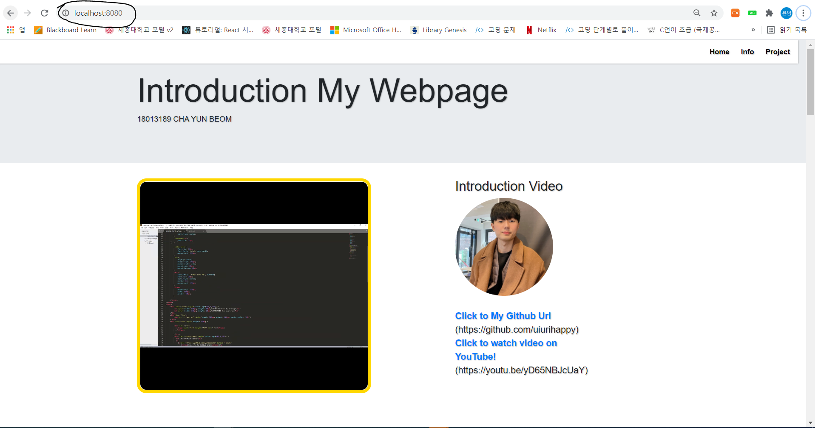

**실행 결과로** [**http://localhost:8080/**](http://localhost:8080/) **주소를 클릭하여 접속하여 저의 html 파일 결과를 확인할 수 있습니다.**

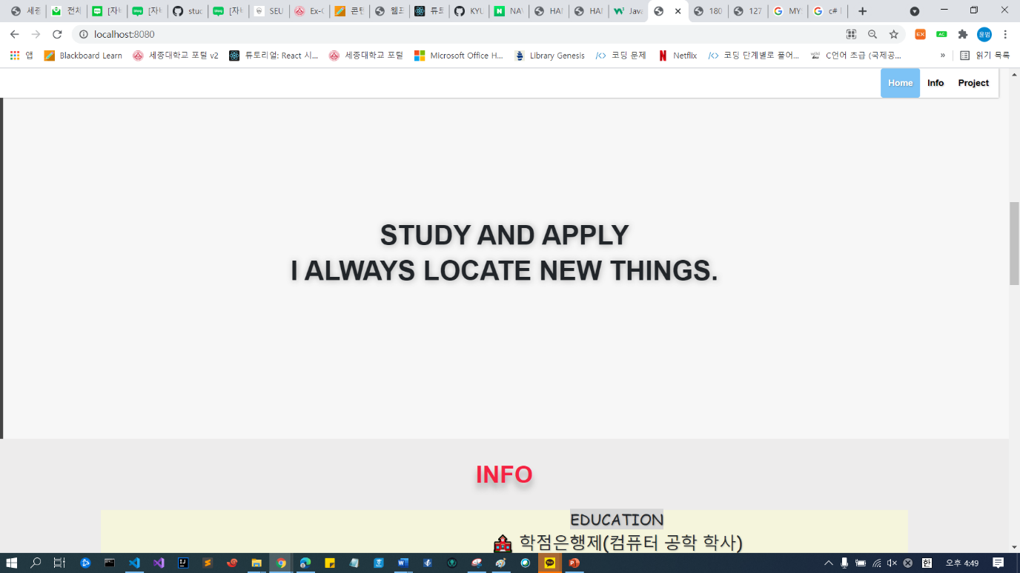

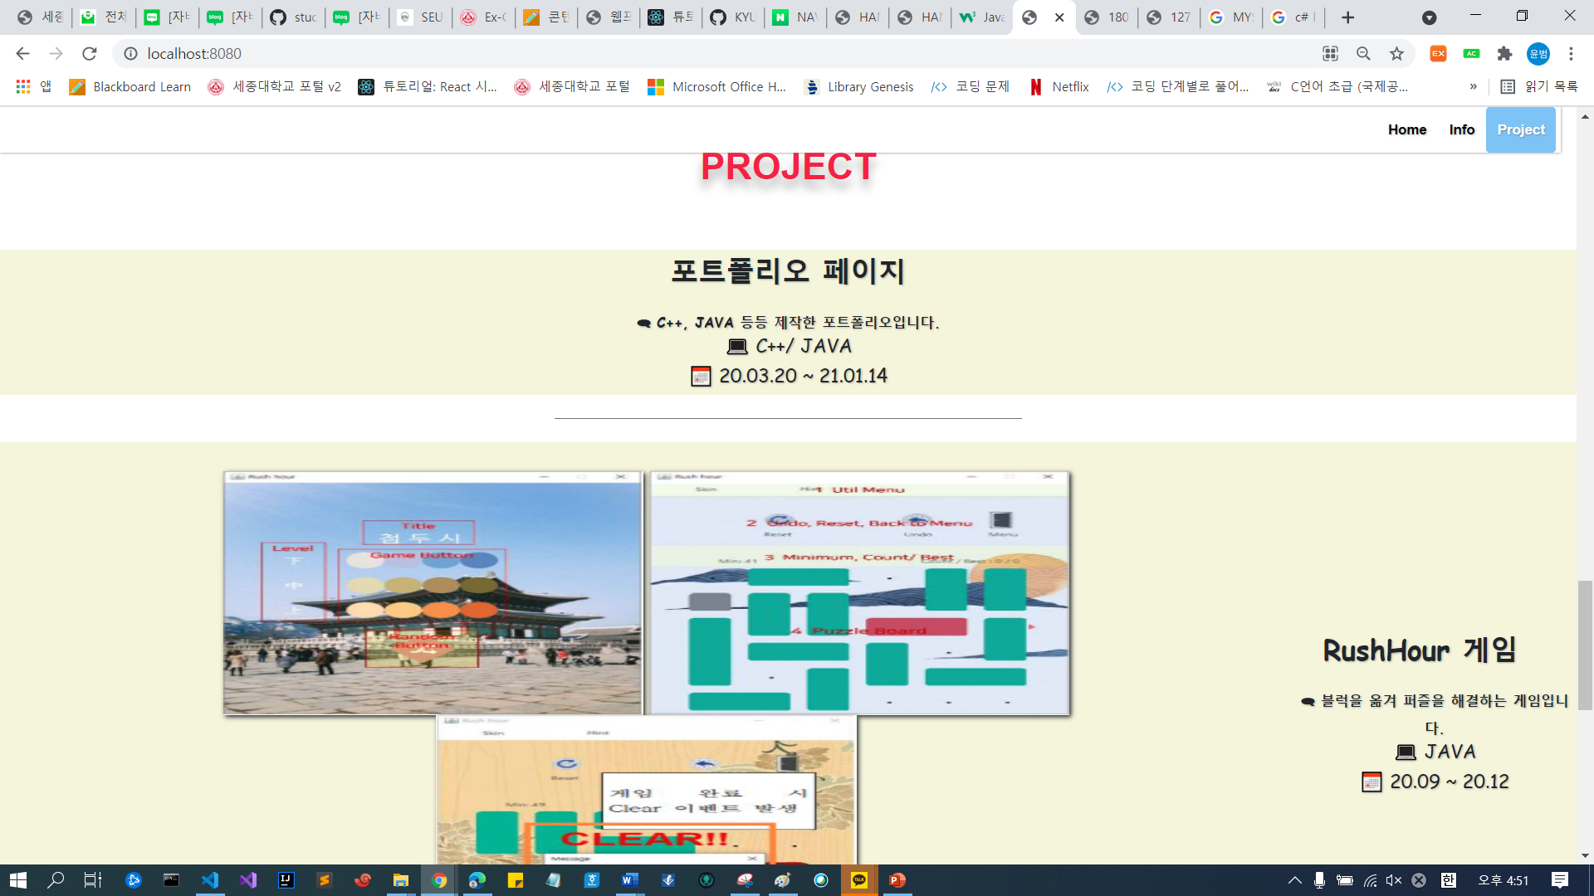

**그리고 오른쪽 상단에 있는 Home, Info, Project 버튼을 클릭하면 해당 section으로 넘어가는 javascript를 구현하였습니다.**