1. Symmetric vs. Asymmetric Encryption
The foundation of cryptography splits into two main methods.

Symmetric Encryption (Shared Secret)
This method uses one single key to both lock and unlock data.
- Pros: Blazing fast and highly efficient.
- Cons: You must find a secure way to share the key in the first place. If an attacker steals it, they can read everything.
- Best For: Encrypting heavy data like medical images, databases, or streaming video.
- Examples: AES-128/256

Asymmetric Encryption (Key Pair)
This method uses a mathematically linked pair: a Public Key (which you share openly with the world) and a Private Key (which you keep strictly secret). Anyone can use your Public Key to lock a message, but only your Private Key can unlock it.
- Pros: Solves the key sharing problem. You don't need to risk sending a shared password over the internet.
- Cons: Extremely slow and resource-heavy.
- Best For: Secure handshakes, and swapping small symmetric keys.
- Examples: RSA, ECC, and new quantum-safe tools like ML-KEM.

The Hybrid Solution
Real-world systems combine both. Asymmetric encryption handles the initial digital handshake to safely agree on a temporary key. Once that key is established, the system immediately switches to symmetric encryption to transmit the actual data quickly.

2. What is AEAD?
Basic encryption only hides your data (Confidentiality). It does not stop a hacker from messing with the encrypted bits mid-transit. If they alter the scrambled data, your computer will decrypt it into corrupted garbage without realizing it was tampered with.
AEAD (Authenticated Encryption with Associated Data) fixes this by providing three guarantees simultaneously:
- Confidentiality: Nobody can read the data without the key.
- Integrity: The system detects if even a single bit of data was altered.
- Authenticity: It proves the data came from a trusted source who holds the key.
It achieves this by generating a short, secure checksum called an Authentication Tag alongside the scrambled data. If a hacker alters the file, the tag won't match during decryption, and the computer will instantly reject the file. When your server receives the file, it doesn't just blindly trust it. Before it decrypts anything, it runs a test:
- The server takes the modified scrambled data and your secret key.
- It runs the exact same math machine to calculate a Brand New Tag.
- It compares the two: [Brand New Tag] vs [Original Tag].
Because the hacker changed even one tiny bit of the data, the math completely shifts). The Brand New Tag will look completely different from the Original Tag.

Associated Data
AEAD also lets you leave certain information unencrypted (like a patient ID or a routing header) while still protecting it from tampering. This allows network routing systems to read the necessary metadata without exposing the sensitive medical image inside.

3. Why GCM Mode is the Default Choice
GCM (Galois/Counter Mode) is an engineering framework that turns standard AES into a high-speed AEAD system. It is the gold standard for several practical reasons:
- Hardware Speed: It processes data in parallel rather than one block at a time. Modern CPU chips are physically designed to fast-track GCM calculations.
- Single-Pass Efficiency: Older systems required running one formula to encrypt data and a completely separate formula to seal it. GCM handles encryption and authentication at the same time in one single pass.
- Industry Standard: It forms the backbone of modern web security (TLS 1.3), VPNs, and secure storage systems.

The Critical Flaw: Nonce Reuse
GCM relies on a Nonce (a number used only once). This is a random string mixed into the key for every single encryption cycle to ensure the scrambled output always looks unique.
If you ever use the exact same Nonce twice with the same key, the underlying mathematics collapse. An attacker can compare the two files, peel away the encryption layer to read the contents, and reverse-engineer the authentication key to forge their own fake data.

What Kem is?
KEM stands for key exchange mechanisn and it is used to secure keys transmitted over a channel for encryption or decryption.
steps:
• KeyGen :Receiver generates (public key ek, private key dk).
• Encapsulation : Sender runs Encaps(ek), which outputs a ciphertext c and a shared secret K together (sender doesn't pre-choose K).
• Transmission : Sender sends c to the receiver (safe over an insecure channel).
• Decapsulation : Receiver runs Decaps(dk, c) with their private key to recover the same K.
• Use : Both sides now hold identical K; it's used as the AES-256 key to encrypt/decrypt the actual data.

Why RSA & ECC are Completely Broken: Shor's Algorithm
RSA and ECC rely on math problems that classical computers find too slow to solve (like factoring massive numbers).
- The Quantum Cheat: Shor’s Algorithm is a specialized quantum math shortcut. It turns factoring into a pattern-finding game that quantum computers can solve almost instantly using quantum physics.
- The Result: RSA and ECC are completely destroyed. Making their keys longer will not save them. This is why we must switch to quantum-safe alternatives like ML-KEM.

Why AES-256 Survives: Grover's Algorithm
Symmetric encryption like AES doesn't use clever math patterns; it relies on raw, brute-force secrecy (trying every possible password combination).
- The Quantum Speedup: Grover’s Algorithm is a quantum search engine. It can search through possibilities faster, but it doesn't have a total shortcut. Instead, it effectively halves the security bits of a key.
- The Math: * AES-128 drops to 64 bits of security (Dangerous/Crackable).
  - AES-256 drops to 128 bits of security (Still completely uncrackable).
- The Result: AES survives quantum attacks. To stay perfectly safe, you don't need a new algorithm—you just need to double your key size by using AES-256.

Hmac: hash based message authentication code:

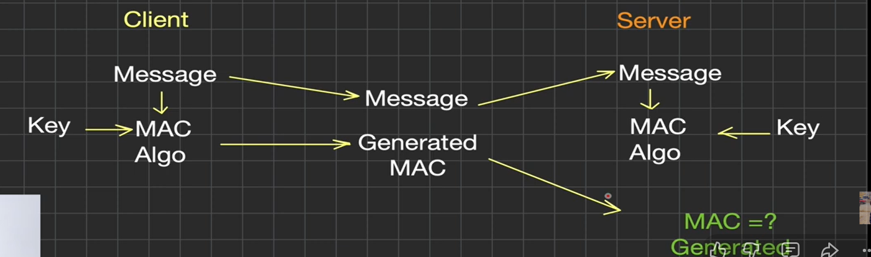
It uses a nested construction hashing the message with the key mixed in twice, using two different padded versions of the key ich is specifically designed to be secure even if the underlying hash function has certain weaknesses.
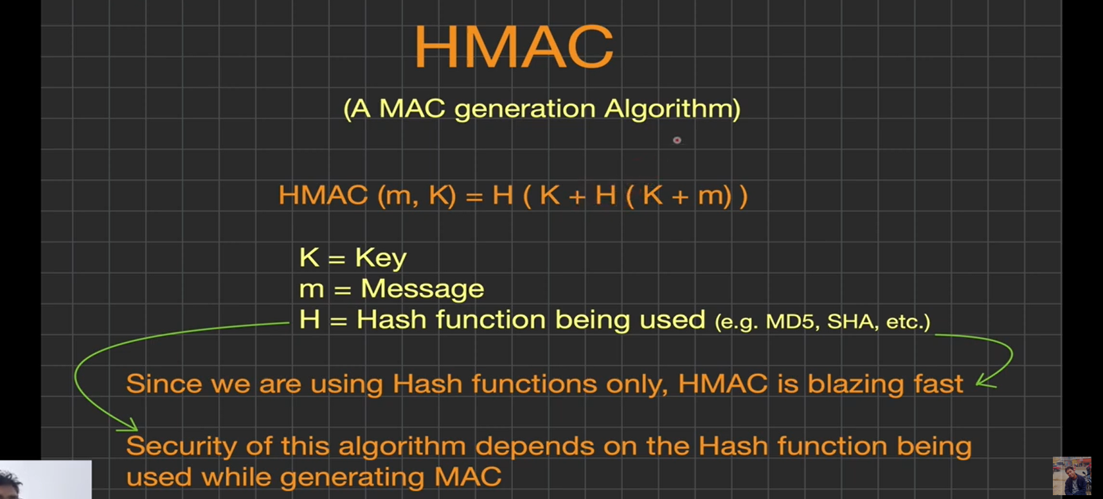

4.2 What HMAC Guarantees
- Integrity — if even one bit of the message changes, the resulting HMAC tag changes completely (avalanche effect), so tampering is detectable.
- Authenticity — because computing a valid HMAC tag requires knowing the secret key, only someone who holds the key could have produced that tag. This proves the message came from someone who has the key.
- It does NOT provide confidentiality. HMAC does not encrypt anything — the message itself is still visible in plaintext unless you separately encrypt it. HMAC only proves the message wasn't altered and was sent by someone with the right key.
This is why AEAD schemes like AES-GCM matter — they give you confidentiality and an HMAC-like authentication guarantee (via GHASH) in one pass, whereas plain HMAC only gives you the authentication half.

Code Snippets and screenshots:
exp01_aes_gcm.py:

import os
from pathlib import Path

from cryptography.exceptions import InvalidTag
from cryptography.hazmat.primitives.ciphers.aead import AESGCM

# Real Word document to encrypt (binary bytes, not a text string).
INPUT_PATH = Path(r"D:\BlockChain\week01\W1D1.docx")
# Keep experiment artefacts next to this script.
OUT_DIR = Path(__file__).resolve().parent
CIPHERTEXT_PATH = OUT_DIR / "W1D1.docx.enc"
RECOVERED_PATH = OUT_DIR / "W1D1.recovered.docx"

def main():
if not INPUT_PATH.is_file():
raise FileNotFoundError(f"Input file not found: {INPUT_PATH}")

# 1. Generate a random 256-bit (32-byte) AES key.
# In a real system this key would come from ML-KEM's shared secret (or HKDF).
key = AESGCM.generate_key(bit_length=256)
aesgcm = AESGCM(key)

# 2. A 96-bit (12-byte) nonce is required for GCM.
# MUST be unique per encryption with the same key (nonce reuse = broken).
nonce = os.urandom(12)

# 3. Read the real file as raw bytes (works for .docx, DICOM, images, etc.).
plaintext = INPUT_PATH.read_bytes()
print(f"Input file: {INPUT_PATH}")
print(f"Original size: {len(plaintext)} bytes")

# 4. Optional associated data: authenticated but NOT encrypted

associated_data = INPUT_PATH.name.encode("utf-8")

# --- ENCRYPT ---
ciphertext = aesgcm.encrypt(nonce, plaintext, associated_data)
# Store nonce || ciphertext so we can decrypt later without a separate sidecar.
# (GCM tag is already appended inside `ciphertext` by the library.)
CIPHERTEXT_PATH.write_bytes(nonce + ciphertext)
print(f"Encrypted file: {CIPHERTEXT_PATH}")
print(f"Ciphertext size: {len(ciphertext)} bytes "
f"(+ {len(nonce)}-byte nonce on disk = {CIPHERTEXT_PATH.stat().st_size})")
print(f"Ciphertext preview: {ciphertext[:32].hex()}...")
print()

# --- DECRYPT (normal case: should succeed and recreate the file) ---
blob = CIPHERTEXT_PATH.read_bytes()
nonce_r, ciphertext_r = blob[:12], blob[12:]
decrypted = aesgcm.decrypt(nonce_r, ciphertext_r, associated_data)
RECOVERED_PATH.write_bytes(decrypted)

print("[OK] Decryption succeeded.")
print(f"Recovered file: {RECOVERED_PATH}")
print(f"Recovered size: {len(decrypted)} bytes")
assert decrypted == plaintext, "Recovered bytes do not match the original file!"
print("[OK] Recovered file bytes == original file bytes.")
print()

# --- DECRYPT (tampered ciphertext: should FAIL) ---
# Flip a single bit to simulate an attacker modifying the file on disk/in transit.
tampered = bytearray(ciphertext_r)
tampered[0] ^= 0x01
tampered = bytes(tampered)

print("Tampering with ciphertext (flipped 1 bit)...")
try:
aesgcm.decrypt(nonce_r, tampered, associated_data)
print("[UNEXPECTED] Decryption succeeded on tampered data — this should never happen!")
except InvalidTag:
print("[EXPECTED] Decryption FAILED: InvalidTag raised.")
print("This is AEAD's authentication guarantee working correctly:")
print("tampered ciphertext is rejected instead of returning a corrupted .docx.")

if __name__ == "__main__":
main()

Screenshots:
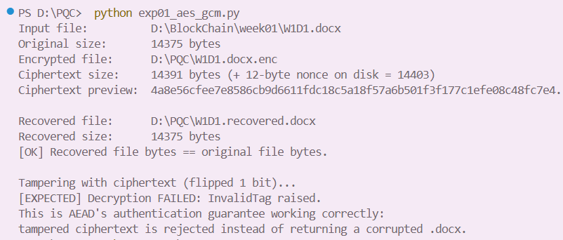
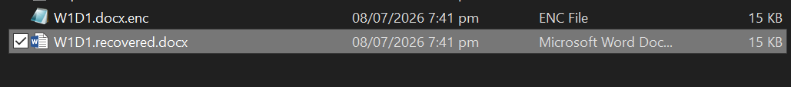

exp02_hmac.py:

import hmac
import hashlib
import os

def hmac_sha256(key: bytes, message: bytes) -> str:
return hmac.new(key, message, hashlib.sha256).hexdigest()

def main():
key_a = os.urandom(32) # 256-bit key #1
key_b = os.urandom(32) # 256-bit key #2 (different from key_a)

keywords = ["fracture", "mri", "fracture", "ct-scan"]

print("=== Same key, multiple keywords ===")
tags_with_key_a = {}
for word in keywords:
tag = hmac_sha256(key_a, word.encode())
tags_with_key_a.setdefault(word, []).append(tag)
print(f"HMAC(key_a, {word!r}) = {tag}")

print()
print("=== Property 1: same keyword + same key -> same tag ===")
fracture_tags = tags_with_key_a["fracture"]
print("Both 'fracture' tags equal:", fracture_tags[0] == fracture_tags[1])
assert fracture_tags[0] == fracture_tags[1]

print()
print("=== Property 2: same keyword + different key -> different tag ===")
word = "fracture"
tag_key_a = hmac_sha256(key_a, word.encode())
tag_key_b = hmac_sha256(key_b, word.encode())
print(f"HMAC(key_a, {word!r}) = {tag_key_a}")
print(f"HMAC(key_b, {word!r}) = {tag_key_b}")
print("Tags equal?", tag_key_a == tag_key_b)
assert tag_key_a != tag_key_b

print()
print("Takeaway: the tag is a deterministic fingerprint of (key, message).")
print("Without the key, you cannot predict or forge the tag for a given")
print("keyword - that's what makes it usable as a secure search index.")

if __name__ == "__main__":
main()

Screeenshots
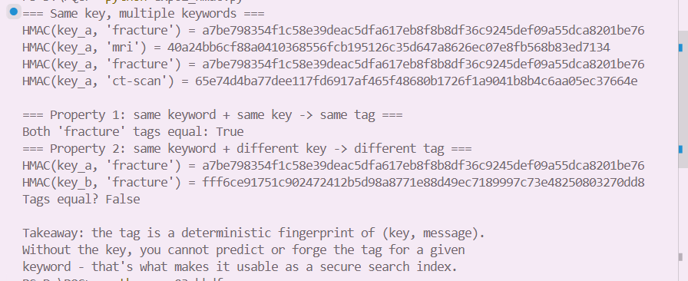
exp03_hkdf.py

import os
from cryptography.hazmat.primitives import hashes
from cryptography.hazmat.primitives.kdf.hkdf import HKDF

def derive_key(shared_secret: bytes, info: bytes, length: int = 32) -> bytes:
"""
HKDF = HMAC-based Key Derivation Function.
- shared_secret: the raw input key material (e.g. ML-KEM's output K)
- info: a context/label string that makes each derived key unique
for its purpose, even from the same shared_secret
- salt=None here for simplicity; in production use a random salt
exchanged alongside the ciphertext, or a fixed protocol-defined salt.
"""
hkdf = HKDF(
algorithm=hashes.SHA256(),
length=length,
salt=None,
info=info,
)
return hkdf.derive(shared_secret)

def main():
# Simulate the 32-byte shared secret you'd get from ML-KEM's Decaps().
shared_secret = os.urandom(32)
print("Shared secret (from ML-KEM, simulated):", shared_secret.hex())
print()

# Derive two keys from the SAME shared secret using different "info" labels.
encryption_key = derive_key(shared_secret, info=b"image-encryption-key")
index_key = derive_key(shared_secret, info=b"searchable-index-key")

print("Derived encryption key (for AES-256-GCM):", encryption_key.hex())
print("Derived index key (for HMAC index): ", index_key.hex())
print()

print("Are the two derived keys different?", encryption_key != index_key)
assert encryption_key != index_key

print()
print("Reproducibility check: deriving again with the same secret + info")
print("gives back the SAME key (HKDF is deterministic given the same inputs).")
encryption_key_again = derive_key(shared_secret, info=b"image-encryption-key")
print("Matches original encryption key?", encryption_key_again == encryption_key)
assert encryption_key_again == encryption_key

print()
print("Takeaway: one shared secret -> many purpose-specific keys, just by")
print("changing the 'info' label. This is exactly the pattern to use so")
print("the AES-256 encryption key and the HMAC index key (exp02) are never")
print("the same key, even though they both trace back to one ML-KEM secret.")

if __name__ == "__main__":
main()

SS:
