Week 14 Concepts Assignment

CS441

*This is exercises based on the textbook ones for Chapter 22 and 23. Note, there are additional steps or requirements that might not be in the book, or steps removed from the book, so be sure to follow this document vs directly following the textbook.*

*Note, all required student files are located in the Week 1 Module of Canvas. Look for the “Student Download files” and add to your htdocs folder. Remember that the weekly code will be copied back and forth from your local Github repository and the htdocs folder.*

*Before starting, make sure to copy the directories “book_apps” and “ex_starts” to your local computer in the following directory: C:*xampp\htdocs\

***With lab PCs, sync Github prior to starting work, commit all changes, and PUSH those changes to Github.***

**Instructions:**

# Exercise 22-1 Work with uploads and Images

## This exercise gives you a chance to enhance the Upload application presented in this chapter.

## Test the application

1. Run the application in the ex_starts/ch22_ex1 directory.
2. Test the application by uploading one or more of the image files in the ex_starts/ch22_images directory. Note that this creates three files for every image that you upload (the original file plus two more files). For this to work on Windows, the GD library must be enabled as described in appendix A. For this to work on macOS, permissions for the htdocs directory must be set correctly as described in appendix B.
3. Use the application to view the uploaded images. Capture a screenshot of your results:
4. View the files in the ex_starts/ch22_ex1/images directory. Note that the uploaded files have been copied to this directory and that the processed versions of the files have also been stored in this directory.
5. Use the application to delete one or more of the files that you have uploaded. Capture a screenshot of your results:

## Modify the code

1. Open the uploadform.php file and modify it so it allows you to upload three files at a time. When you’re through, the form should look something like this:

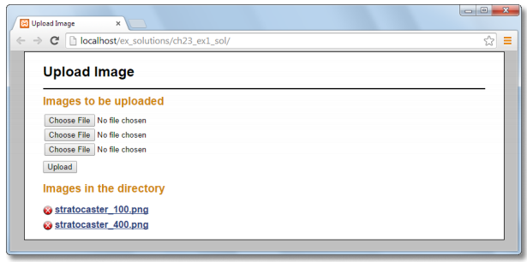

1. Open the index.php file and modify it so it provides for uploading one, two, or three files at a time. To avoid code duplication, you can create a function that performs the upload for each file.
2. Open the image_util.php file and modify the process_image() function so it creates three new images. The first two should be a maximum of 100 and 400 pixels wide, and the third one should be a maximum 250 pixels wide.

# Exercise 23-1 Test and Review the prototype

## Run some of the examples from this exercise.

1. Start phpMyAdmin. (XAMPP)
   1. Run through the examples in the book for chapter 23-1.
   2. No screenshots are needed for validation – but be prepared to review and discuss in class.

***Commit this document and all edited code to your Week 14 Github repository by the deadline. Any late work must be communicated.***