Design Document of
Job Scheduler

Team Members
Prasad K K
Ujesh Mohanan
Sanoj Thomas

Over All Architecture Diagram
Thread Read Input
Thread Push to slave
Master Queue
Slave 2
Slave 1
Slave 3
Slave 4
Slave Threads
Slave Queue
Master

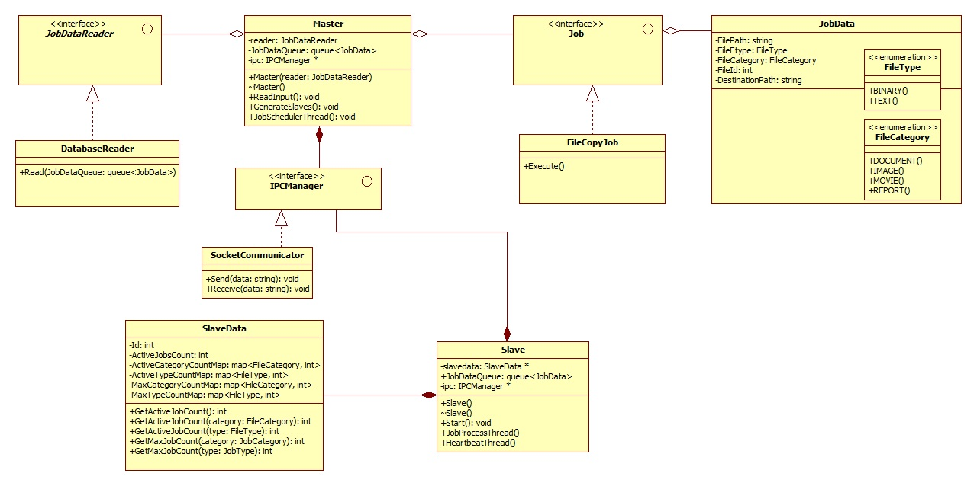

Class Diagrams

Module Design
MasterProcess
Tasks involved in MasterProcess are as below
- Create Slaves
Creates slave objects with unique slave id
Insert slave objects into list of slave (STL MAP is used)
Spawn slave process by passing slave id to the process
- Threads for reading file inputs
Select filename, type category, path, destination path from database.
Create job data objects with file id, file name, category, path
Wrap file object with job information (adding destination path etc.)
Insert into process queue
- Threads for Pushing file data to Slave
Select job info object from process queue
Check the type and category of the file
Check the active count of slaves
Push to slave which is free
- Thread for reading slave response and update data structure of slaves
Read the response from slave from IPC
Take the slave ID and reduce the active job count of that slave
SlaveProcess
Tasks involved in SlaveProcess are as below

- Thread for Reading job objects from queue
Make file objects and push to individual queues of threads
- Thread for reading individual queues
Read individual queues for new job objects
Call execute command
Create JobStatus object with status of the job
Push the JobStatus to MasterProcess by inserting to IPC

