B. TECH - COMPUTER SCIENCE AND ENGINEERING (V SEMESTER)
CST 303Concurrent and Parallel Programming Lab
Week: 5 Batch:3
- Implement solution of Critical Section problem with Semaphores (N processes).
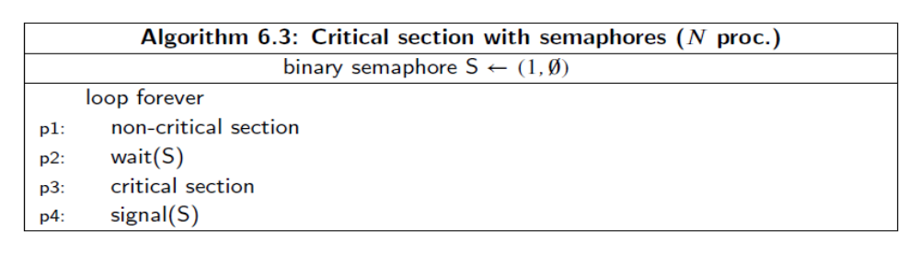
- Implement producer-consumer problem with Semaphores (infinite buffer).
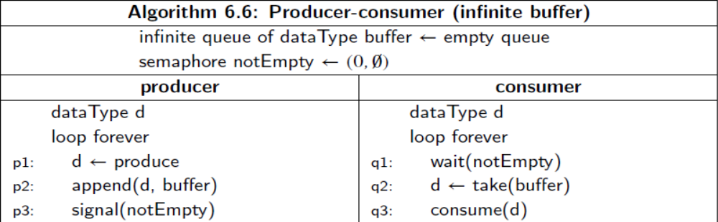
- Implement producer-consumer problem with Semaphores (finite buffer).
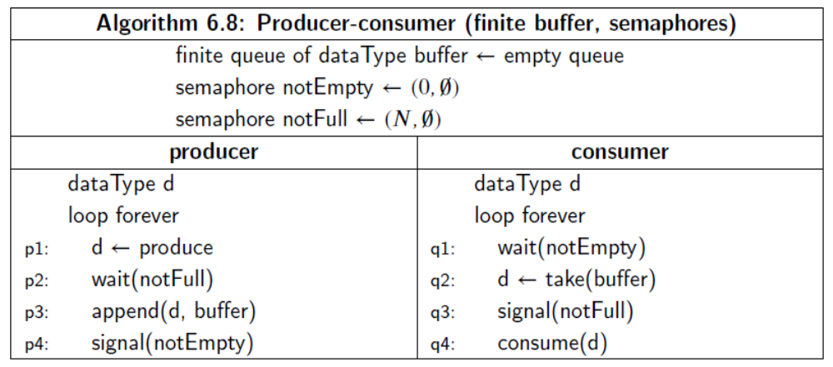

- Implement producer-consumer problem with Semaphores (circular buffer).
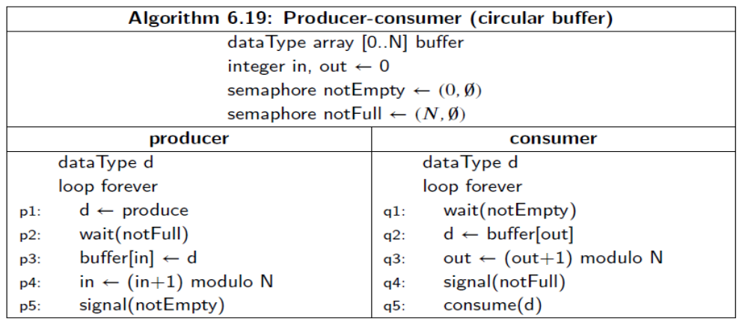
- Implement Readers Writers problem using Semaphores
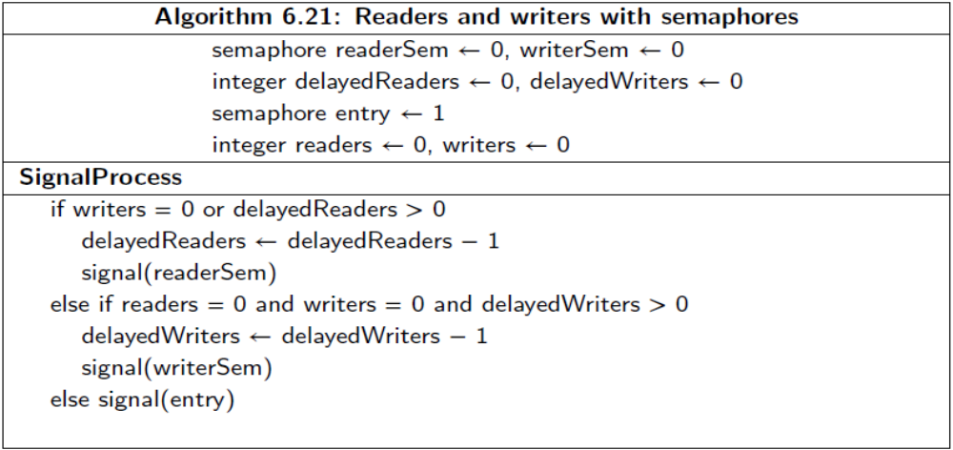
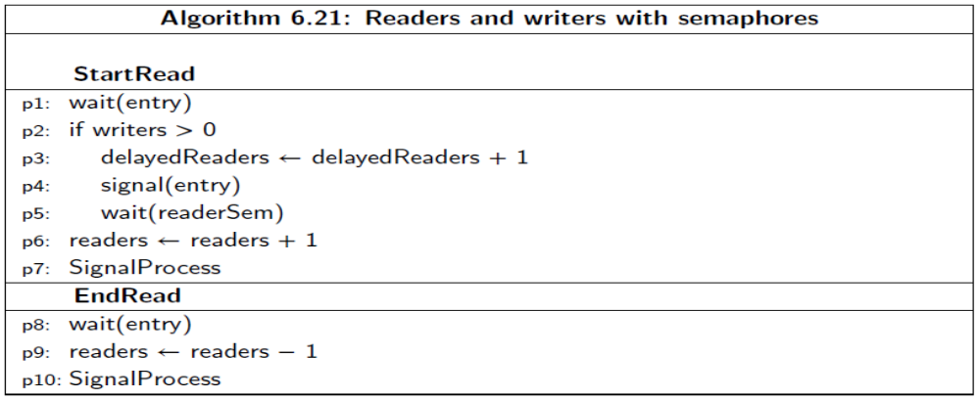
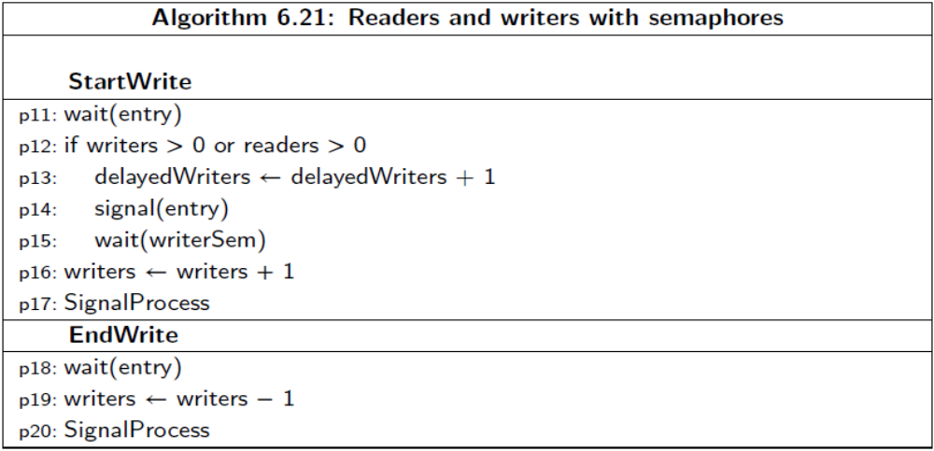
- Implement critical section problem with compare-and-swap
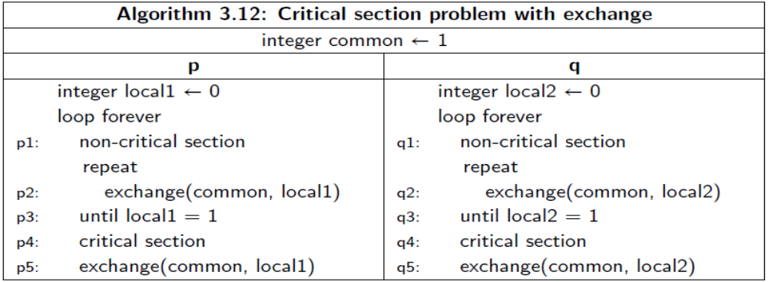
Replace exchange function with compare_and_swap
compare_and_swap (common, old, new) is
integer temp
temp common
if common = old
common new
return temp

