GPU-accelerated and CPU SIMD Optimized Monte Carlo Simulation of φ⁴ Model
John Piotr Bialas, Jakub Kowal, and Adam Strzelecki
Faculty of Physics, Astronomy and Applied Computer Science
Jagiellonian University
ul. Reymonta 4, 30-059 Krakow, Poland

email: pbialas@th.if.uj.edu.pl
Keywords: GPGPU, CUDA, Monte Carlo, OpenMP, SIMD, simulation
- Introduction
This contribution is concerned with an efficient implementation of the Monte-Carlo simulations of the φ⁴ model[1]. The problem is defined as follows: having a vector field φ defined on a regular rectangular two or three dimensional grid we want to generate the field configurations with probability proportional to exp(−H(φ)) where H(φ) is some function of all the fields φ_{i}.
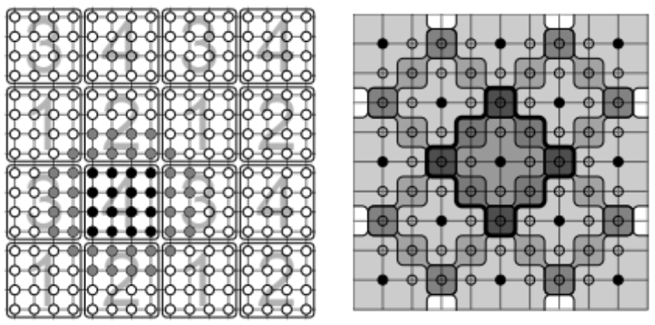
Fig. 1. (Left) The partition of the lattice into blocks. The blocks with same number are processed in parallel by different thread blocks. (Right) Partitioning of the blocks into disjoint sublattices. Thick black line denotes the neighborhood used in updating the center point. Black points are processes in parallel by different threads of the same thread block.
- Description of a problem solution
The actual generation is done by the mean of the Metropolis algorithm. This amounts to sequentially updating all the points of the lattice. The crucial feature of this algorithm is that the update is local i.e. the new value of the field in a given point depends only on the values of fields in the immediate neighborhood of the updated point. In our case this neighborhood is extended compared to usual nearest neighbors (see figure 1 (Right)). The update is random and requires a good source of pseudo-random numbers. We use the Tausworthe RNG[3].
While model is inherently parallelizable, grid points that lie in the same neighborhood cannot be updated together. Taking into account a larger neighborhood means that a simple checkerboard decomposition pattern cannot be used and we have devised a new grid decomposition scheme.
- Results
On GPU we adopt the hierarchical scheme from ref. [2] suitably modified to account for bigger neighborhood. We first divide the whole lattice in blocks of 32 × 32 points. Then we start a kernel that process every forth block (see figure 1). Each block is assigned to a block of 128 threads. First we fetch the values of the fields from global to shared memory (including border points). After that each thread updates one point from the first partition. Then after synchronization, next partition is updated and so on. After processing all eight(2D) or 16 (3D) partitions the kernel writes the shared memory back into global and new kernel is started processing next batch of blocks. Altogether in this way we managed to achieve 0.13 nanoseconds for single lattice field update on NVIDIA GTX 470, reaching around 430 Gflops that is 40% of 1088 Gflops peak performance of this device.
In order to provide unbiased CPU vs GPU speed up results we provide multithreaded vectorized CPU implementation. It uses OpenMP for parallel execution, SSE/AVX and compiler vector extensions for vectorization. This implementation does mimic GPU SIMT execution model. The SIMD instructions are used to process four (SSE) or eight (AVX) updates in parallel. We use partitions as on GPU but we use only one level i.e. we do not partition the lattice into blocks. However not all scalar x86 instructions have vector counterparts. In particular direct XMM registers gather and scatter and vectorized integer operations for full length AVX 256-bit registers are missing, which makes impossible to port random number generator from 128-bit SSE to 256-bit AVX. Initially planned for AVX standard, these were postponed to AVX2 planned for 2013. As soon AVX2 capable CPU devices appear on the market we plan to revise our evaluation.
- Conclusions and future work
Our CPU OpenMP and SSE/AVX implementation compiled via GCC 4.4 or higher and running on Intel Core i5 2.5 Ghz quad core CPU presented 15× performance boost comparing to single threaded scalar code and 3.76 nanoseconds for single lattice field update. Which gives the 15 Gflops that is ~10% of the 160 Gflops peak performance of tested i5 CPU. There is no significant increase in performance while switching from SSE to AVX instructions.
This gives around 28× advantage to GPU, which is noticeably less than promised by many publications, however much higher that comes from comparison of tested i5 CPU to GTX 470. This can be traced back to 128-bit only Tausworthe random number generator implementation and inefficient vector store and load operations (gather/scatter).
References
- G. Parisi “Statistical Field Theory” Chapter 5, Perseus Books Publishing (1998).
- M. Weigel, J. Comput. Phys. 231, 3064 (2012).
- Lee Howes and David Thomas. “Efficient random number generation and application using CUDA.” In Hubert Nguyen, editor, GPU Gems 3, chapter 37. Addison Wesley, August 2007.

