Tropical Cyclone Report
Hurricane Rita
18-26 September 2005

Richard D. Knabb, Daniel P. Brown, and Jamie R. Rhome
National Hurricane Center
17 March 2006

Updated 14 August 2006 for updated property damage cost estimates
and for a few storm surge observations

Rita was an intense hurricane that reached Category 5 strength (on the Saffir-Simpson Hurricane Scale) over the central Gulf of Mexico, where it had the fourth-lowest central pressure on record in the Atlantic basin. Although it weakened prior to making landfall as a Category 3 hurricane near the Texas/Louisiana border, Rita produced significant storm surge that devastated coastal communities in southwestern Louisiana, and its winds, rain, and tornadoes caused fatalities and a wide swath of damage from eastern Texas to Alabama. Additionally, Rita caused floods due to storm surge in portions of the Florida Keys.

- Synoptic History

Rita originated from a complex interaction between a tropical wave and the remnants of a cold front. The tropical wave moved off the west coast of Africa on 7 September. It failed to produce much deep convection as it traversed the tropical Atlantic during 8-12 September. Convection briefly consolidated along the axis of the tropical wave late on 13 September about 800 miles east of the Lesser Antilles, but it soon diminished again. Meanwhile, a cold front had pushed southward over the central Atlantic during 11-12 September and then became stationary a couple hundred miles north of the Leeward Islands on 13 September. The southern extent of the stationary front lost definition and became a remnant surface trough on 14 September. This trough then drifted westward on 15 September and detached from the remainder of the weakening front as strong high pressure built eastward over the western Atlantic. The detached trough moved slowly westward to the north of Puerto Rico and the Virgin Islands on 16 September, producing a large but disorganized area of disturbed weather.

Accompanied by very limited convection, the tropical wave moved westward across the Leeward Islands on 16 September and then merged with the surface trough north of Puerto Rico early on 17 September. Shower and thunderstorm activity became more concentrated later that day north of the Dominican Republic, and the area of disturbed weather was given its first satellite classifications by the Tropical Analysis and Forecast Branch (TAFB) and the Satellite Analysis Branch (SAB) at 1800 UTC 17 September. A continued gradual increase in organization was aided by just enough relaxation of vertical shear, as a middle- to upper- tropospheric low that had been positioned over the western Atlantic shifted westward over Cuba and the northwestern Caribbean Sea. A tropical depression is estimated to have formed by 0000 UTC 18 September approximately 70 n mi east of Grand Turk in the Turks and Caicos.

The “best track” chart of the tropical cyclone’s path is given in Fig. 1, with the wind and pressure histories shown in Figs. 2 and 3, respectively. The best track positions and intensities are listed in Table 1. On 18 and 19 September, Rita moved toward the west-northwest over the Turks and Caicos and the southeastern Bahamas. The depression gradually gained organization on 18 September, with strong convection wrapping around the north side of the low-level circulation center. It became a tropical storm by 1800 UTC that day about 25 n mi east-southeast of the island of Mayaguana in the southeastern Bahamas. However, moderate southerly vertical shear, to the east of the middle- to upper-level low over the northwestern Caribbean Sea, continued to affect the system by confining upper-level outflow and deep convection to the north of the center. While the steering flow was generally toward the west, the low-level center steadily reformed to the north, resulting in a west-northwestward motion. Once the upper-level low to the west weakened on 19 September and the shear over Rita relaxed, the convection became more symmetric about the center and the storm strengthened. Rita reached an intensity of 60 kt (maximum sustained surface winds) by 1800 UTC that day while centered just south of the island of Great Exuma. The storm then turned more westward early on 20 September along the southern periphery of a deep-layer ridge positioned over the western Atlantic and Florida. For several hours Rita struggled to maintain an inner core, and it remained a tropical storm with maximum winds of 60 kt into the morning of 20 September as it approached the Florida Straits. Once there, however, Rita began to strengthen, and it became a hurricane with an intensity of 70 kt by 1200 UTC 20 September about 100 n mi east-southeast of Key West, Florida. Rita then attained an intensity of 85 kt (Category 2) by 1800 UTC that day, and its center passed about 40 n mi south of Key West about an hour later.

Even more rapid strengthening ensued. Rita proceeded westward into the southeastern Gulf of Mexico as a Category 3 hurricane early on 21 September. Throughout most of the remainder of that day, Rita quickly intensified over the very warm waters of the Loop Current and within an environment of very weak vertical wind shear, reaching an intensity of 145 kt by 1800 UTC. Rita had strengthened from a tropical storm to a Category 5 hurricane in less than 36 h. It remained at Category 5 strength for about the next 18 h, reaching its estimated peak intensity of 155 kt by 0300 UTC 22 September while located about 270 n mi south-southeast of the mouth of the Mississippi River. During that time it also turned toward the west-northwest around the western extent of the middle- to upper-tropospheric ridge centered over the southeastern United States.

The inner eyewall deteriorated later on 22 September and Rita abruptly weakened to Category 4 strength with 125 kt maximum winds by 1800 UTC that day. By early on 23 September a new, outer eyewall had consolidated and the hurricane had grown in size. However, Rita did not re-intensify following the structural changes. Due to increasing southwesterly wind shear and slightly cooler waters, steady weakening continued on 23 September. Rita rounded the western periphery of the deep-layer ridge and turned toward the northwest that day, with a slight increase in forward speed from about 8 to about 10 kt. It weakened to a Category 3 hurricane with 110 kt maximum winds by 1800 UTC 23 September about 140 n mi southeast of Sabine Pass at the Texas/Louisiana border. Rita maintained Category 3 status up to the time of landfall of the center, which occurred at 0740 UTC 24 September with an estimated intensity of 100 kt, in extreme southwestern Louisiana just west of Johnson’s Bayou and just east of Sabine Pass.

Rita weakened after making landfall, remaining a hurricane until only about 1200 UTC 24 September when it was centered about 35 n mi north of Beaumont, Texas. As a steadily weakening tropical storm, Rita proceeded northward, with its center moving roughly along the Texas/Louisiana border during the remainder of that day. Rita weakened to a tropical depression by 0600 UTC 25 September while centered over southwestern Arkansas and then turned northeastward ahead of an approaching frontal system. The depression lost its organized convection and degenerated to a remnant low early on 26 September over southeastern Illinois. The low was absorbed into a frontal zone later that morning over the southern Great Lakes region.

- Meteorological Statistics

Observations in Rita (Figs. 2 and 3) include data from satellites, aircraft, airborne and ground-based radars, conventional land-based surface and upper-air observing sites, Coastal-Marine Automated Network (C-MAN) stations, National Ocean Service (NOS) stations, ocean data buoys, and ships. Selected ship reports of winds of tropical storm force associated with Rita are given in Table 2, and selected surface observations from land stations and from coastal and fixed ocean data buoys are given in Table 3. Data from many Automated Surface Observing System (ASOS) sites, C-MAN and NOS stations, and buoys are incomplete due to weather-induced failures prior to or about the time when peak winds and minimum pressures occurred.

Satellite observations include geostationary satellite-based Dvorak Technique intensity estimates from TAFB, SAB, and the U. S. Air Force Weather Agency (AFWA). Microwave satellite data and imagery from National Oceanic and Atmospheric Administration (NOAA) satellites, Defense Meteorological Satellite Program (DMSP) satellites, and National Aeronautics and Space Administration (NASA) satellites, including the Tropical Rainfall Measuring Mission (TRMM), QuikSCAT, and Aqua, were also useful in tracking Rita and assessing changes in its internal structure.

Since Rita formed in the western Atlantic and spent its entire life span near or over land areas, aircraft reconnaissance missions were tasked almost continuously from its genesis until final landfall. Observations from aircraft include flight-level and dropwindsonde data from 16 operational missions into Rita that were conducted by the 53rd Weather Reconnaissance Squadron of the U. S. Air Force Reserve Command, which produced 63 center fixes. Seven missions were flown by the NOAA Aircraft Operations Center (AOC) WP-3D aircraft, producing additional flight-level and dropwindsonde observations, 15 center fixes, surface wind speed data from the Stepped Frequency Microwave Radiometer (SFMR) with post-storm calibration conducted by the NOAA Hurricane Research Division (HRD), and airborne Doppler radar-derived wind analyses also provided by HRD. Additionally, the NOAA G-IV jet conducted eight synoptic surveillance missions around Rita during 19-23 September.

NWS WSR-88D Doppler radars at Key West, Florida and Lake Charles, Louisiana provided center fixes on Rita. Velocity data from these radars were used to help estimate the intensity of Rita when it was near or over land.

Several data sources indicate that Rita was a hurricane with maximum sustained surface winds (one-minute average at 10 m elevation) of 70 kt by 1200 UTC 20 September, although it probably first reached hurricane status an hour or two earlier. Radar imagery from the Key West NWS WSR-88D shows that as Rita moved into the Florida Straits that morning it developed a persistent eye, and the radar velocity data indicate that winds near 90 kt at about 5000 ft (corresponding to about 70 kt at the surface using an average 80% adjustment from that altitude) began about 1200 UTC. A surface wind estimate of 73 kt was then obtained at 1342 UTC from a dropwindsonde, derived from the mean wind over the lowest 150 m of the sounding (labeled ‘LLM’ in Fig. 2). The intensity of 85 kt at 1800 UTC 20 September, near the time of the center’s closest approach to Key West, is based on WSR-88D velocity data, a peak SFMR surface wind speed measurement of 81 kt at 1605 UTC, and a few dropwindsondes that directly measured surface (10 m) winds near 90 kt between about 1330 UTC and 2230 UTC. The maximum winds in Rita remained just south of the Florida Keys, although sustained hurricane-force winds might have impacted portions of the extreme lower Keys for a brief period. The Sand Key C-MAN station, located about 6 n mi southwest of Key West but with an anemometer height of 44 m, reported a 10-minute average wind of 63 kt at 2110 UTC, with an earlier peak gust to 80 kt. A one-minute sustained wind was probably slightly stronger, and the actual peak wind could have occurred after the instrument was destroyed around 2200 UTC. The Key West International Airport later measured a two-minute sustained wind of 54 kt with a gust to 66 kt at 2314 UTC. Most of the remainder of the Keys experienced sustained winds and gusts of tropical storm force (Table 3). Wind gusts of tropical storm force were experienced over much of the extreme southern Florida peninsula south of Lake Okeechobee on 20 September. Several reports of sustained winds of tropical storm force were received from western Cuba on 20 and 21 September while the center passed within about 40 n mi from the north coast of the island.

Aircraft and satellite data indicate that Rita intensified on 21 September from 95 kt (Category 2) at 0000 UTC that day to 145 kt (Category 5) just 18 h later. The first wind observation supporting Category 5 intensity was 138 kt at 1606 UTC from the SFMR, using a post-season calibration based on dropwindsonde data to improve performance at extreme wind speeds. The peak SFMR estimate was 146 kt at 1912 UTC 21 September, followed by a 144 kt estimate at 1945 UTC. A 700-mb flight-level wind of 161 kt was measured near 1935 UTC, corresponding to about 145 kt at the surface based on the average 90% adjustment from 700 mb. Two dropwindsondes directly measured 10-m winds of 142 and 149 kt shortly after 1930 UTC (Fig. 2).

Analysis of dropwindsonde observations indicates that the central pressure in Rita fell a remarkable 70 mb in the 24-h period ending 0000 UTC 22 September (Fig. 3), when the pressure had fallen to an estimated 897 mb with an estimated wind intensity of 150 kt. The best track central pressure at that time is based upon a dropwindsonde observation at 2309 UTC 21 September of 899 mb, but with a surface wind of 32 kt; therefore, the actual central pressure was likely a couple of mb lower. Following that penetration of the eye, the aircraft departed Rita and no reconnaissance data were available during the subsequent six-hour period between about 2330 UTC 21 September and 0530 UTC 22 September.

When the next aircraft arrived, dropwindsondes in the eye measured 898 mb (with a surface wind of 13 kt) at 0538 UTC and 899 mb (with a surface wind of 35 kt) at 0715 UTC. Based on these data, the best track central pressure is also estimated at 897 mb at 0600 UTC 22 September. However, due to the roughly six-hour gap in aircraft data, the lowest pressure and maximum winds that actually occurred in Rita are subject to speculation. Since the pressure was falling until 0000 UTC and rising after 0600 UTC, the minimum pressure in Rita probably occurred at about 0300 UTC 22 September and is estimated at 895 mb. This value represents the fourth-lowest on record in the Atlantic basin best track database, behind 882 mb in Wilma (2005), 888 mb in Gilbert (1988), and 892 mb in the 1935 Florida Keys hurricane. The maximum 700-mb flight-level wind observed during Rita was 165 kt at 0538 UTC 22 September, corresponding to about 149 kt at the surface. However, the very limited temporal and spatial sampling by aircraft during the period of minimum pressure increases the likelihood that the actual maximum flight-level wind was not measured. The eye diameter as reported by aircraft contracted from 20 n mi near 0000 UTC to 16 n mi near 0600 UTC, suggesting that slight strengthening could have occurred during that time. Dvorak intensity estimates from both TAFB and SAB were 155 kt at 0645 UTC 22 September, and that was the first time both agencies provided an estimate that high (only SAB estimated 155 kt at 2345 UTC 21 September). Considering all of these factors, the peak best track intensity is set to 155 kt (just 5 kt greater than what was assessed operationally) and is estimated to have occurred at 0300 and 0600 UTC 22 September. Following two days of rapid strengthening, Rita had also become a large hurricane, with 34-kt winds extending up to 160 n mi from the center at the time of peak intensity.

The weakening of Rita during the last 48 h leading up to landfall was associated with significant changes in its internal structure. Aircraft flight-level wind maxima and passive microwave imagery reveal that on 22 September an outer eyewall developed while the inner eyewall deteriorated. By early on 23 September, the original, inner eyewall was no longer present, and the eye diameter had increased to about 30 n mi. This sequence of events is depicted in Fig. 4 (panels B through E) by a series of passive microwave images from AMSR-E, TRMM, and SSMI; for comparison, panel A shows Rita shortly after reaching Category 5 intensity on 21 September. One consequence of these structural changes was some additional expansion of Rita’s wind field, and by early on 23 September, winds of tropical storm force extended up to about 180 n mi from the center and hurricane-force winds extended up to about 75 n mi out. The central pressure only slowly climbed while Rita’s winds weakened over the northwestern Gulf. However, due to the structural changes, the maximum sustained winds decreased fairly quickly, especially in the first 24 h after peak intensity, as indicated by all available aircraft data (Fig. 2).

The strongest 700-mb flight-level winds during the few hours leading up to landfall were 111-115 kt, east and northeast of the eye within the deep convection that remained north of the center. These data correspond to surface winds of 100-104 kt using the average 90% adjustment. However, WSR-88D velocity data from Lake Charles, Louisiana around the time of landfall depict winds near the top of the boundary layer (about 500 m in altitude) of up to about 120 kt over water near the coast and east of the eye. Based on an average 75% adjustment from that altitude, these data would correspond to about 90 kt surface winds. Additionally, a dropwindsonde at 0544 UTC provided an estimated 92 kt surface wind, derived from an average 80% adjustment of the 115 kt mean boundary layer wind speed in the profile. Based on these various data, and since the maximum surface wind at landfall was likely not sampled by the aircraft or radar, the landfall intensity is set to 100 kt. This intensity is 5 kt less than what was assessed operationally but is still of Category 3 strength.

The central pressure at landfall is estimated at 937 mb based on dropwindsonde data just a few minutes earlier. The landfall pressure and the 935 mb best track pressure at 0600 UTC 24 September are the lowest on record in the Atlantic basin for an intensity of 100 kt. Similar to Katrina one month earlier, the relatively weak winds in Rita for such a low pressure result from the broadening pressure field during its last 48 h over the Gulf of Mexico that spread the pressure gradient over a much larger than average distance from the center, as confirmed by both surface and aircraft observations.

The strongest sustained wind reported from an official surface observing site was 71 kt (with a gust to 86 kt) at the C-MAN station (anemometer height of 13 m) at Sabine River, Texas near the Louisiana border at 0700 UTC 24 September. Sustained hurricane-force winds were also reported at the Southeast Texas Regional Airport in Beaumont, Texas (70 kt) and at the Calcasieu Pass, Louisiana NOS station (67 kt), although the latter became inoperative more than two hours prior to landfall of the center of Rita. A variety of temporary instrumented towers in extreme southeastern Texas also measured sustained hurricane-force winds, as strong as 82 kt, with peak 3-second gusts up to about 100 kt (Table 3). All available data suggest that many areas in extreme southeastern Texas and extreme southwestern Louisiana experienced Category 1 hurricane conditions, and a few areas experienced Category 2 hurricane conditions, with Category 3 hurricane conditions being confined to a very small area east of the eye along the immediate coast of extreme southwestern Louisiana. Due to its large size, Rita produced sustained winds of tropical storm force in many portions of southeastern Louisiana (including cities such as Baton Rouge) and southeastern Texas (including the Houston and Galveston areas) (Table 3).

Despite having weakened, Rita was still a large Category 3 hurricane at landfall and produced a very significant storm surge in southwestern Louisiana, an area very vulnerable to surge. Since so many structures were completely destroyed, and because many gages failed up to several hours before the center of the hurricane crossed the coast (see Table 3), measuring the storm surge has been a daunting task. Only a few high water marks have been collected and analyzed under the direction of the Federal Emergency Management Agency (FEMA). These data along with unofficial visual estimates suggest that the storm surge in portions of the Cameron, Louisiana area was as high as about 15 ft. Water was also pushed into Calcasieu Lake, flooding portions of communities along its shoreline, such as Grand Lake, with a storm surge of at least about 8 ft. The surge then propagated up the Calcasieu River and flooded portions of the Lake Charles area, where in several locations the surge reached Interstate 10 (about 25 n mi from the Gulf coast). Flood waters in downtown Lake Charles were as deep as about 6 ft in some places. Farther east, most or all of Vermillion, Iberia, and St. Mary Parishes south of Highway 14 and U. S. 90 (several miles inland) were inundated by the storm surge, visually estimated at 8-12 ft in some of these areas; a high water mark of nearly 12 ft was also observed in western St. Mary Parish near the town of Louisa. The water crossed these highways in numerous locations and was 3 to 6 ft deep in many homes.

Rita also produced storm surge, generally 4-7 ft based on gage data and a high water mark observation, in coastal areas of southeastern Louisiana, flooding some areas that had already been impacted by the surge from Hurricane Katrina about one month earlier. Some flooding was also reported along Lake Pontchartrain in Slidell and Mandeville. Some local drainage levees in southern Jefferson and southern Terrebonne Parishes were overtopped or breached, as were a few repaired levees in the New Orleans area. While the additional flooding was not as extensive as during Katrina, it contributed to prolonging the efforts, which lasted until early October, to remove all floodwaters from the New Orleans area.

Just west of the landfall location of the circulation center, incomplete gage data suggest a storm surge of at least 5 ft occurred at Sabine Pass. Gages that survived the event farther north along Sabine Lake measured peak water levels of about 4-5 ft. Storm tides measured at gages along much of the Texas coast were generally in the 3-5 foot range, and most of these peaks occurred during the day on 23 September (the day prior to landfall). Some flooding occurred later on 24 September after landfall of Rita’s center along the northern shores of Galveston Island and the Bolivar Peninsula, as northerly winds pushed waters of Galveston Bay southward. Sustained winds of tropical storm force produced by Rita also resulted in a surge of about 1.5 ft on Lake Livingston, located in southeastern Texas about 60 miles north of Houston and about 50 miles west of the path of the center of the storm.

Rita also produced storm surge in the Florida Keys while its center passed just south of the island chain on 20 September. Visual storm tide estimates suggest the maximum storm surge in the Keys might have been about 4-5 ft along the south-facing shores of Key West and the remaining lower Keys, and 3-4 ft along portions of the Atlantic shores of the middle and upper Keys. The surge flooded the runway at Key West International Airport, and it penetrated up to about four blocks inland along streets in Key West that were flooded to depths of about three ft.

Storm total rainfall in the lower and middle Florida Keys was generally 2-4 in, with greater than 6 in estimated by radar in portions of the Upper Keys. A few storm total amounts exceeding 3 in were reported over the extreme southern Florida peninsula. Rita also produced very heavy rains in many portions of Mississippi, Louisiana, and extreme eastern Texas. Storm total amounts of 5-9 in were common in these areas, with some isolated maxima of 10-15 in. Flash floods occurred in several areas, including the Big Black River basin of west-central Mississippi. Several cities reported flooded streets due to heavy rains. Portions of Arkansas received 3-6 in of rain from Rita.

At least 90 tornadoes were reported in association with Rita, mainly to the north and east of the circulation center in portions of Alabama, Mississippi, Louisiana, and Arkansas. Rita produced the most tornadoes (56) in a single event (of 48 h or less in duration) ever recorded in the area of responsibility of the Jackson, Mississippi NWS forecast office (which also includes portions of northeastern Louisiana and extreme southeastern Arkansas). Eleven tornadoes were reported in other portions of Arkansas, and 23 tornadoes were reported in Alabama.

- Casualty and Damage Statistics

The approach of Rita provoked one the largest evacuations in U. S. history. Media reports indicate that the number of evacuees in Texas could have exceeded two million. Additional evacuations involving smaller numbers took place in Louisiana.

Seven fatalities have been directly attributed to the forces of Rita. One was due to drowning near Lake Charles, Louisiana; two people died in Hardin, Texas when a tree was blown down onto their home; one person died when a tree fell on her home in Point Blank, Texas; another person was killed by a falling tree in Angelina County, Texas; one person was killed in a tornado near Isola, Mississippi; and one person drowned in a rip current at Miramar Beach in the Florida panhandle on 24 September. At least 55 “indirect” fatalities have been reported in Texas. Six of these occurred in Beaumont due to carbon monoxide poisoning. A bus accident south of Dallas during the course of the evacuation killed more than 20 persons, mostly elderly evacuees from a nursing home. Other persons died during the evacuation due to heat exhaustion.

The storm surge of Rita devastated entire communities in coastal areas of southwestern Louisiana, including Holly Beach, Cameron, Creole, and Grand Cheniere in Cameron Parish. Almost every structure in these areas was destroyed, and some were completely swept away. Severe beach erosion occurred at Holly Beach. Several miles inland from the Gulf along Calcasieu Lake, numerous homes in the town of Grand Lake were damaged or destroyed. Many portions of the Lake Charles area suffered substantial flood damage, including downtown and some surrounding residential communities. In Vermillion Parish, dozens of homes and businesses were flooded and damaged by storm surge, and most structures in the town of Pecan Island were destroyed. Storm surge damage to homes and businesses in low-lying areas extended eastward along the entire coast of Louisiana, although the impact in the New Orleans area was not nearly as widespread as during Hurricane Katrina. In Jefferson County, Texas, west of where the center made landfall and adjacent to Sabine Lake, the storm surge flooded several homes, and some mobile homes floated away from their original locations. The surge on Lake Livingston in southeastern Texas caused some damage to the Lake Livingston Dam. Rita also caused some damage to homes and businesses due to storm surge in portions of the Florida Keys. Rita’s winds, tornadoes, and fresh water floods caused damage to many other homes and businesses over a large area including portions of Louisiana, eastern Texas, Mississippi, Alabama, Arkansas, and the Florida Keys. Rita caused wide swaths of downed trees and power lines, leaving well over one million customers in these areas without electrical service, some for days or even weeks. Oil and gas production and refining in the northwestern Gulf of Mexico region was disrupted by Rita (largely due to evacuations), but the impacts were not as severe as those farther east due to Hurricane Katrina. The most recent available estimate by the American Insurance Services Group of the insured property damage in the United States caused by Rita is $5.05 billion. Doubling this figure to account for uninsured losses yields a rough estimate for total damage of about $10 billion.

- Forecast and Warning Critique

Development of the system that eventually became Rita was well-anticipated in the Atlantic Tropical Weather Outlook (TWO) products issued by the NHC. The system was first mentioned in the TWO, along with the expectation that upper-level winds would become more conducive for its development, more than 48 h prior to genesis. An increased potential for the formation of a tropical depression was conveyed more than 24 h prior to genesis.

Average official (OFCL) track forecast errors in nautical miles (n mi) (with number of cases in parentheses) for Rita were 27 (29), 54 (29), 76 (27), 93 (25), 120 (21), 164 (17), and 197 (13) for the 12, 24, 36, 48, 72, 96, and 120 h forecasts, respectively. These forecast errors are considerably smaller than the corresponding average official Atlantic track errors for the 10-year period 1995-2004: 42, 75, 107, 138, 202, 236, and 310 n mi (Table 4). However, OFCL errors varied widely during the life span of Rita. Official forecasts issued on 18-19 September, when Rita was a tropical depression and then a tropical storm, had exceptionally small errors, quite accurately forecasting Rita’s path through the Florida Straits and into the central Gulf followed by a turn toward the northwest. Official forecasts issued on 20-21 September, however, were more biased to the south and were late in forecasting Rita’s turn toward the northwest. Then, on 22-23 September, official forecasts within about 48 h of final landfall were once again quite accurate, except for incorrectly anticipating Rita to stall within a couple of days after moving inland (as did all of the reliable models). The significant changes in OFCL errors were essentially concurrent with two fairly dramatic changes in the track guidance. The model forecasts shifted south early on 20 September but then back north early on 22 September, and since these changes were in general unanimous among the reliable models, the official forecasts trended toward the guidance in both instances. However, in part because the official track forecasts were changed fairly conservatively, they had average errors beyond 36 h that were smaller than any of the consensus guidance including GUNA, CONU, and the Florida State University Superensemble (FSSE). The official track forecasts also had smaller errors at all forecast times than the interpolated NOGAPS (NGPI), GFDN (GFDI), and UK Met Office (UKMI) models. The NWS dynamical models performed rather well during Rita. The interpolated GFDL (GFDI) slightly outperformed OFCL at 72-120 h, while the interpolated GFS (GFSI) had smaller errors than OFCL out to 48 h and at 120 h (Table 4).

Average official intensity errors during Rita (including depression stage) were 11, 16, 18, 20, 29, 23, and 18 kt for the 12, 24, 36, 48, 72, 96, and 120 h forecasts respectively. The errors through 72 h are considerably larger than the corresponding Atlantic 10-year (1995-2004) averages of 6, 10, 12, 15, and 18 kt. The rapid intensification of Rita during 20-21 September, from a tropical storm to a Category 5 hurricane in less than 36 h, was not anticipated in official intensity forecasts (although a slower strengthening to major hurricane status was forecast). The observed rate of weakening after peak intensity also was not anticipated. Obviously, forecasting such rapid intensity changes remains an operational challenge. However, official forecasts issued on 19 September, when Rita was still a tropical storm, did anticipate Rita to be at or near Category 2 hurricane strength before passing by the Florida Keys the next day. Also, every official forecast issued within about four days of final landfall indicated Rita would be a major hurricane (at least Category 3 intensity) upon reaching the coast in the northwestern Gulf of Mexico. Official intensity forecasts generally had smaller average errors than most of the objective intensity guidance; exceptions were that the SHIPS model (with inland decay component included) had smaller errors at 48, 72, and 96 h, and the FSSE had smaller errors at 72 and 96 h. The smaller SHIPS errors at 48-96 h are mostly due to its forecasts of more weakening after Rita’s peak intensity than was indicated in the official intensity forecasts.

Table 5 lists the watches and warnings issued for Rita. Hurricane watches and warnings for the United States were issued well in advance of the arrival of hurricane conditions. The hurricane watch for the Florida Keys was issued roughly 48 h before the center of Rita passed near the Keys and produced hurricane-force winds (at least in gusts) in Key West and storm surge flooding in many portions of the Keys. The hurricane watch for the Keys was upgraded to a warning about 36 h in advance. The initial hurricane watch for the northwestern Gulf coast, which included most of the Texas coast and extreme southwestern Louisiana as far east as Cameron, was issued about 58 h prior to landfall of the circulation center near the Texas/Louisiana border. The hurricane watch was later extended eastward to Intracoastal City, Louisiana about 46 h before landfall of the center. A portion of the hurricane watch area was upgraded to a warning about 40 h in advance, and Rita made landfall near the center of that warning area. These long lead times were necessary to account for the large size of Rita and for the need to complete preparations prior to the arrival of winds of tropical storm force. It is important to note that the hurricane watch and warning areas had to be as large as they were, not only due to Rita’s size but also due to the uncertainty in the track forecast at the time the watches and warnings were issued. The fact that Rita made landfall near the eastern edge rather than the middle of the initial hurricane watch area underscores the need to take into account forecast uncertainty and for preparation to occur throughout the entire watch and warning areas.

- Acknowledgements

Some of the aircraft reconnaissance data in this report were processed, interpreted, and furnished by NOAA’s Hurricane Research Division (HRD). Special appreciation is extended to Dr. Peter Black (HRD) and Mr. Eric Ulhorn (HRD) for their analysis of this data. Mr. Colin McAdie (NHC) provided access to and insightful analysis of archived WSR-88D radar data provided by the NWS Forecast Office in Lake Charles, Louisiana. Most of the surface observations in this report were provided by the National Data Buoy Center (NDBC) and by several NWS Forecast Offices in Florida, Mississippi, Louisiana, and Texas. Dr. Stephen Baig (NHC Storm Surge Team Leader) and Lt. Jennifer Pralgo (NOAA Commissioned Corps Officer at NHC) provided storm surge data that were collected and analyzed under the direction of the Federal Emergency Management Agency (FEMA). Appreciation is also extended to NHC Hurricane Specialists Lixion Avila, Jack Beven, James Franklin, Richard Pasch, and Stacy Stewart, to NHC Deputy Director Ed Rappaport, and to NHC Director Max Mayfield for their valuable input to this report.

Table 1. Best track for Hurricane Rita, 18-26 September 2005.

Date/Time  (UTC) | Latitude  (°N) | Longitude  (°W) | Pressure  (mb) | Wind Speed  (kt) | Stage
18 / 0000 | 21.3 | 69.9 | 1009 | 25 | tropical depression
18 / 0600 | 21.6 | 70.7 | 1009 | 25 | "
18 / 1200 | 21.9 | 71.5 | 1007 | 30 | "
18 / 1800 | 22.2 | 72.3 | 1005 | 35 | tropical storm
19 / 0000 | 22.4 | 73.0 | 1002 | 45 | "
19 / 0600 | 22.6 | 73.8 | 999 | 50 | "
19 / 1200 | 22.8 | 74.7 | 997 | 55 | "
19 / 1800 | 23.1 | 75.9 | 994 | 60 | "
20 / 0000 | 23.3 | 77.2 | 992 | 60 | "
20 / 0600 | 23.5 | 78.8 | 990 | 60 | "
20 / 1200 | 23.7 | 80.3 | 985 | 70 | hurricane
20 / 1800 | 23.9 | 81.6 | 975 | 85 | "
21 / 0000 | 24.1 | 82.7 | 967 | 95 | "
21 / 0600 | 24.2 | 84.0 | 955 | 110 | "
21 / 1200 | 24.2 | 85.2 | 941 | 120 | "
21 / 1800 | 24.3 | 86.2 | 920 | 145 | "
22 / 0000 | 24.5 | 86.9 | 897 | 150 | "
22 / 0600 | 24.8 | 87.6 | 897 | 155 | "
22 / 1200 | 25.2 | 88.3 | 908 | 140 | "
22 / 1800 | 25.6 | 89.1 | 914 | 125 | "
23 / 0000 | 26.0 | 89.9 | 915 | 120 | "
23 / 0600 | 26.5 | 90.7 | 924 | 115 | "
23 / 1200 | 27.1 | 91.5 | 927 | 115 | "
23 / 1800 | 27.8 | 92.3 | 930 | 110 | "
24 / 0000 | 28.6 | 93.0 | 931 | 105 | "
24 / 0600 | 29.4 | 93.6 | 935 | 100 | "
24 / 1200 | 30.5 | 94.1 | 949 | 65 | "
24 / 1800 | 31.6 | 94.1 | 974 | 45 | tropical storm
25 / 0000 | 32.7 | 94.0 | 982 | 35 | "
25 / 0600 | 33.7 | 93.6 | 989 | 30 | tropical depression
25 / 1200 | 34.7 | 92.5 | 995 | 25 | "
25 / 1800 | 35.8 | 91.4 | 1000 | 25 | "
26 / 0000 | 37.0 | 90.1 | 1003 | 20 | "
26 / 0600 | 39.5 | 88.0 | 1006 | 20 | remnant low
26 / 1200 |  |  |  |  | absorbed by front
22 / 0300 | 24.7 | 87.3 | 895 | 155 | minimum pressure and maximum wind
24 / 0740 | 29.7 | 93.7 | 937 | 100 | landfall between Johnson’s Bayou, LA and Sabine Pass
Table 2. Selected ship reports with winds of at least 34 kt for Hurricane Rita, 18-26 September 2005.

Date/Time  (UTC) | Ship call sign | Latitude (°N) | Longitude  (°W) | Wind dir/speed (kt) | Pressure (mb)
18 / 1500 | KCGH | 22.1 | 70.5 | 120 / 35 | 1009.5
19 / 0300 | WGJT | 24.6 | 73.7 | 060 / 35 | 1012.4
19 / 0600 | 3FPS9 | 24.7 | 73.9 | 080 / 35 | 1011.0
19 / 0700 | WGJT | 24.0 | 72.9 | 090 / 40 | 1009.6
19 / 0900 | 3FPS9 | 24.2 | 73.2 | 060 / 54 | 1009.0
19 / 1200 | WJBJ | 24.0 | 68.2 | 110 / 35 | 1014.0
19 / 1800 | WJBJ | 22.5 | 67.7 | 120 / 44 | 1013.0
19 / 2100 | A8FS4 | 24.7 | 74.7 | 110 / 37 | 1008.5
20 / 0000 | A8FS4 | 25.6 | 74.6 | 080 / 35 | 1012.0
21 / 0600 | PFEI | 26.7 | 83.5 | 050 / 37 | 1009.5
21 / 0900 | PFEI | 26.0 | 83.4 | 070 / 41 | 1005.5
21 / 1500 | V7HC8 | 27.5 | 90.4 | 020 / 40 | 1010.0
21 / 1700 | C6FM5 | 23.5 | 83.8 | 160 / 38 | 1006.5
21 / 1800 | KSYP | 22.8 | 84.5 | 180 / 36 | 1003.1
21 / 1800 | VRWF2 | 23.0 | 84.3 | 180 / 38 | 1004.5
21 / 1800 | V7HC9 | 28.0 | 88.3 | 050 / 35 | 1011.2
21 / 2100 | WCBP | 28.1 | 88.6 | 050 / 35 | 1009.0
21 / 2100 | V7HC9 | 28.1 | 88.1 | 050 / 35 | 1009.1
22 / 0300 | V7HC6 | 27.0 | 90.5 | 030 / 35 | 1007.5
22 / 0300 | V7HD2 | 28.0 | 86.8 | 070 / 39 | 1011.0
22 / 0600 | V7HC6 | 27.3 | 90.4 | 040 / 35 | 1006.1
22 / 0600 | V7HD2 | 28.0 | 86.9 | 090 / 40 | 1009.0
22 / 0600 | V7HC9 | 28.2 | 87.8 | 050 / 35 | 1009.1
22 / 0900 | V7HC6 | 27.6 | 90.3 | 040 / 35 | 1003.6
22 / 0900 | ZIYE7 | 27.7 | 85.7 | 080 / 37 | 1005.0
22 / 0900 | V7HD2 | 28.0 | 87.0 | 100 / 40 | 1008.0
22 / 0900 | V7HD3 | 28.3 | 87.9 | 110 / 44 | 1002.0
22 / 0900 | V7HC9 | 28.3 | 87.7 | 090 / 40 | 1007.8
22 / 1200 | ZIYE7 | 27.1 | 85.2 | 080 / 37 | 1007.0
22 / 1200 | V7HC9 | 28.3 | 87.7 | 030 / 47 | 1007.5
22 / 1500 | C6KJ5 | 23.2 | 86.5 | 180 / 35 | 1003.7
22 / 1500 | PDHU | 27.7 | 90.8 | 050 / 41 | 1005.0
22 / 1500 | KRPB | 28.0 | 85.3 | 120 / 35 | 1010.0
22 / 1700 | V7HD2 | 27.9 | 87.0 | 100 / 52 | 1009.5
22 / 1800 | C6KJ5 | 23.7 | 86.0 | 180 / 35 | 1004.0
22 / 1800 | WCBP | 27.3 | 85.4 | 100 / 45 | 1008.0
22 / 1800 | V7HC6 | 28.0 | 89.7 | 060 / 39 | 1002.8
23 / 0200 | V7HD3 | 28.1 | 86.6 | 120 / 40 | 1004.0
23 / 0600 | WCBP | 25.6 | 84.2 | 130 / 45 | 1009.0
23 / 1200 | C6KJ5 | 27.1 | 86.7 | 130 / 35 | 1007.0
23 / 1500 | V7HD2 | 27.7 | 86.4 | 130 / 37 | 1013.0
23 / 1800 | V7HC6 | 28.0 | 89.7 | 060 / 39 | 1002.8
24 / 1800 | C6KJ5 | 29.0 | 87.5 | 140 / 37 | 1012.2

Table 3. Selected surface observations for Hurricane Rita, 18-26 September 2005.

Location | Minimum Sea Level Pressure |  | Maximum Surface  Wind Speed |  |  | Storm surge  (ft)^{c} | Storm  tide  (ft)^{d} | Total  rain  (in)
Location | Date/  time  (UTC) | Press.  (mb) | Date/  time  (UTC)ª | Sustained  (kt)^{b} | Gust  (kt) | Storm surge  (ft)^{c} | Storm  tide  (ft)^{d} | Total  rain  (in)
Florida
Official
Key West (KEYW) | 20/2032 | 995.3 | 20/2314 | 54 | 66 |  | e 5.0 | 2.05
Marathon (KMTH) | 20/1505 | 1001.9 | 20/1418 | 36 | 45 |  |  | 2.58
Big Pine Key |  |  | 20/1820 | 30 | 44
West Kendall (KTMB) | 20/1239 | 1008.6 | 20/1330 | 32 | 40 |  |  | 3.29
Miami (KMIA) | 20/0915 | 1009.3 | 20/1408 | 26 | 43
Miami Beach (KMBF) | 20/2027 | 1008.0 | 20/1357 | 34 | 50
Opa Locka (KOPF) | 20/0853 | 1009.3 | 21/0244 | 25 | 34 |  |  | 1.27
Pembroke Pines (KHWO) | 20/0934 | 1011.0 | 20/0813 | 31 | 42 |  |  | 1.55
Fort Lauderdale (KFLL) | 20/0853 | 1009.3 | 20/0808 | 31 | 48 |  |  | 3.00
Pompano Beach (KPMP) | 20/0826 | 1010.6 | 20/1353 | 25 | 47 |  |  | 0.72
Naples (KAPF) | 20/2011 | 1008.6 | 21/0031 | 33 | 39 |  |  | 1.07
Naples Pier  (NOS tide gauge) |  |  |  |  |  | 1.5 | 2.0
Fort Myers (KRSW) | 20/2053 | 1009.3 | 20/1108 | 32 | 38 |  |  | 0.76
Fort Myers (KFMY) | 20/2053 | 1009.8 | 20/1028 | 28 | 35 |  |  | 0.91
Punta Gorda (KPGD) | 20/2053 | 1011.5 | 20/1156 | 31 | 36 |  |  | 1.20
Tenraw^{e} |  |  |  |  |  |  |  | 5.13
Chekika Everglades^{e} |  |  |  |  |  |  |  | 3.80
Oasis Ranger Station^{e} |  |  |  |  |  |  |  | 2.03
Unofficial
Key West  Southernmost Point |  |  | 20/2115 |  | 56 |  | e 4.5
Cudjoe Key |  |  | 20/1542 |  | 56 |  | e 3.0
Tavernier |  |  |  |  |  |  |  | 3.88
Key Largo  (Pennekamp State Park) |  |  |  |  |  |  |  | 4.26
Middle and Upper Keys |  |  |  |  |  |  | e 3-4
North Key Largo and Jewfish Creek |  |  |  |  |  |  | e 2.0
Perrine |  |  |  |  |  |  |  | 3.28
Homestead General Airport |  |  |  |  |  |  |  | 3.00
Fort Lauderdale Dixie Water Plant |  |  |  |  |  |  |  | 2.96
Everglades City |  |  |  |  |  |  |  | 2.87
Marco Island |  |  |  |  |  |  |  | 2.71
Chokoloskee |  |  |  |  |  |  |  | 2.37
Plantation |  |  |  |  |  |  |  | 2.17
Cuba
Cayo Coco |  |  |  |  |  |  |  | 1.37
Caibarien |  |  |  |  |  |  |  | 1.93
Varadero | 20/1620 | 997.5 | 20/1740 | 38 | 50 |  |  | 5.04
Indio Hatuey |  |  |  |  |  |  |  | 2.61
Colon |  |  |  |  |  |  |  | 1.81
Casa Blanca | 20/2200 | 1000.0 | 20/ N/A | 46 | 52 |  |  | 5.39
Santiago de las Vegas |  |  | 20/ N/A | 32 | 43 |  |  | 4.67
Bahia Honda | 21/0000 | 1002.8 | 21/0120 | 32 | 40 |  |  | 2.42
La Palma | 21/0900 | 1003.9 | 21/0820 | 35 | 43 |  |  | 1.97
Cabo de San Antonio | 21/1200 | 1004.2 | 21/1058 | 39 | 49 |  |  | 0.31
Mississippi
Official
Biloxi (KBIX) | 23/1924 | 1006.8 | 23/1946 | 25 | 45
Gulfport (KGPT) |  |  | 23/1952 | 38 | 45
Greenville (KGLH) |  |  |  | 31 | 41 |  |  | 6.81
Greenwood (KGWO) |  |  |  | 26* | 41* |  |  | 3.39*
Columbus (KGTR) |  |  |  | 23 | 34 |  |  | 2.64
Talullah-Vicksburg (KTVR) |  |  |  | 29* | 42* |  |  | 2.16*
Jackson- Hawkins (KHKS) |  |  |  | 26 | 38 |  |  | 2.66
Meridian Key (KMEI) |  |  |  | 23 | 36 |  |  | 2.38
Meridian NAS |  |  |  |  |  |  |  | 4.34
Natchez (KHEZ) |  |  |  | 26* | 40* |  |  | 5.56*
Unofficial
Newton |  |  |  |  | 38 |  |  | 3.11
Bude-Franklin^{e} |  |  |  |  | 35 |  |  | 4.07
Tombigbee National Forrest (Choctaw County) ^{e} |  |  |  |  |  |  |  | 3.52
Delta Road (Sharkey County) ^{e} |  |  |  |  |  |  |  | 3.94
Warren County^{e} |  |  |  |  |  |  |  | 4.83
Lauderdale County^{e} |  |  |  |  |  |  |  | 4.16
Holmes County^{e} |  |  |  |  |  |  |  | 3.12
Highway 43-Madison County^{e} |  |  |  |  |  |  |  | 3.50
Louisiana
Official
Slidell (KASD) | 23/2141 | 1005.1 | 24/1838 | 30 | 38 |  |  | 0.64
New Orleans (KMSY) | 23/2153 | 1002.4 | 24/1840 | 30 | 42 |  |  | 2.07
Belle Chase (KNBG) | 23/2355 | 1003.7 | 24/0915 |  | 37
Baton Rouge (KBTR) | 24/0558 | 997.6 | 24/1643 | 36 | 46 |  |  | 9.30
Lake Pontchartrain  Mid Lake |  |  |  |  |  | 6.5
Rigoletes |  |  |  |  |  | 4.48
Barataria Bay |  |  |  |  |  | 7.34
Bayou Barataria Lafitte |  |  |  |  |  | 5.80
Bayou Grand Caillou |  |  |  |  |  | 7.10
Caillou Lake |  |  |  |  |  | 6.95*
GIWW at Houma |  |  |  |  |  | 4.32
Point Fourchon |  |  |  |  |  |  | 5.00
Fullerton (KBKB) | 24/1219 | 992.2 | 24/1819 | 26 | 40 |  |  | 6.14
Allen Parish Airport (KL42) | 24/0320 | 998.3* | 24/0020 | 22* | 42*
Beauregard Regional (KDRI) | 24/1101 | 980.4* | 24/0821 | 31* | 54*
Alexandria (KAEX) | 24/1404 | 991.5 | 24/1543 | 43 | 54
Alexandria Esler Regional (KESF) | 24/1425 | 994.6 | 24/1410 | 31 | 40 |  |  | 4.06
Jasper County Bell Field  (KJAS) | 24/0525 | 996.6* | 24/0205 | 24* | 37*
Fort Polk AAF (KPOE) | 24/1200 | 983.8 | 24/1400 | 32 | 51 |  |  | 6.14
Lake Charles (KLCH) | 24/0806 | 968.2 | 24/0208 | 50* | 64* |  |  | 7.68
Lake Charles (NWS) |  |  | 24/0820 |  | 83
Lafayette (KLFT) | 24/0817 | 992.2 | 24/1321 | 44 | 51 |  |  | 6.24
Orange County Airport  (KORG) | 24/0428 | 983.4* | 24/0428 | 31* | 47*
Acadiana (KARA) | 24/0801 | 992.9 | 24/2311 | 34 | 51
Salt Point | 23/2153 | 993.0* | 23/2153 | 19* | 38*
Alexandria Dean Lee Research Station (ALDL1) | 24/1017 | 991.8 | 24/1605 | 40 | 54 |  |  | 6.79
Crowley Rice Research Station (CRRL1) |  |  | 24/1805 | 47* | 64* |  |  | 8.33
Jeanerette Iberia Research Station (JNRL1) |  |  | 23/2153 | 24* | 37*
Lake Charles Calcasieu Parish Ag. Center (LCPL1) | 24/0717 | 965.5 | 24/0745 | 66 | 83 |  |  | 8.77
Rd. Research Farm Port Barre (RDRL1) | 24/0918 | 992.5 | 24/1245 | 40 | 61 |  |  | 7.80
Rosepine Research Station (RPRL1) | 24/0942 | 978.9 | 24/0819 | 41 | 59
Baton Rouge (Ben Hur) | 24/1116 | 996.1 | 24/0220 | 35 | 50 |  |  | 7.47
Baton Rouge (Burden) | 24/0420 | 998.3 | 23/2053 | 22 | 34 |  |  | 9.10
Franklinton | 24/1010 | 998.2 | 24/1323 | 29 | 41
Houma | 24/0231 | 996.7 | 24/0232 | 38 | 50 |  |  | 2.62
Hammond | 24/1020 | 1002.7 | 24/1654 | 29 | 39 |  |  | 1.85
Livingston | 24/0649 | 999.6 | 24/1635 | 25 | 35 |  |  | 6.50
St. Gabriel | 24/0303 | 996.4 | 24/0211 | 35 | 50 |  |  | 5.00
Cameron^{e} (CLCL1) |  |  | 24/0620 | 63* | 94* |  |  | 8.13
Dove Field^{e} (VRNL1) |  |  | 24/0900 | 23 | 46 |  |  | 7.51
Evangeline/Gardner^{e} (GARL1) |  |  | 24/2100 | 23 | 42 |  |  | 7.93
Lacassine^{e} (LACL1) |  |  | 24/0245 | 38* | 62*
Vernon^{e} (LEVL1) |  |  | 24/1000 | 22 | 43 |  |  | 7.96
Western St. Mary Parish near Louisa |  |  |  |  |  | 11.95
Central Plaquemines Parish |  |  |  |  |  | 6.29
North-central Cameron Parish just east of Calcasieu Lake |  |  |  |  |  | 8.11
Unofficial
Johnsons Bayou (ULM) | 24/0739 | 939.1 | 24/0724 | 61 | 79
Lake Charles Port  (Ship Atlantic Forest) | 24/0900 | 967.8
Cameron | 24/0500 | 950
St. Joseph-Tensas |  |  |  |  | 37 |  |  | 6.90
Winnsboro-Franklin |  |  |  |  | 43 |  |  | 5.15
Hebert’s Marina  Grand Lake |  |  |  |  | 116
Iberia Parish OEP |  |  |  |  | 52
Bayou Sorrel Lock |  |  |  |  |  |  |  | 5.21
Convent |  |  |  |  |  |  |  | 7.60
Donaldsonville |  |  |  |  |  |  |  | 3.63
Lutcher |  |  |  |  |  |  |  | 4.48
N.O Audubon Park |  |  |  |  |  |  |  | 2.29
Reserve |  |  |  |  |  |  |  | 4.66
Baton Rouge Concord |  |  |  |  |  |  |  | 7.91
Baton Rouge Sherwood |  |  |  |  |  |  |  | 9.80
Bayou Manchac |  |  |  |  |  |  |  | 10.11
Bogalusa |  |  |  |  |  |  |  | 2.61
Brusly |  |  |  |  |  |  |  | 5.91
Franklinton |  |  |  |  |  |  |  | 2.02
Greenwell Springs |  |  |  |  |  |  |  | 5.56
Livingston |  |  |  |  |  |  |  | 6.94
Oaknolia |  |  |  |  |  |  |  | 5.24
Plaquemine |  |  |  |  |  |  |  | 5.31
Pontchatoula |  |  |  |  |  |  |  | 5.65
Laplace (5 NE) |  |  |  |  |  |  |  | 12.42
Baton Rouge (Joor Road) |  |  |  |  |  |  |  | 6.35
Holden |  |  |  |  |  |  |  | 5.02
Baptist |  |  |  |  |  |  |  | 4.78
Lake Charles |  |  |  |  | 100
Grand Lake |  |  |  |  | 116
Abbeville |  |  |  |  |  |  |  | 7.39
Beaver Fire Tower |  |  |  |  |  |  |  | 8.25
Alexandria |  |  |  |  |  |  |  | 7.68
Alexandria Power Plant |  |  |  |  |  |  |  | 7.60
Boyce 7SW |  |  |  |  |  |  |  | 7.40
Boyce 3WNW |  |  |  |  |  |  |  | 5.30
Bunkie |  |  |  |  |  |  |  | 16.00
Butte La Rose |  |  |  |  |  |  |  | 6.99
Carencro |  |  |  |  |  |  |  | 7.05
Crowley 2SW |  |  |  |  |  |  |  | 8.32
Deridder |  |  |  |  |  |  |  | 14.00
Eunice |  |  |  |  |  |  |  | 8.72
Franklin |  |  |  |  |  |  |  | 3.25
Grand Coteau |  |  |  |  |  |  |  | 8.65
Elmer (2 SW) |  |  |  |  |  |  |  | 7.68
Jeanerette 5NW |  |  |  |  |  |  |  | 9.21
Leesville |  |  |  |  |  |  |  | 4.90
Lafayatte |  |  |  |  |  |  |  | 8.60
Marksville |  |  |  |  |  |  |  | 8.37
Moss Bluff |  |  |  |  |  |  |  | 8.64
Oakdale |  |  |  |  |  |  |  | 3.00
Opelousas |  |  |  |  |  |  |  | 9.85
Red River Lock 2 |  |  |  |  |  |  |  | 8.10
St Martinville 3 SW |  |  |  |  |  |  |  | 8.13
Sulphur |  |  |  |  |  |  |  | 9.49
Jennings |  |  |  |  |  |  |  | 9.75
Lafayette |  |  |  |  |  |  |  | 8.60
LSU Dean Lee Alexandria |  |  |  |  |  |  |  | 7.98
Old Town Bay |  |  |  |  |  |  |  | 8.40
Ragley |  |  |  |  |  |  |  | 8.50
Sam Houston Jones  State Park |  |  |  |  |  |  |  | 7.92
St. Martinville |  |  |  |  |  |  |  | 8.13
Texas
Official
Beaumont (KBPT) | 24/0809 | 952.3 | 24/0833 | 70 | 91 |  |  | 8.89
Houston (KIAH) | 24/1047 | 988.1 | 24/0630 | 39 | 53 |  |  | 0.87
Houston Hobby Airport (KHOU) | 24/0827 | 988.8 | 24/0625 | 38 | 48 |  |  | 1.02
Galveston (KGLS) | 24/0142 | 994.6* | 24/0142 | 39* | 54*
Angleton (KLBX) | 24/0949 | 992.9 | 24/0434 | 28 | 38
Pearland (KLVJ) | 24/0459 | 991.9 | 24/0417 | 33 | 41 |  |  | 0.28
Sugarland (KSGR) | 24/0934 | 993.2 | 24/0750 | 33 | 44 |  |  | 0.44
Tomball (KDWH) | 24/0938 | 990.9 | 24/0145 | 27 | 38
Conroe (KCXO) | 24/1540 | 990.9 | 24/1619 | 33 | 48
College Station (KCLL) | 24/1420 | 997.3 | 24/1914 | 31 | 41
Huntsville (KUTS) | 24/1420 | 991.5 | 24/1644 | 30 | 41
Rollover Pass (NOS) |  |  |  |  |  |  | 4.58
South Jetty |  |  |  |  |  |  | 2.98
Rainbow Bridge (TCOON) |  |  |  |  |  |  | 7.93
Clear Creek/Seabrook |  |  |  |  |  |  | 3.23
East Matagorda Bay |  |  |  |  |  |  | 4.53
Battleship Texas St. Park |  |  |  |  |  |  | 3.21
Manchester Houston |  |  |  |  |  |  | 3.38
McFadden^{e} (FADT2) |  |  | 24/0240 | 36* | 59*
Southern Rough^{e} (WRRT2) |  |  | 24/0940 | 21* | 45* |  |  | 9.45
Woodville^{e} (WVLT2) |  |  | 24/1200 | 43* | 66* |  |  | 9.25
Kirbyville^{e} (KRBT2) |  |  |  |  |  |  |  | 8.13
Unofficial
Port Arthur (FCMP) | 24/0824 | 949.7 | 24/0826 | 82 | 101
Nederland (FCMP) | 24/0830 | 942.3 | 24/0809 | 57 | 80
Orange (FCMP) | 24/0845 | 941.0 | 24/0819 | 65 | 85
Port Arthur (TTU) |  |  |  | 81 | 101
Orange (TTU) |  |  | 24/0815 | 57* | 77*
Galveston Causeway |  |  | 24/0608 | 40 | 52
Hartman Bridge |  |  | 24/0718 | 41 | 57
Rollover Pass |  |  | 24/0601 | 50
Highway 146 East Kemah |  |  | 24/1031 | 38
San Jacinto (E I-10) |  |  | 24/0641 | 43 | 52
Hardy Toll Road (E I-10) |  |  | 24/0730 | 34 | 50
Loop 610 E Ship Channel |  |  | 24/1000 | 39 | 56
Lake Conroe |  |  | 24/1130 |  | 49
Lake Livingston |  |  | 24/1200 | 54* | 102
Highway 290- E Highway 6 |  |  | 24/1203 |  | 42
Jamaica Beach | 24/0700 | 985.7 |  |  |  |  |  | 1.33
E. Beaumont |  |  |  |  | 83
Beaumont Docks  (Ship Cape Vincent) | 24/0930 | 948.9
Beaumont Research Center |  |  |  |  |  |  |  | 6.58
Jasper |  |  |  |  |  |  |  | 7.66
New Caney |  |  |  |  |  |  |  | 4.33
Anahuac |  |  |  |  |  |  |  | 4.12
Cleveland |  |  |  |  |  |  |  | 3.77
Weches |  |  |  |  |  |  |  | 2.49
Crockett (8 S) |  |  |  |  |  |  |  | 2.00
Luce Bayou |  |  |  |  |  |  |  | 5.98
Gum Gully Diamond Head |  |  |  |  |  |  |  | 2.91
Cedar Bayou |  |  |  |  |  |  |  | 3.70
Goose Creek (Baker Road) |  |  |  |  |  |  |  | 2.44
Goose Creek (SH 146) |  |  |  |  |  |  |  | 2.13
Peach Creek |  |  |  |  |  |  |  | 5.04
Trinity River (US 90) |  |  |  |  |  |  |  | 4.57
Old Danville Road |  |  |  |  |  |  |  | 2.60
Caney Creek |  |  |  |  |  |  |  | 3.27
Midway |  |  |  |  |  |  |  | 2.84
White Rock |  |  |  |  |  |  |  | 3.07
Friday |  |  |  |  |  |  |  | 3.78
Chita |  |  |  |  |  |  |  | 3.94
Wyser Bluff |  |  |  |  |  |  |  | 2.13
Woodlake |  |  |  |  |  |  |  | 4.33
Onalaska |  |  |  |  |  |  |  | 4.72
Harmon Creek |  |  |  |  |  |  |  | 2.40
Point Blank/Waterwood |  |  |  |  |  |  |  | 3.19
Cold Spring/  Wolf Creek Park |  |  |  |  |  |  |  | 3.51
Long King Creek/ Livingston |  |  |  |  |  |  |  | 4.44
Lake Livingston |  |  |  |  |  |  |  | 2.79
Kountze |  |  |  |  |  |  |  | 8.90
Orange 9N |  |  |  |  |  |  |  | 9.00
Silsbee 4N |  |  |  |  |  |  |  | 12.50
Wildwood |  |  |  |  |  |  |  | 4.67
Woodville |  |  |  |  |  |  |  | 9.50
Buoys/C-MAN/NOS
Settlement Point (SPGF1)  (26.7ºN 79.0ºW) |  |  | 20/0210 | 31 | 40
Fowey Rocks (FWYF1)  (25.6ºN 80.1ºW) | 20/0900 | 1007.8 | 20/1600 | 48 | 56
Virginia Key NOS (VAKF1)  (25.7ºN 80.2ºW) | 20/0900 | 1008.7 | 20/1400 | 29 | 44 | 1.2 | 2.5
Vaca Key NOS (VCAF1)  (24.7ºN 81.1ºW) | 20/1500 | 1001.6 | 20/1600 | 33 | 47 |  | 1.5
Sombrero (SMKF1)  (24.6ºN 81.1ºW) | 20/1600 | 1001.0 | 20/1700 | 61 | 69
Long Key (LONF1)  (24.8ºN 80.9ºW) | 20/1200 | 1003.3 | 20/1530 | 39 | 52 |  | 1.9
Molasses Reef (MLRF1)  (25.0ºN 80.4ºW) | 20/1200 | 1003.4 | 20/1418 | 36 | 45
Dry Tortugas (DRYF1)  (24.6ºN 82.9ºW) | 21/0100 | 994.0* | 21/0120 | 57* | 76*
Sand Key (SANF1)  (24.5ºN 81.9ºW) | 20/2100 | 988.5* | 20/2110 | 63* | 80*
Key West NOS (KYWF1)  (24.6ºN 81.8ºW) | 20/2100 | 995.8 | 20/1600 |  | 42 |  | 2.5
Buoy 42001  (25.8ºN 89.7ºW) | 22/2250 | 925.7 | 23/0030 | 88 | 119
Buoy 42002  (25.2ºN 94.4ºW) | 23/2050 | 1001.3 | 23/1730 | 30 | 37
Buoy 42046  (27.9ºN 94.0ºW) | 23/1330 | 997.9* | 23/1500 | 31* | 45*
Dauphin Island (DPIA1)  (30.3ºN 88.1ºW) |  |  | 24/1000 | 34 | 47
Buoy 42040  (29.2ºN 88.2ºW) | 23/0850 | 1004.5 | 23/0130 | 33 | 43
Bayou LaBranch NOS (LABL1)  (30.1ºN 90.4ºW) | 23/2200 | 1002.9
Bayou Gauche NOS (BYGL1)  (29.8ºN 90.4ºW) | 24/0624 | 1001.6
Isle Dernieres^{f} (ILDL1)  (29.1ºN 90.5ºW) |  |  | 23/1300 | 50 | 62
Mid-Lake Pontchartrain |  |  |  |  |  |  | 6.5
South Timbalier Block^{f} (SPLL1) (28.9ºN 90.5ºW) | 23/1700 | 995.5
Salt Point^{f} (SLPL1)  (29.5ºN 91.6ºW) | 23/2300 | 990.2 | 23/2300 | 46* | 63*
Marsh Island^{f} (MRSL1)  (29.4ºN 92.1ºW) | 24/0400 | 983.6 | 24/0000 | 62* | 81*
Calcasieu Pass NOS (CAPL1)  (29.8ºN 93.3ºW) | 24/0112 | 983.0* | 24/0518 | 67* | 97* |  | 5.50*
Sabine Pass North NOS (SBPT2) (29.7ºN 93.9ºW) | 24/0542 | 967.8* | 24/0500 | 55* | 70* |  | 8.12*
Sabine Pass (SRST2)  (29.7ºN 94.1ºW) | 24/0800 | 951.3 | 24/0700 | 71 | 86 |  | 6.37*
Buoy 42035  (29.3ºN 94.4ºW) | 24/0650 | 972.3 | 24/0450 | 54 | 66
Port Arthur (TCOON) |  |  | 24/0800 | 61 | 82 |  | 9.24
Galveston Pleasure Pier NOS (GPST2)  (29.3ºN 94.8ºW) | 24/0700 | 983.5 | 24/0600 | 41 | 57 |  | 4.69
Galveston Bay Entrance North Jetty NOS/TCOON | 24/0800 | 979.9 | 24/0300 | 51 | 64 |  | 3.98
Galveston Pier 21 NOS (GTOT2) (29.3ºN 94.8ºW) | 24/0818 | 984.7 |  |  |  |  | 3.59
Eagle Point NOS (EPTT2) (29.5ºN 94.9ºW) | 24/0800 | 984.3 | 24/0224 | 34 | 48 |  | 3.67
Morgans Point NOS (MGPT2) (29.7ºN 95.0ºW) | 24/0942 | 982.9 | 24/0836 | 43 | 64 |  | 3.04
Buoy 42019  (27.9ºN 95.4ºW) | 24/0050 | 995.9 | 24/0110 | 34 | 49

ª Date/time is for sustained wind when both sustained and gust are listed.
^{b} Except as noted, sustained wind averaging periods for C-MAN and land-based ASOS reports are 2 min; buoy averaging periods are 8 min; NOS station averaging periods are 6 min.
^{c} Storm surge is water height above normal astronomical tide level.
^{d} Storm tide is water height above National Geodetic Vertical Datum (1929 mean sea level).
^{e} Remote Automated Weather Station (RAWS)
^{f} Louisiana State University (LSU) Coastal Studies Institute Station
* Incomplete data
Table 4. Preliminary forecast evaluation (heterogeneous sample) for Hurricane Rita, 18-26 September 2005. Forecast errors (n mi) are followed by the number of forecasts in parentheses. Errors smaller than the NHC official forecast are shown in bold-face type. Verification includes the depression stage. Models not available at the time the official forecasts were made are indicated by (*).

Forecast Technique | Forecast Period (h)
Forecast Technique | 12 | 24 | 36 | 48 | 72 | 96 | 120
CLP5 | 36 (29) | 79 (29) | 138 (27) | 194 (25) | 288 (21) | 446 (17) | 655 (13)
GFNI | 37 (26) | 78 (26) | 108 (24) | 149 (22) | 223 (18) | 385 (14) | 582 (10)
GFDI | 29 (28) | 55 (28) | 78 (27) | 95 (25) | 118 (21) | 163 (17) | 176 (13)
GFDL* | 24 (26) | 45 (26) | 63 (26) | 91 (25) | 119 (21) | 166 (17) | 204 (13)
GFDN* | 37 (26) | 72 (26) | 110 (25) | 147 (23) | 216 (19) | 356 (15) | 536 (11)
GFSI | 24 (27) | 41 (27) | 64 (25) | 90 (23) | 133 (19) | 182 (15) | 190 (11)
GFSO* | 23 (29) | 38 (28) | 55 (26) | 78 (24) | 118 (20) | 172 (16) | 199 (12)
AEMI | 23 (27) | 46 (27) | 70 (25) | 102 (23) | 146 (19) | 178 (15) | 189 (11)
NGPI | 29 (26) | 56 (26) | 87 (24) | 119 (22) | 170 (18) | 271 (14) | 445 (10)
NGPS* | 34 (28) | 57 (27) | 85 (25) | 119 (23) | 167 (19) | 263 (14) | 406 (11)
UKMI | 32 (28) | 58 (28) | 84 (26) | 115 (24) | 191 (20) | 277 (16) | 316 (12)
UKM* | 31 (15) | 49 (15) | 71 (14) | 100 (13) | 170 (11) | 249 ( 9) | 311 ( 7)
A98E | 34 (29) | 63 (29) | 82 (27) | 100 (25) | 151 (21) | 179 (17) | 244 (13)
A9UK | 36 (15) | 64 (15) | 94 (14) | 121 (13) | 151 (11)
BAMD | 23 (29) | 40 (29) | 57 (27) | 74 (25) | 134 (21) | 182 (17) | 176 (13)
BAMM | 33 (28) | 67 (28) | 96 (26) | 118 (24) | 186 (21) | 219 (17) | 193 (13)
BAMS | 40 (27) | 78 (27) | 112 (25) | 148 (24) | 221 (21) | 248 (17) | 256 (13)
CONU | 27 (28) | 52 (28) | 75 (26) | 102 (24) | 150 (20) | 229 (16) | 271 (12)
GUNA | 24 (25) | 45 (25) | 70 (24) | 96 (22) | 138 (18) | 192 (14) | 206 (10)
FSSE | 24 (25) | 48 (25) | 70 (23) | 100 (22) | 150 (18) | 208 (14) | 209 (10)
OFCL | 27 (29) | 54 (29) | 76 (27) | 93 (25) | 120 (21) | 164 (17) | 197 (13)
NHC Official  (1995-2004 mean)¹ | 42  (3400) | 75  (3116) | 107  (2848) | 138  (2575) | 202  (2117) | 236  (649) | 310  (535)
¹ Errors given for the 96 and 120 h periods are averages over the four-year period 2001-04.

Table 5. Watch and warning summary for Hurricane Rita, 18-26 September 2005.

Date/Time (UTC) | Action | Location
18 / 0300 | Tropical Storm Warning issued | Southeast and Central Bahamas including the Turks and Caicos
18 / 0300 | Hurricane Watch issued | Northwest Bahamas
18 / 1500 | Hurricane Watch issued | Ocean Reef to Dry Tortugas including Florida Bay
18 / 2100 | Tropical Storm Watch issued | Deerfield Beach to  East Cape Sable
18 / 2100 | Tropical Storm Watch issued | Ciego de Avila to Cienfuegos
18 / 2100 | Hurricane Watch issued | Villa Clara to Pinar del Rio
19 / 0300 | Tropical Storm Watch changed to Tropical Storm Warning/Hurricane Watch | Deerfield Beach to  East Cape Sable
19 / 0300 | Hurricane Watch changed to Hurricane Warning | Ocean Reef to Dry Tortugas  including Florida Bay
19 / 0300 | Tropical Storm Watch issued | East Cape Sable to Chokoloskee
19 / 0600 | Hurricane Watch upgraded to Hurricane Warning | Northwest Bahamas excluding Grand Bahama and the Abacos
19 / 0600 | Hurricane Watch changed to Tropical Storm Warning | Grand Bahama and the Abacos
19/1200 | Hurricane Warning issued | Exumas and Andros Island
19/1500 | Tropical Storm Warning/Hurricane Watch changed to Hurricane Warning | Golden Beach to  East Cape Sable
19/1500 | Hurricane Warning upgraded to Hurricane Warning | Villa Clara to Matanzas
19 / 1500 | Hurricane Watch modified to | Ciudad de Habana to Pinar del Rio
19/1500 | Tropical Storm Warning issued | Jupiter Inlet to Deerfield Beach
19 / 1500 | Hurricane Watch modified to | Deerfield Beach to Golden Beach
19 / 1500 | Tropical Storm Watch changed to Hurricane Watch | East Cape Sable to Chokoloskee
19 / 1500 | Tropical Storm Watch issued | Chokoloskee to Englewood
19 / 1800 | Tropical Storm Warning discontinued | Turks and Caicos
19 / 2100 | Tropical Storm Watch discontinued | Ciego de Avila to Cienfuegos
19 / 2100 | Tropical Storm Warning issued | Lake Okeechobee
19 / 2100 | Tropical Storm Warning issued | Ciego de Avila to Pinar del Rio
19 / 2100 | Hurricane Watch discontinued | Ciudad de Habana to Pinar del Rio
19 / 2100 | Hurricane Warning modified to | Villa Clara to La Habana
20 / 0000 | Tropical Storm Warning discontinued | Southeast Bahamas
20 / 0300 | Tropical Storm Watch changed to Tropical Storm Warning | Chokoloskee to Englewood
20 / 0300 | Hurricane Watch discontinued | East Cape Sable to Chokoloskee
20 / 0300 | Hurricane Warning modified to | Golden Beach to Chokoloskee
20 / 0900 | Tropical Storm Warning discontinued | Central Bahamas
20 / 0900 | Hurricane Warning downgraded to Tropical Storm Warning | Exumas and Andros Island
20 / 1500 | Tropical Storm Warning discontinued | All of the Northwest Bahamas
20 / 1500 | Hurricane Watch discontinued | All
20 / 1500 | Hurricane Warning modified to | Matanzas to La Habana
20 / 1800 | Tropical Storm Warning modified to | Jupiter Inlet to Florida City and Lake Okeechobee
20 / 1800 | Hurricane Warning modified to | Florida City to Chokoloskee and all Florida Keys including Florida Bay
20 / 2100 | Tropical Storm Warning discontinued | Jupiter Inlet to Florida City and Lake Okeechobee
21 / 0300 | Hurricane Warning changed to Tropical Storm Warning | Seven Mile Bridge to Ocean Reef including Florida Bay
21 / 0300 | Hurricane Warning modified to | Dry Tortugas to Seven Mile Bridge
21 / 0300 | Hurricane Warning discontinued | Florida City to Chokoloskee
21 / 0300 | Tropical Storm Warning discontinued | Chokoloskee to Englewood
21 / 0600 | Hurricane Warning changed to Tropical Storm Warning | Dry Tortugas to Seven Mile Bridge
21 / 0600 | Tropical Storm Warning discontinued | Seven Mile Bridge to Ocean Reef including Florida Bay
21 / 0600 | Hurricane Warning and Tropical Storm Warning discontinued | All of Cuba
21 / 0900 | Tropical Storm Warning modified to | Dry Tortugas to Marquesas Keys
21 / 1500 | Tropical Storm Warning discontinued | Dry Tortugas to Marquesas Keys
21 / 2100 | Hurricane Watch issued | Port Mansfield to Cameron
21 / 2100 | Tropical Storm Watch issued | Cameron to Grand Isle and Port Mansfield to Rio San Fernando Mexico
22 / 0900 | Hurricane Watch modified to | Port Mansfield to Intracoastal City
22 / 0900 | Tropical Storm Warning issued | Morgan City to Mississippi River
22 / 0900 | Tropical Storm Watch modified to | Intracoastal City to Morgan City and Port Mansfield to Rio San Fernando Mexico
22 / 1500 | Hurricane Warning issued | Port O'Connor to Morgan City
22 / 1500 | Tropical Storm Warning issued | Port O'Connor to Port Manfield
22 / 1500 | Tropical Storm Watch issued | Mississippi River to Pearl River including Lake Ponchartrain
22 / 1500 | Tropical Storm Watch discontinued | Intracoastal City to Morgan City
22 / 1500 | Hurricane Watch discontinued | All
22 / 2100 | Tropical Storm Watch discontinued | Mississippi River to Pearl River
22 / 2100 | Tropical Storm Warning modified to | Morgan City to Pearl River
23 / 0900 | Tropical Storm Watch discontinued | Port Mansfield to Rio San Fernando Mexico
23 / 1500 | Tropical Storm Warning modified to | Port O'Connor to Port Aransas
23 / 2100 | Hurricane Warning modified to | Sargent to Morgan City
23 / 2100 | Tropical Storm Warning modified to | Morgan City to Mouth of Pearl River including Lake Ponchartrain and Sargent to Port Aransas
24/0900 | Tropical Storm Warning discontinued | Port Aransas to Port  O’ Connor
24 / 1200 | Hurricane Warning modified to | High Island to Morgan City
24 / 1500 | Hurricane Warning changed to Tropical Storm Warning | High Island to Morgan City
24 / 1500 | Tropical Storm Warning modified to | High Island to Morgan City
24 / 1500 | Tropical Storm Warning discontinued | Sargent to Port O'Connor
25 / 0000 | Tropical Storm Warning discontinued | All

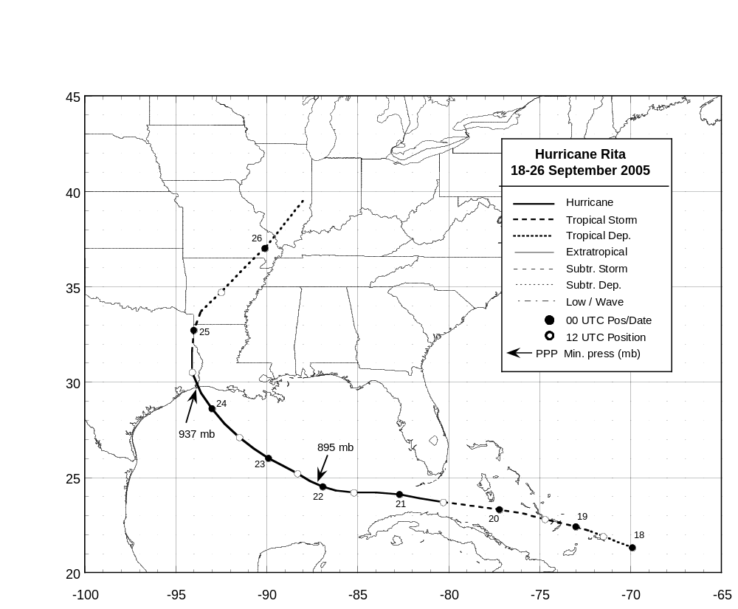

Figure 1. Best track positions for Hurricane Rita, 18-26 September 2005.

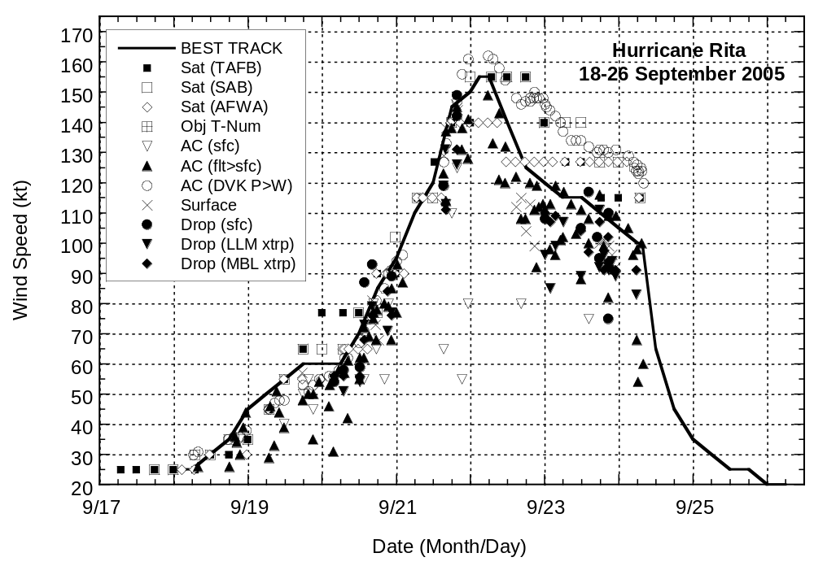

Figure 2. Selected wind observations and estimates and best track maximum sustained surface wind speed curve for Hurricane Rita, 18-26 September 2005. Aircraft observations have been adjusted for elevation using 90%, 80%, and 80% reduction factors for observations from 700 mb, 850 mb, and 1500 ft, respectively. Dropwindsonde observations include actual 10 m winds (sfc), as well as surface estimates derived from the mean wind over the lowest 150 m of the wind sounding (LLM), and from the sounding boundary layer mean (MBL).

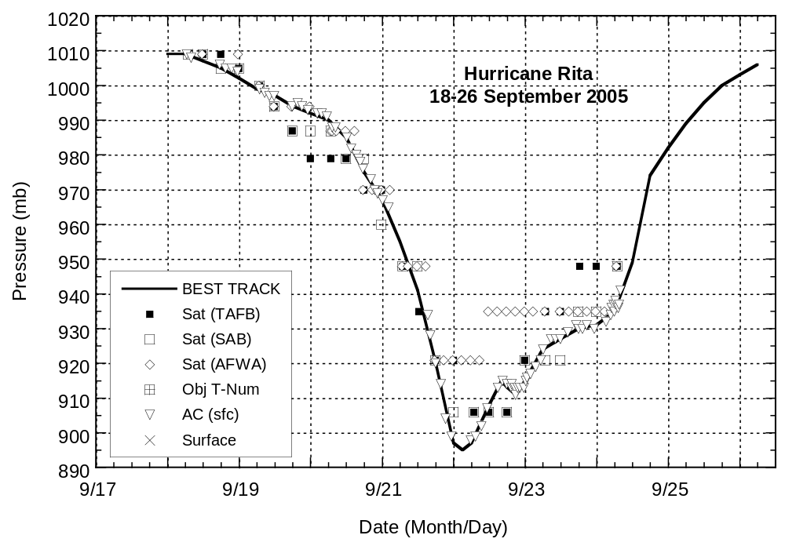

Figure 3. Minimum pressure observations and estimates and best track minimum central pressure curve for Hurricane Rita, 18-26 September 2005.
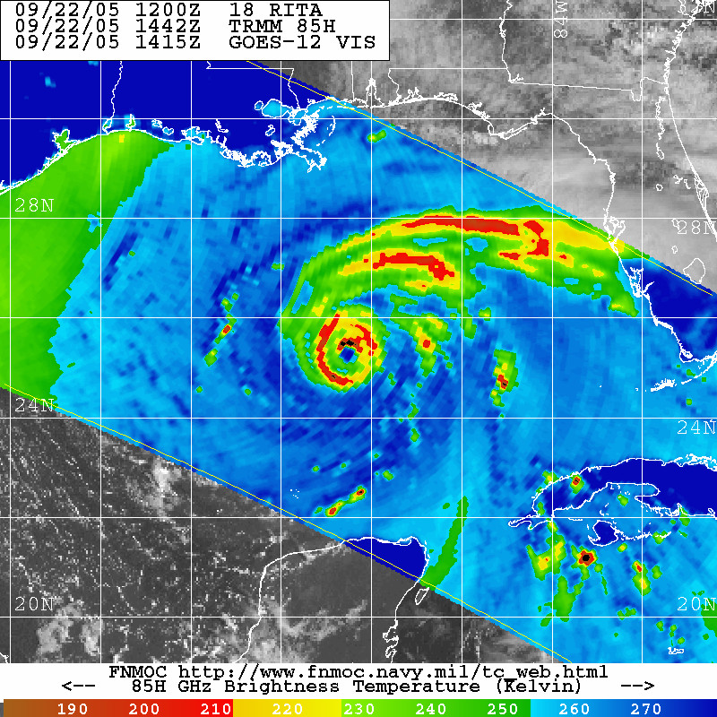
A B C
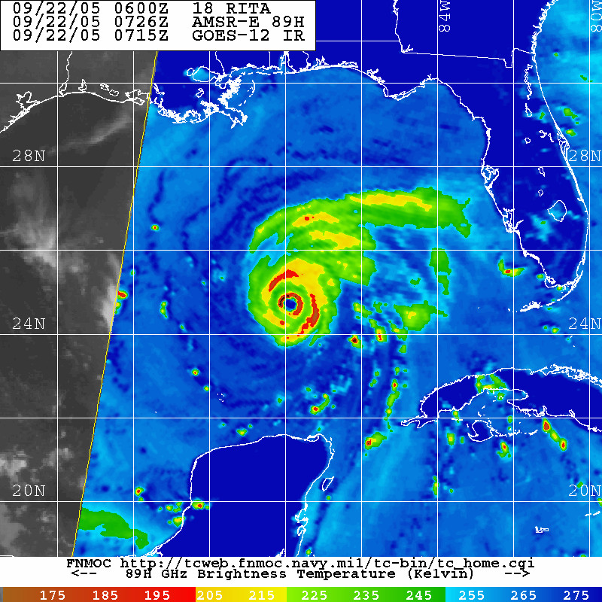
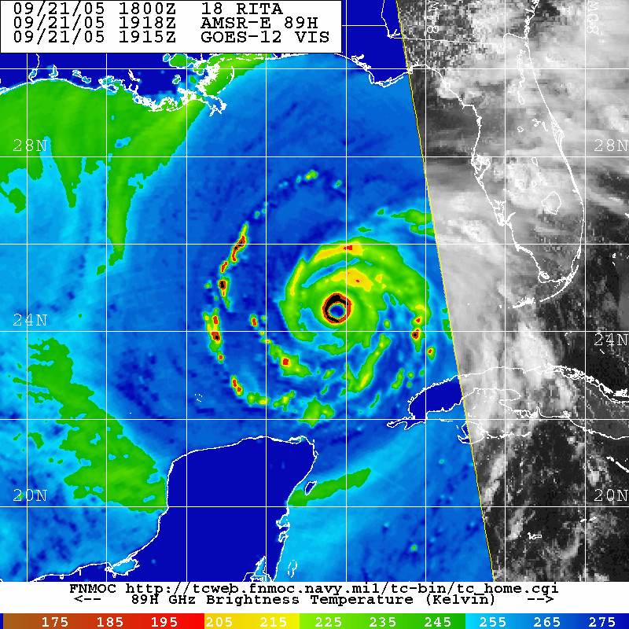

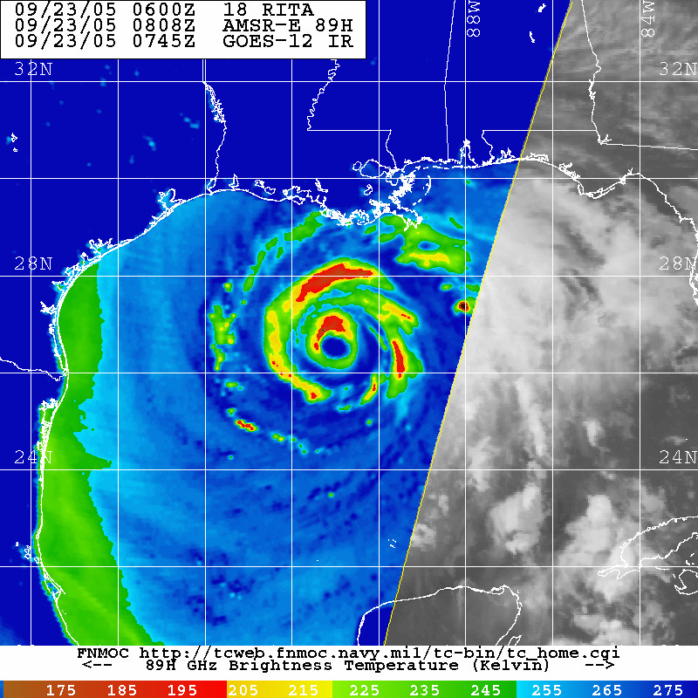
D E

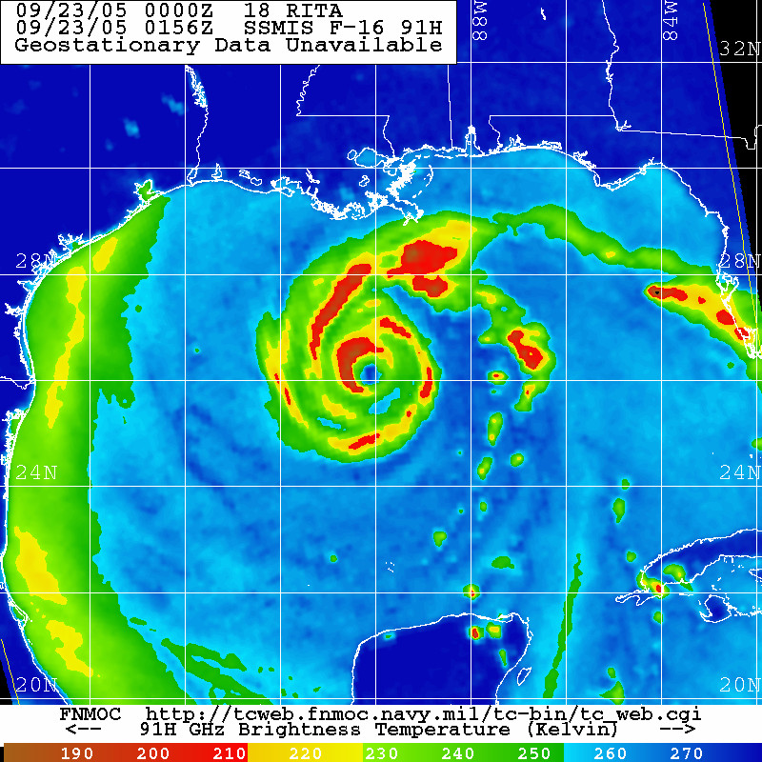
Images provided by the Fleet Numerical Meteorology and Oceanography Center (FNMOC).

Figure 4. Series (in order A-E) of 85-91 GHz passive microwave images of Hurricane Rita during 21-23 September 2005.

Errors given for the 96 and 120 h periods are averages over the four-year period 2001-4.

