**Narrative Visualization Walkthrough –**

**Demonstrating Interactive Slideshow using COVID-19 Dataset for United States**

* By Ujjal Saha
* **Messaging.** What is the message you are trying to communicate with the narrative visualization?

This is a Narrative Visualization project demonstrating the Interactive Slideshow Structure using the COVID-19 Dataset of United States and tries to establish sequence of hierarchies putting forward the observation in terms of various Scenes as pages. This narrative visualization mainly explores the overall cases and daily new cases of COVID-19 pandemic within United States and presenting the analysis mainly answering the questions, how each state is affected by the COVID-19 case counts, what are the case count status on each states, were any states able to slow down the spread, what role did reopening from lockdown played on the case counts.

* **Narrative Structure.** Which structure was your narrative visualization designed to follow (martini glass, interactive slide show or drop-down story)? How does your narrative visualization follow that structure? (All of these structures can include the opportunity to "drill-down" and explore. The difference is where that opportunity happens in the structure.)

I have taken the approach of Interactive Slideshow structure to demonstrate the narrative visualization work. The way I am looking at the COVID-19 dataset and the way I have considered to present the visualization to the audience is a step by step slideshow process. The COVID-19 dataset can be complex to represent all information at once. As I could think of a best possible approach, would be to show the progress of case counts as the dates progresses. Thus, making date as a primary parameter for the entire visualization. The entire dataset were broken down into window of dates, and each date range showing the intermediate state of the country with COVID-19 pandemic. This will help the user to make fine observations with the data by taking the user control on each slide and drilling down further before advancing to the next slide (next window of date). The interactive slideshow approach will also help the user to understand the information that author is trying to put forward at each individual stage and digest it before proceeding to the next slide. With the flexibility of user controls on each slide, user can drill down to see the see information at more granular level. For e.g. in the slideshow, I have provided two section new cases and overall cases of COVID-19, where each section has a map and a corresponding line chart grouped together. The map chart in each section will show new case count and over case counts respectively and corresponding line chart will show the case counts by date at country level. The map has a cross-filter, where selecting each state will bring the line chart for that respective state case counts. With the click of a button on the line chart, user can come back at the country level data on the same line chart. This can be done n number of times back and forth as much as user wants to analyze the dataset and for any state for any scene. Tooltips and annotations will also help the user as extra information while browsing through the slides. This approach I thought would best match they way I (author of the narrative visualization) want the user not only to understand the narration giving with some flexibility to the user to gather more info. I have always liked the approach of interactive communication even during trainings where I can pause in a slide to explore more info and digest and I feel this approach is a good way of storytelling to the audience.

Below are the diagrams that will demonstrate how user to explore state level data as a drill down in interactive slideshow:

1. Below is the snapshot where User is on a scene that displays case counts for June:

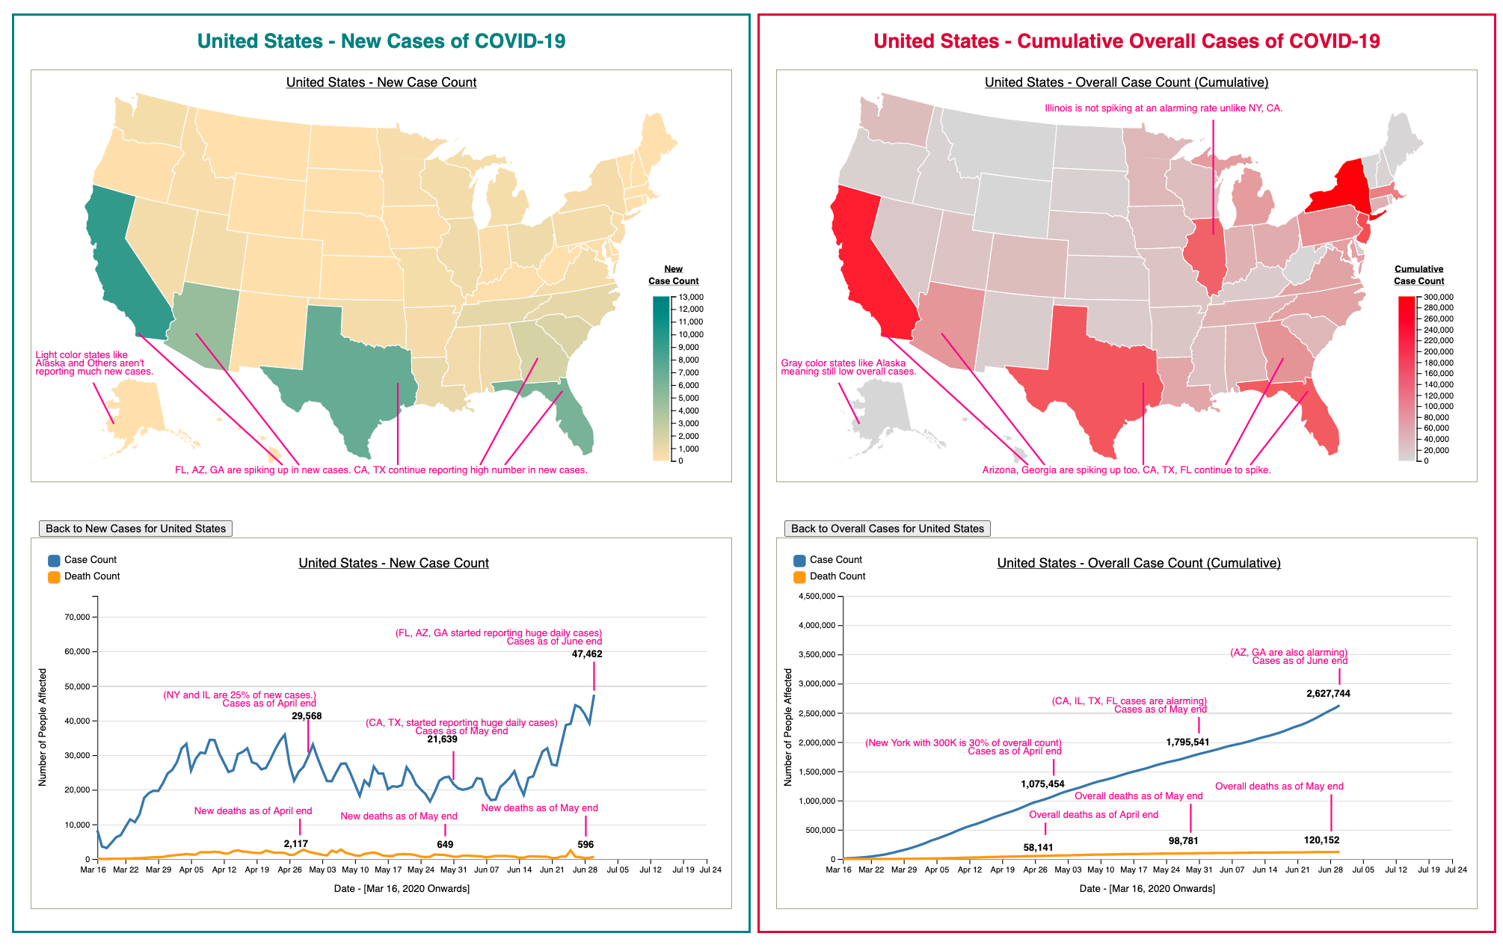

1. Below is the snapshot User in the same scene clicks a state in Maps for New cases changes the line chart view from United States to Utah (light blue). Using the button user can go back to previous view.:

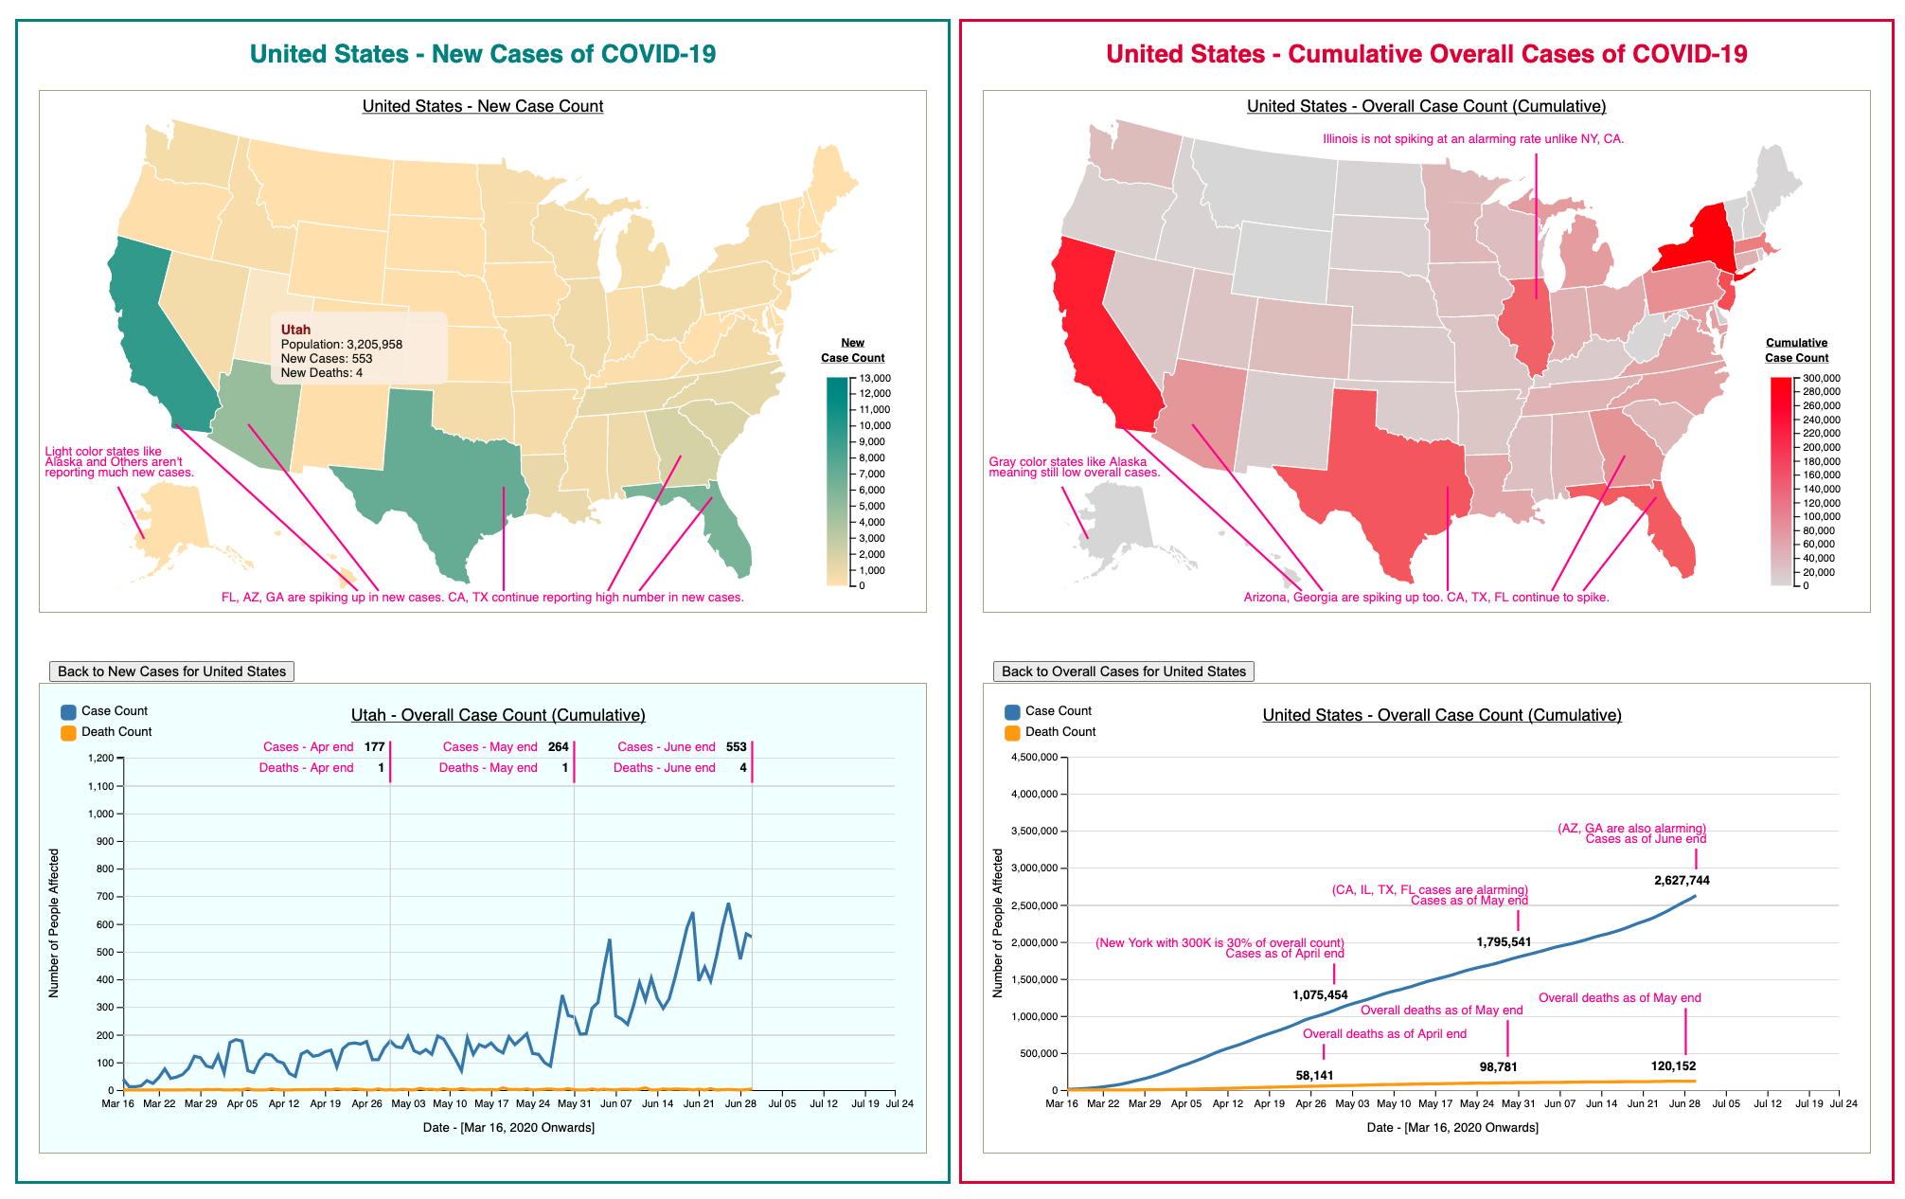

* **Visual Structure.** What visual structure is used for each scene? How does it ensure the viewer can understand the data and navigate the scene? How does it highlight to urge the viewer to focus on the important parts of the data in each scene? How does it help the viewer transition to other scenes, to understand how the data connects to the data in other scenes?

With this interactive slideshow I have taken a story telling approach. The narrative visualization first starts with introducing the dataset and the explanation of various fields on the datasets. The key definitions section on the header section of the webpages introduces the terms to the user, if any user is unaware of any terminologies used in the narrative visualization. Next the webpage tells about the various scenes that the visualization will go through and significance of each scenes are also mentioned. The author also mentions about the key parameters that are acting as state change variables (reason behind change of each scenes). The author clearly explains on the webpage what each scene is meant for and how the scenes will be navigated. The author provides a detailed description of the navigation that user will be using for the entire interactive slideshow, explaining the navigations buttons, how the button will be activated and change colors on scene to scene etc. The author also mentions about the triggers that will take place changing the scenes. Last but not the least, the author kept a separate scene section just to explain a scene in more details, what the scene is supposed to do, what user should expect from the scene. Author also explains the various user controls in detail (such Cross-filters, changing view of charts, tooltips) so user is aware upfront about the drill down tasks that can be performed (allowed) on each scene. With all the details of navigations, user controls, scene description author intended to put the user in much more comfortable place when the user actually starts looking the narrative visualization. For the data representation I have used map chart to display state level counts along combined with color intensities to represent how much a state is affected with the case counts. The scale and legends in the map char clearly show the user about the distribution of values and color intensities used. For the continuous date based case counts I have used line charts and it would have been the best fit to represent continuous data.

* **Scenes.** What are the scenes of your narrative visualization? How are the scenes ordered, and why

This whole Visualization is based on four Scenes. The scenes are ordered per the dates windows

1. Scene 1 (United States - COVID-19 Until April 2020): where author presents the situation with daily new cases and overall cases for the states of United States until April 2020 and lets user explore using the provided User controls within scene1. With help of annotations, author also presents fine observations. This scene depicts early state of COVID-19 pandemic in united states.
2. Scene 2 (United States - COVID-19 Until May 2020): where author presents the situation with daily new cases and overall cases for the states of United States until May 2020 and lets user explore using the provided User controls within scene2. With help of annotations, author also presents fine observations. Author put forward many observations with the scene showing some states are spiking up and rest not.
3. Scene 3 (United States - COVID-19 Until June 2020): where author presents the situation with daily new cases and overall cases for the states of United States until Jun 2020 and lets user explore using the provided User controls within scene3. With help of annotations, author also presents fine observations. Author presented observation of some states having a curve during April May are slowly settling down, while spike in new cases are being emerged from other states.
4. Final Scene: Scene 4 (United States - COVID-19 Until July 2020): where author presents the situation with daily new cases and overall cases for the states of United States until July 2020 and lets user explore using the provided User controls within scene4. With help of annotations, author also presents fine observations. Author also presents fine observation how reopening from lockdown affected the overall countries and statewide, how some states although high in overall cases (New York, Illinois, New Jersey) are not reporting spikes in new cases and appears to be recovering, while other states are aggressively reporting new cases and continue to spike.

* **Annotations.** What template was followed for the annotations, and why that template? How are the annotations used to support the messaging? Do the annotations change within a single scene, and if so, how and why

Annotations have been extensively used throughout interactive slideshow in the narrative visualization. I tried to maintain a pattern in the annotation, so it doesn’t appear to be distracting as well as informative and appealing to the user. In the map chart I have used lines and strings to put the annotations displaying fine observation that changes with scenes. Keeping in mind here, annotation does changes with change in scenes. Annotation are also provided in the line chart where more information related to instance of line chart have been shared. Annotations will also be shown on state level line chart thus dynamically changing from country view to state view in the line chart. Based on where a line in the instance of the line chart, annotation will be displayed accordingly on the line charts.

* **Parameters.** What are the parameters of the narrative visualization? What are the states of the narrative visualization? How are the parameters used to define the state and each scene?

The scene changes from slide to slide based on the parameters such as date, overall cases and new cases. The slide button triggers the change in parameters that brings up a new scene each time. The Chart area view refreshes with new visualization whenever a scene change event takes place.

* **Date**: With changes in scenes creates a trigger to change visualization scene and present COVID-19 data for a different window frame. This opens more opportunity for analysis and observation regarding impact by COVID-19 on last few months.
* **Overall Positive Cases (Overall Case counts - Cumulative):** Data visualization changes by change in scene, likewise overall case counts is another paramater whose content changes by change in the scene. Change in a scene triggers a change in date which in turn changes overall case counts. Difference in overall cases opens up ways for in-depth analysis and studying impact of COVID-19 in terms of total cases.
* **Daily New Cases:** Daily new cases count is another parameter whose content changes by change in the scene. Change in a scene triggers a change in date which in turn changes new case counts and creates a different visualization. Difference in daily new cases opens up ways for in-depth analysis and studying impact of COVID-19 in terms of new rising cases.

1. **Triggers.** What are the triggers that connect user actions to changes of state in the narrative visualization? What affordances are provided to the user to communicate to them what options are available to them in the narrative visualization?