Desired Launch Date: November 16, 2015

Language: Laravel PHP Framework

Scalability: Able to handle about 1,000,000 simultaneous users in a few years

**Description:**

Integrated custom platform where each product can be tailored to the consumer based on their individual account data. Brands create base products based on their avg person(weight, gender, etc). Customer buy those base products and can choose to have them customized to them for small fee ~$5. Orders would be sent to compounding machine based on raw order output so can be produced autonomously. Just have prototype on arduino, can continue to use this but need to just increase components. (Have ~300 ingredients)

**Technology**:

1. Hosting.
   1. <http://www.softlayer.com/>
   2. Server Specs
   3. Linux, ubuntu or centos
2. Language - Laravel
3. DB - ?
4. Payment - <http://www.nationalbankcard.com/>, authorize.net framework
5. API’s
   1. <http://neo4j.com/>
   2. facebook open graph
   3. authorize.net

**Frontend**

* Mix of 8tracks search: <http://8tracks.com/home/staff-picks>
  + Copy how the search bar works when you type in with drop down. However search should be broken into three categories: brand, blend, ingredients as rotten tomatoes: http://www.rottentomatoes.com/
* Facebook open graph system for display and altering of blends

**V1 -**

**Soft beta launch - 11/09/15**

**Production Launch - 11/23/15**

**User Privileges:**

* **Admin** -- Control everything, approve brand pages add remove, pay out brand based on sales see shopify payout schedule.
  + Approves/Rejects Brands
  + Can delete Products
  + Can add/delete/edit ingredients and ingredient rules
  + Can waive membership fee for brand or member
  + Sees all site traffic
  + See’s all orders
  + Updates Miramix distribution orders
  + Sets membership prices
  + Can send payment to brands
* **Brand** -- Creates products, can edit their storefront, can see sales per time period. Almost like Amazon/Shopify: ecommerce experience. Where brand can upload content and customer can buy from. Balance is tracked in the Brand/Customer backend. Almost like bank account. Can credit/charge account for related services.

* + **Creates Brand Account -** Brand’s create thier brand accounts. They can select if they also have a clinic(s) they will be shipping to and provide details about the clinic(s). They must schedule a telephone call with a Miramix rep to have their account approved.
  + **Creates/Manages Brand Users -**Brands can also create admin and limited user accounts to manage their brand. Admin accounts have full access, limited accounts can view/update orders
  + **Creates product**
    - Manufacturer
      * Miramix
      * Brand
    - Form
      * Capsul
      * Pill
      * Powder
    - Ingredients - ingredients will have governing rules associated with them (ie: can’t add more than 5% max weight of ingredient x if ingredient y is present)
      * Ingredient
      * Volume/weight
    - Tags
      * Can add multiple tags to a product, new or existing tags
  + **Updates orders for brand products**
  + **Creates product blends**
    - base blend
    - Change variables
  + **Manages store front**
    - Info
    - Logo
    - active products
  + **Can see sales data**
    - can filter sales data by time range, product, product blend, member/customer, ingredient, tag
    - Can see order status for all orders, can update order status for brand manufactured products
  + **Order Process Page -** Brands have their own payment pages where they can create orders for clients. They can pick an existing product(s)/quantity/blend, select a new or existing member, select shipping address to members address or brand clinic, enter their payment information, and process the order. This order should then be process like any other order for the selected product(s)
  + **Can see traffic stats**
    - Brand Page stats
    - Product Pages Stats
    - Tag Stats
    - Customers Stats

* **Member--** Can upload custom data to their profile see facebook. Want to use that data to create a custom experience for each individual. Open social graph type system
  + Has profile
  + Are owned by brands
    - Members are owned by brands once they purchase a brand product
    - can be owned by multiple brands
  + Can create personal product
    - can create a personal product in the same manner as brands would. Key difference is product can only be manufactured by Miramix, product can not mimic other brands product, in case of duplicate product direct to brands product page, will always be a higher price than if brand created the product.
* **Paid Member -** Same as member but pays a monthly or yearly fee and can order *unlimited* products.
  + Unlimited product amount can be managed by the admin backend. Rules can be set limiting ingredients, and total shipments.
* **Customer** - just buys a product.

**Products**

Products have forms and are made up of ingredients. Products have blends. Products are owned by Brands. Products can be managed by Brands and deleted by Admin.

* Forms - Products can have 1 of x forms (currently x = 3)
  + Capsul
  + Pill
  + Powder
* Ingredients - products are made up of many ingredients. Ingredients have their own rules and controls by admin backend. Ingredients weights and percentages to whole mix are recorded and shown on label.
* Blends - blends are variations of the ingredients proportions. There can be many blends to a product, but there must be 1 base blend. The blend a buyer will get is based on their body type and demographics.
* Quantity
  + Capsules - count
  + Pills - count
  + Powder - gm/kg

**MIRAMIX API:**

**PRICING:**

Min value x is distributed a% miramix and b% miramix

Total value - x is distributed c% miramix and d% miramix.

**Payments:**

Using authorize.net. Accept payment from members and brands, send payments to brands

* Members can pay per transaction/order
* Members can pay monthly or quarterly recurring payment for unlimited* order membership.
* Brands pay a monthly membership

**Integrations**

* API to integrate payment processing on third party website. Almost like the Indiegogo API
* Able to import all accounts from current wc with seamless transition for users. (same username and password)

**Custom Formulations/Inventory Management**

* Each ingredient has data about that is currently in backend. Check it out need info such as calories, fat, carbs, etc. Will use this data to output custom labels. The label always has the same template as ingredients are added the label dynamically changes. <http://www.truenutrition.com/p-1126-custom-mix.aspx>
* 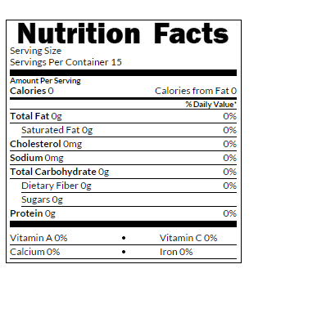
* Each supplement has a custom page that display information about it where its sourced, numerical metrics, etc.
* Inventory Management- Can see how much of each ingredient/packaging in inventory. get alerts for low level that is stated by admin
* brands can choose form factor they allow products to be made( tablets, capsules, pills etc). See purebulk. customer then can choose particular form factor from available

http://purebulk.com/spirulina-powder/

* 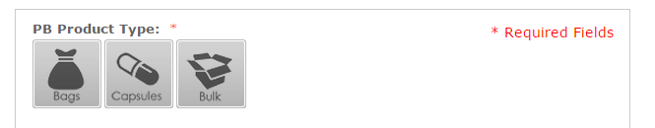

**Search**

* Can search directly in browser, and display as shown
* SEO with links, etc, etc

**V2.**

**Miramix API**

* Need to create an endpoint api with proper authentication that can dispatch order information and receive order updates
* Api needs to be able to be integrated to third party sites so that users can buy products directly from miramix off of third party sites (like shopify buttons)

**Microcontroller Integration**

* Each order has ingredient, amount, and packaging type associated with it. Each ingredient is getting stored in a compunding machine that I built but need to integrate website to send batches to the machine according to some machine code.