



EVENT HEAD:

BOLISETTI DHEERAJ(7024484438)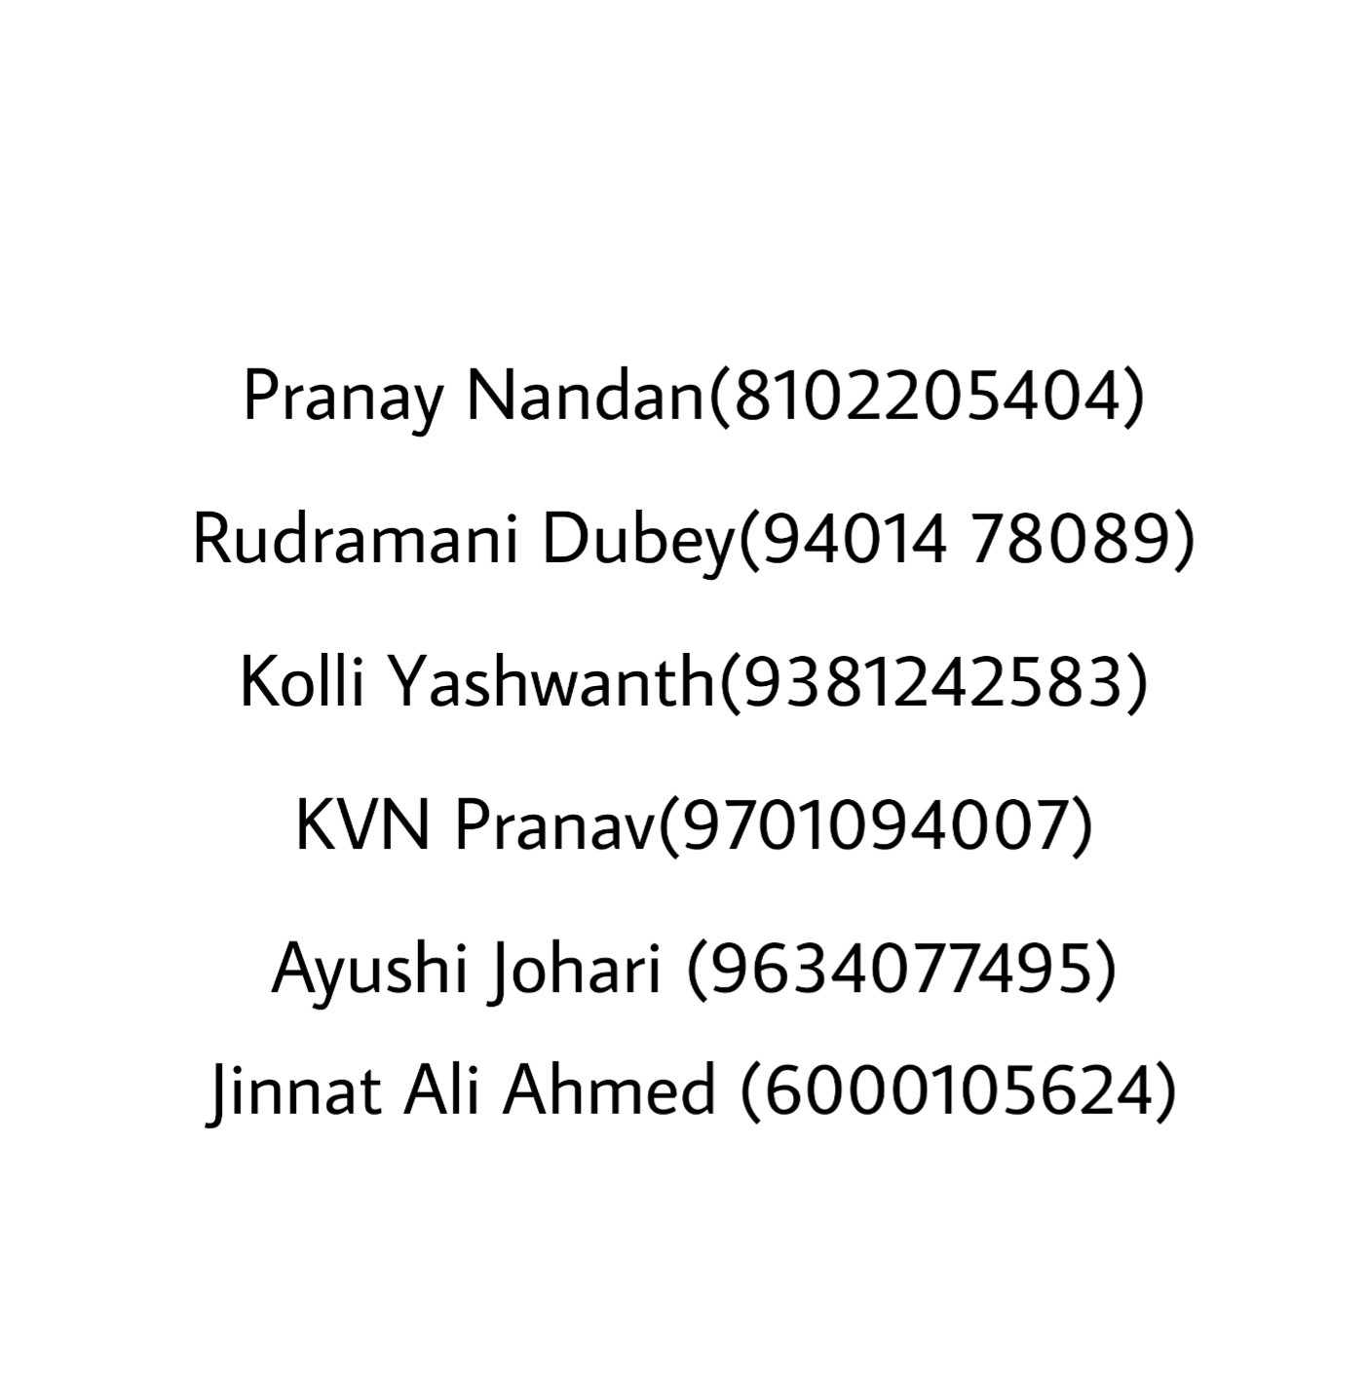

**ROBOSOCCER**

**About:** Sports has always aided us in our enjoyments. But now it’s time for an upgrade. Why not throw in a little technology, a tad of hard work, one Hella enthusiasm, and viola: we have ourselves the perfect balance of robotics and football; “ROBOSOCCER”. This event is your chance to find out how good your robotic skills can be by creating a bot that plays soccer.

**Problem statement:** Teams must build two robots, designed and engineered in the sense that one of them will kick the ball while the other will defend your goalpost.

Specifications: -

**Bot specifications:**

1. **STRIKER BOT:** The dimensions of the striker bot should strictly not exceed 30cm*30cm*25cm (l*b*h*), this includes the striking mechanism, guider and the wheels.
2. **DEFENDER BOT:** The dimensions of the defender bot should not exceed 25cm*25cm*20cm(l*b*h) including the guider and the wheels.
3. Weight should not exceed 4.5kg per bot.
4. Use of ready made mechanical guiders or striking mechanism or any type of LEGO kits are strictly prohibited.
5. The potential difference between any two points in the bot should not exceed 12 volts.
6. A 220 v AC supply and adapters will be provided by the organisers. No other kind of supply will be used.
7. Wireless bots are not allowed.
8. Only 12V, 200 rpm DC motors are allowed to use. Maximum Number of motors that are allowed are 10 (including the striker and defenders).

**Arena specifications:**

1. The dimensions of the arena will be 5m*3.5m(l*b).
2. The dimensions of the goal post on either side will be

40-45cm*25-30cm(l*b).

1. The diameter of the ball will be 6-7cm(standard smiley ball).

(*Arena specifications are liable to changes*)

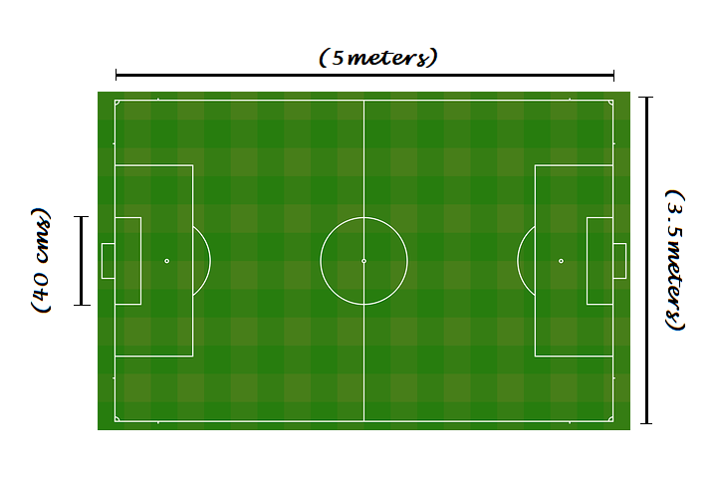

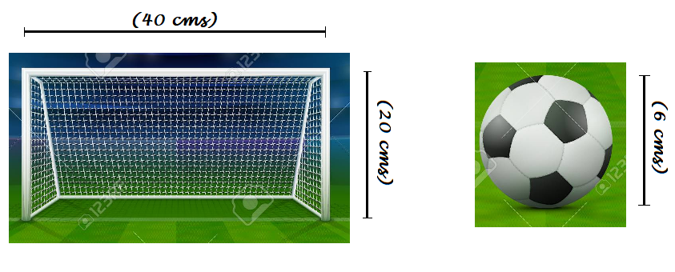

**Team specifications:**

1. Each team can have a maximum of 5 members.
2. Teams can also be a mix of boys and girls.
3. Teams from outside college are always welcome.

Rules: -

1. One player will control the striker bot and the other will control the defender bot.
2. No bot is allowed to pick the ball, grip it, or incorporate the ball within its body.
3. Participants are not allowed to touch the bot or the ball directly or indirectly during the match unless the bots are immobile for more than 30 secs.
4. 2 mins of repair time will be given in case of any problems during the match. If a team is unable to rectify and repair the bot, it is liable to be disqualified.
5. The bots should not damage the arena.

**game play:**

1. All first-round match fixtures will be random. Teams that will qualify the first round will be decided on the basis of wins and points scored.
2. Teams can play the matches according to their own strategies but will earn points purely on goals scored.
3. The defender bot can also try teaming up with the striker to score goals.
4. Every match will be of 8 mins excluding repair time and a half time of 2 mins duration during which basic repairs can be performed.

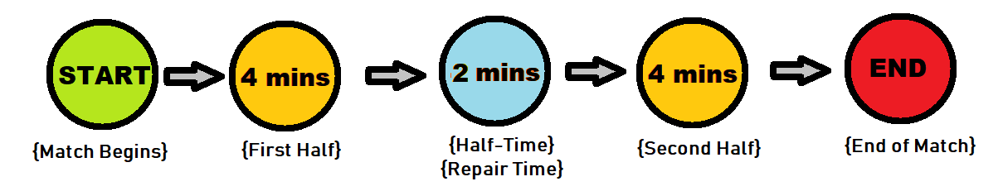

**Scoring:**

1. Each goal scored is worth 5 points irrespective of which bot scores it.
2. If a goal is scored from outside the D-box, 10 points will be awarded.
3. Fouls committed by any team will result on the decrement of 2.5 points. Fouls include: collision other than head on, collision without the ball in between, disrupting the movement of the ball in any way etc…
4. Winners of each round will be decided by the total points scored including deduction of points by foul if any.
5. In case of a tie, the winner will be decided by the GOLDEN ROUND.
6. GOLDEN ROUND: In this round the defender bots will be removed and the match will be played purely by the striker bots. The team which scores the first goal in the golden round will be deemed the winner of the match.

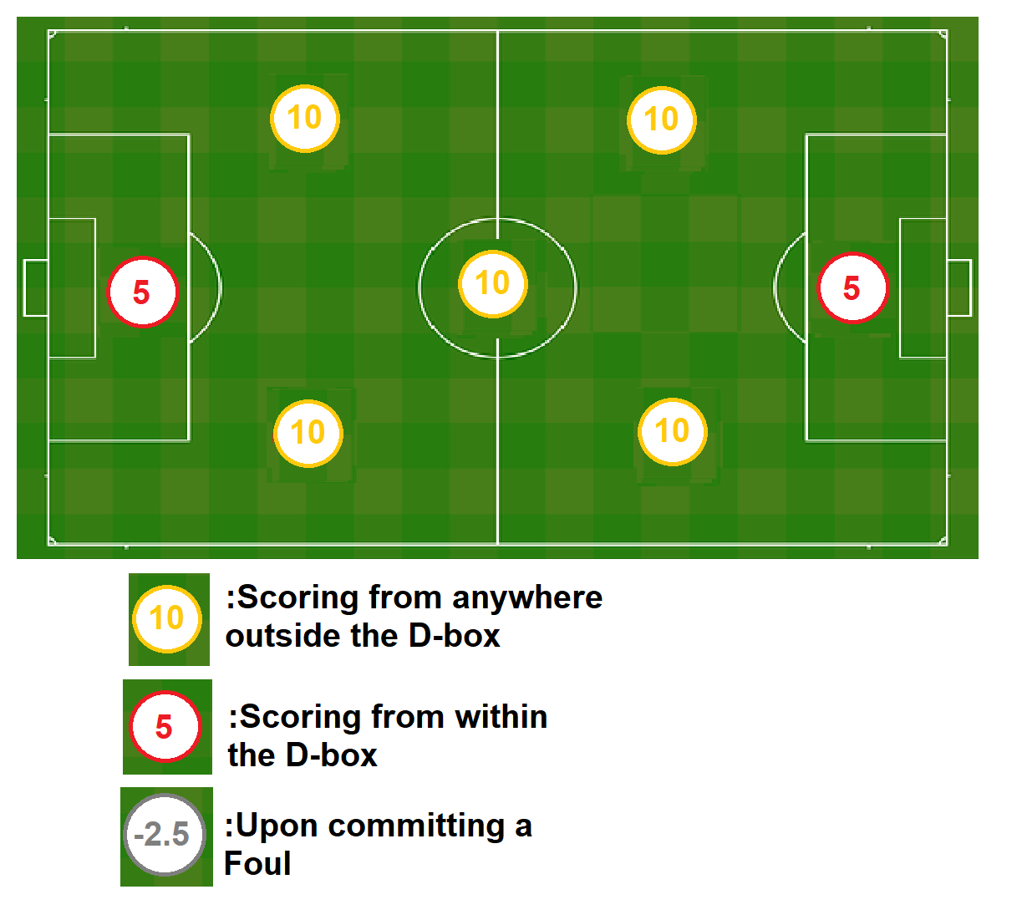

General Rules: -

1. Organizers reserve the right to disqualify any team indulging in misbehaviour or violating the rules in any way.
2. Any team that is not ready at the specified time will be disqualified and the opposing team will win by walkover.
3. The time and points measured by the organizers will be final.
4. In case of any disputes between the teams, the organizers’ decision will be final and binding.
5. The organizers reserve the right to change any rule if necessary. The change in rules if any will be notified to the teams beforehand.