**Assignment - 9**

**Name: Ujjawal Mandhani**

**Enroll: 9918103237**

**Batch: F6**

1. Addition of two 16-bit numbers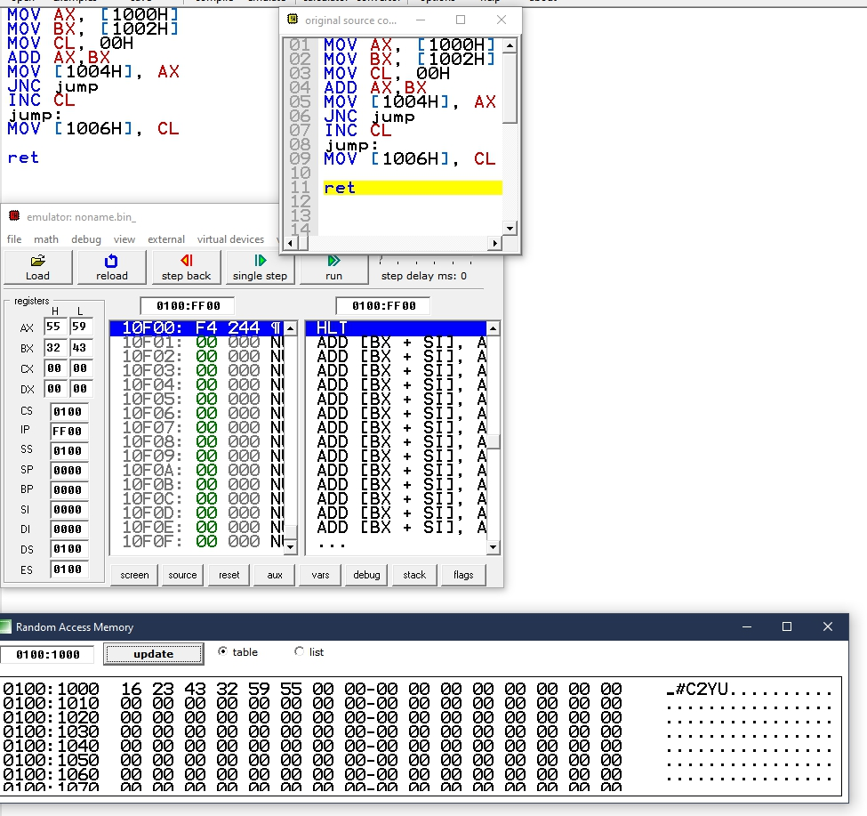

|  |
| --- |
| MOV AX, [1000H]  MOV BX, [1002H]  MOV CL, 00H  ADD AX,BX  MOV [1004H], AX  JNC jump  INC CL  jump:  MOV [1006H], CL |

Subtraction of two 16-bit numbers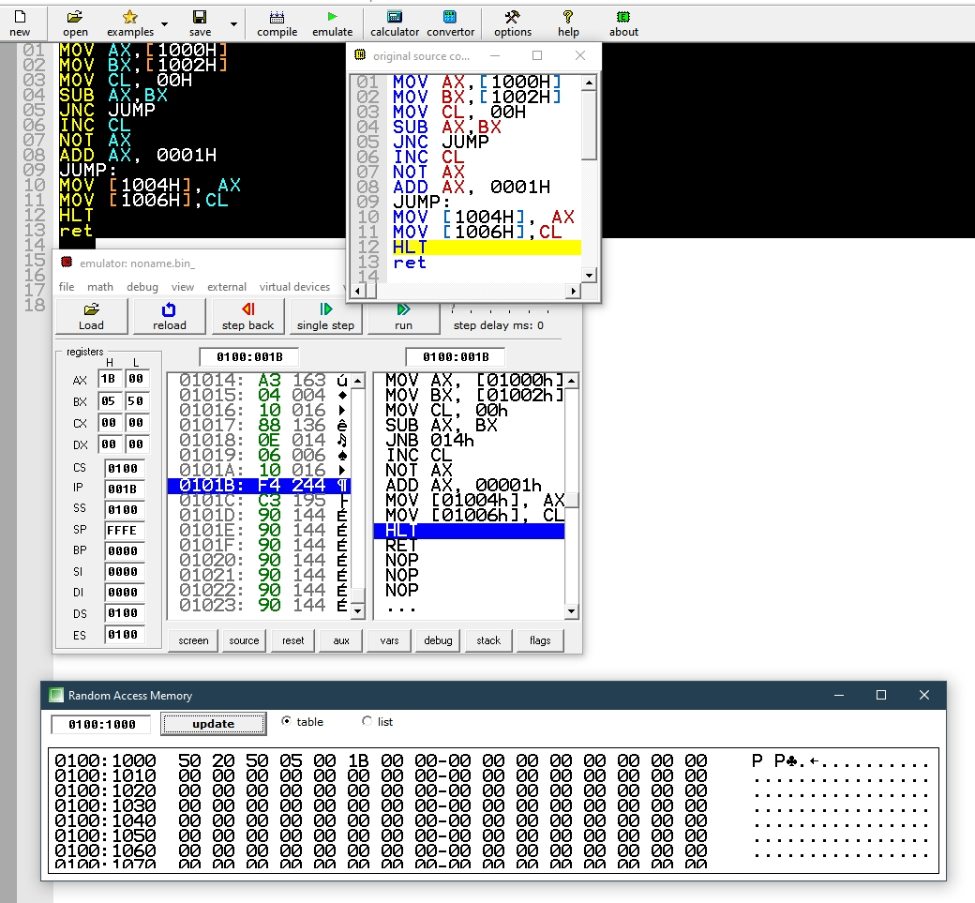

|  |
| --- |
| MOV AX,[1000H]  MOV BX,[1002H]  MOV CL, 00H  SUB AX,BX  JNC JUMP  INC CL  NOT AX  ADD AX, 0001H JUMP:  MOV [1004H], AX MOV [1006H],CL  HLT ret |

Addition of two 8-bit numbers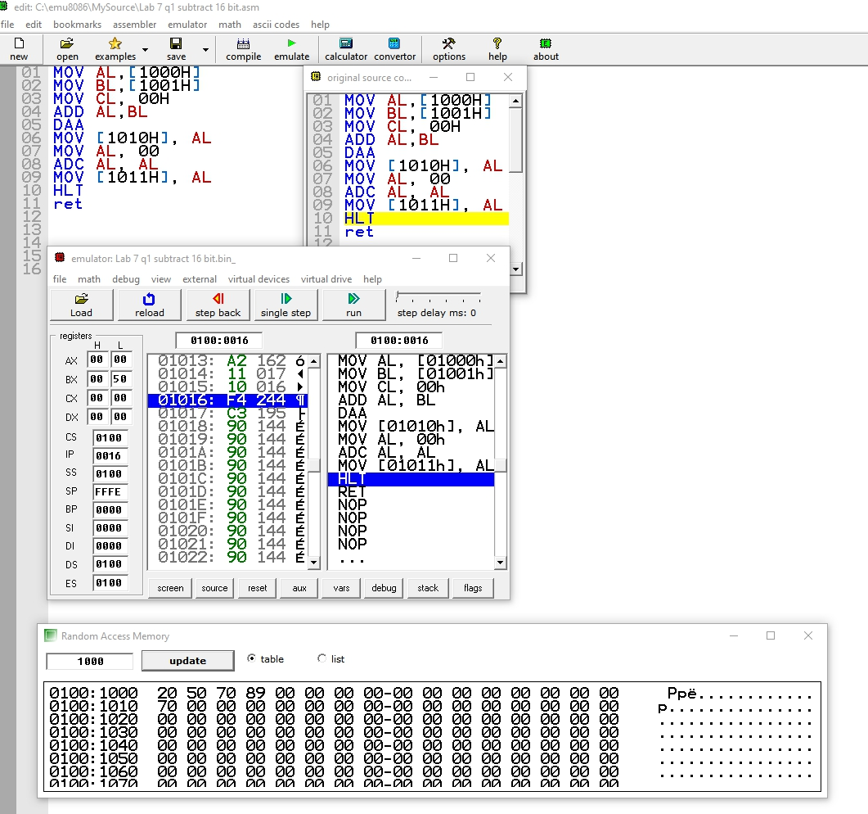

|  |
| --- |
| MOV AL,[1000H] MOV BL,[1001H] MOV CL, 00H  ADD AL,BL  DAA  MOV [1010H],AL MOV AL, 00  ADC AL, AL  MOV [1011H],AL HLT ret |

Subtraction of two 8-bit numbers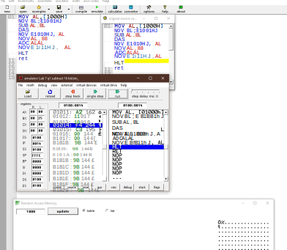

|  |
| --- |
| MOV AL,[1000H]  MOV BL,[1001H]  SUB AL,BL  DAS  MOV [1010H],AL  MOV AL, 00  ADC AL, AL  MOV [1011H],AL  HLT ret |

1. Multiplication of two 16-bit numbers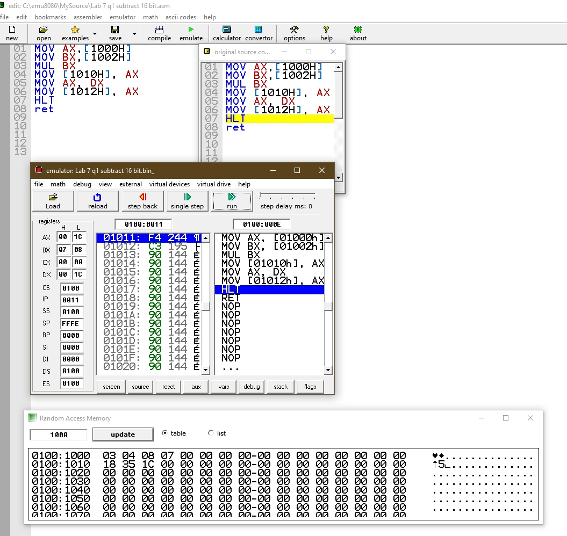

|  |
| --- |
| MOV AX,[1000H]  MOV BX,[1002H]  MUL BX  MOV [1010H], AX MOV AX, DX  MOV [1012H], AX HLT ret |

Division of a 16-bit and an 8-bit number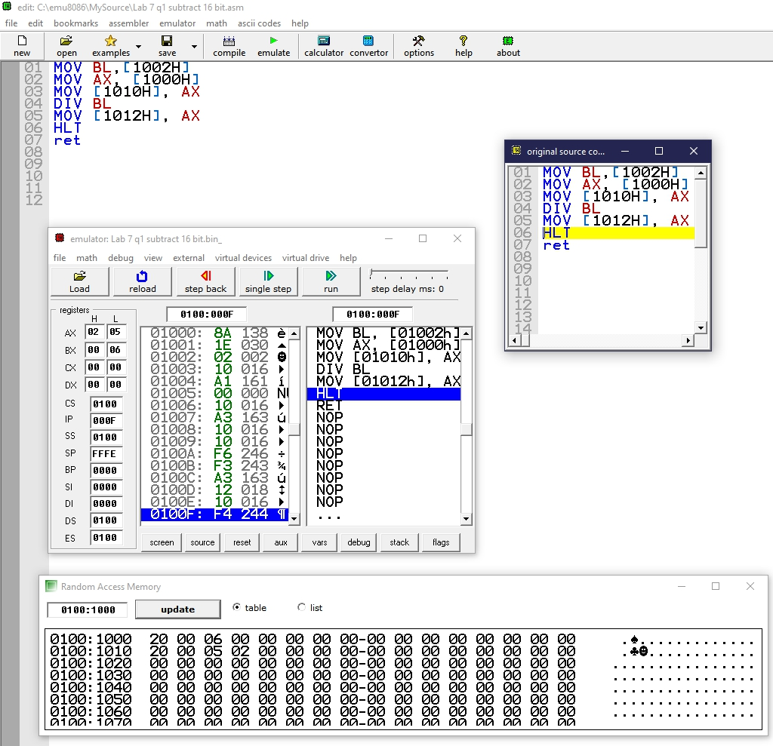

|  |
| --- |
| MOV BL,[1002H]  MOV AX, [1000H] MOV [1010H], AX  DIV BL  MOV [1012H], AX HLT ret |

1. Find the largest number in an array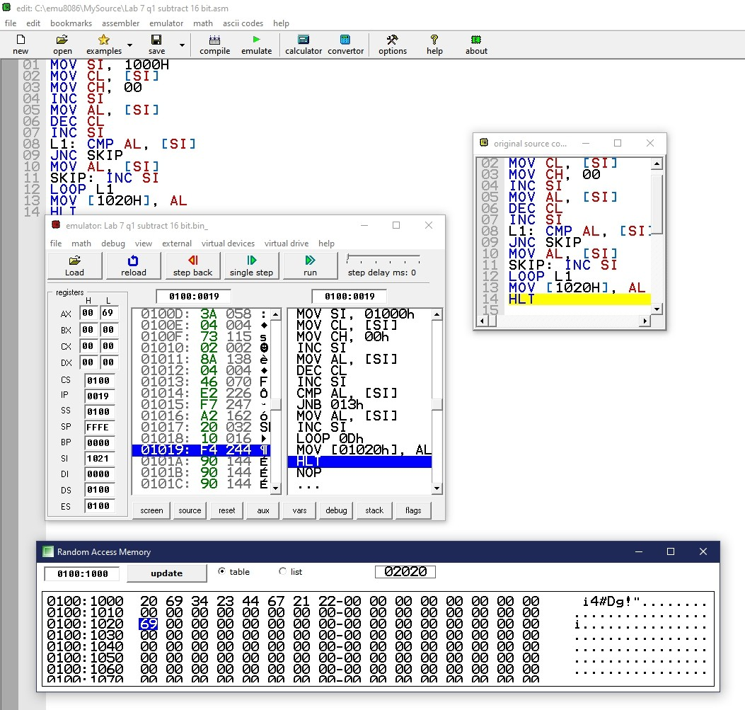

|  |
| --- |
| MOV SI, 1000H  MOV CL,[SI]  MOV CH,00  INC SI  MOV AL,[SI]  DEC CL  INC SI  L1:  CMPAL,[SI]  JNC SKIP  MOV AL,[SI]  SKIP:  INC SI  LOOP L1  MOV [1020H], AL HLT |

1. Factorial of a number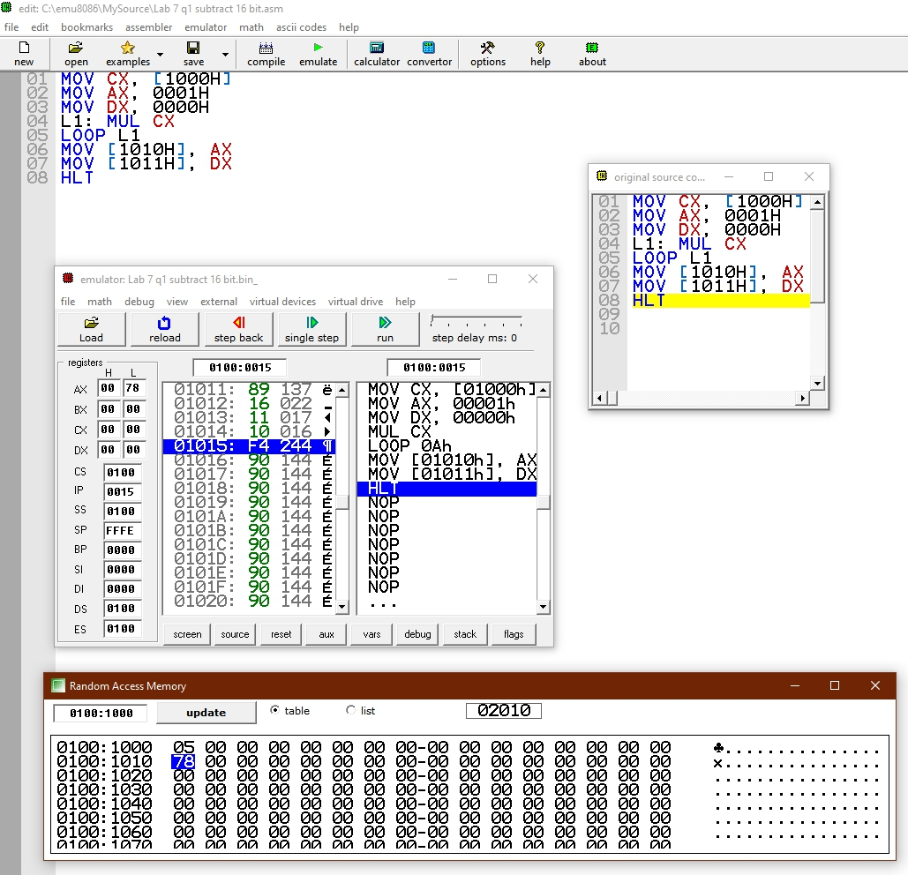

|  |
| --- |
| MOV CX,[1000H]  MOV AX, 0001H  MOV DX, 0000H  L1:  MUL CX  LOOP L1  MOV [1010H], AX MOV [1011H],DX  HLT |

1. Sort numbers in ascending order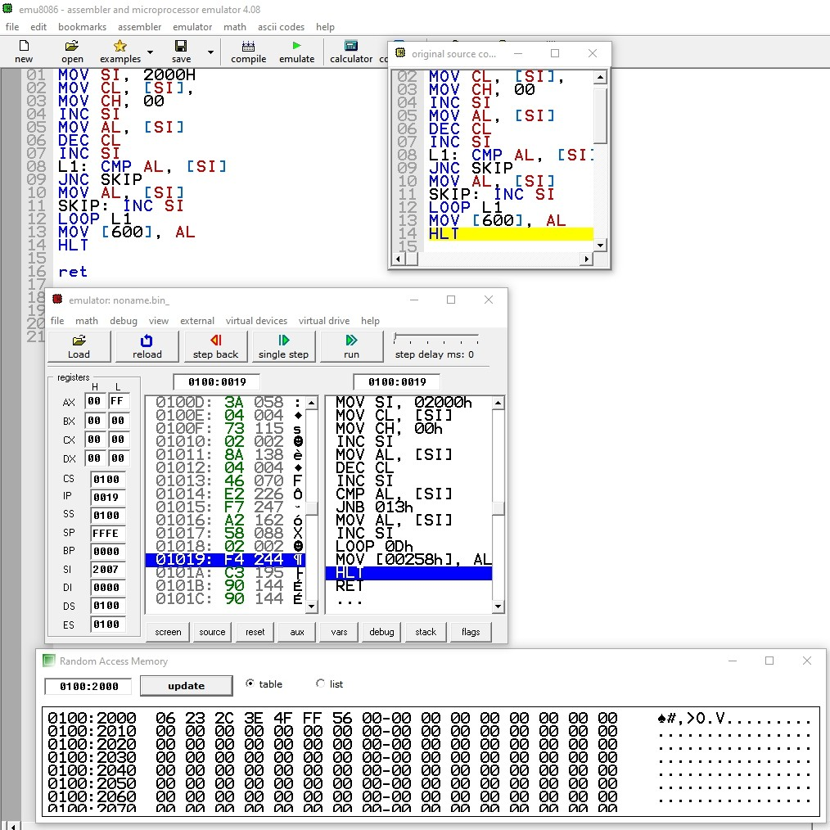

|  |
| --- |
| MOV SI, 2000H  MOV CL, [SI]  MOV CH, 00  INC SI  MOV AL, [SI]  DEC CL  INC SI  L1:  CMP AL, [SI]  JNC SKIP  MOV AL, [SI]  SKIP:  INC SI  LOOP L1  MOV [600], AL  HLT ret |

1. Sort in Descending Order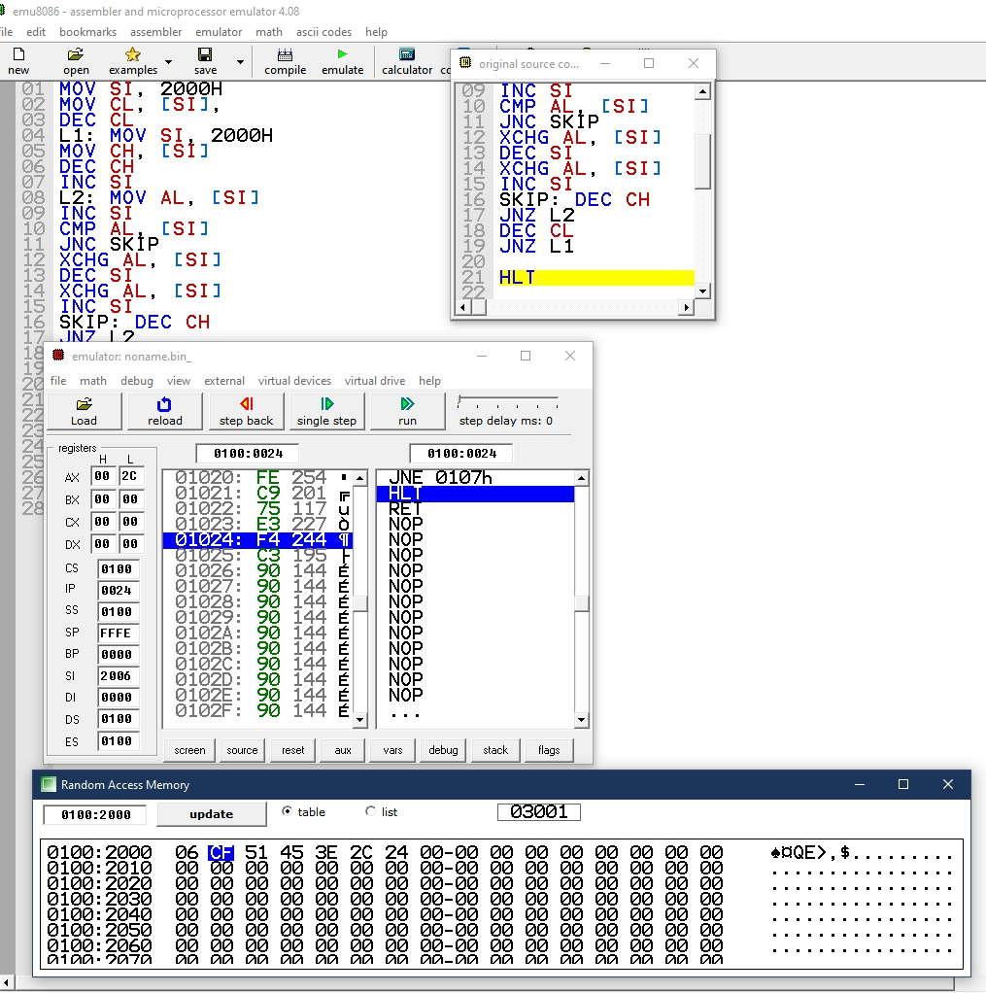The-Boss

|  |
| --- |
| MOV SI, 2000H  MOV CL, [SI]  DEC CL  L1:  MOV SI, 2000H  MOV CH, [SI]  DEC CH  INC SI  L2:  MOV AL, [SI]  INC SI  CMP AL, [SI]  JNC SKIP  XCHG AL, [SI]  DEC SI  XCHG AL, [SI]  INC SI  SKIP:  DEC CH JNZ  L2  DEC CL  JNZ L1  HLT ret |