**Name-Ujjawal Mandhani**

**Batch-F6**

**Enroll No.-9918103237**

**COA Lab – 4**

**Question 1:** Design the decoder circuits with defined logic.

**1 to 2 AND 2 to 4 DECODER**

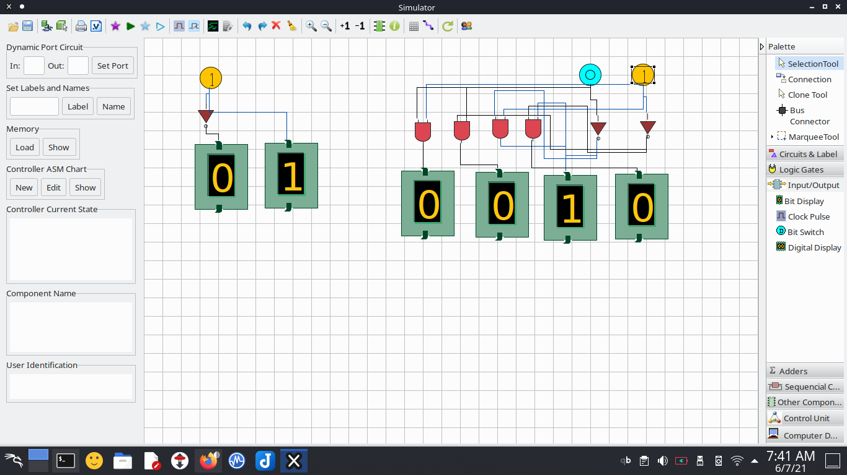

**3 to 8 DECODER**

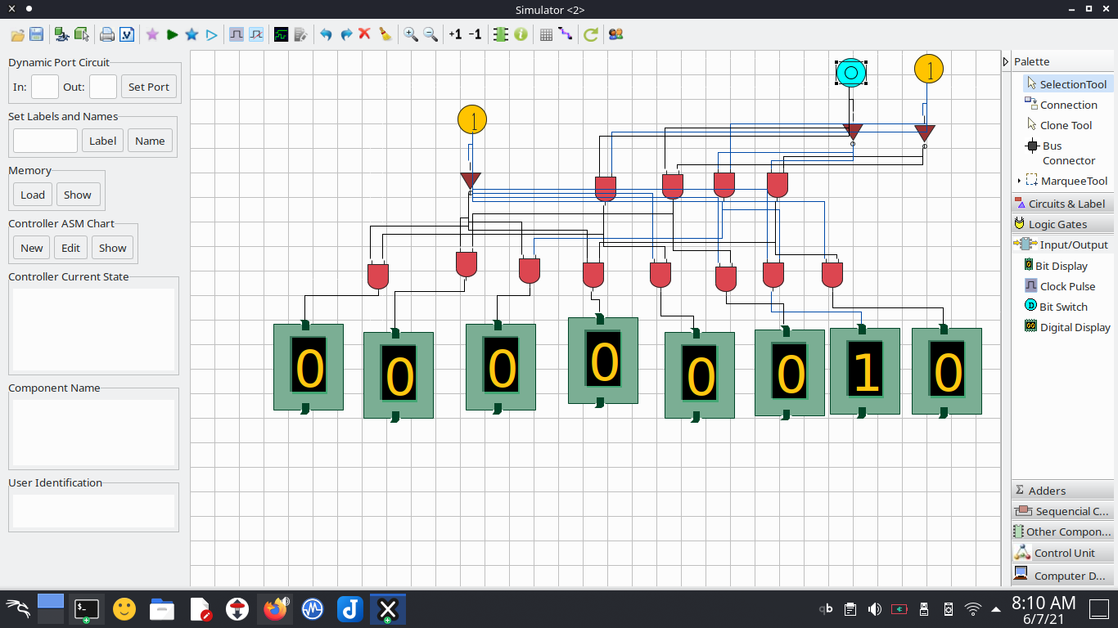

**Question 2:** Design a Logical Unit that support Basic Logical Operation and Shift Operations.

**ALU OR**

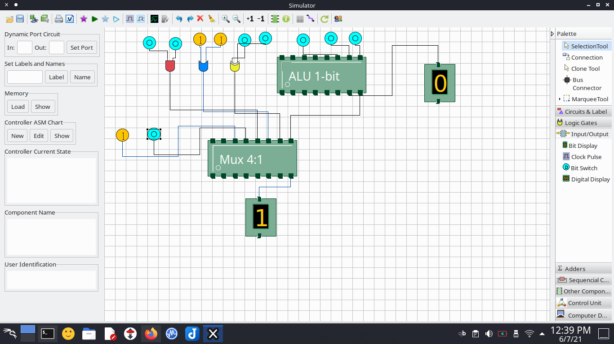

**ALU AND**

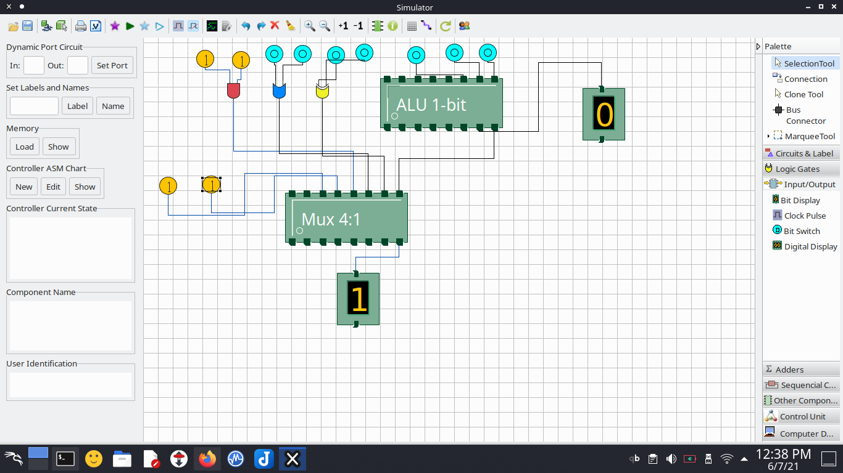

**ALU XOR**

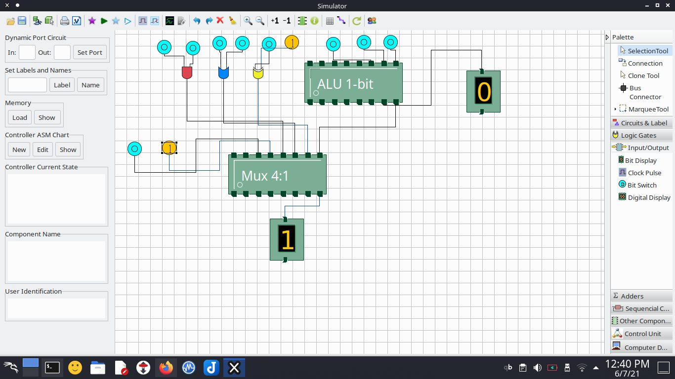

**ALU ALU**

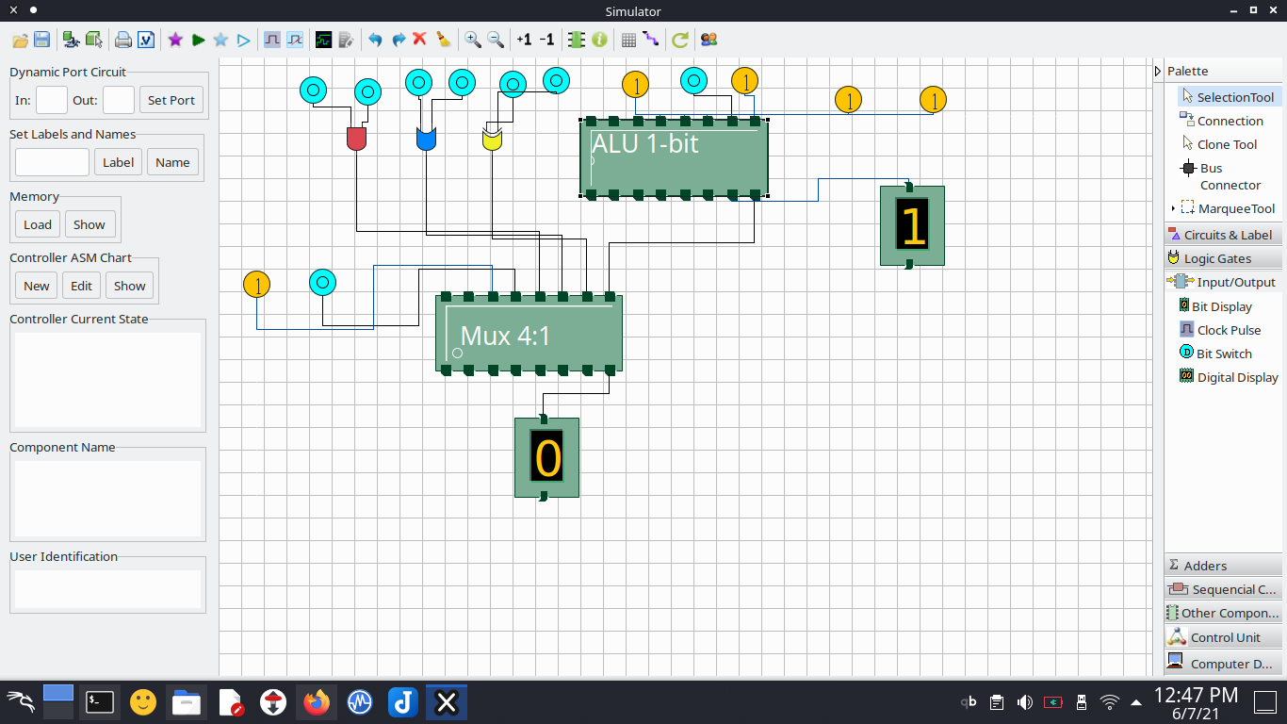

**ALU LOGIC SHIFT OPERATORS**

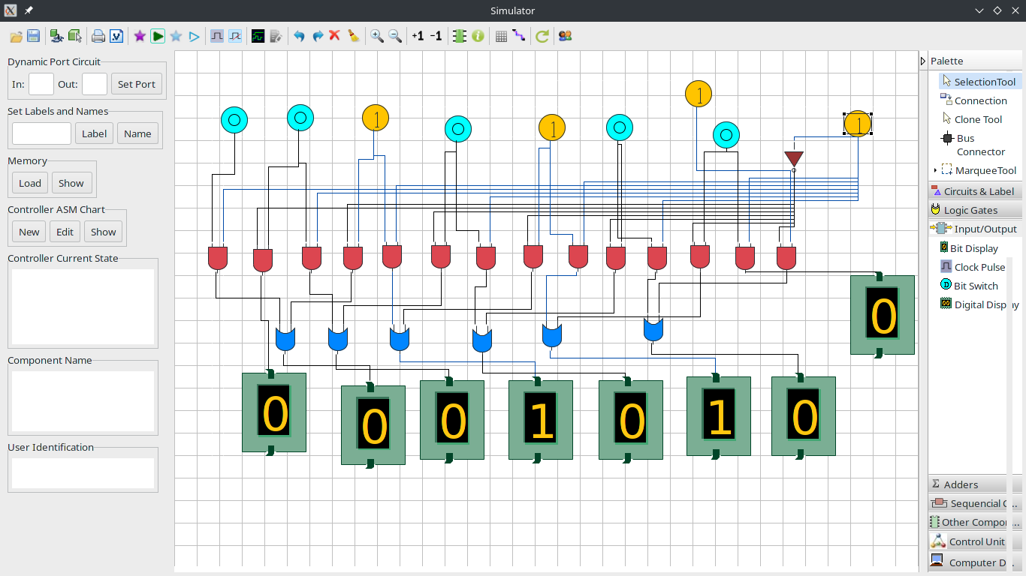

**Question 3: Design a arithmetic Cicuit that Do addition, subtraction, Multiplication and Division.**

