**Name-Ujjawal Mandhani**

**Batch-F6**

**Enroll No.-9918103237**

**COA Lab – 5**

**Question 1:**Load add two 8-bit numbers from load sample program from file manu, assemble

and execute it step by step and see the contents of registers and memory.

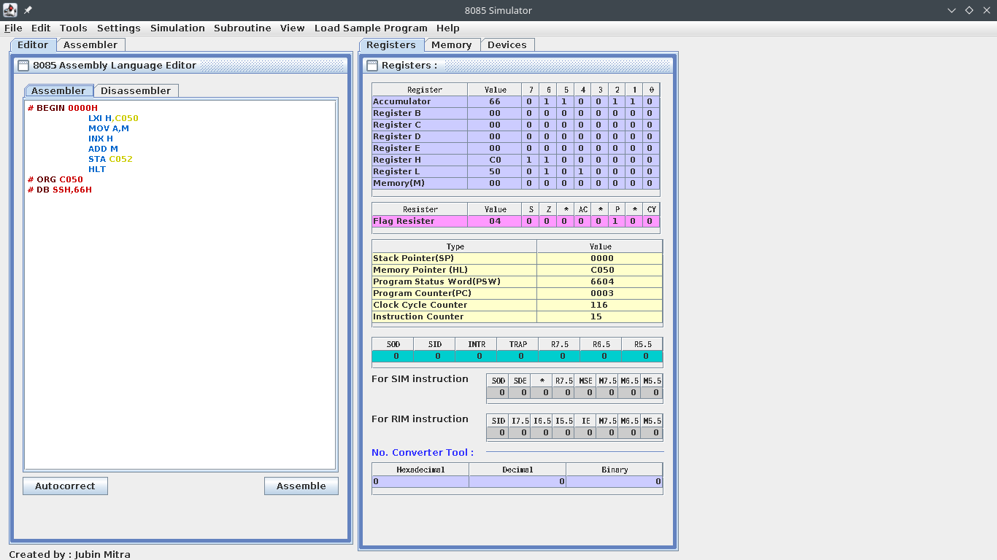

**Question 2:** Study the basic data transfer instructions of 8085 and perform the following:

Immediate and reg to reg data

BEGIN #0

MVI B,5

MVI A,10

MOV A,B

HLT

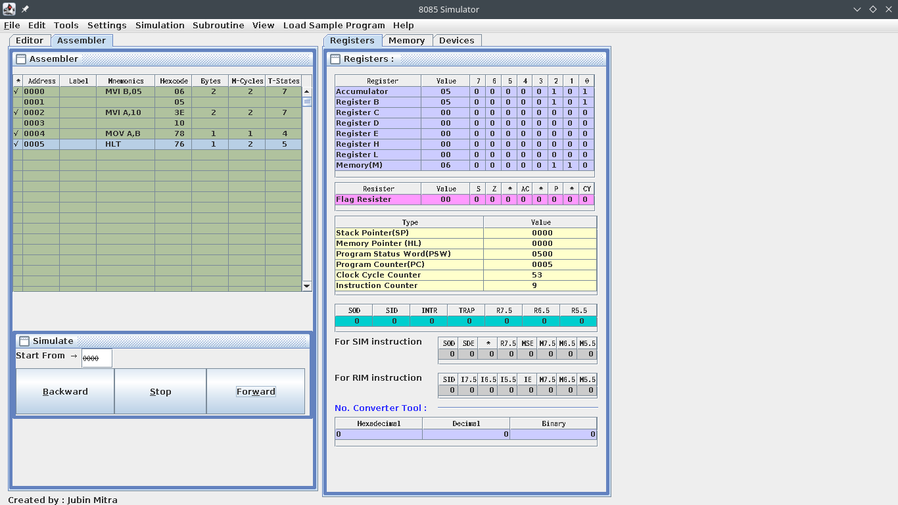

Mem to reg

Reg to mem

MVI B,10

MVI M,20

MOV M,B

MOV A,M

HLT

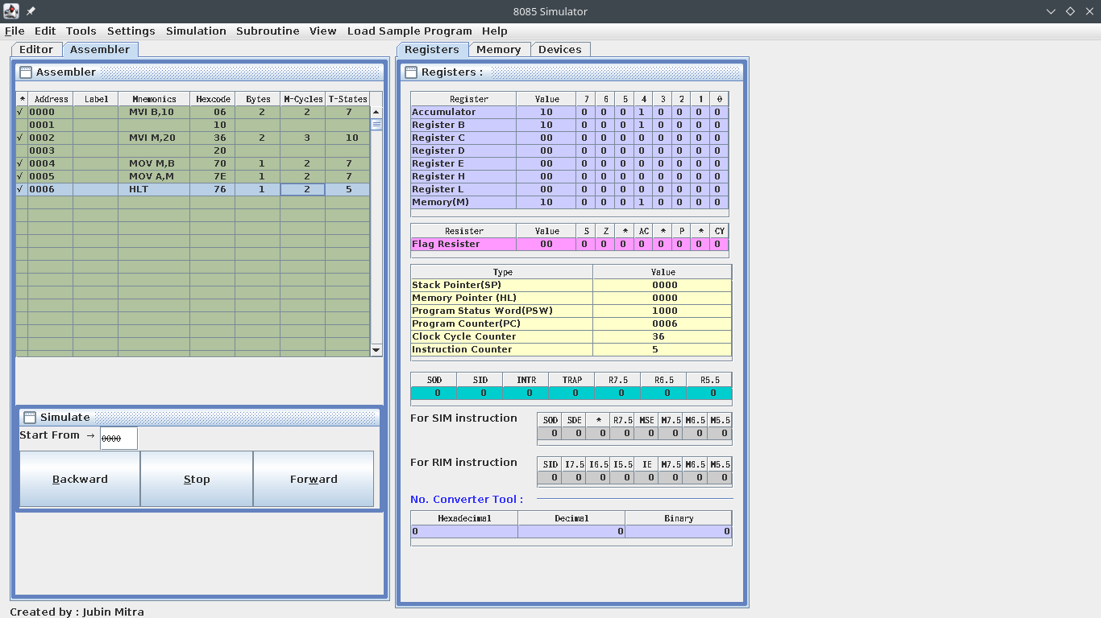

MEM to MEM

GIVES NOP error i.e. NO OPERATION

Load and store instruction

LXI H, 2050

LXI B, 4411

DAD B

SHLD 3050

HLT

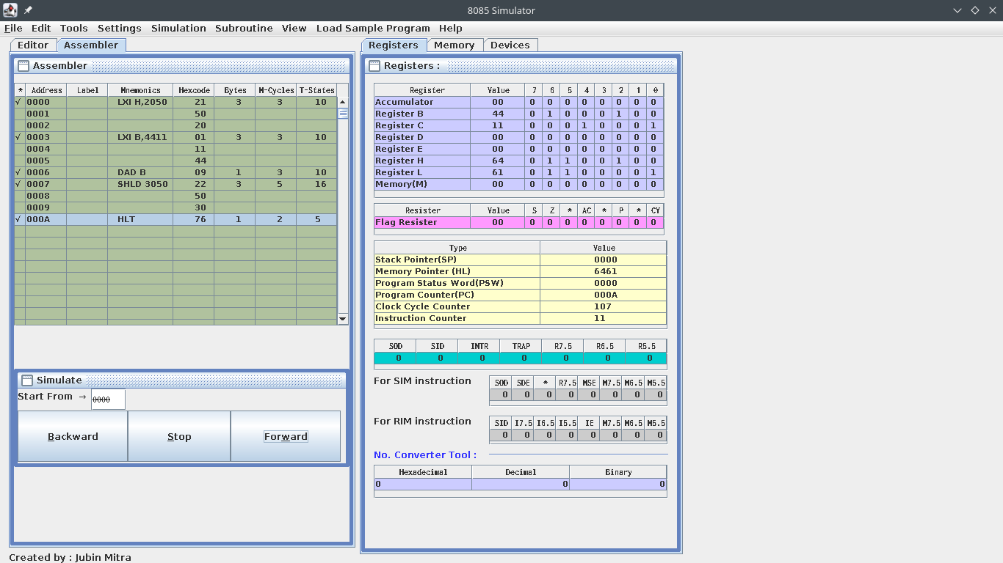

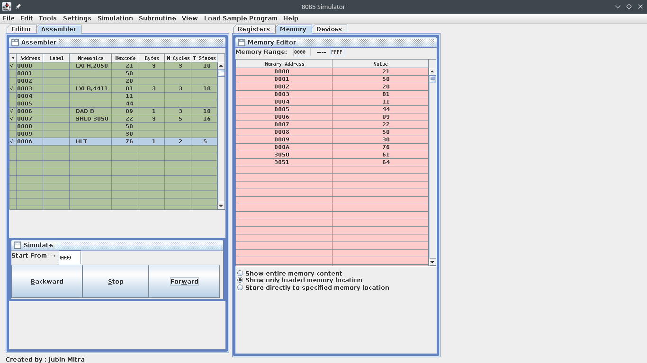

**Question 3:** Study the basic Arithematic instruction instructions of 8085 and perform the

following and note the changes in the flag register.

Add, sub, how about mul and div

BEGIN #0

MVI B,5

MVI A,10

ADD B

HLT

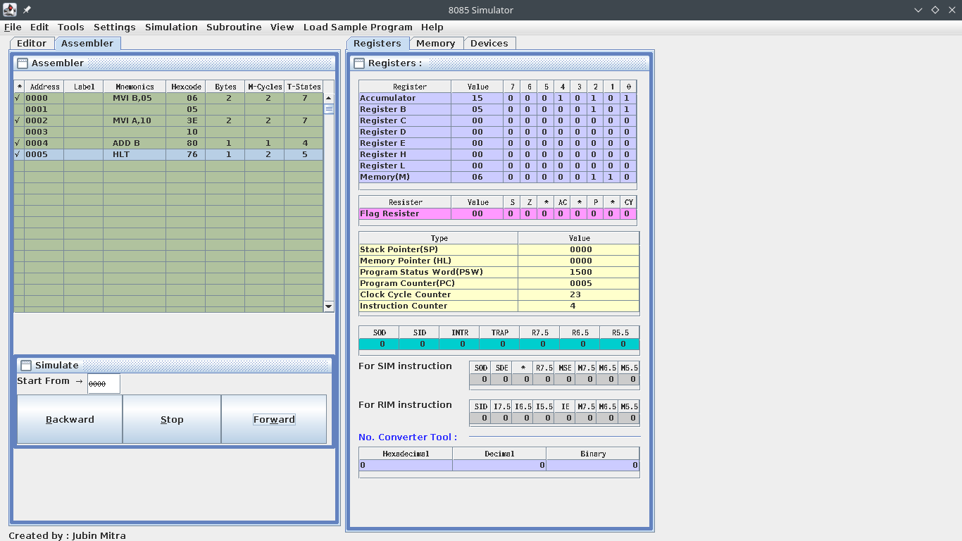

SUB

BEGIN #0

MVI B,10

MVI A,5

SUB B

HLT

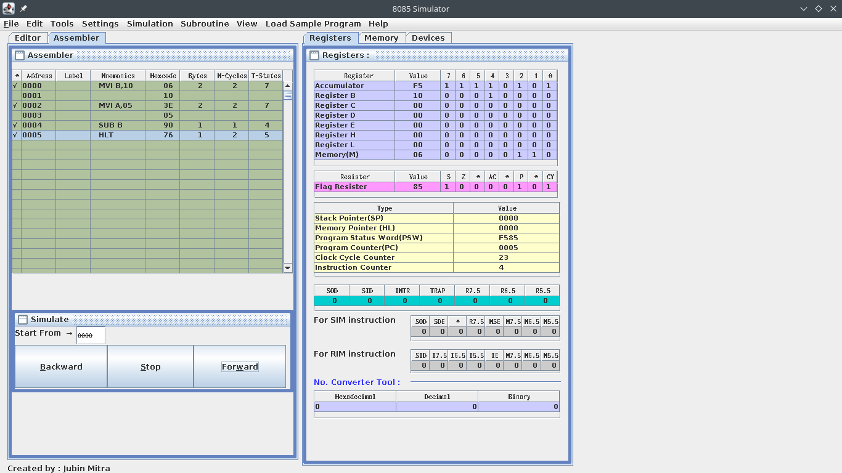

MUL -

MVI B,10

MVI C,05

LOOP: ADD B

DCR C

JNZ LOOP

HLT

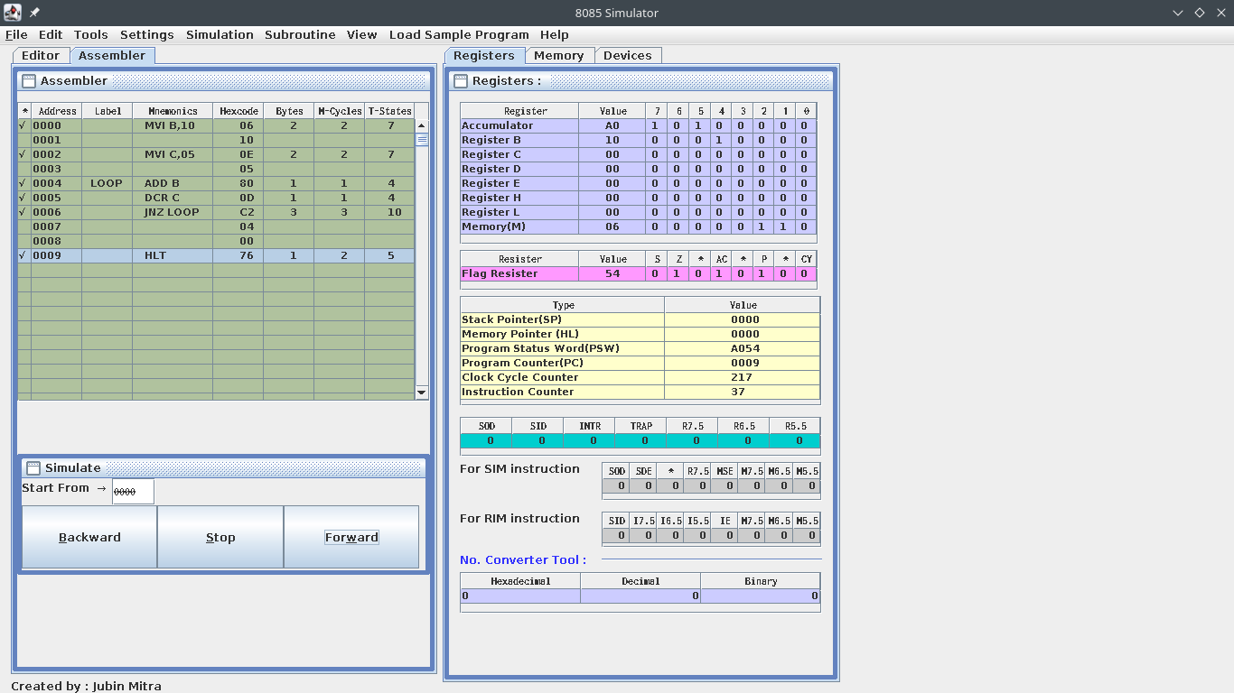

DIV-

LHLD 2501

LDA 2503

MOV B,A

MVI C,08

LOOP: DAD H

MOV A,H

SUB B

JC AHEAD

MOV H,A

INR L

AHEAD: DCR C

JNZ LOOP

SHLD 2504

HLT

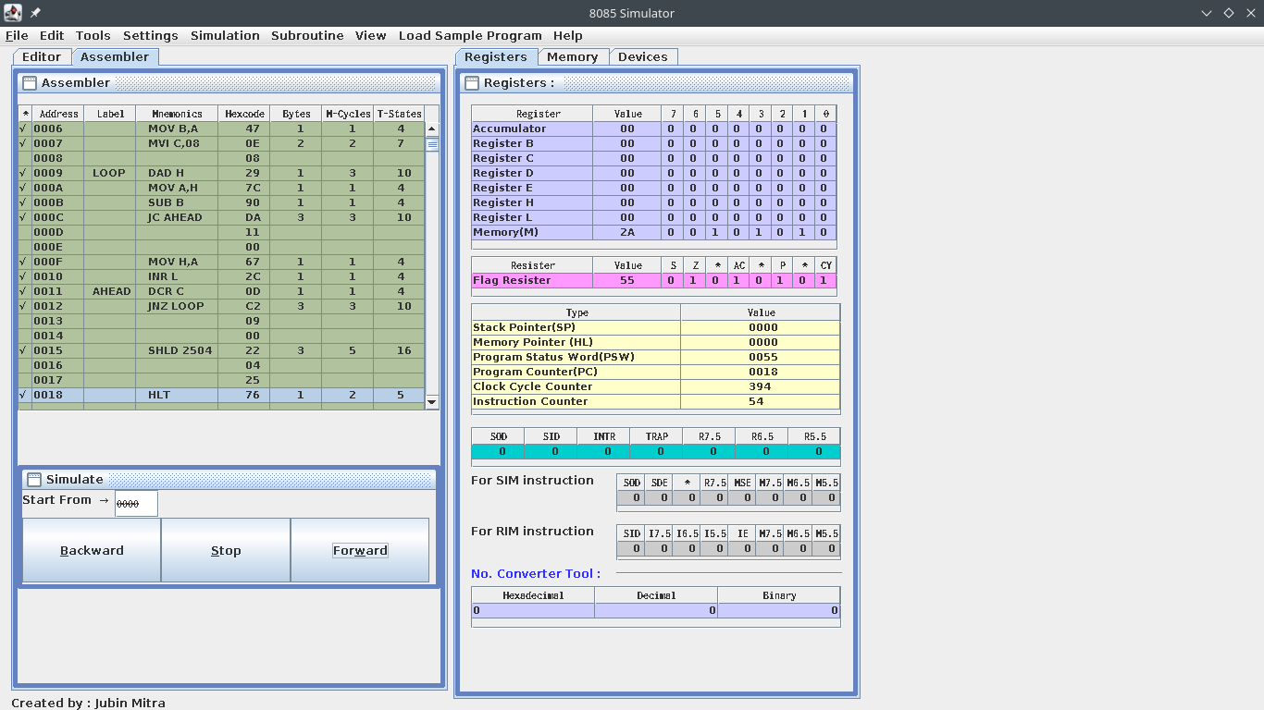

**Question7:** Study the basic Logical instruction instructions of 8085 and perform the following

and note the changes in the flag register.

AND, OR, NOT and XOR

Ans -

MVI A,5Ah

MVI B,1Fh

ANA B

MVI A,5Ah

ORA B

MVI A,5Ah

XRA B

MVI A,5Ah

CMA

HLT

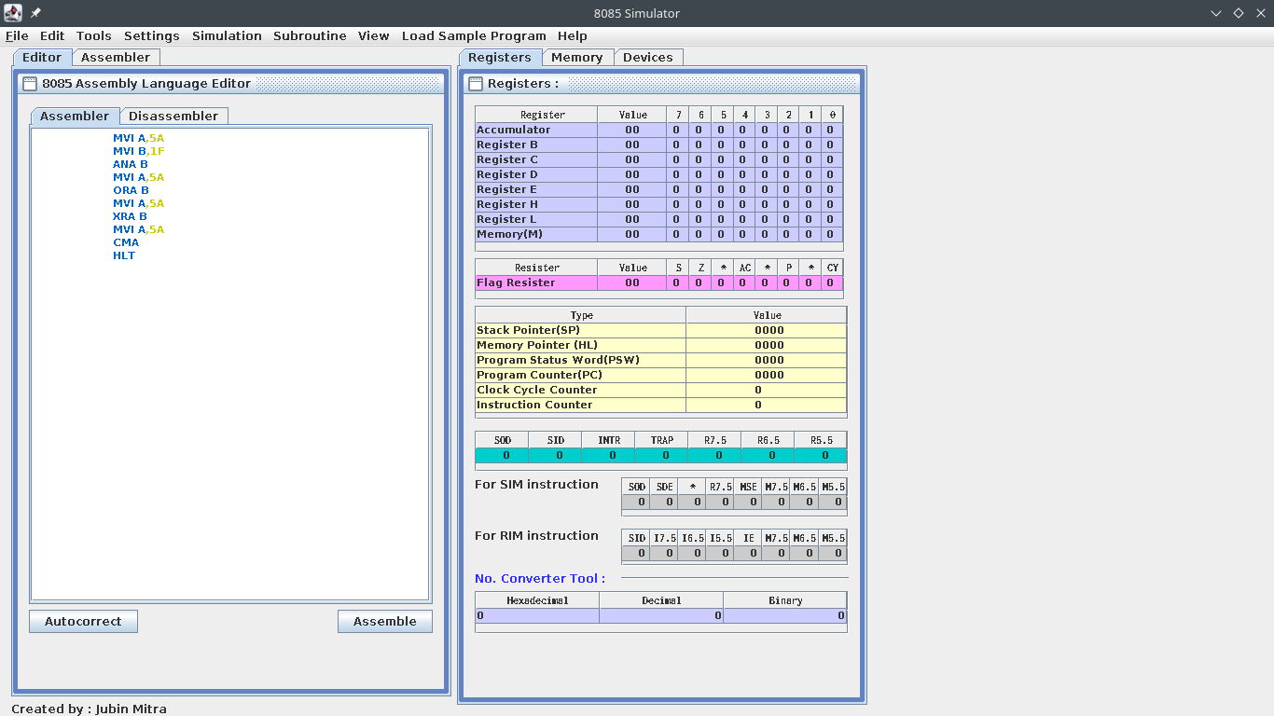

**AND Operation (5A + 1F = 1A)**

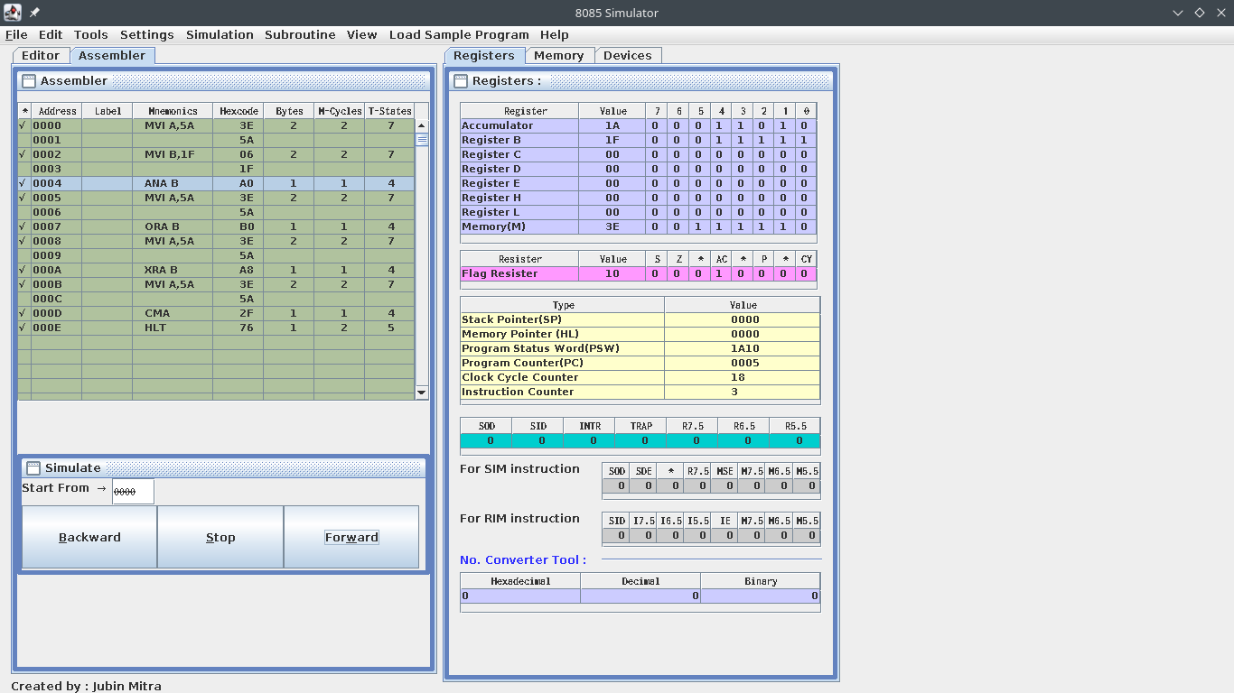

OR Operation (5A - 1F = 5F)

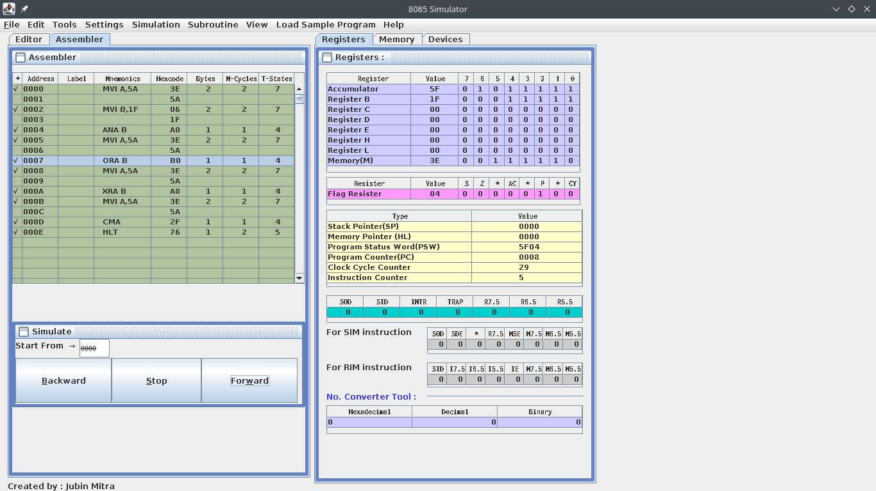

XOR Operation (5A xor 1F = 45)

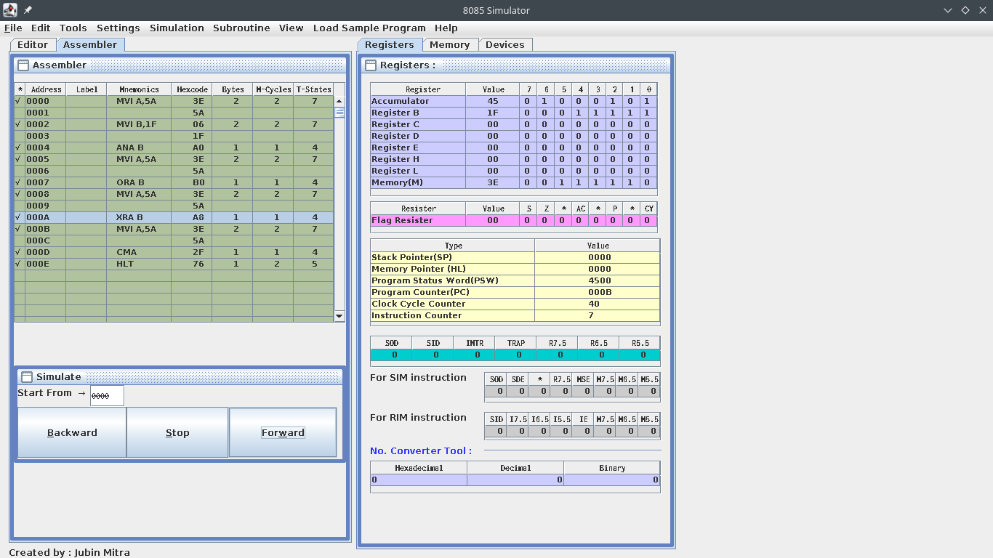

NOT(5A =A5)

