**Name-Ujjawal Mandhani**

**Batch-F6**

**Enroll No.-9918103237**

**COA Lab-6**

**Question 1:**Write assembly code for multiplying 2 numbers by the repeated addition method i.e., 2* 3 = 2 + 2 + 2. Note: you can NOT use the shift method or any other algorithm in this program.

LDA 0000H

MOV C,A

MVI B, 00H

LDA 0001H

LXI H, 0000H

LOOP: DAD B

DCR A

JNZ LOOP

HLT

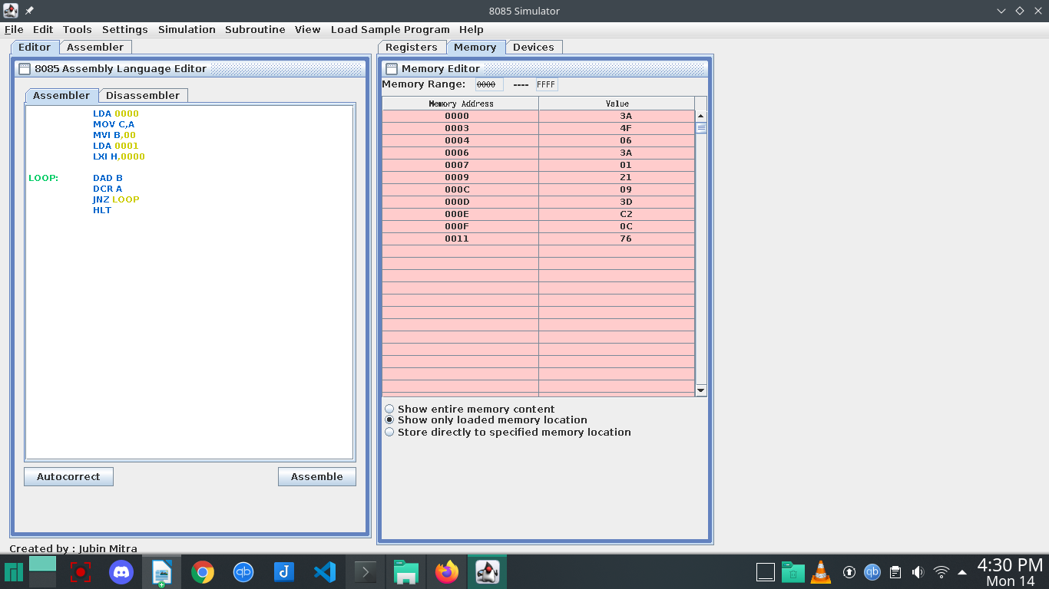

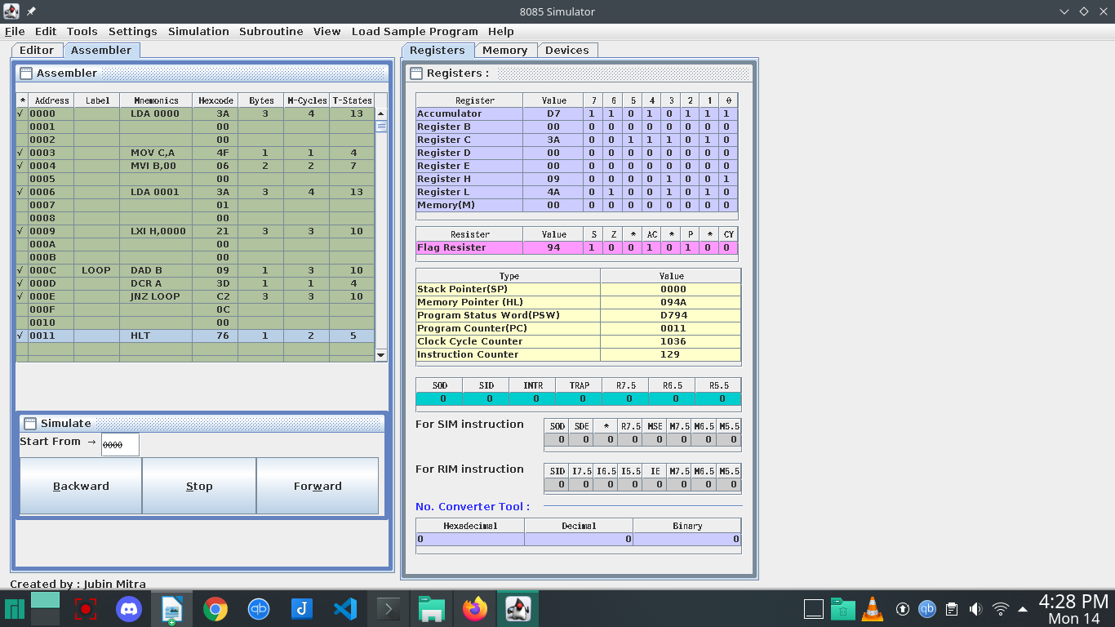

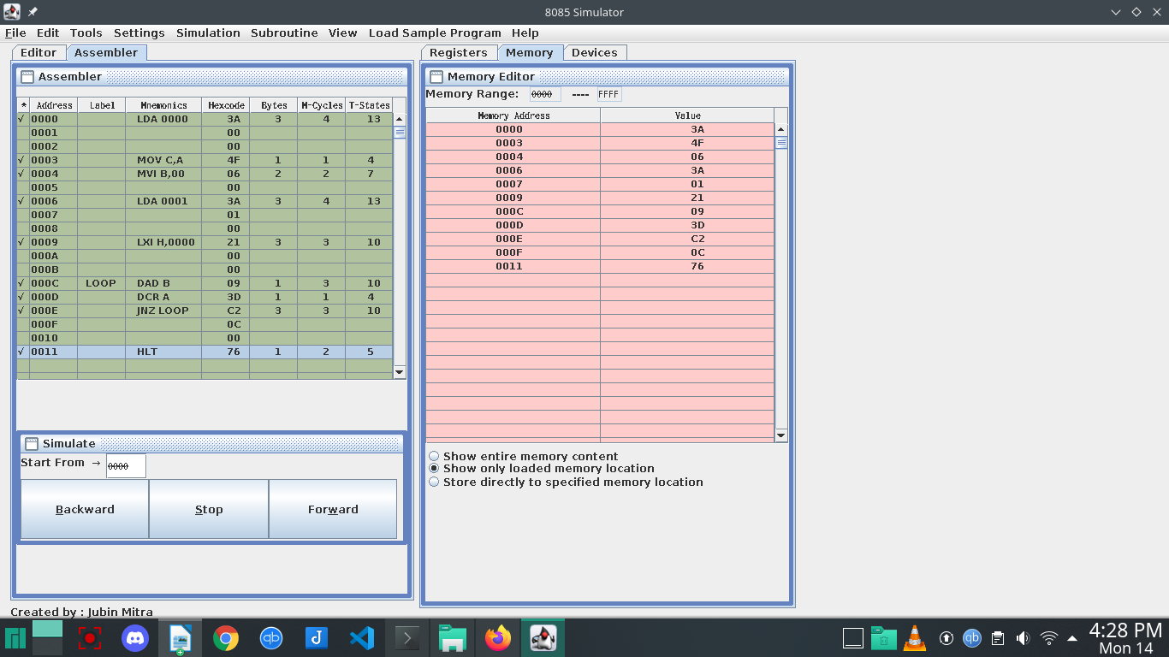

**Question 2:** Write an assembly program for adding elements present in 2 arrays and storing the

corresponding sum in another array.

LXI H, 2200H

LXI B, 2300H

LXI D, 2400H

BACK: LDAX B

ADD M

STAX D

INX H

INX B

INX D

MOV A, L

CPI 0AH

JNZ BACK

HLT

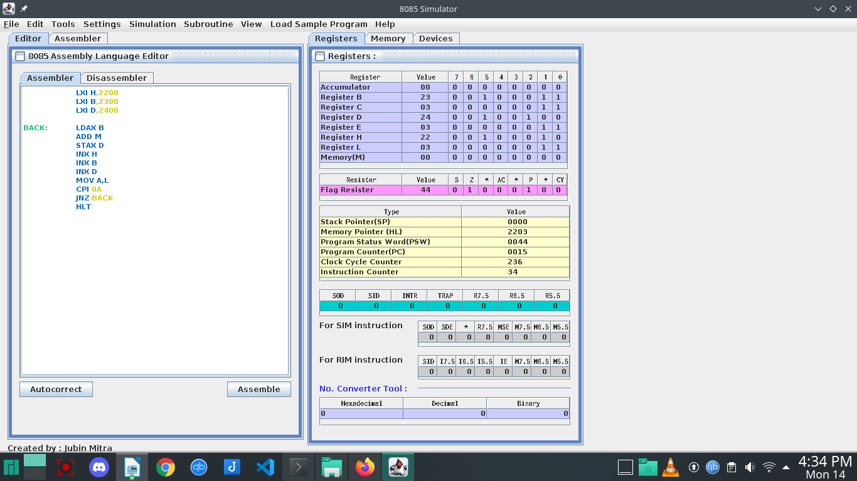

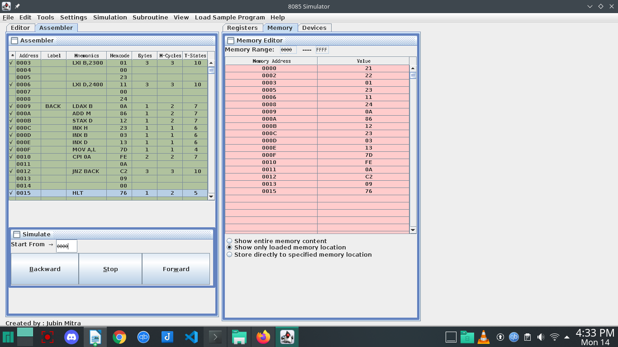

**Question 3:**Write an assembly program for converting a Hexadecimal number to BCD value.

LXI H,5000

MVI D,00

XRA A

MOV C,M

LOOP2: ADI 01

DAA

JNC LOOP1

INR D

LOOP1: DCR C

JNZ LOOP2

STA 5001

MOV A,D

STA 5002

HLT

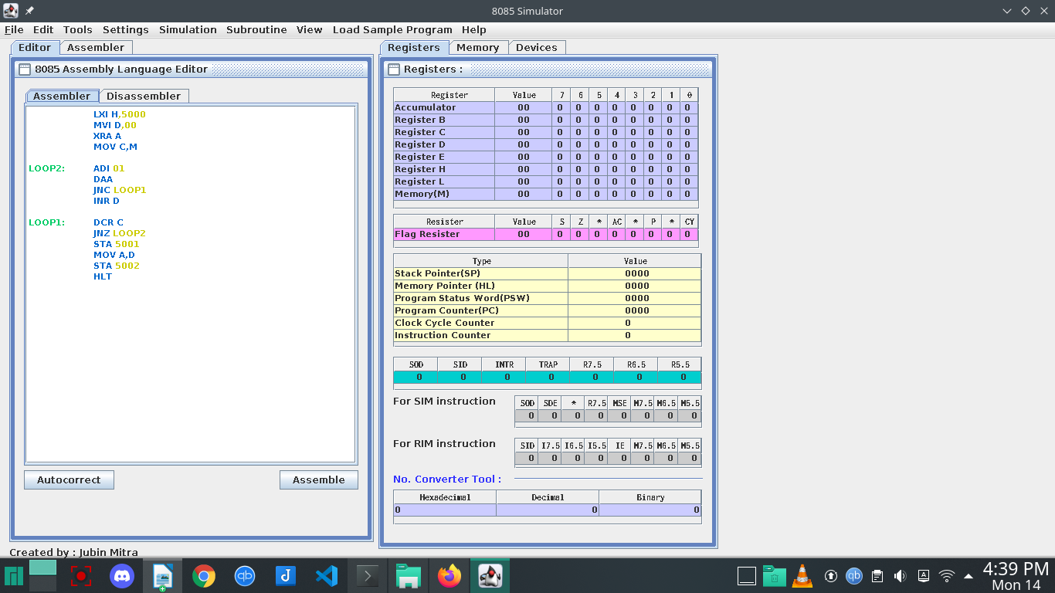

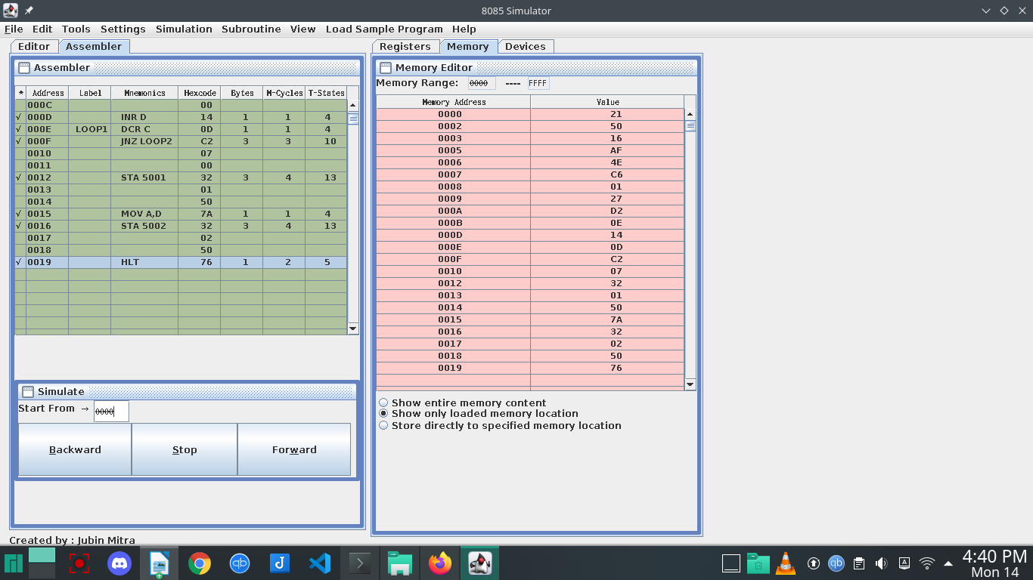

**Question 4:** Write an assembly program for reverse the half of the string/Number

LDA 2050

RLC

RLC

RLC

RLC

STA 3050

HLT

