Name-Ujjawal Mandhani
Batch-F6
Enroll no- 9918103237
COA Lab 3

Question 1:Design the subtractor circuits with defined bit logic.

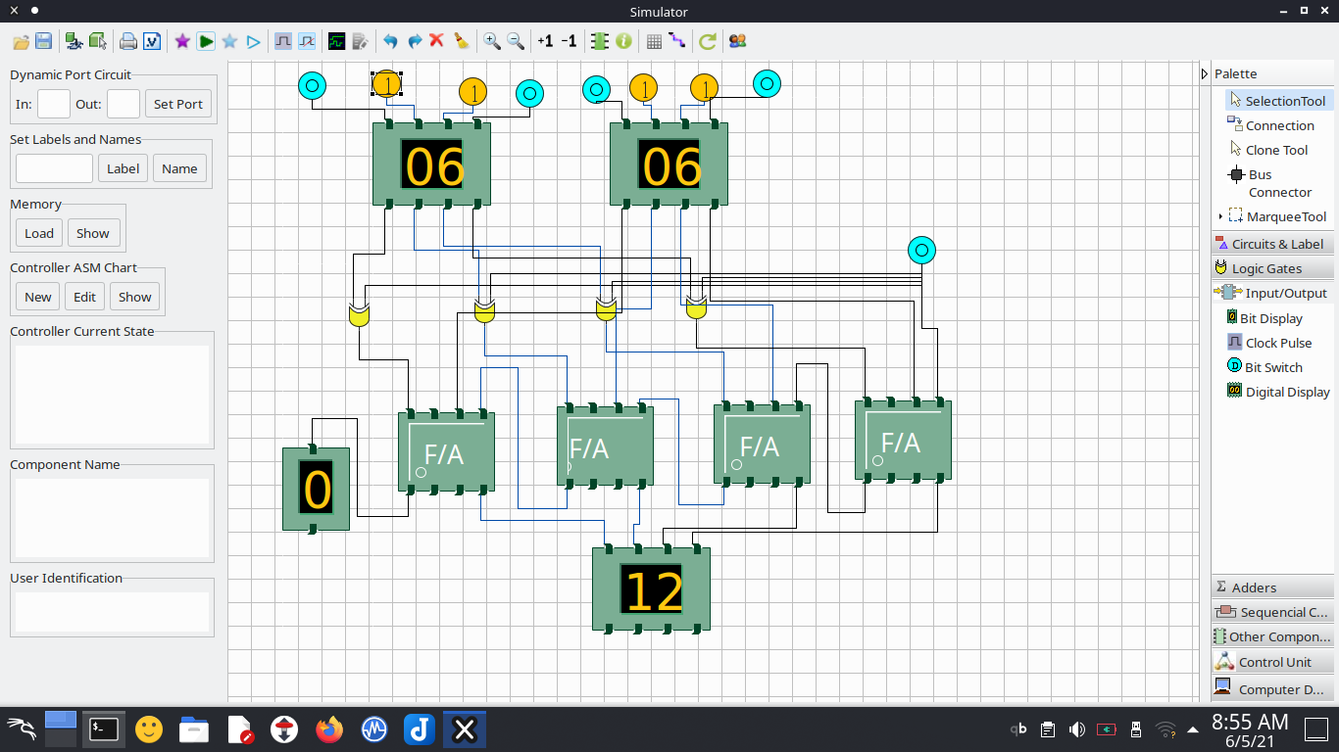
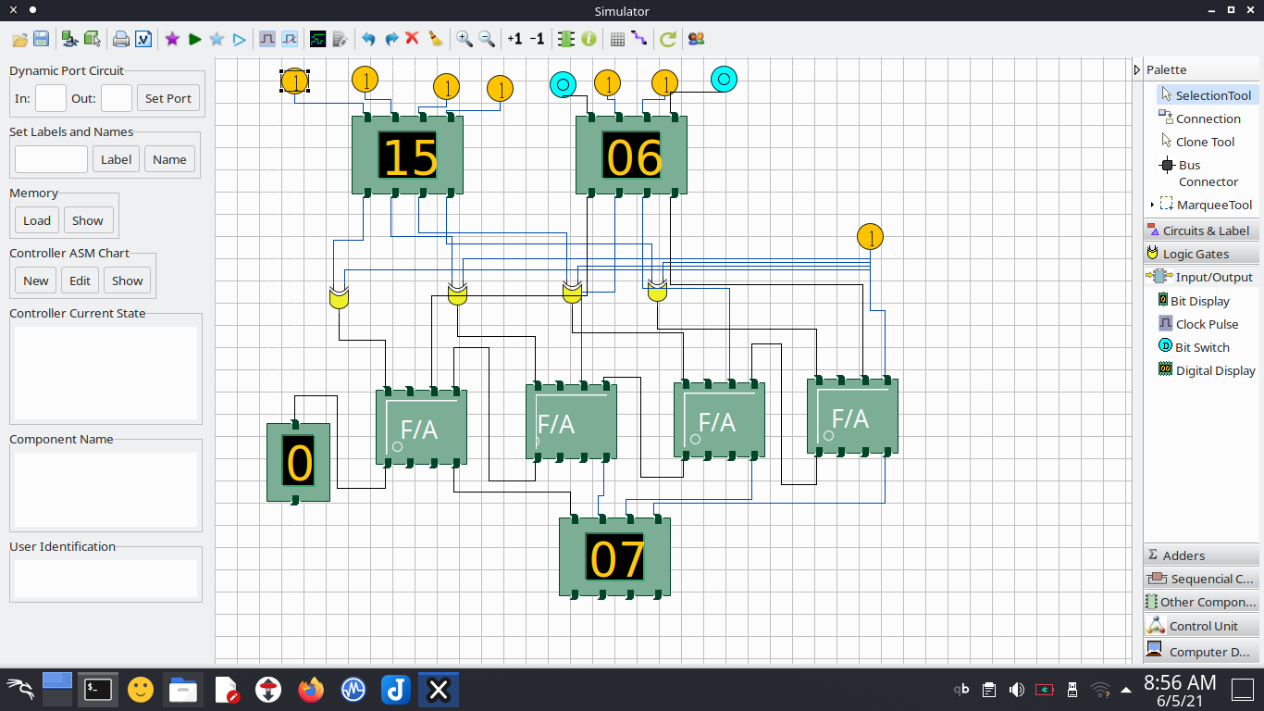
Question 2:Design the adder subtractor logic circuits.

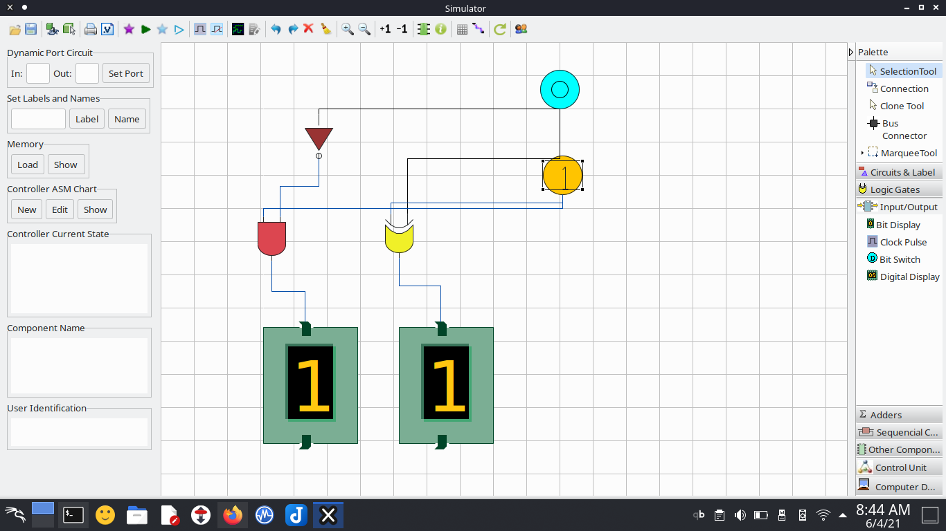
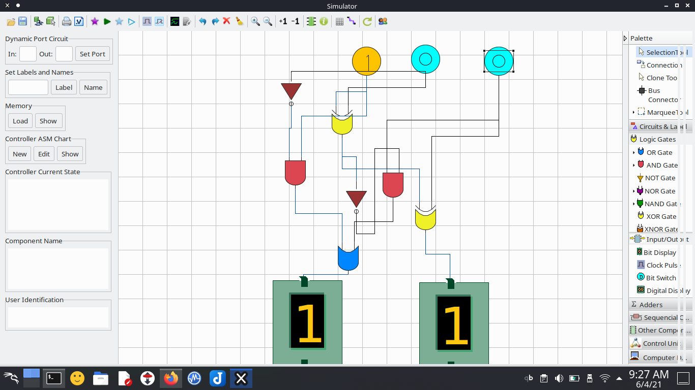
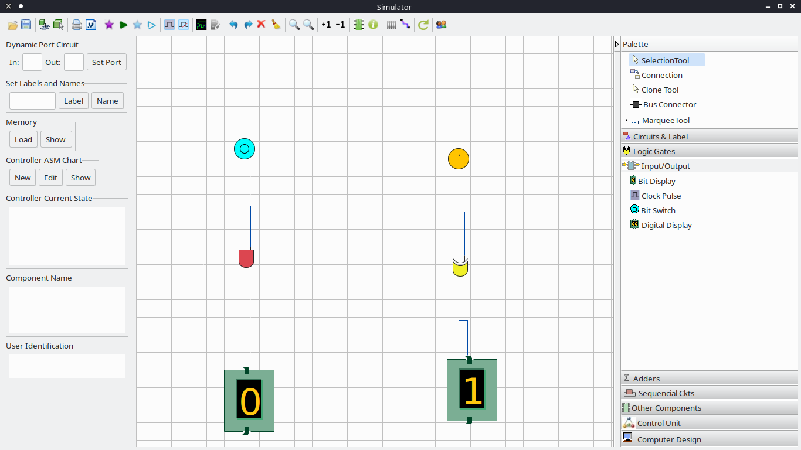
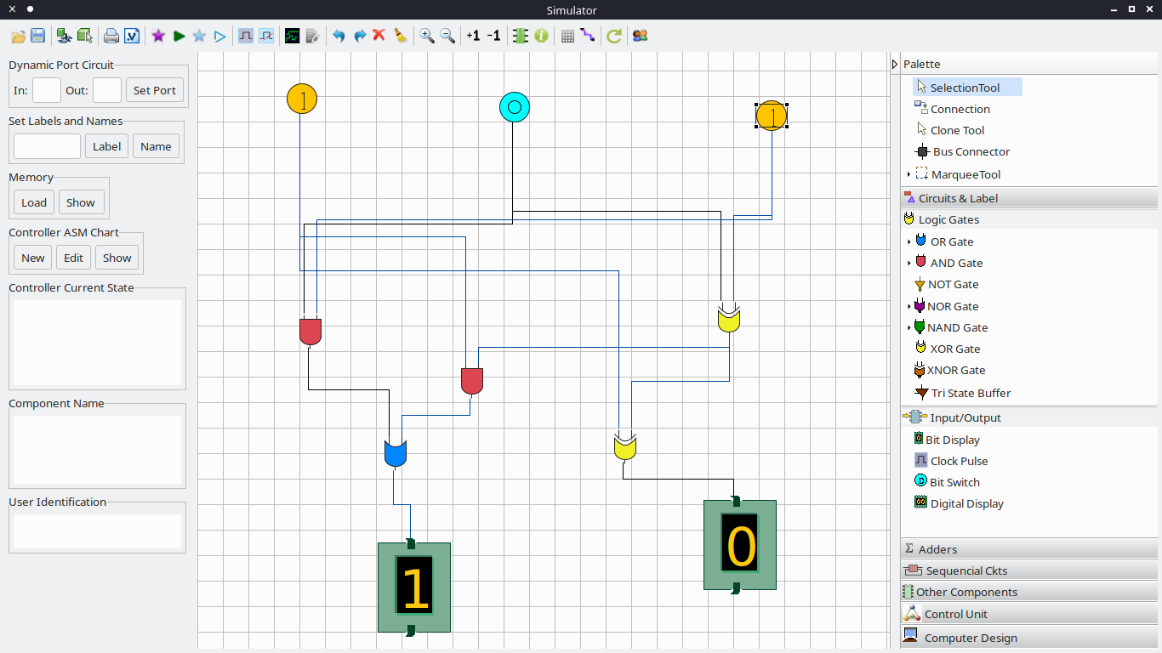
Question 4: Design the carry lookup adder, carry select and carry save adder circuits by modifying the ripple carry adder logic given in lab1.

Carry lookup adder

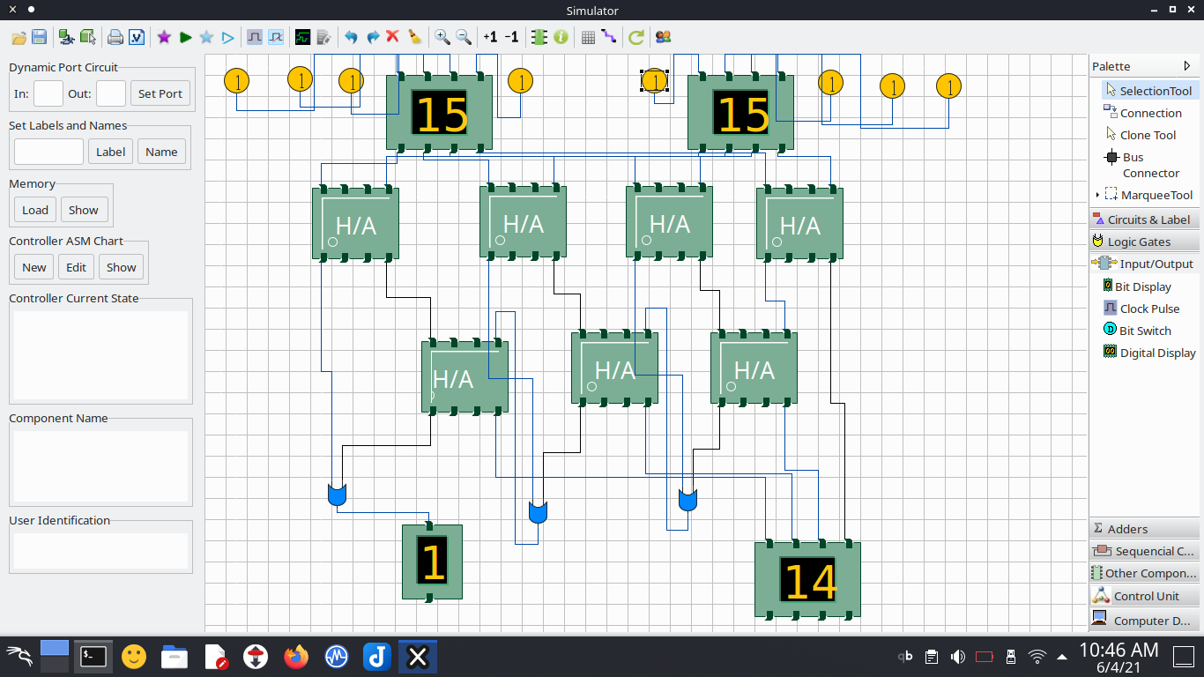
Carry Select Adder

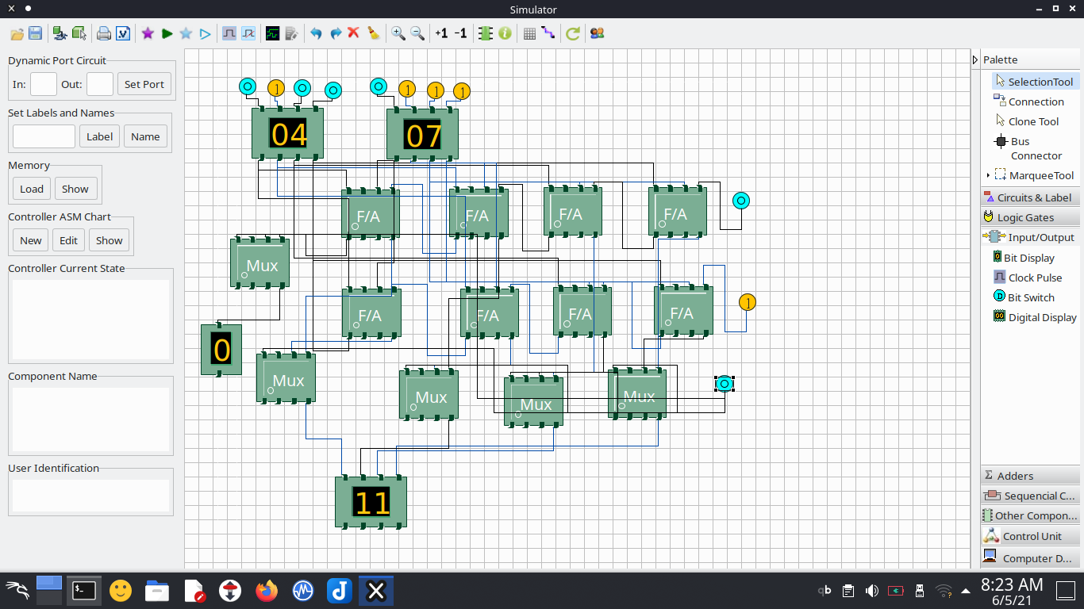
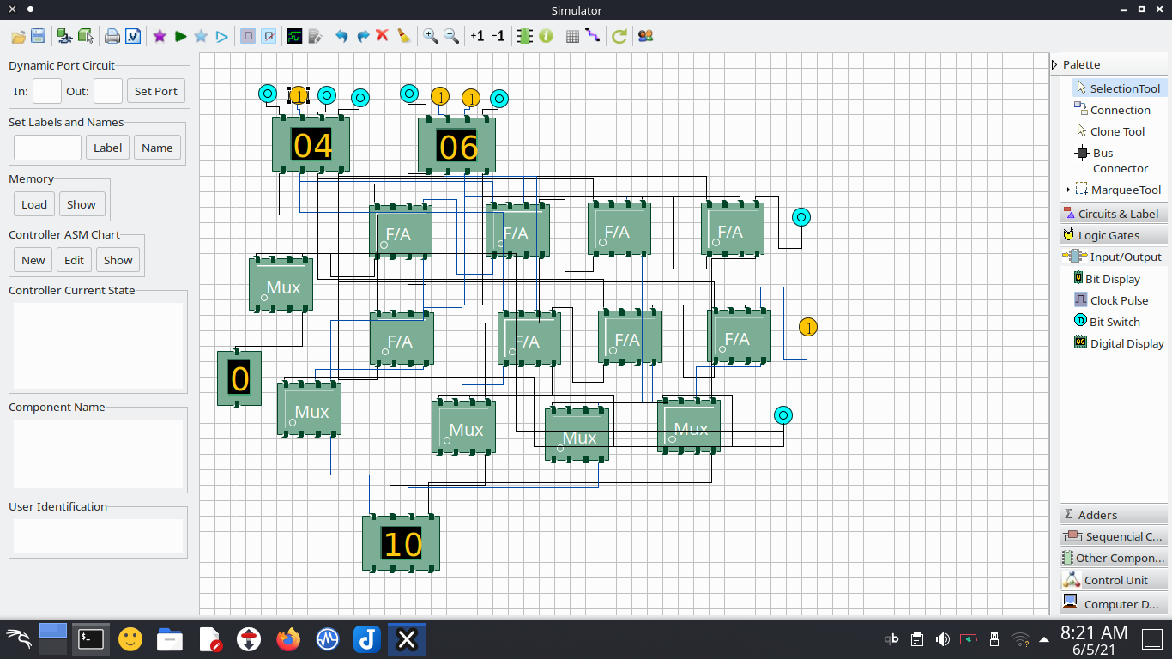
Carry Save Adder:

