Name-Ujjawal Mandhani
Batch-F6
Enroll No.-9918103237
OSSP Lab-8

Question 1:Consider the following page reference string:
1, 2, 3, 4, 2, 1, 5, 6, 2, 1, 2, 3, 7, 6, 3, 2, 1, 2, 3, 6
Implement following page replacement algorithms, assuming three, four, five, six, or seven
frames? Assume that all frames are initially empty.

i. LRU replacement
ii. FIFO replacement
iii. Optimal replacement

LRU

#include <bits/stdc++.h>
using namespace std;
int pageFaults(int pages[], int n, int capacity)
{
unordered_set<int> s;
unordered_map<int, int> indexes;
int page_faults = 0;
for (int i = 0; i < n; i++)
{
if (s.size() < capacity)
{
if (s.find(pages[i]) == s.end())
{
s.insert(pages[i]);
page_faults++;
}
indexes[pages[i]] = i;
}
else
{
if (s.find(pages[i]) == s.end())
{
int lru = INT_MAX, val;
for (auto it = s.begin(); it != s.end(); it++)
{
if (indexes[*it] < lru)
{
lru = indexes[*it];
val = *it;
}
}
s.erase(val);
s.insert(pages[i]);
page_faults++;
}
indexes[pages[i]] = i;
}
}
return page_faults;
}
int main()
{
int pages[] = {1, 2, 3, 4, 2, 1, 5, 6, 2, 1, 2, 3, 7, 6, 3, 2, 1, 2, 3, 6};
int n = sizeof(pages) / sizeof(pages[0]);
int capacity = 3;
cout << pageFaults(pages, n, capacity) << endl;
capacity = 4;
cout << pageFaults(pages, n, capacity) << endl;
capacity = 5;
cout << pageFaults(pages, n, capacity) << endl;
capacity = 6;
cout << pageFaults(pages, n, capacity) << endl;
capacity = 7;
cout << pageFaults(pages, n, capacity) << endl;
return 0;
}

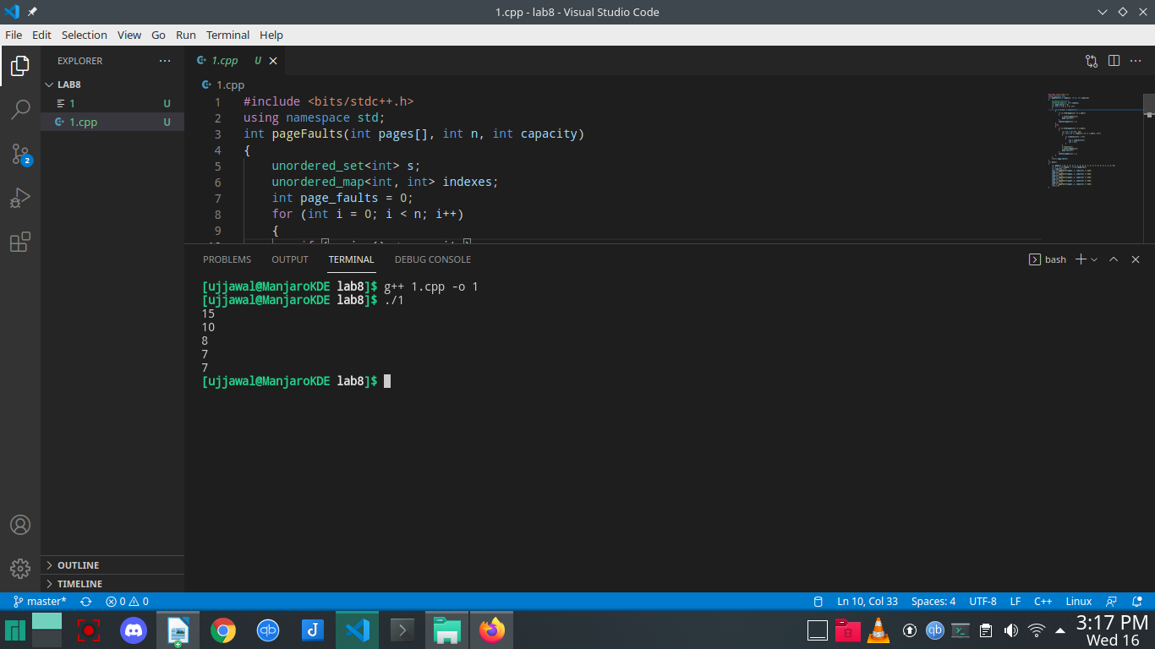
FIFO
#include <bits/stdc++.h>
using namespace std;
int pageFaults(int pages[], int n, int capacity)
{
unordered_set<int> s;
queue<int> indexes;
int page_faults = 0;
for (int i = 0; i < n; i++)
{
if (s.size() < capacity)
{
if (s.find(pages[i]) == s.end())
{
s.insert(pages[i]);
page_faults++;
indexes.push(pages[i]);
}
}
else
{
if (s.find(pages[i]) == s.end())
{
int val = indexes.front();
indexes.pop();
s.erase(val);
s.insert(pages[i]);
indexes.push(pages[i]);
page_faults++;
}
}
}
return page_faults;
}
int main()
{
int pages[] = {1, 2, 3, 4, 2, 1, 5, 6, 2, 1, 2, 3, 7, 6, 3, 2, 1, 2, 3, 6};
int n = sizeof(pages) / sizeof(pages[0]);
int capacity = 3;
cout << pageFaults(pages, n, capacity) << endl;
capacity = 4;
cout << pageFaults(pages, n, capacity) << endl;
capacity = 5;
cout << pageFaults(pages, n, capacity) << endl;
capacity = 6;
cout << pageFaults(pages, n, capacity) << endl;
capacity = 7;
cout << pageFaults(pages, n, capacity) << endl;
return 0;
}

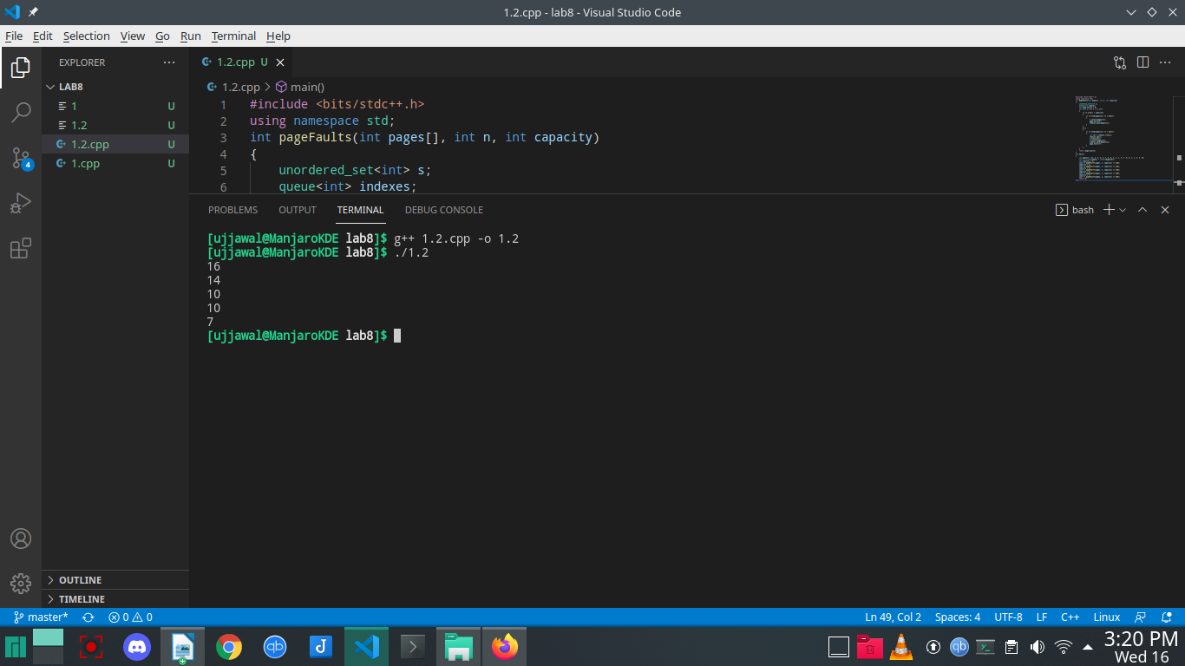
OPTIMAL:

#include <bits/stdc++.h>
using namespace std;
bool search(int key, vector<int>& fr)
{
for (int i = 0; i < fr.size(); i++)
if (fr[i] == key)
return true;
return false;
}
int predict(int pg[], vector<int>& fr, int pn, int index)
{
int res = -1, farthest = index;
for (int i = 0; i < fr.size(); i++) {
int j;
for (j = index; j < pn; j++) {
if (fr[i] == pg[j]) {
if (j > farthest) {
farthest = j;
res = i;
}
break;
}
}
if (j == pn)
return i;
}
return (res == -1) ? 0 : res;
}
void optimalPage(int pg[], int pn, int fn)
{
vector<int> fr;
int hit = 0;
for (int i = 0; i < pn; i++) {
if (search(pg[i], fr)) {
hit++;
continue;
}
if (fr.size() < fn)
fr.push_back(pg[i]);
else {
int j = predict(pg, fr, pn, i + 1);
fr[j] = pg[i];
}
}
cout << "No. of hits = " << hit << endl;
cout << "No. of misses = " << pn - hit << endl;
}

int main()
{
int pg[] = {1,2,3,4,2,1,5,6,2,1,2,3,7,6,3,2,1,2,3,6};
int pn = sizeof(pg) / sizeof(pg[0]);
int fn = 3;
optimalPage(pg, pn, fn);
fn = 4;
optimalPage(pg, pn, fn);
fn = 5;
optimalPage(pg, pn, fn);
fn = 6;
optimalPage(pg, pn, fn);
fn = 7;
optimalPage(pg, pn, fn);
return 0;
}

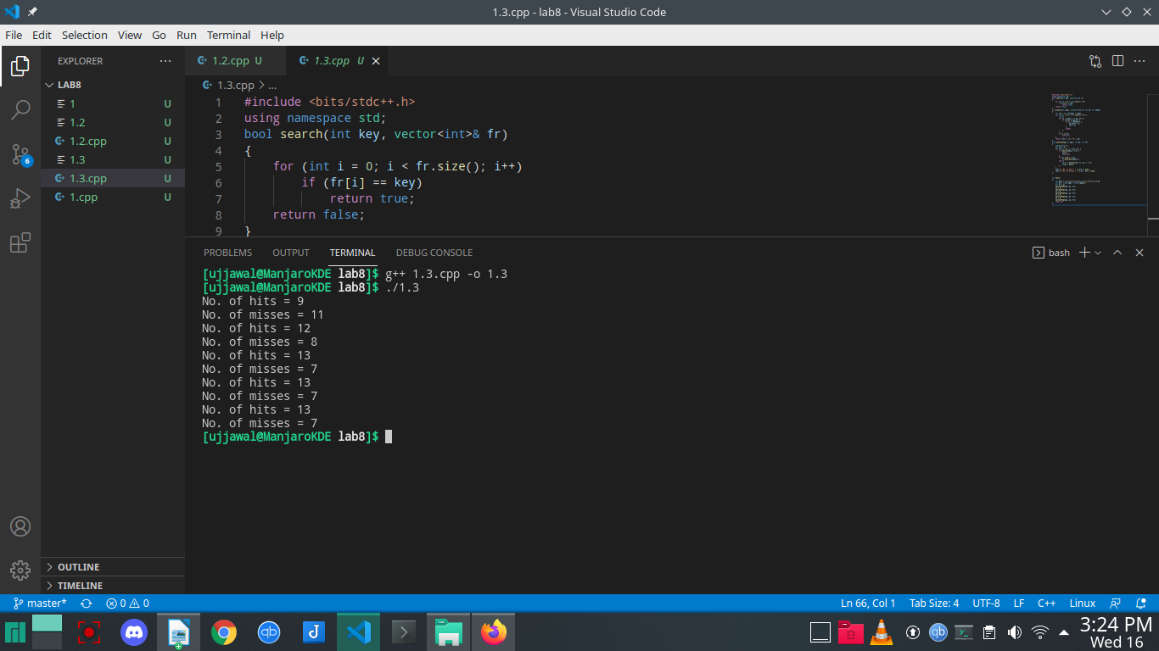
Question 2:Consider the following page reference string:
1, 2, 3, 4, 2, 1, 5, 6, 2, 1, 2, 3, 7, 6, 3, 2, 1, 2, 3, 6
Implement following page replacement algorithms, assuming three, four, five, six, or seven
frames? Assume that all frames are initially empty.
• Least frequently used
• Most Frequently used

Least frequently used
#include <bits/stdc++.h>
using namespace std;
int main()
{
int m, i, j, k;
vector<int> v{3, 4, 5, 6, 7};
m = 20;
vector<int> p{1, 2, 3, 4, 2, 1, 5, 6, 2, 1, 2, 3, 7, 6, 3, 2, 1, 2, 3, 6};
for (int z = 0; z < v.size(); z++)
{
int n = v[z];
vector<vector<int>> a(n, vector<int>(m, -1));
map<int, int> mp, lfmp;
for (i = 0; i < m; i++)
{
vector<int> op;
vector<pair<int, int>> c, lf;
for (auto q : mp)
{
c.push_back({q.second, q.first});
}
for (auto q : lfmp)
{
lf.push_back({q.second, q.first});
}
sort(lf.begin(), lf.end());
bool dontCall = true;
if (lf.size() > 2)
{
if (lf[0].first != lf[1].first)
{
dontCall = false;
}
}
sort(c.begin(), c.end());
bool hasrun = false;
for (j = 0; j < n; j++)
{
if (a[j][i] == p[i])
{

mp[p[i]]++;
lfmp[p[i]]++;
hasrun = true;
break;
}
if (a[j][i] == -1)
{
for (k = i; k < m; k++)
a[j][k] = p[i];
mp[p[i]]++;
lfmp[p[i]]++;
hasrun = true;
break;
}
}
if (j == n || hasrun == false)
{
for (j = 0; j < n; j++)
{
if (dontCall == true)
{
int q;
if (lf[lf.size() - 1].second == c[c.size() - 1].second && lf[lf.size() - 1].first > 1)
{
if (a[j][i] == c[c.size() - 2].second)
{
mp.erase(a[j][i]);
lfmp.erase(a[j][i]);
for (k = i; k < m; k++)
a[j][k] = p[i];
mp[p[i]]++;
lfmp[p[i]]++;
break;
}
}
else
{
if (a[j][i] == c[c.size() - 1].second)
{
mp.erase(a[j][i]);
lfmp.erase(a[j][i]);
for (k = i; k < m; k++)
a[j][k] = p[i];
mp[p[i]]++;
lfmp[p[i]]++;
break;
}
}
}
else if (dontCall == false)
{
if (a[j][i] == lf[0].second)
{
mp.erase(a[j][i]);
lfmp.erase(a[j][i]);
for (k = i; k < m; k++)
a[j][k] = p[i];
mp[p[i]]++;
lfmp[p[i]]++;
break;
}
}
}
}
for (auto q : mp)
{
if (q.first != p[i])
{
mp[q.first]++;
}
}
}
int hit = 0;
vector<int> hitv(m);

for (i = 1; i < m; i++)
{
for (j = 0; j < n; j++)
{
if (p[i] == a[j][i - 1])
{
hit++;
hitv[i] = 1;
break;
}
}
}
cout << "Process ";
for (i = 0; i < m; i++)
{
cout << p[i] << " ";
}
cout << '\n';
for (i = 0; i < n; i++)
{
cout << "Frame " << i << " ";
for (j = 0; j < m; j++)
{
if (a[i][j] == -1)
cout << "E ";
else
cout << a[i][j] << " ";
}
cout << '\n';
}
cout << "HIT ";
for (i = 0; i < hitv.size(); i++)
{
if (hitv[i] == 0)
cout << " ";
else
cout << hitv[i] << " ";
}
cout << "\n";
cout << "Hit " << hit << '\n'
<< "Page Fault " << m - hit << '\n';
}
return 0;
}

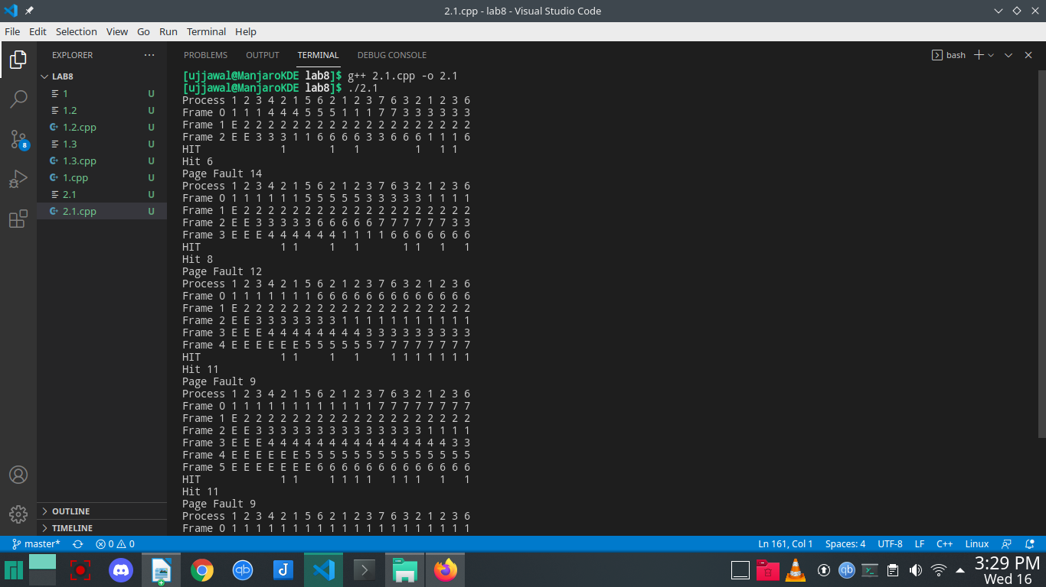
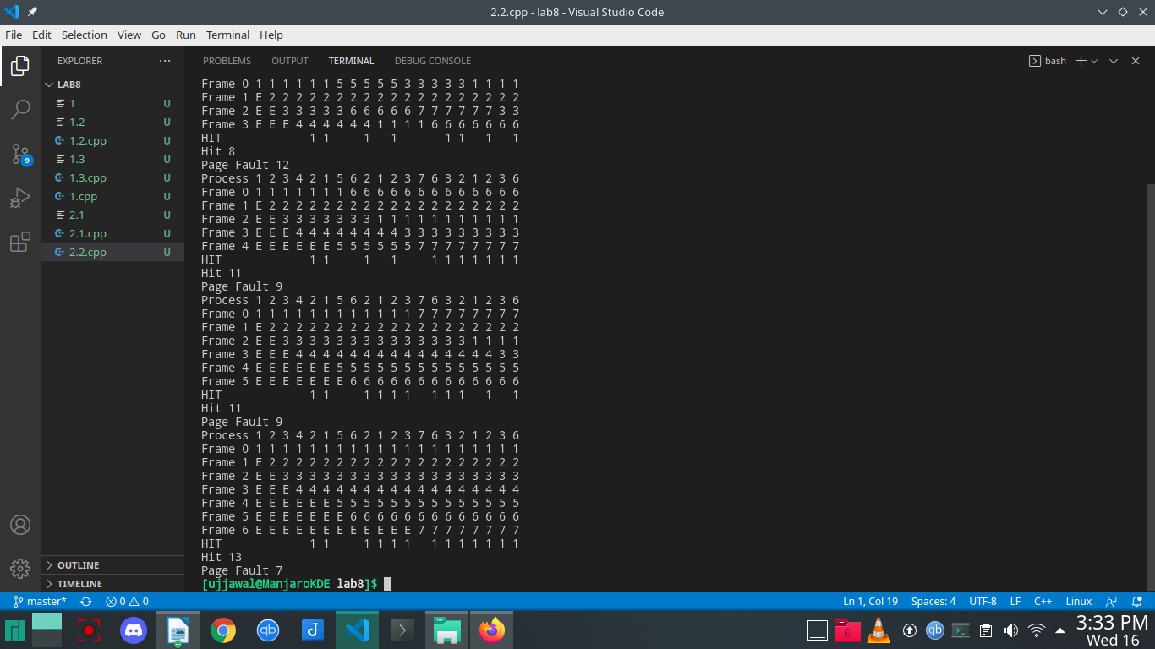

Most Frequently used

#include <stdio.h>
struct node
{
int pno, freq;
} frames[20];
int n;
int page_found(int pno)
{
int fno;
for (fno = 0; fno < n; fno++)
if (frames[fno].pno == pno)
return fno;
return -1;
}

int get_free_frame()
{
int fno;
for (fno = 0; fno <= n; fno++)
if (frames[fno].pno == -1)
return (fno);
return (-1);
}

int get_mfu_frame()
{
int fno;
int selfno = 0;
for (fno = 1; fno < n; fno++)
if (frames[fno].freq > frames[selfno].freq)
selfno = fno;
return selfno;
}
void main()
{
int p_request[] = {1, 2, 3, 4, 2, 1, 5, 6, 2, 1, 2, 3, 7, 6, 3, 2, 1, 2, 3, 6};
int size = 15;
int page_falts = 0, i, j, fno;
n = 3;
for (i = 0; i < n; i++)
{
frames[i].pno = -1;
frames[i].freq = 0;
}
printf("\nPageNo Page Frames Page Fault");
printf("\n---------------------------------------------------");
for (i = 0; i < size; i++)
{
j = page_found(p_request[i]);
if (j == -1)
{
j = get_free_frame();
if (j == -1)
j = get_mfu_frame();
page_falts++;
frames[j].pno = p_request[i];
frames[j].freq = 1;
printf("\n%4d\t ", p_request[i]);
for (fno = 0; fno < n; fno++)
printf("%4d:%2d", frames[fno].pno, frames[fno].freq);
printf(" : YES");
}
else
{
printf("\n%4d\t ", p_request[i]);
frames[j].freq++;
for (fno = 0; fno < n; fno++)
printf("%4d:%2d", frames[fno].pno, frames[fno].freq);
printf(" : NO");
}
}
printf("\n-------------------------------------------------------");
printf("\n Number of Page_Falts=%d", page_falts);
}

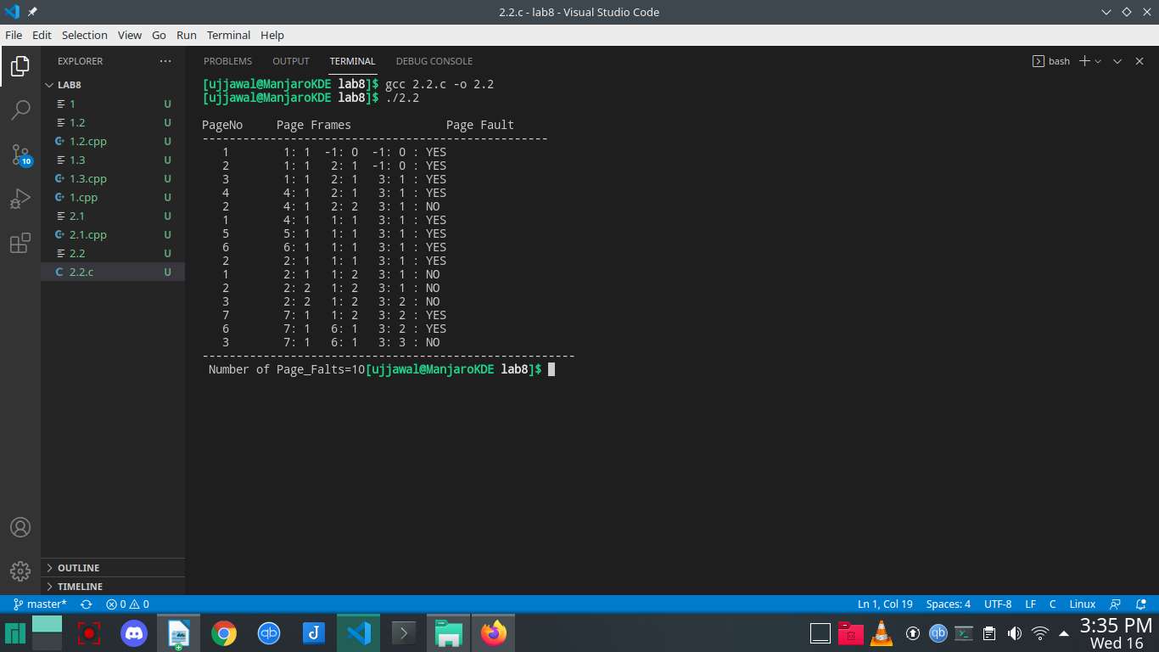
Question 3:Which of the above algorithm suffers from Belady’s anomaly, take an example of page reference and prove that the algorithm chosen suffers from Belady’s anomaly.
Assuming a system that has no pages loaded in the memory and uses the FIFO Page replacement algorithm. Consider the following reference string:
1, 2, 3, 4, 1, 2, 5, 1, 2, 3, 4, 5
Case-1: If the system has 3 frames, the given reference string on using FIFO page replacement algorithm yields a total of 9 page faults. The diagram below illustrates the pattern of the page faults occurring in the example.

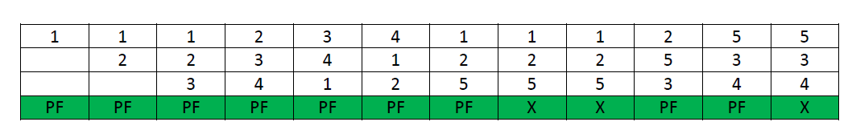

Case-2: If the system has 4 frames, the given reference string on using FIFO page replacement algorithm yields a total of 10 page faults. The diagram below illustrates the pattern of the page faults occurring in the example.
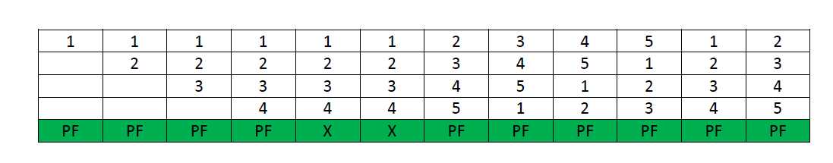
It can be seen from the above example that on increasing the number of frames while using the FIFO page replacement algorithm, the number of page faults increased from 9 to 10.
Note – It is not necessary that every string reference pattern cause Belady anomaly in FIFO but there are certain kind of string references that worsen the FIFO performance on increasing the number of frames.
Why Stack based algorithms do not suffer Anomaly –
All the stack based algorithms never suffer Belady Anomaly because these type of algorithms assigns a priority to a page (for replacement) that is independent of the number of page frames. Examples of such policies are Optimal, LRU and LFU. Additionally these algorithms also have a good property for simulation, i.e. the miss (or hit) ratio can be computed for any number of page frames with a single pass through the reference string.
In LRU algorithm every time a page is referenced it is moved at the top of the stack, so, the top n pages of the stack are the n most recently used pages.Even if the number of frames are incremented to n+1, top of the stack will have n+1 most recently used pages.
Similar example can be used to calculate the number of page faults in LRU algorithm. Assuming a system that has no pages loaded in the memory and uses the LRU Page replacement algorithm. Consider the following reference string:
1, 2, 3, 4, 1, 2, 5, 1, 2, 3, 4, 5
Case-1: If the system has 3 frames, the given reference string on using LRU page replacement algorithm yields a total of 10 page faults. The diagram below illustrates the pattern of the page faults occurring in the example.
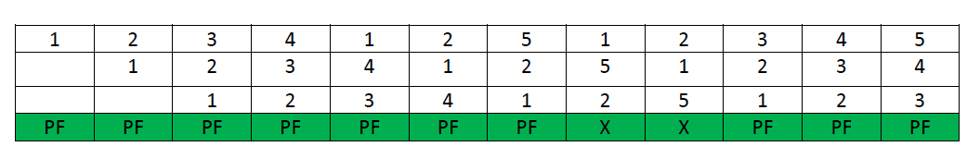

Case-2: If the system has 4 frames, the given reference string on using LRU page replacement algorithm, then total 8 page faults occur. The diagram shows the pattern of the page faults in the example.
