Name-Ujjawal Mandhani
Batch-F6
Enroll No.-9918103237
COA LAB TEST 2

Question 1:

LDA 2000
MOV B,A
ANI 0F
MOV C,A
MOV A,B
ANI F0
RLC
RLC
RLC
RLC
CMP C
JZ LABEL
MVI A,FF
STA 3021
HLT

LABEL: MVI A,00
STA 3020
HLT

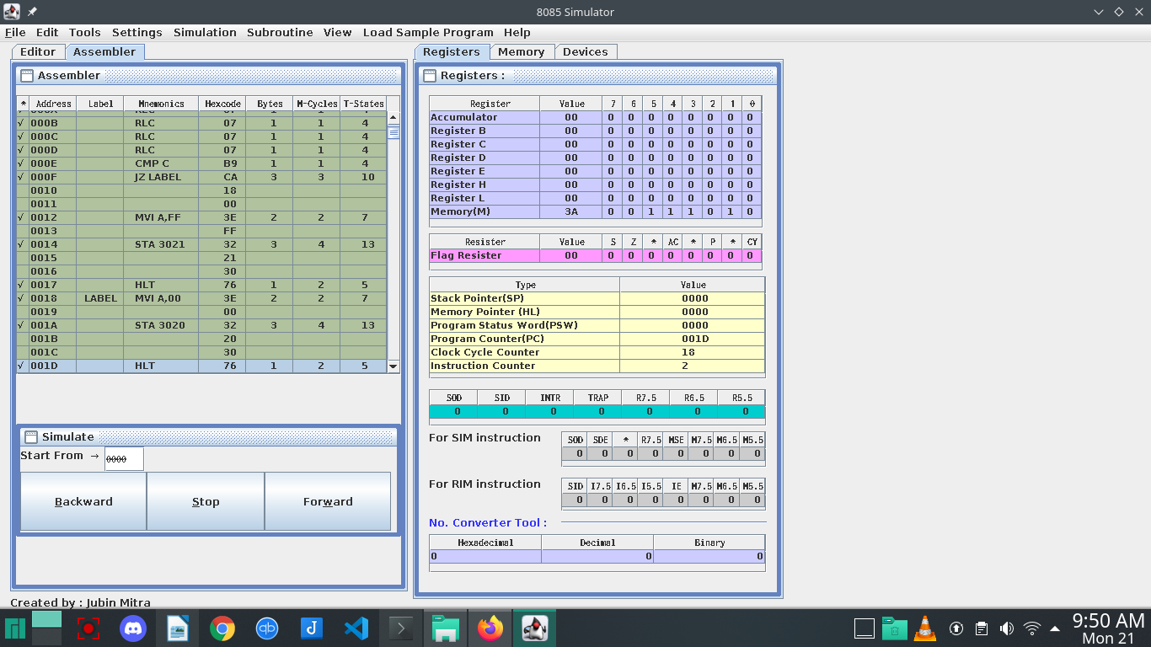
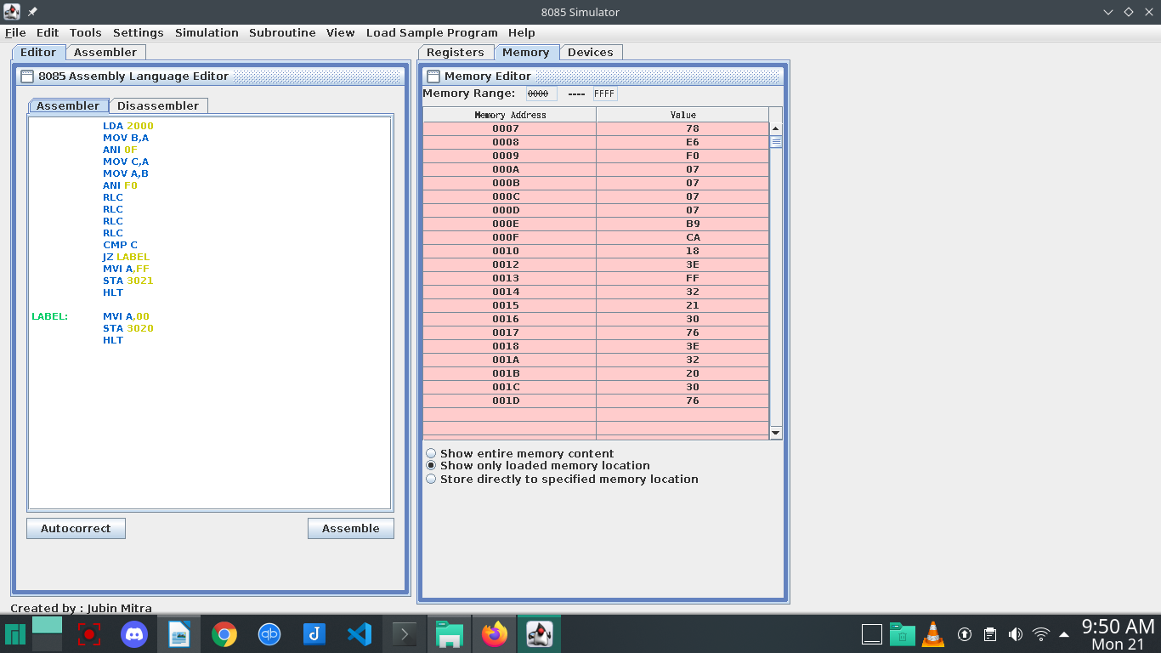

Question 2:

LDA 2050
MOV H,A
LDA 2051
ADD H
MOV L,A
MVI L,0A

ADC A
MOV H,A
SHLD 3050
HLT
