Name-Ujjawal Mandhani
Batch-F6
Enroll No.-9918103237
COA Lab-8

Question 1:

START: LXI H,2000
MVI D,00
MOV C,M
DCR C
INX H

CHECK: MOV A,M
INX H
CMP M
JC NEXTBYT
MOV B,M
MOV M,A
DCX H
MOV M,B
INX H
MVI D,01

NEXTBYT: DCR C
JNZ CHECK
MOV A,D
RRC
JC START
HLT
# ORG 2000H
# DB 06H,06H,05H,04H,01H,02H,03H

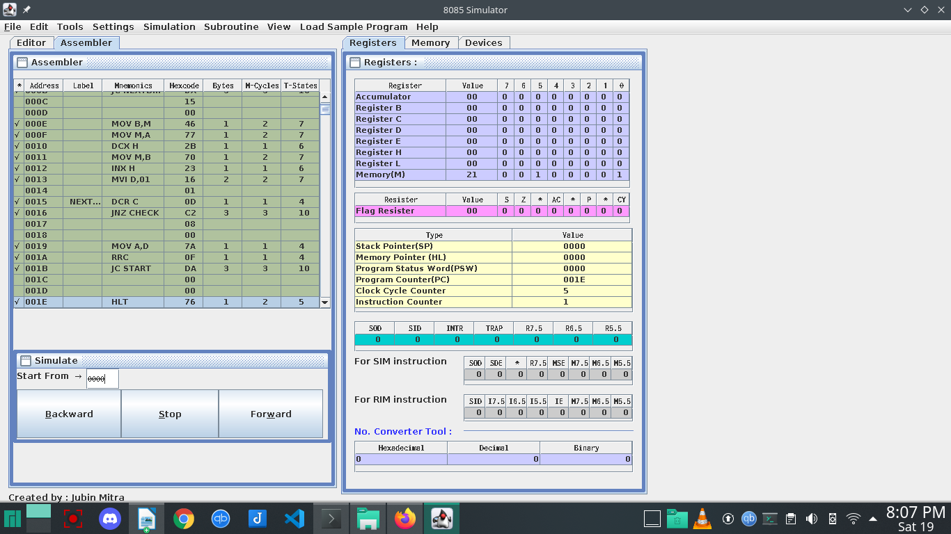
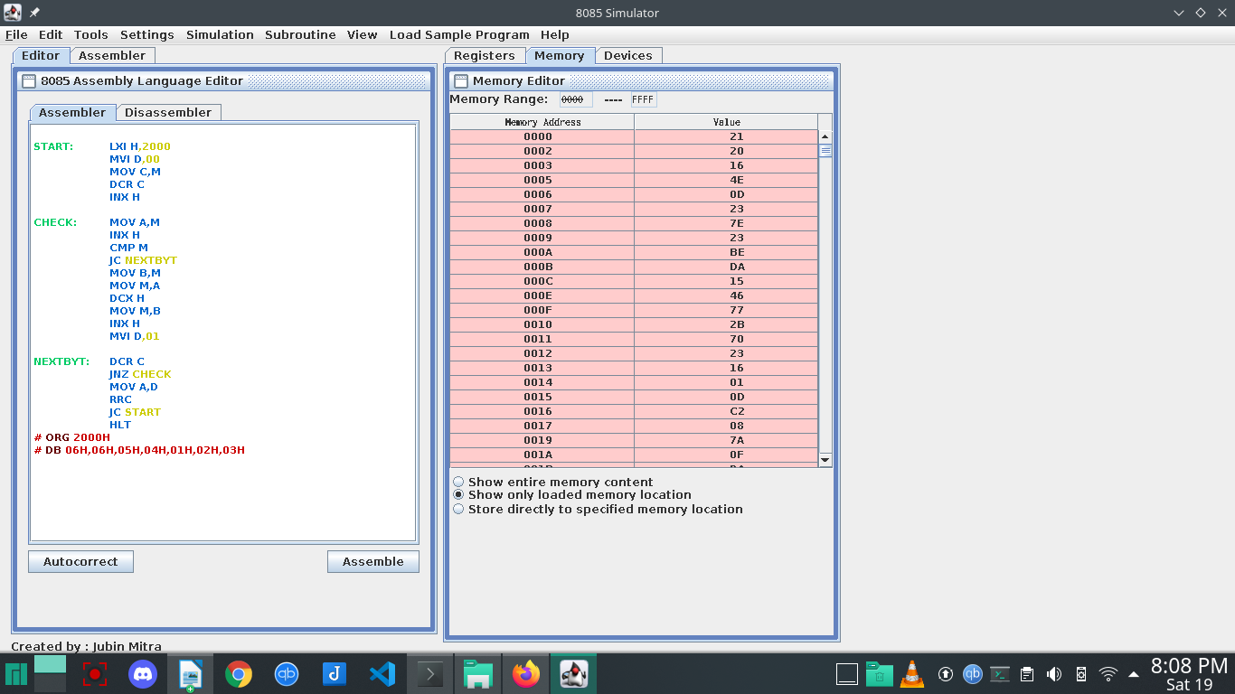
Question 2:

START: LXI H,2000
MVI D,00
MOV C,M
DCR C
INX H

CHECK: MOV A,M
INX H
CMP M
JNC NEXTBYT
MOV B,M
MOV M,A
DCX H
MOV M,B
INX H
MVI D,01

NEXTBYT: DCR C
JNZ CHECK
MOV A,D
RRC
JC START
HLT
# ORG 2000H
# DB 06H,06H,05H,04H,01H,02H,03H
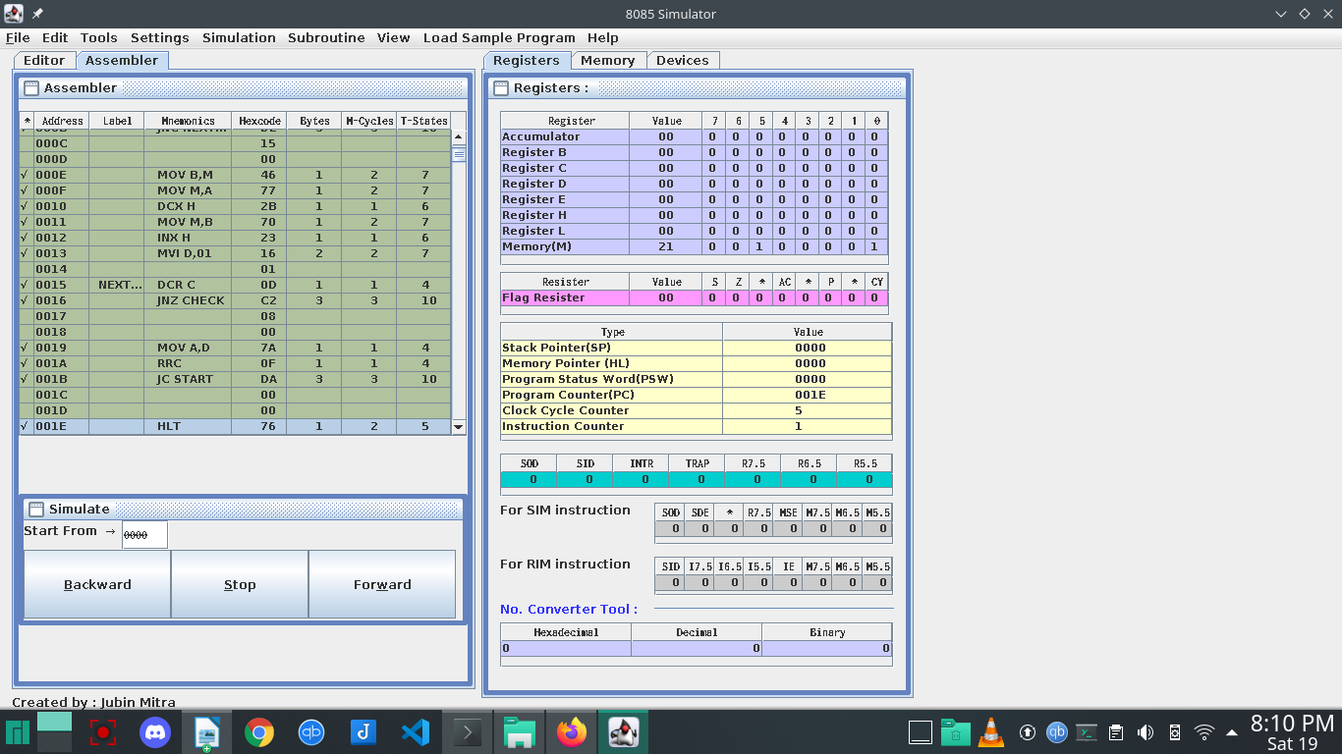
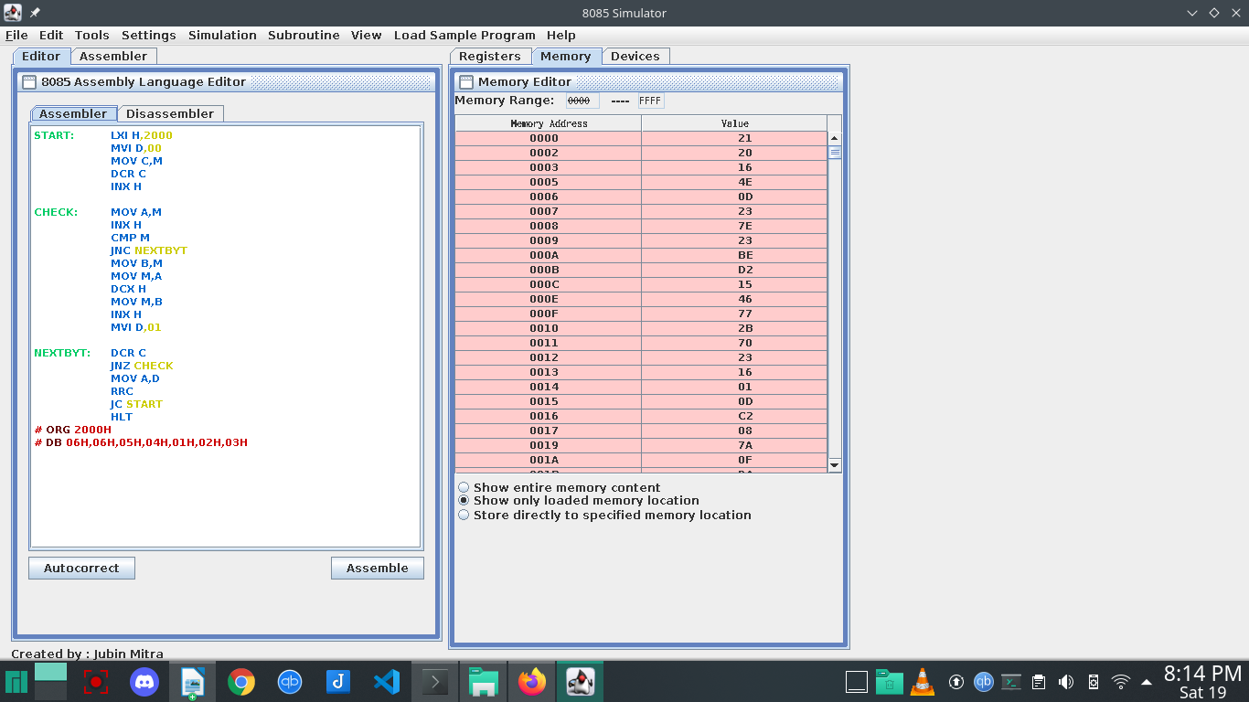
Question 3:

LXI H,2200
LXI D,2300
MVI C,32

BACK: MOV A,M
ANI 01
JNZ SKIP
MOV A,M
STAX D
INX D

SKIP: INX H
DCR C
JNZ BACK
HLT
# ORG 2200H
# DB 06H,06H,05H,04H,01H,02H,03H,08H,07H,09H
