Wireframe Documentation

Expenditure Data Analysis

|  |  |
| --- | --- |
| **Written By** | Ujjawal Jani |
| **Document Version** | 1.1 |
| **Last Revised Date** |  |

Homepage

As per the problem statement we have created a single dashboard which shows all the measures of economy of a state along with its annual distribution.

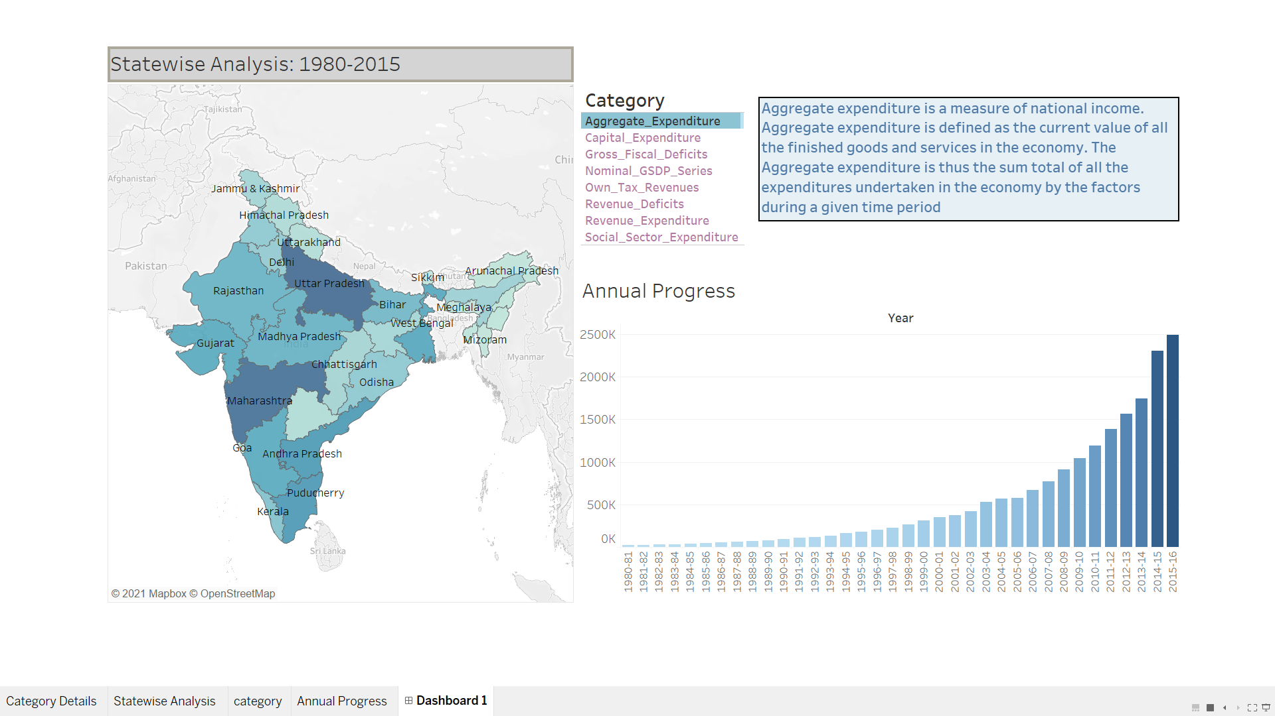

The Dashboard is divided into 4 sections:

1. State wise Expenditure

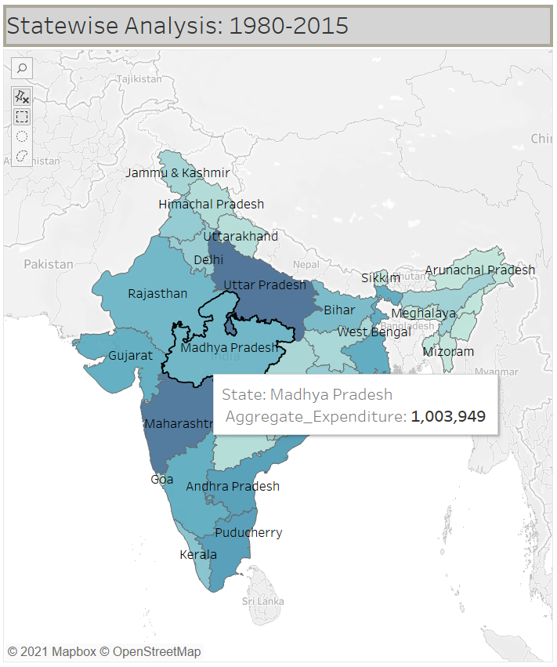

This Map shows Value of selected measure on hovering over states.

Also, the color of states ranging from lighter to dark represents total measure value as a sum. Such that color depends to the value of measure.

1. Select Category

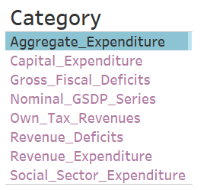

This section helps to choose between various economic measures. Selecting any one measure will lead to changes in color of map and Annual progress chart.

1. Category Description

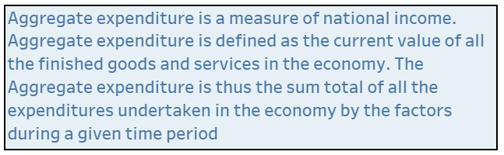

This section will provide a short description of the selected measure. This will help viewers to gain a knowledge about each factors.

1. Annual Progress

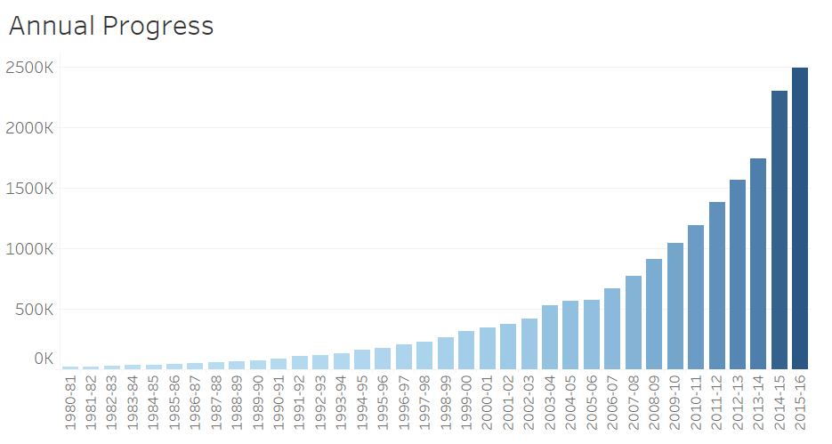This section will provide an insight about the growth of each factor every year.

Demonstration of using Filters:

1. Using Category as a filter

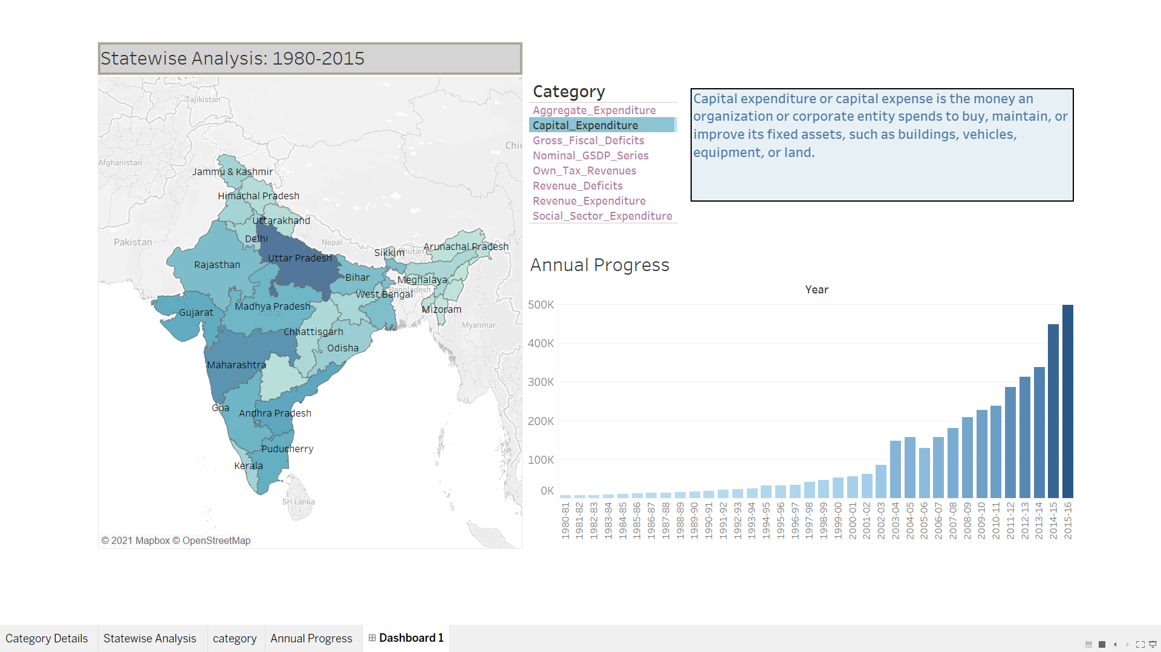

Here, Capital Expenditure is selected. Now color of states and the progress chart are filters for just one category.

1. Using State as a filter.

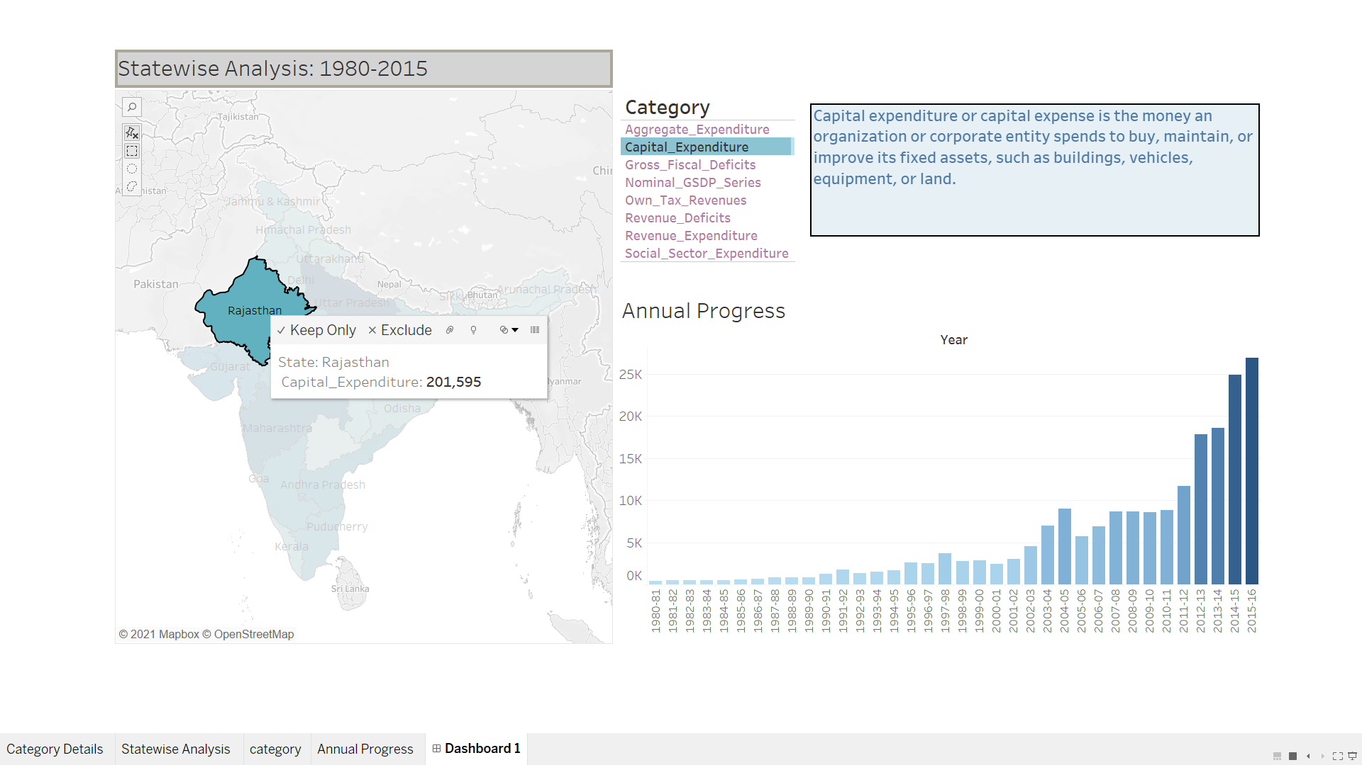

As category is still selected, we can choose just one state for which we want the insights.