Low Level Design
Expenditure Data Analysis

Written By | Ujjawal Jani
Document Version | 1.1
Last Revised Date

Contents

1 Introduction…………………………………………………………………………………………………………03

1.1 What is Low-Level Design Document? …………………………………………………..03
1.2 Scope ……………………………………………………………………………………………………03

2 Architecture ………………………………………………………………………………………………………. 04

3 Architecture Description ……………………………………………………………………………………. 06

3.1 Data Description ………………………………………………………………………………….. 06
3.2 Web Scrapping …………………………………………………………………………………….. 07
3.3 Data Preparation …………………………………………………………………………………. 08
3.4 Data cleaning ……………………..……………………………………………………………..... 13
3.5 Connection with Tableau …...……………………………………………………………….. 14
3.6 Deployment …………………………………………………………………………………………. 14

1. Introduction

1.1 What is Low-Level design document?
The goal of the LDD or Low-level design document (LLDD) is to give the internal logic design of the actual program code for the Expenditure Data Analysis dashboard. LDD describes the class diagrams with the methods and relations between classes and programs specs. It describes the modules so that the programmer can directly code the program from the document.

1.2 Scope
Low-level design (LLD) is a component-level design process that follows a step-by-step refinement process. The process can be used for designing data structures, required software architecture, source code and ultimately, performance algorithms. Overall, the data organization may be defined during requirement analysis and then refined during data design work.

2. Architecture

Tableau Server Architecture

Tableau has a highly scalable, n-tier client-server architecture that serves mobile clients, web clients and desktop-installed software. Tableau Server architecture supports fast and flexible deployments.

The following diagram shows Tableau Server’s architecture:
Tableau Server is internally managed by the multiple server processes.
1] Gateway/Load Balancer
It acts as an Entry gate to the Tableau Server and also balances the load to the Server if multiple Processes are configured.
2) Application Server
Application Server processes (wgserver.exe) handle browsing and permissions for the Tableau Server web and mobile interfaces. When a user opens a view in a client device, that user starts a session on Tableau Server. This means that an Application Server thread starts and checks the permissions for that user and that view.
3) Repository
Tableau Server Repository is a PostgreSQL database that stores server data. This data includes information about Tableau Server users, groups and group assignments, permissions, projects, data sources, and extract metadata and refresh information.
4) VIZQL Server
Once a view is opened, the client sends a request to the VizQL process (vizqlserver.exe). The VizQL process then sends queries directly to the data source, returning a result set that is rendered as images and presented to the user. Each VizQL Server has its own cache that can be shared across multiple users
5) Data Engine
It Stores data extracts and answers queries.
6) Backgrounder
The backgrounder Executes server tasks which includes refreshes scheduled extracts, tasks initiated from tab cmd and manages other background tasks.
7) Data Server
Data Server Manages connections to Tableau Server data sources
It also maintains metadata from Tableau Desktop, such as calculations, definitions, and groups.

3. Architecture Description

3.1. Data Description
The Dataset contains year wise distribution of all the states of India for the following parameters:
- Aggregate Expenditure:
Aggregate expenditure is a measure of national income. Aggregate expenditure is defined as the current value of all the finished goods and services in the economy. The Aggregate expenditure is thus the sum total of all the expenditures undertaken in the economy by the factors during a given time period
- Capital Expenditure:
Capital expenditure or capital expense is the money an organization or corporate entity spends to buy, maintain, or improve its fixed assets, such as buildings, vehicles, equipment, or land.
- Gross Fiscal Deficits:
The gross fiscal deficit (GFD) is the excess of total expenditure including loans net of recovery over revenue receipts (including external grants) and non-debt capital receipts. Generally fiscal deficit takes place either due to revenue deficit or a major hike in capital expenditure.
- Nominal GDP Series:
Nominal GDP is an assessment of economic production in an economy that includes current prices in its calculation. In other words, it doesn't strip out inflation or the pace of rising prices, which can inflate the growth figure.
- Own Tax Revenues:
The income generated by states for various activities include revenue receipts like taxes & grants and capital receipts like loans. States which are able to generate more revenue on their own are less dependent on the devolution & central grants.
- Revenue Deficits:
A revenue deficit occurs when realized net income is less than the projected net income. This happens when the actual amount of revenue and/or the actual amount of expenditures do not correspond with budgeted revenue and expenditures.
- Revenue Expenditure:
Revenue expenditures are short-term expenses used in the current period or typically within one year. Revenue expenditures include the expenses required to meet the ongoing operational costs of running a business, and thus are essentially the same as operating expenses (OPEX).
- Social Sector Expenditure:
Social sector expenditure has been defined as the total of all expenditures incurred by the central and the state governments on promotional and protective measures.

3.2. Web Scrapping

Web scraping is a technique to automatically extract content and data from websites using bots. It is also known as web data extraction or web harvesting. Web scrapping is made simple now days, many tools are used for web scrapping. Some of python libraries used for web scrapping are Beautiful Soup, Scrapy, Selenium, etc.

3.3. Data Preparation

In the Preparation Process, we will convert our original datasets with other necessary attributes format. And will merge it with the Scrapped dataset.
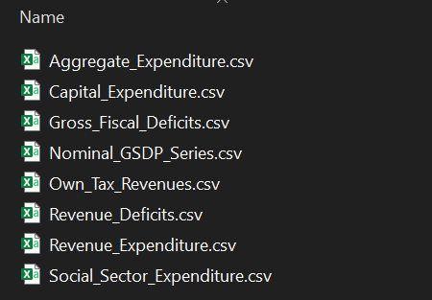
All the 8 datasets are of same format as shown below:
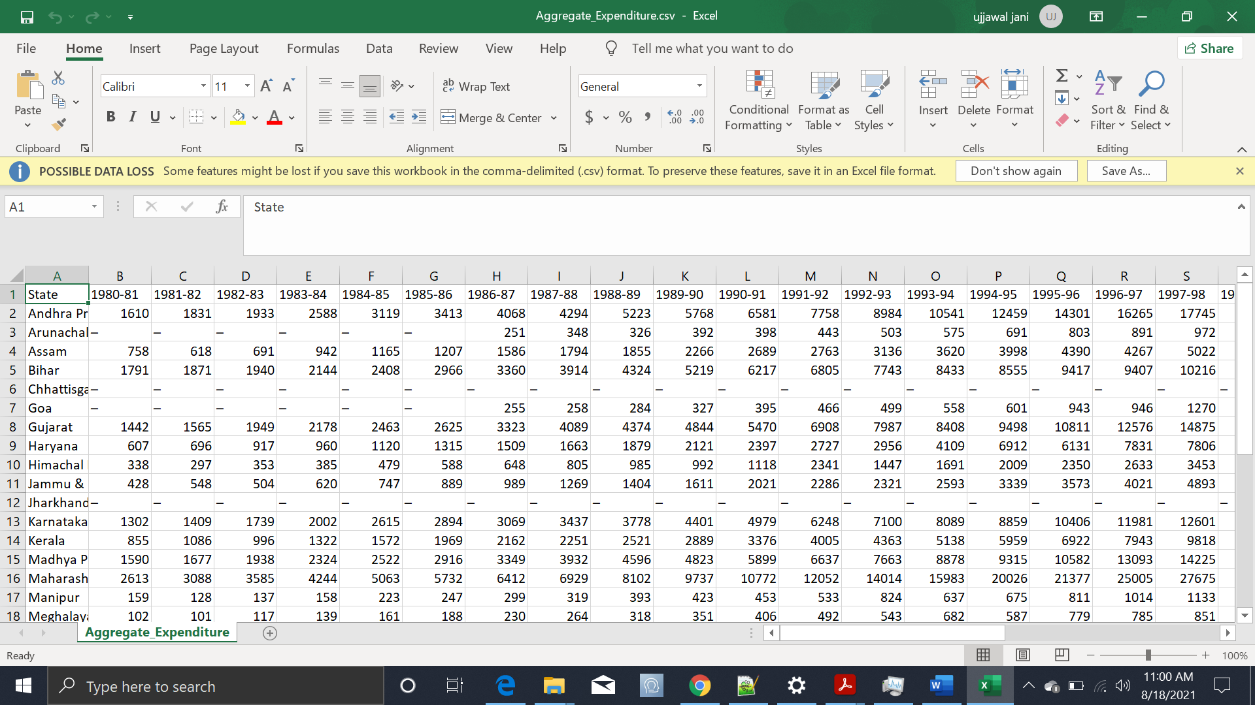
As you all can notice that format of the data we have is not good to analyze and visualize. So, we need to reconstruct the structure of the dataset.
As this is a pivoted data set, we need to unpivot it. That’s the only way by which we can make meaningful insights from it. This process is know as converting wide data to long data.
We will be using only MS Excel for data restructuring and cleaning purpose.

Step 1) Select all rows and columns.
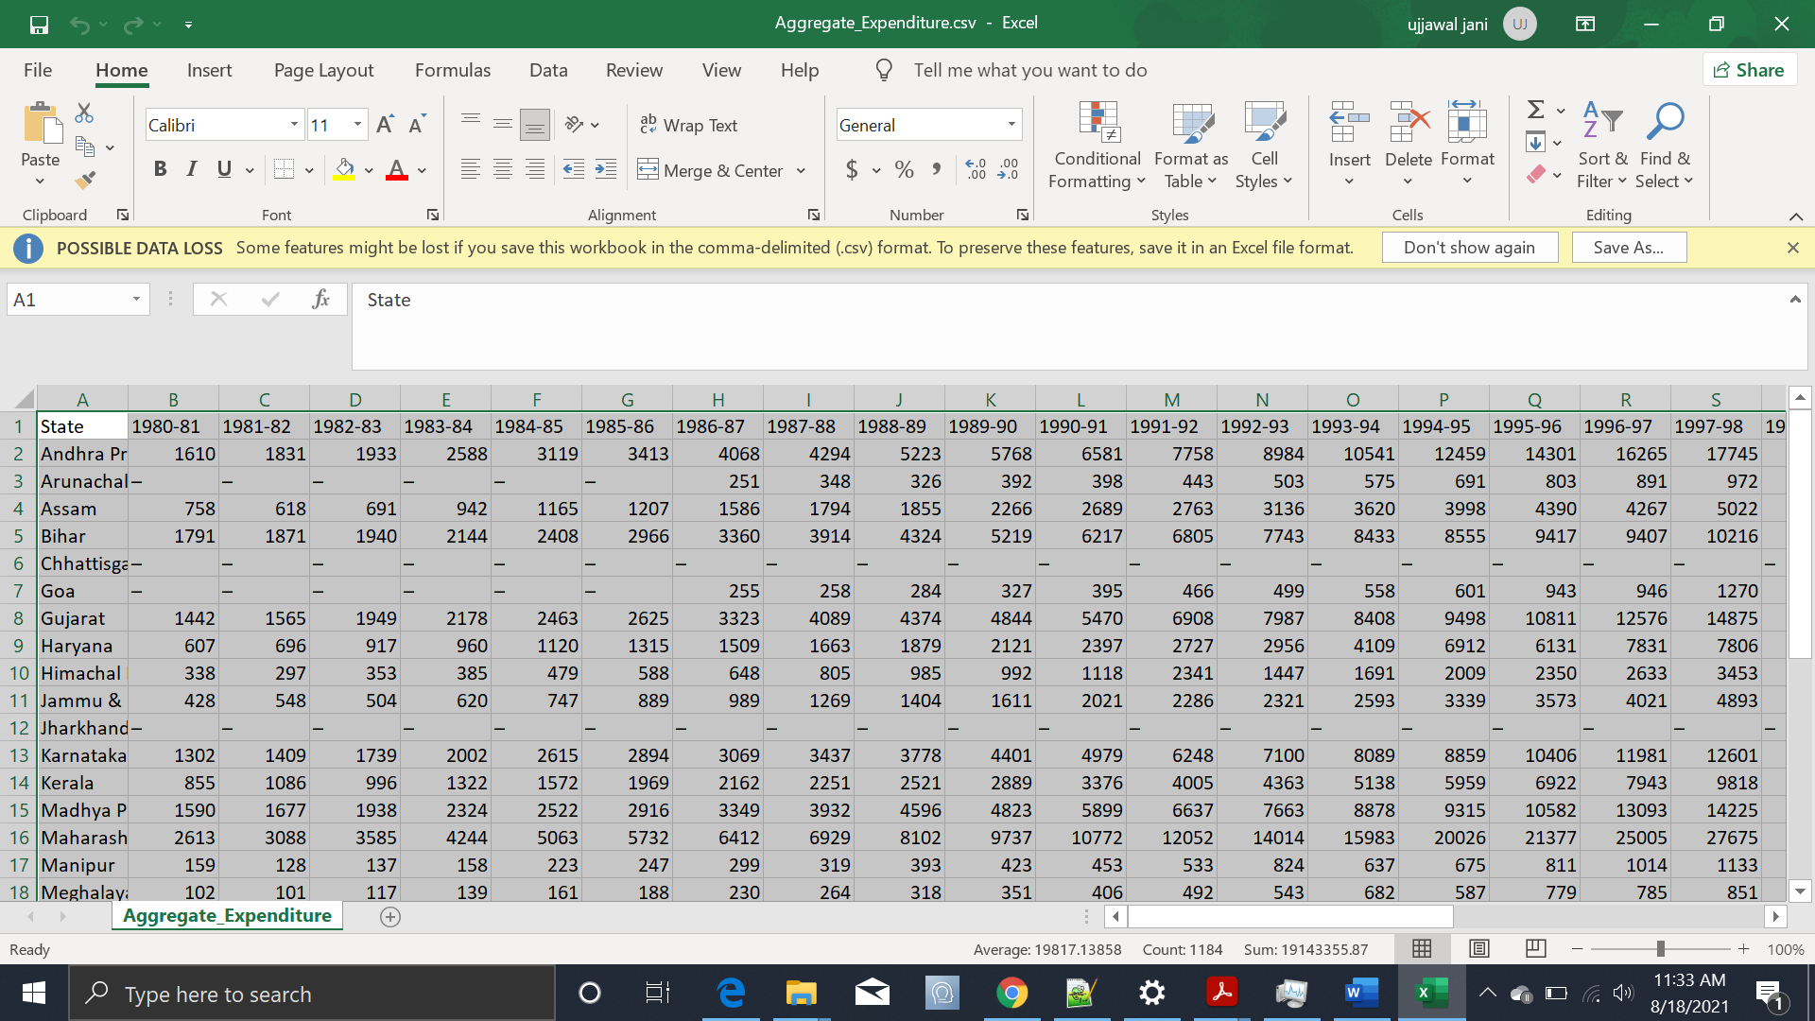
Step 2) Go to data section: click From Table/Range: then click OK.
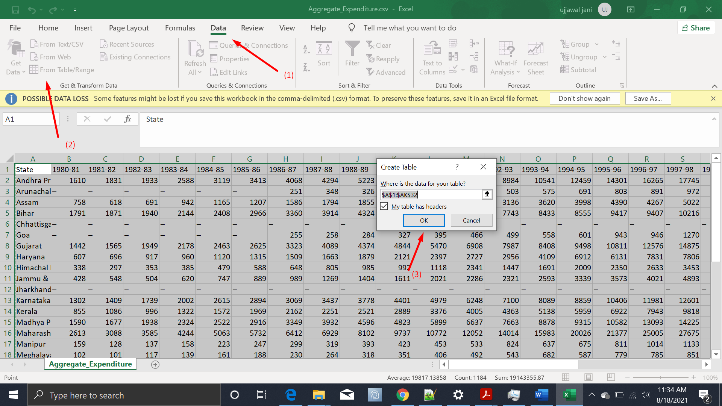

Then a Power Query Editor window will get popped up.
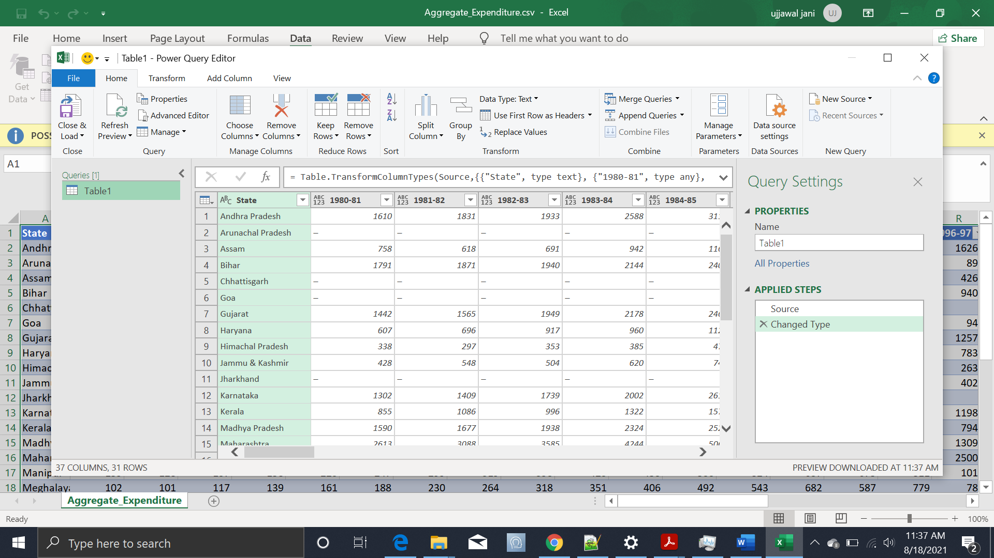
Step 3) Select all the columns(i.e. all the years columns) that we have to unpivot.
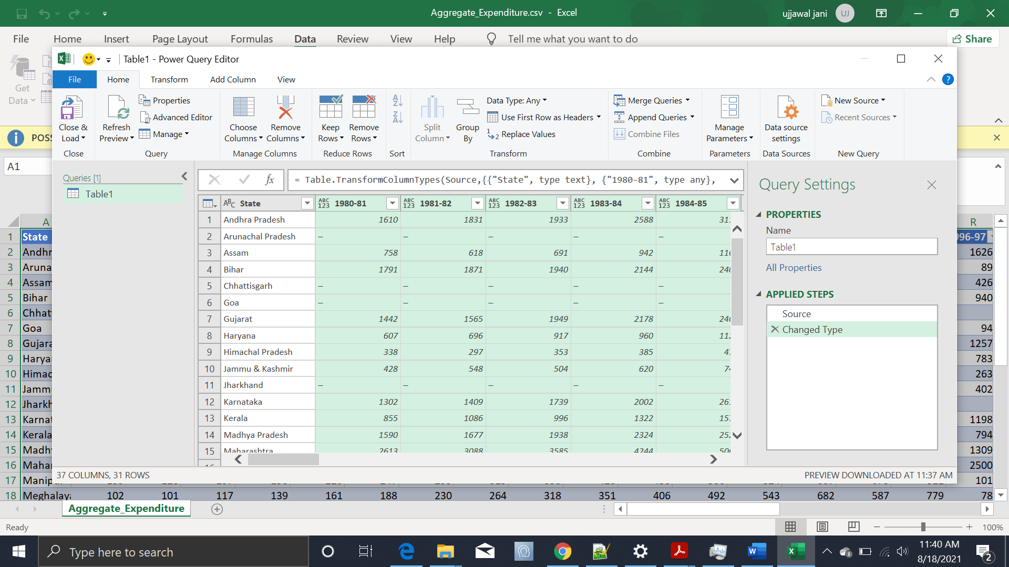

Step 4) Go to transform section and click unpivot columns.
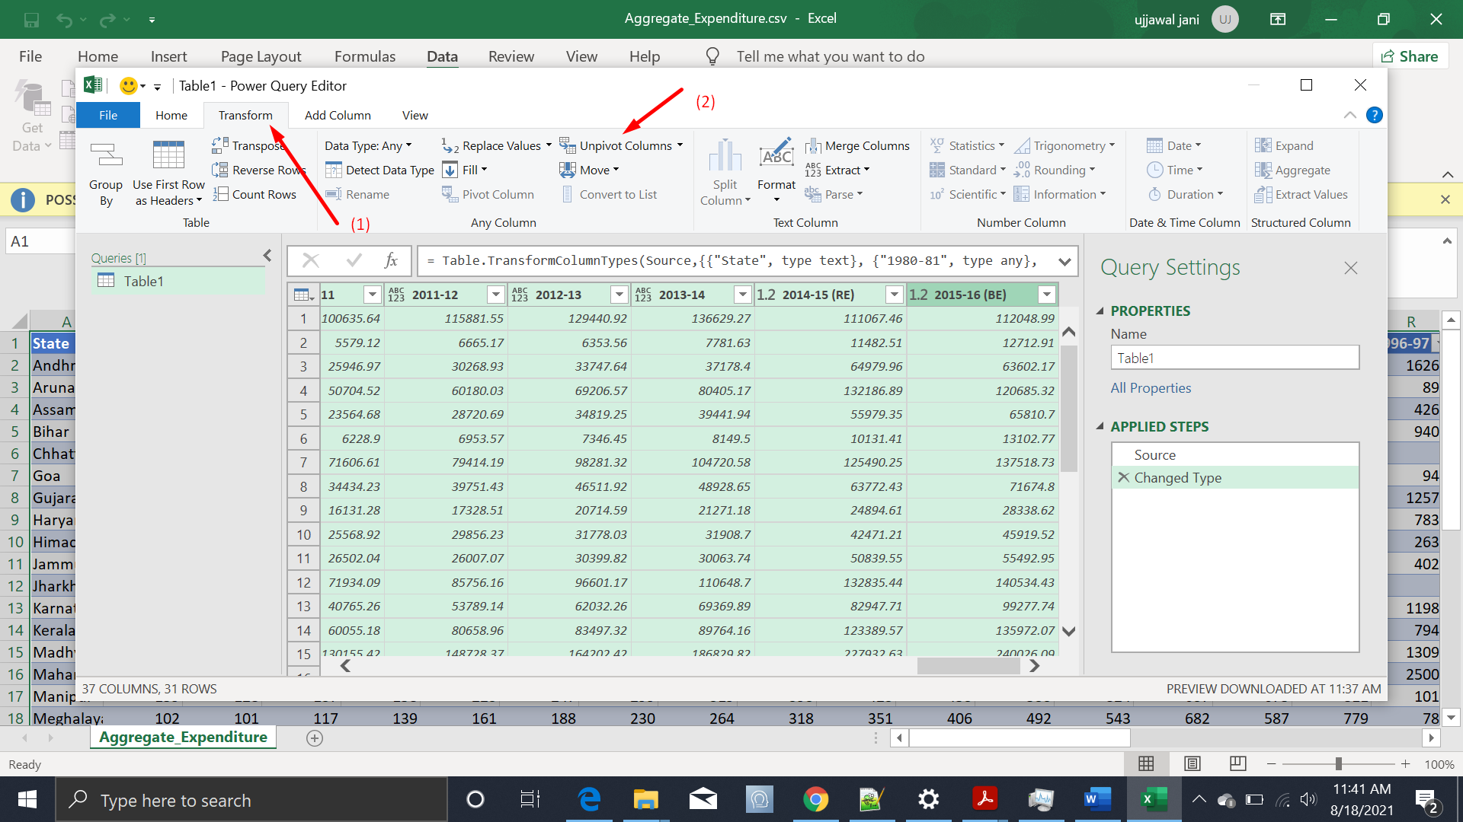
Now an unpivoted dataset will be shown, change column name of attribute to year.
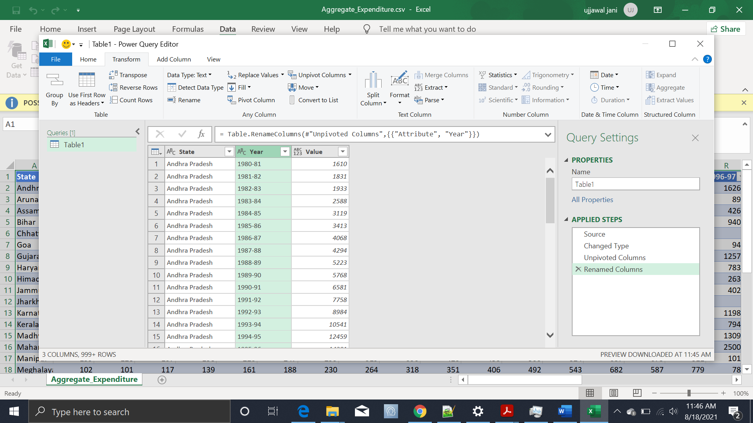

Step 5) Now go to home section and click close and load.
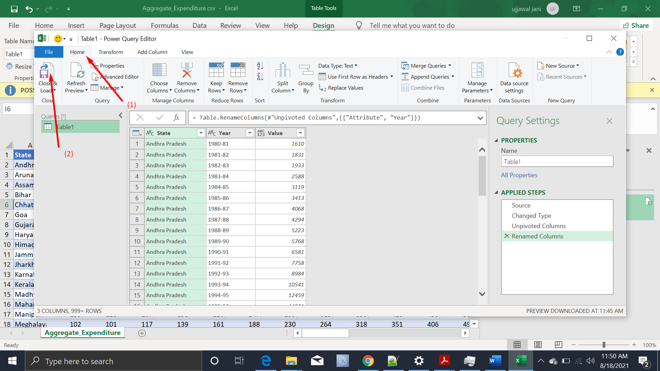
Now another table has been created with unpivoted columns.
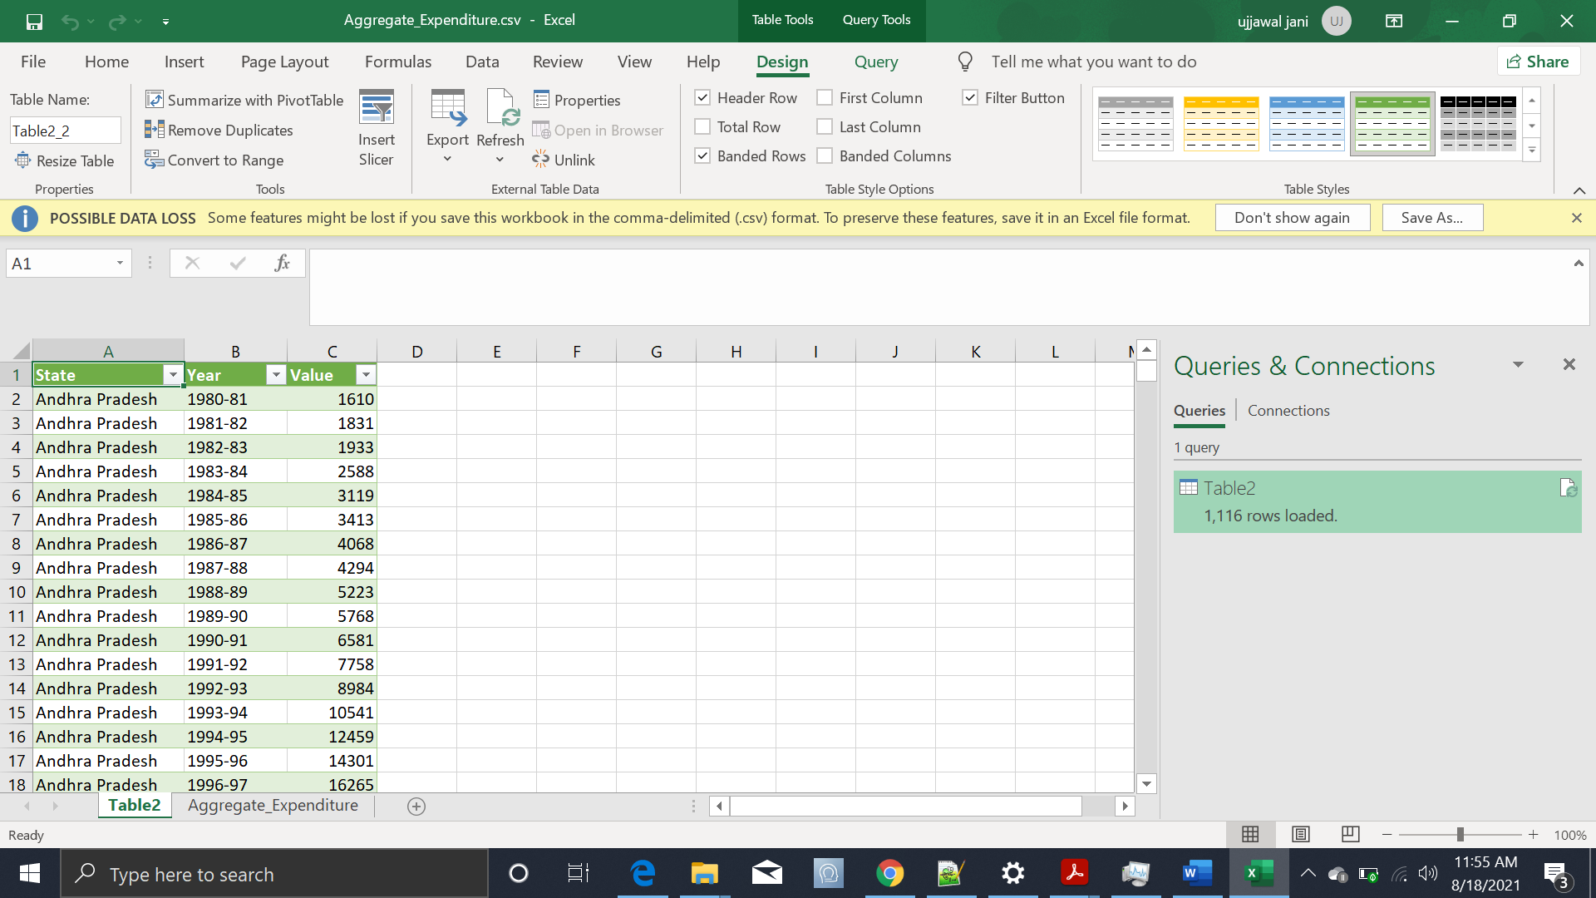
Now we need to all these steps for all the datasets we have.

We can even combine all the datasets by having a column which specifies the dataset name.
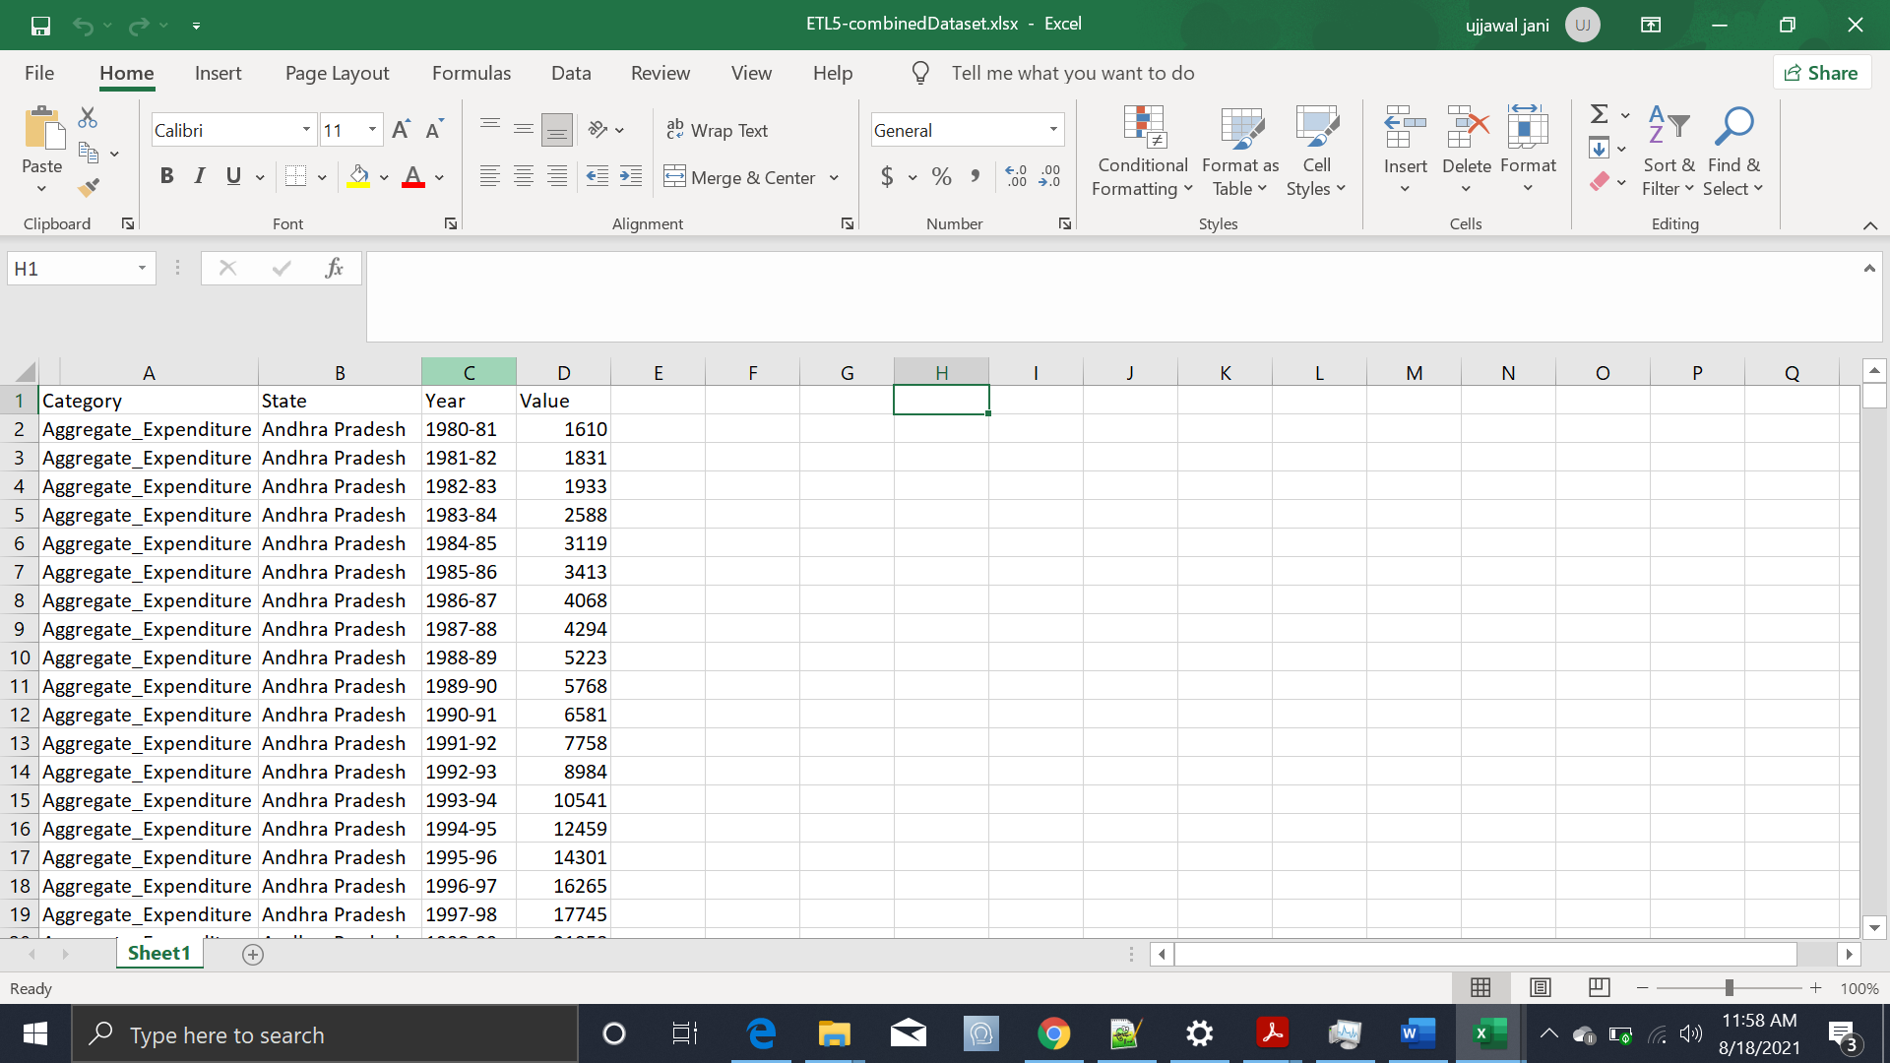
Thus, we have restructured and combined all the datasets into one file. This way we can visualize using filters of category, state or year.

3.4 Data Cleaning.

The data we have contains blank or “-” values. We have to fill them with Zero(0) to make values column a proper numerical column.
In Excel we can do that by selecting the whole column,
- Click on “Find and select” and then “Find” to replace all “-” values with “0”.
- Click on “Find and select” and then “Go To Special” to replace all Blanks with “0”.
Next, In the years column some data points have extra text. To remove them, we can create a new column with formula “=Right(C2,7)” and apply it for whole column to select only year range from Years column and replace it with original Years column.

3.5 Make the MS Excel connection and set up the data source

Step 1: Configuring Tableau
- After you open Tableau, under Connect, click Excel.
- Select the Excel workbook you want to connect to, and then click Open.
- On the Data Source page, click the sheet tab to start your analysis.

  - Deployment.

- Once you’ve completed your dashboard, follow these steps: Server, Tableau Public, Save to Tableau Public As
- You may be prompted to log into your Tableau Public profile first if this is your first-time publishing.

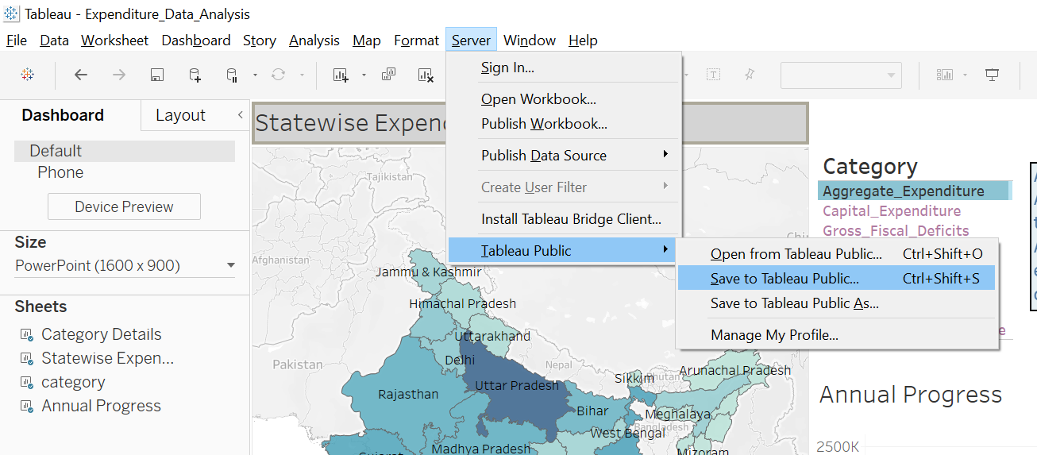
- Next, fill out the title you want your viz to have and click “save”.
- Here in the below screenshot, we can see that out workbook has been published to tableau public.
