Project Overview

The aim of the project was to develop a web application that allows users to create, read, update, and delete data through a RESTful API. The application was designed to have a front-end interface that communicates with the backend API using AJAX.

# POSTGRESQL DB

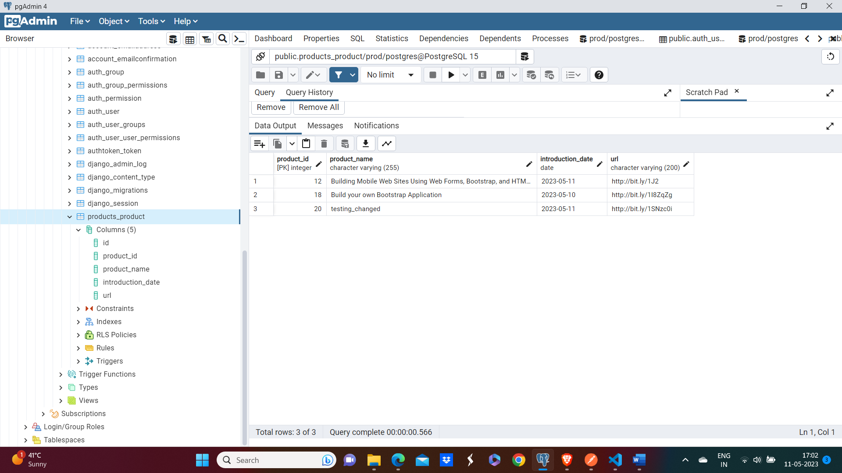

# Django Server

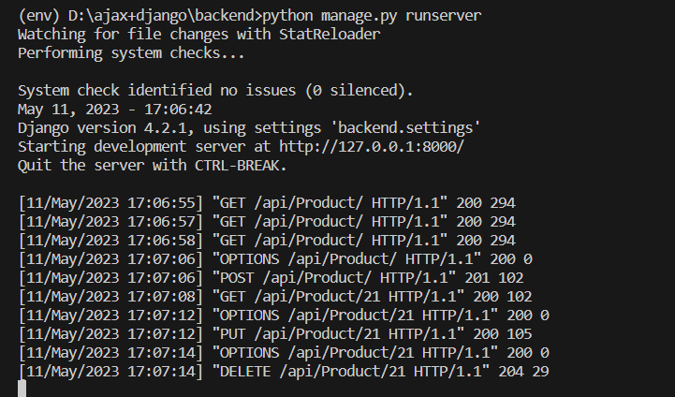

# API testing on POSTMAN

1. Getting all the products

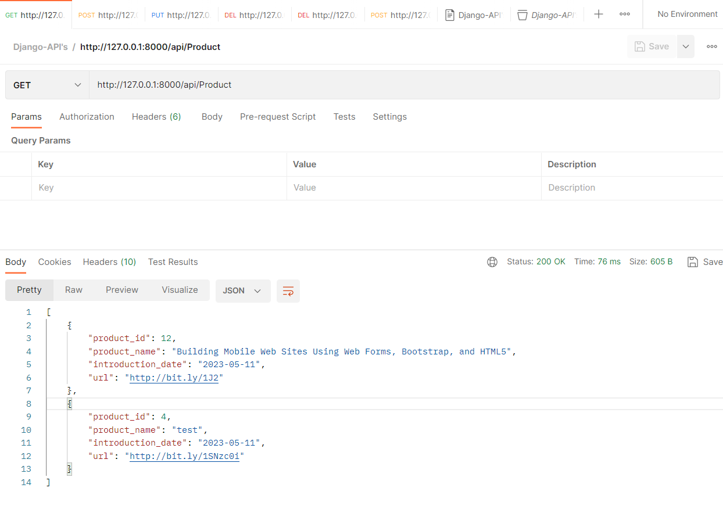

1. Adding a new product

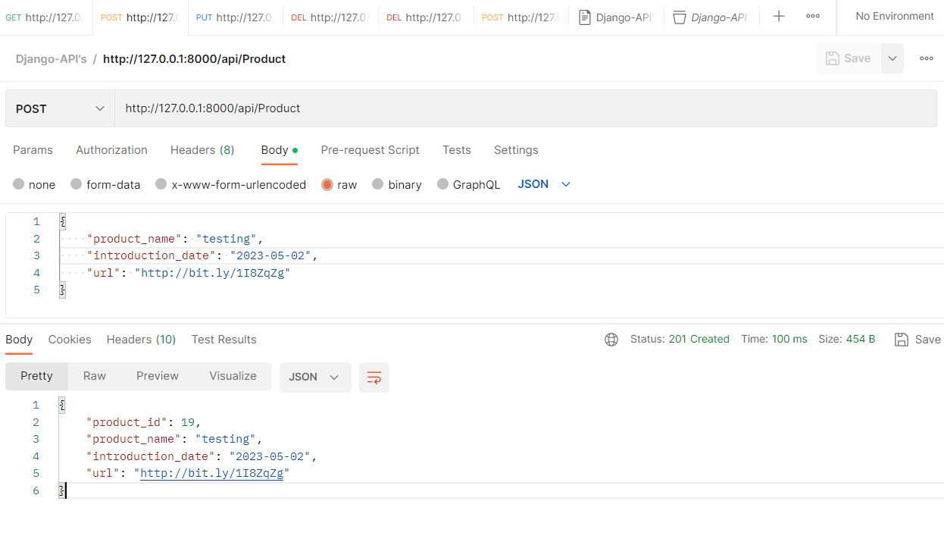

1. Updating the details of an already existing product

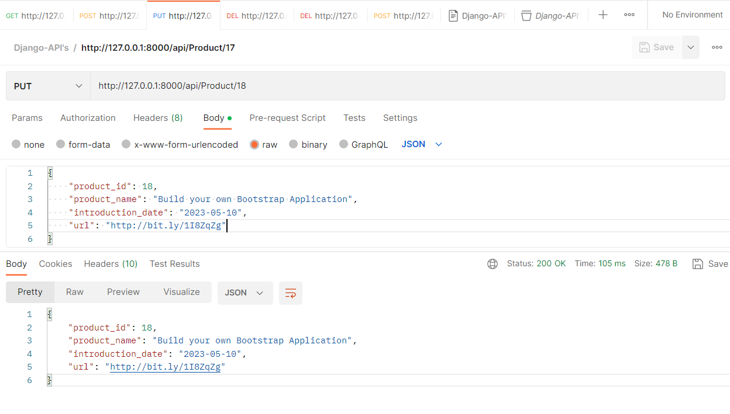

1. Deleting a product

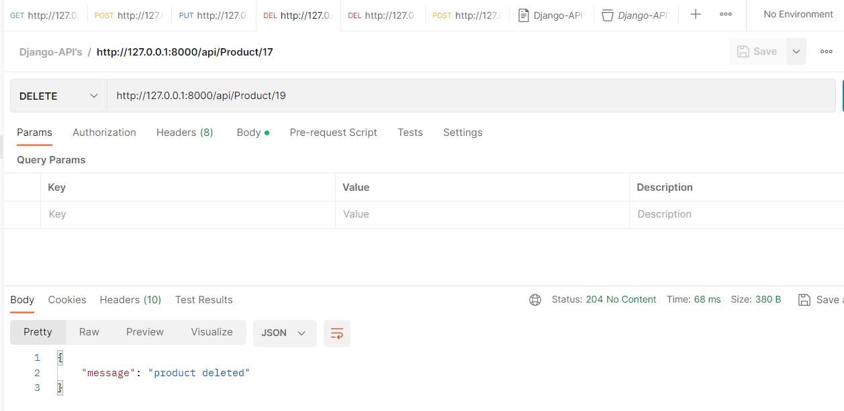

1. Showing error on trying to delete a non-existing product

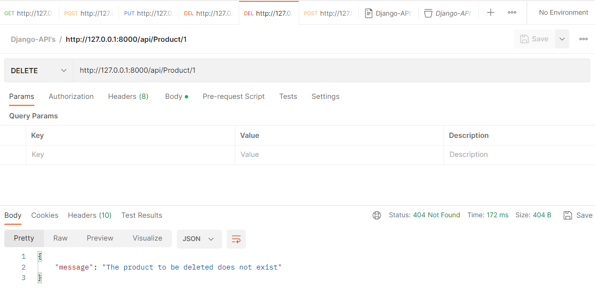

# Doing CRUD operations on a frontend

1. Adding a new product

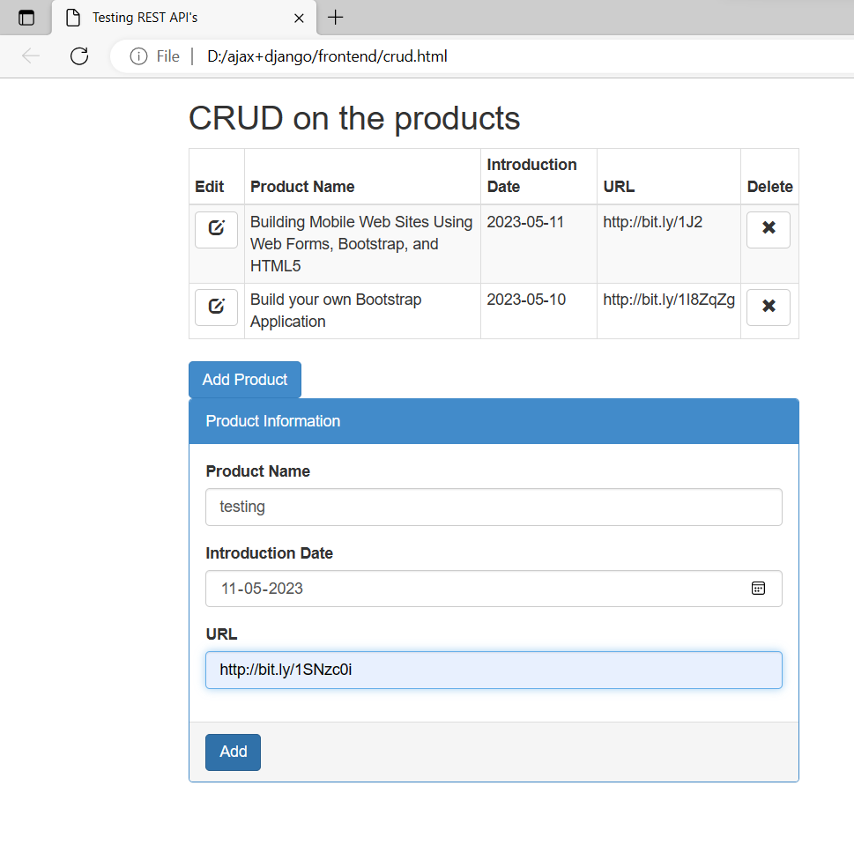

1. Editing an existing product.

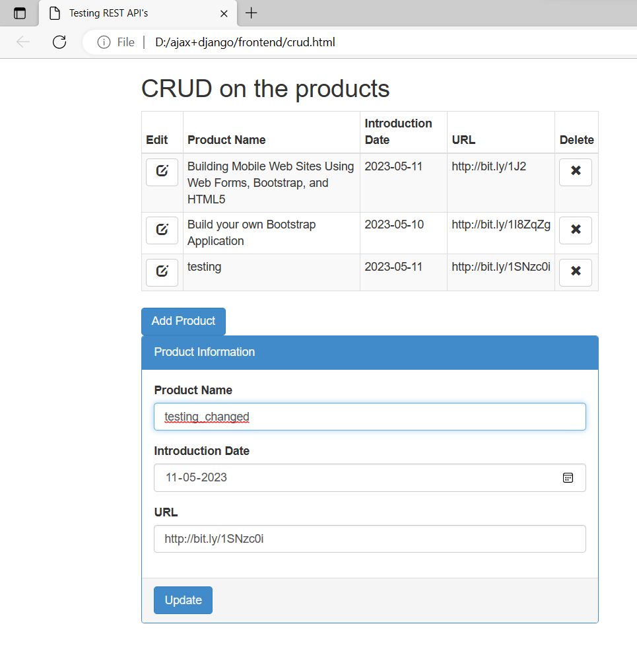

1. Deleting the product

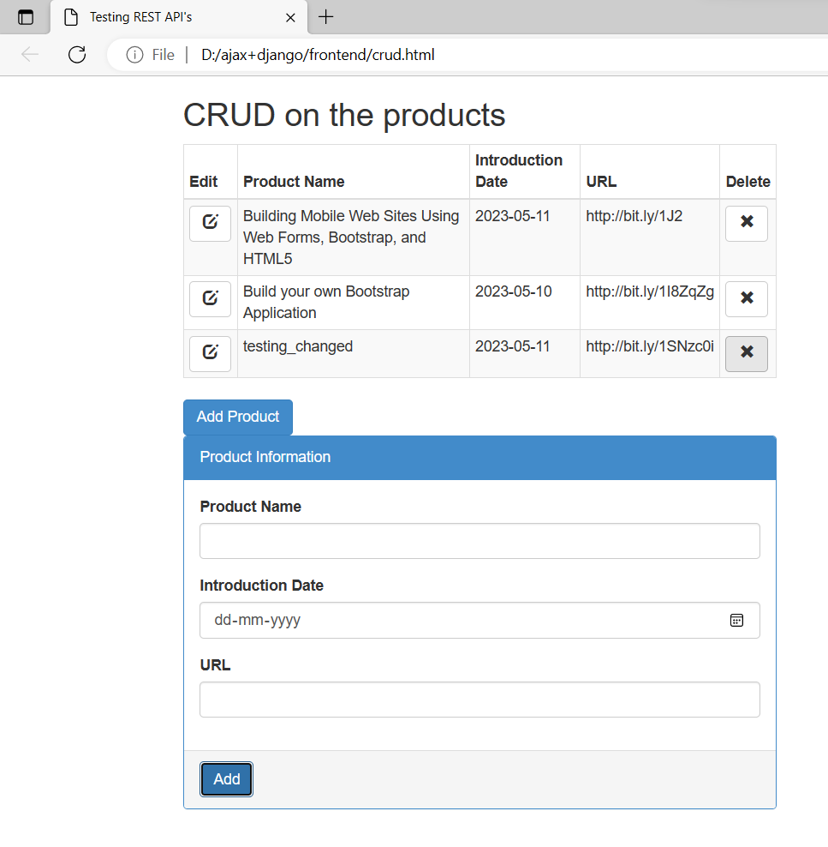

1. 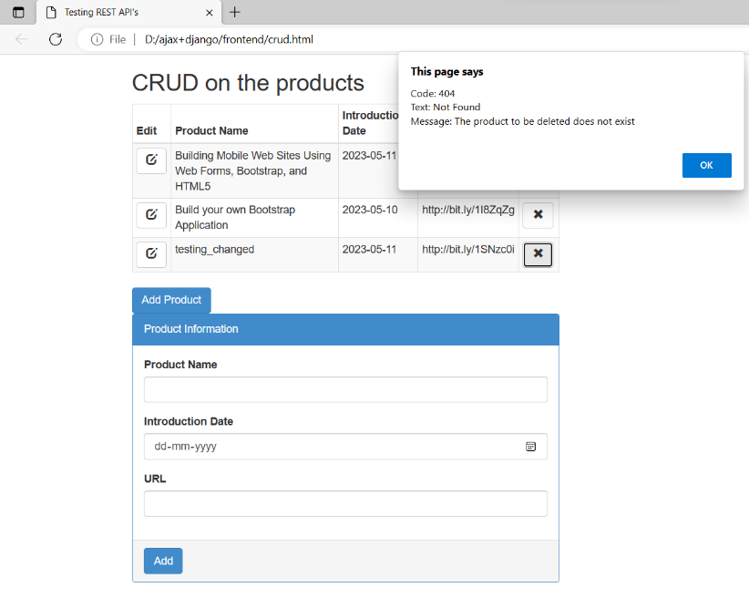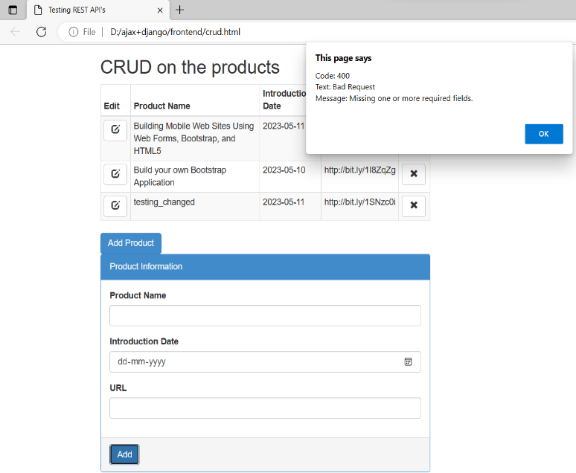Showing error messages on the alert box through error handling.

# Challenges faced

1. During the post request from the frontend duplicate products were getting created having the same product_id attribute but then during the put/delete request it was not able to uniquely delete a product since multiple products were there with same product_id.

Solution :- I made the product_id as the primary key and an automatically incrementing field

so that it would be automatically assigned uniquely for a newly posted product and now the user would not need to give the product an id while trying to make a post request.

1. I was getting the below error

“RuntimeError: You called this URL via PUT, but the URL doesn't end in a slash and you have APPEND_SLASH set. Django can't redirect to the slash URL while maintaining PUT data. Change your form to point to 127.0.0.1:8000/api/Product/8/ (note the trailing slash), or set APPEND_SLASH=False in your Django settings”

Since there was no matching in my url , a slash was getting appended to match for the url and thus this error was coming.

Solution:- I resolved this error by changing the url pattern to match both api/Product/8/ and api/Product/8 type of urls.