5. Multi stage Jenkins pipeline

* Pipeline code fetched from GIT using pipeline script suing scm option
* Approval stage added before deployment for each stage

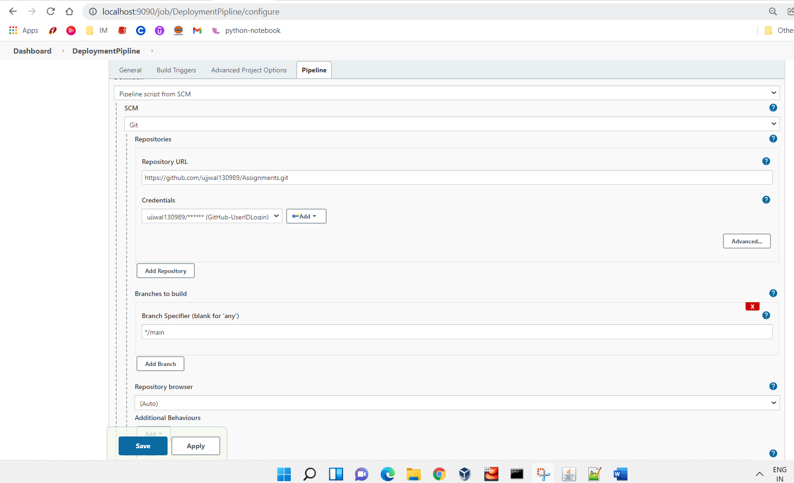

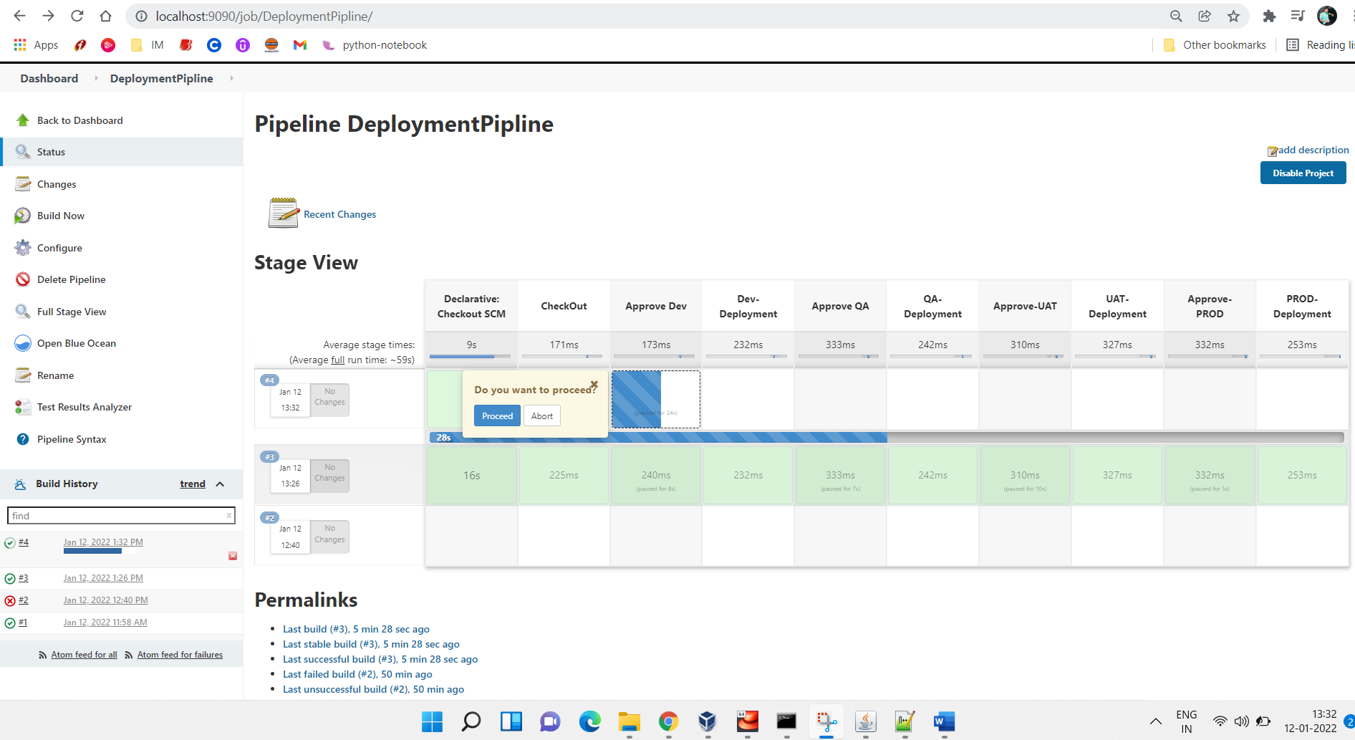

##PipeLine Code##

pipeline {

agent any

stages {

stage('CheckOut') {

steps {

echo 'Code CheckOut step'

}

}

stage('Approve Dev') {

steps {

input('Do you want to proceed?')

}

}

stage('Dev-Deployment') {

steps {

echo 'Dev deployment'

}

}

stage('Approve QA') {

steps {

input('Do you want to proceed?')

}

}

stage('QA-Deployment') {

steps {

echo 'QA deployment'

}

}

stage('Approve-UAT') {

steps {

input('Do you want to proceed?')

}

}

stage('UAT-Deployment') {

steps {

echo 'UAT deployment'

}

}

stage('Approve-PROD') {

steps {

input('Do you want to proceed?')

}

}

stage('PROD-Deployment') {

steps {

echo 'Prod deployment'

}

}

}

}

**Install Docker on Centos7**

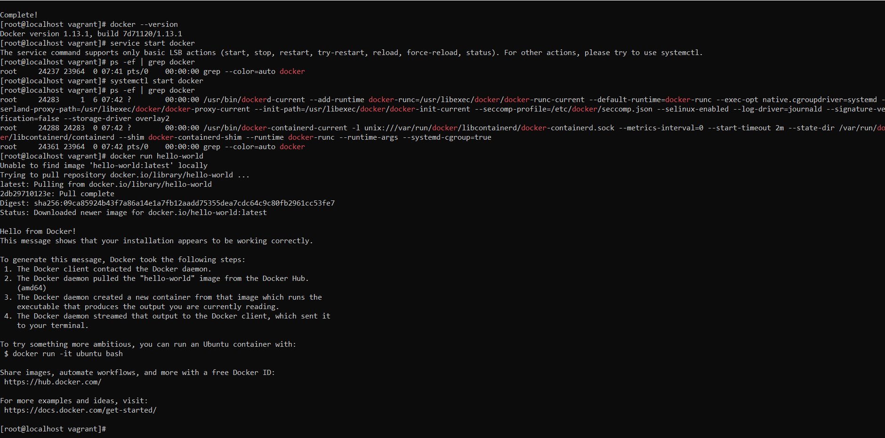

**Schedule job to run every 5 hours**

