**DAY 1 Assignments(11-01-2021)**

1. Select employee_id, concat(first_name,last_name) as full_name, salary as basic_salary,(Salary*0.1) as HRA, (salary*0.05) as DA, (salary*0.07) as PF, (salary+ (Salary*0.1)+ (salary*0.05)-( salary*0.07)) as gross_salary from employees;
2. Select employee_name, salary, hire_date from employees where hire_date between ‘1990-01-01’ to ‘1995-05-05’.
3. **Using Where clause:**

select emp.first_name, dept.department_name, loc.city from employees emp, departments dept, locations loc where emp.department_id=dept.department_id and dept.location_id=loc.location_id;

**Using on clause:**

select emp.first_name, dept.department_name, loc.city from (employees emp join departments dept on emp.department_id=dept.department_id) join locations loc on dept.location_id=loc.location_id;

1. Display details of jobs where the minimum salary is greater than 10000.

select first_name, hire_date from employees where hire_date between 2002 and 2005;

1. Display first name and join date of the employees who is either IT Programmer or Sales Man.

select first_name, hire_date from employees where job_id in('IT_PROG','SA_MAN');

1. Display first name, salary, commission pct, and hire date for employees with salary less than 10000.

select first_name, hire_date,salary,commission_pct from employees where salary<10000;

1. Display employees where the first name or last name starts with S.

select first_name,last_name from employees where first_name like's%' or last_name like 's%';

1. Display details of the employees where commission percentage is null and salary in the range 5000 to 10000 and department is 30.

select * from employees where commission_pct is null and salary between 5000 and 10000 and department_id=30;

1. Display job title, employee ID, number of days between ending date and starting date for all jobs in department 30 from job history.

select j1.job_title, jh.employee_id, datediff(jh.end_date, jh.start_date) from jobs j1, job_history jh where j1.job_id= jh.job_id;

1. Display country name, city, and department name.

select con.country_name, loc.city, dept.department_name from countries con, locations loc, departments dept where con.country_id=loc.country_id and loc.location_id=dept.location_id;

1. Display employee name and country in which he is working.

select concat(first_name,' ', last_name) as employee_name, country_name from employees join departments using(department_id) join locations using(location_id) join countries using(country_id);

1. Display details of jobs where the minimum salary is greater than 10000.

select job_id, job_title from jobs where min_salary>10000;

1. Display job Title, the difference between minimum and maximum salaries for jobs with max salary in the range 10000 to 20000.

select job_id,(max_salary-min_salary) from jobs where max_salary between 10000 and 20000;

1. Display details of jobs in the descending order of the title.

select job_id, job_title from jobs order by job_title desc;

1. Display employees who joined in the month of May.

select concat(first_name,' ',last_name) as employee_name from employees where hire_date like '____-05-__%';

1. Display first name, salary, and round the salary to thousands.

select first_name,round(salary,-3) from employees;

1. Display first name and date of first salary of the employees.

select first_name,last_day(hire_date) from employees;

1. Display first name and experience of the employees.

select first_name, datediff(sysdate(),hire_date)/365 as experience from employees;

1. Display the length of first name for employees where last name contain character ‘b’ after 3rd position.

select length(first_name) from employees where last_name like '___b%';

1. Display first name in upper case and email address in lower case for employees where the first name and email address are same irrespective of the case.

select upper(first_name),lower(email) from employees where first_name=email;

1. Display the number of days between system date and 1st January 1995.

select datediff(sysdate(),'1995-01-01');

1. Display employee ID and the date on which he ended his previous job.

select employee_id,max(end_date) from job_history where employee_id in(select employee_id from job_history group by 1 having count(employee_id)>1) group by 1;

1. Display the country ID and number of cities we have in the country.

select country_id, count(*) from locations group by country_id;

1. Display average salary of employees in each department who have commission percentage.

select department_id,avg(salary) from employees where commission_pct is not null group by department_id;

1. Display job ID, number of employees, sum of salary, and difference between highest salary and lowest salary of the employees of the job.

select job_id, count(*), sum(salary),max(salary)-min(salary) from employees group by job_id;

1. Display job ID for jobs with average salary more than 10000.

select job_id from employees group by job_id having avg(salary)>10000;

1. Display years in which more than 10 employees joined.

select date_format(hire_date,'%y') from employees group by date_format(hire_date,'%y') having count(employee_id)>10;

1. Display departments in which more than five employees have commission percentage.

select department_name from departments where department_id=(select department_id from employees group by department_id having count(commission_pct)>5);

1. Display department name and number of employees in the department.

select department_name, count(*) from departments inner join employees on employees.department_id=departments.department_id group by departments.department_id, department_name order by department_name;

1. Display employee ID for employees who did more than one job in the past.

select employee_id from employees where employee_id not in(select employee_id from job_history);

**Day 2 Assignments(21/01/2021):**

1. Change salary of employee 115 to 8000 if the existing salary is less than 6000.

update employees set salary=8000 where employee_id=115 and salary<6000;

1. Insert a new employee into employees with all the required details.

insert into employees(employee_id,first_name,last_name,email,phone_int,hire_date,job_id,salary,department_id) values(207,'sam','levis','sam','216 235 1234',sysdate(),'sa_man',15000,50);

1. Change job ID of employee 110 to IT_PROG if the employee belongs to department 10 and the existing job ID does not start with IT.

update employees set job_id='IT_PROG' where employee_id=110 and department_id=10 and not job_id like 'IT%';

1. Insert a row into departments table with manager ID 120 and location ID in any location ID for city Tokyo.

insert into departments values(280,'sports',120,1200);

1. Display job title, employee ID, number of days between ending date and starting date for all jobs in department 30 from job history.

select job_title,employee_id,end_date-start_date from job_history join jobs where department_id=30;

1. Table ---> Customer

custId, firstName,lastName,age,city, mobileNumber, dob

Add the Constraints

custId is Primary Key

firstName not null

age must be greater than 21

mobile must be unique .

create table customer(custid int primary key,firstname varchar(10) not null,age int check(age>21),mobilenumber int unique,dob int);

1. Table ----> Branch

branchId, branchName, city

Add the Constraints

branchId is Primary Key

branchName not null

city not null.

create table branch(branchid int primary key,branchname varchar(10) not null,city int not null);

1. Table ----> Transaction

transactionId, transactionDate, MediumOfTransaction, TransactionAmount

Add the Constraints

transactionId is primary key.

create table transaction(tranid int primary key,trandate int,mediumoftran varchar(10),tranamount int);

1. Display details of departments managed by ‘John’.

select * from departments where manager_id in(select employee_id from employees where first_name='john');

1. Display employees who did not do any job in the past.

select * from employees where employee_id not in(select employee_id from job_history);

1. Display job title and average salary for employees who did a job in the past.

select job_title,avg(salary) from jobs natural join employees group by job_title where employee_id in(select employee_id from job_history);

1. Display country name, city, and number of departments where department has more than 5 employees.

select country_name,city,count(department_id) from countries join locations using(country_id) join departments using(location_id) where department_id in(select department_id from employees group by department_id having count(department_id)>5) group by country_name,city;

1. Display details of manager who manages more than 5 employees.

select first_name from employees where employee_id in(select manager_id from employees group by manager_id having count(*)>5);

1. Display details of current job for employees who worked as IT Programmers in the past.

select * from jobs where job_id in(select job_id from employees where employee_id in(select employee_id from job_history where job_id='IT_PROG'));

1. Display the details of employees drawing the highest salary in the department.

select * from employees where salary=(select max(salary) from employees);

1. Display third highest salary of all employees

select salary from employees order by salary desc limit 2,1;

**Day 3 Assignment(14/01/2021):**

**Assignment 2**

Take n number records through keyboards as Id,Name,Salary,Desg

(array id,name,salary,Desg).

Salary = salary + hra + da – pf;

Hra is 10% salary

Da is 7 % salary

Pf 5 % salary

If desg is manager desg.equals(“Developer”)

15% bonus

If developer 10% bonus

Else

5 % bonus

Id, name, salary( grossSalary +bonus ) and desg.

**Solution:**

import java.util.Scanner;

class Assignment2

{

public static void main(String args[])

{

Scanner sc=new Scanner(System.in);

System.out.println("Enter number of details you want to store:");

int n=sc.nextInt();

int []id= new int[n];

String []name=new String[n];

float []salary=new float[n];

String []desg=new String[n];

for(int i=0;i<n;i++)

{

System.out.println("Enter id of employee "+(i+1));

id[i]=sc.nextInt();

sc.nextLine();

System.out.println("Enter name of employee "+(i+1));

name[i]=sc.nextLine();

System.out.println("Enter salary of employee "+(i+1));

salary[i]=sc.nextFloat();

sc.nextLine();

System.out.println("Enter designation of employee "+(i+1));

desg[i]=sc.nextLine();

System.out.println("\n");

}

for(int k=0;k<n;k++)

{

float hra,da,pf;

hra=salary[k]*0.1f;

da=salary[k]*0.07f;

pf=salary[k]*0.05f;

if(desg[k].equals("manager"))

{

salary[k]=(salary[k]+hra+da-pf)+(salary[k]*0.15f);

System.out.println("\n");

System.out.println("Details of Employee:"+(k+1));

System.out.println("id="+id[k]);

System.out.println("Name="+name[k]);

System.out.println("Salary="+salary[k]);

System.out.println("Designation="+desg[k]);

}

else if(desg[k].equals("developer"))

{

salary[k]=(salary[k]+hra+da-pf)+(salary[k]*0.1f);

System.out.println("\n");

System.out.println("Details of Employee:"+(k+1));

System.out.println("id="+id[k]);

System.out.println("Name="+name[k]);

System.out.println("Salary="+salary[k]);

System.out.println("Designation="+desg[k]);

}

else

{

salary[k]=(salary[k]+hra+da-pf)+(salary[k]*0.05f);

System.out.println("\n");

System.out.println("Details of Employee:"+(k+1));

System.out.println("id="+id[k]);

System.out.println("Name="+name[k]);

System.out.println("Salary="+salary[k]);

System.out.println("Designation="+desg[k]);

}

}

}

}

Output:

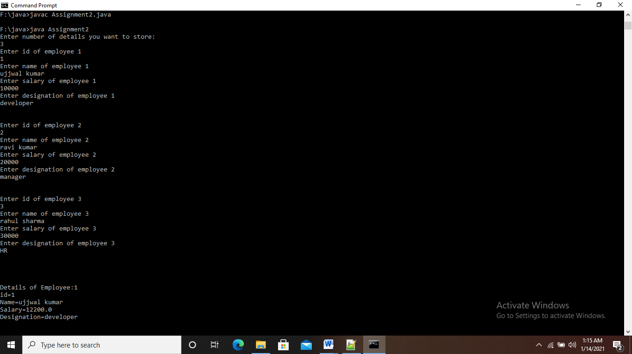

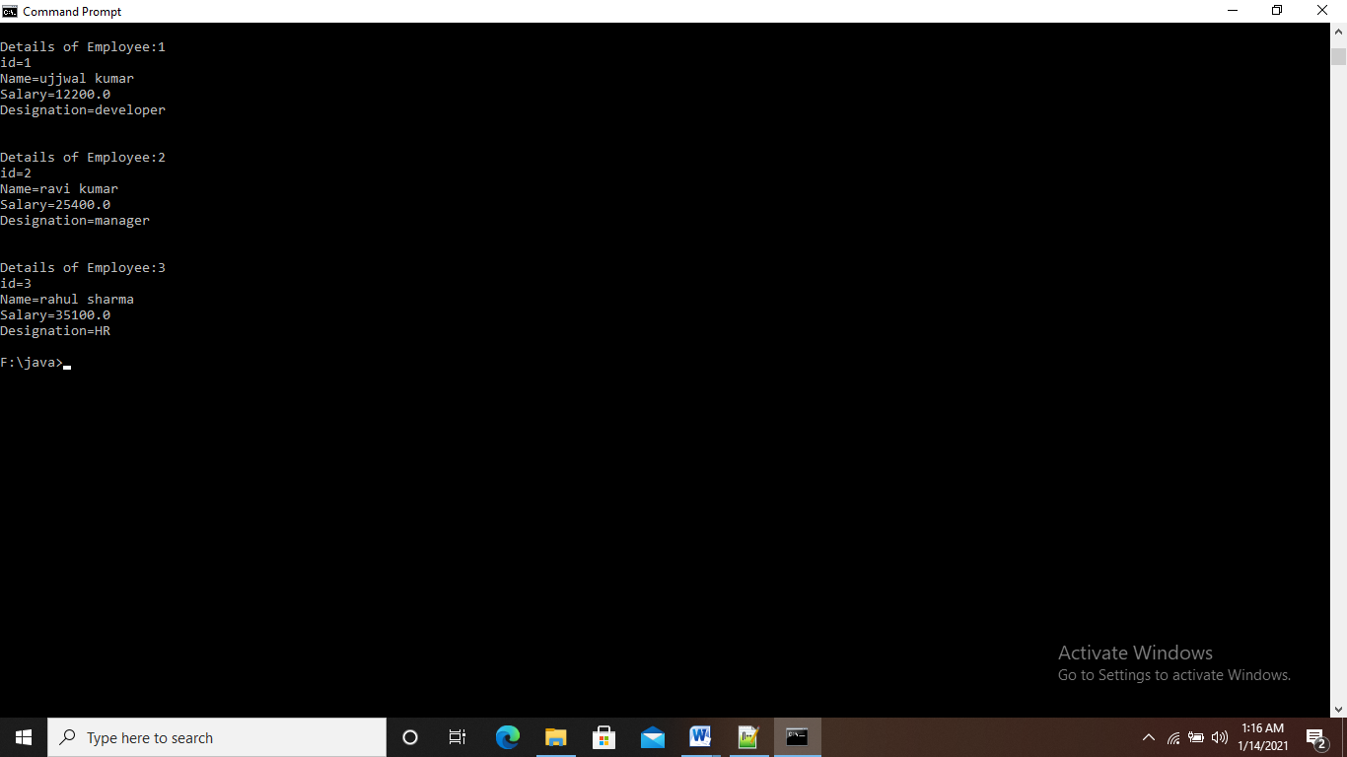

**Assignment 3**

Create EmployeeDetails class with 4 instance array variables.

EmployeeDetails() : memory size for array id,name,salary, desg must assign in constructor at run time.

read()

read all employee id,name,salary,desg

calSalary()

hra, da, pf local variables.

calculate salary

bonus()

apply bonus

display()

display details

EmployeeTest :

Main methods

Object creation

And calling all methods

Take n number records through keyboards as Id,Name,Salary,Desg

(array id,name,salary,Desg).

Salary = salary + hra + da – pf;

Hra is 10% salary

Da is 7 % salary

Pf 5 % salary

If desg is manager

15% bonus

If developer 10% bonus

Else

5 % bonus

Id, name, salary( grossSalary +bonus ) and desg

**Solution:**

import java.util.Scanner;

class EmployeeDetails

{

Scanner sc=new Scanner(System.in);

int n;

EmployeeDetails(int size)

{

n=size;

id=new int [size];

name=new String [size];

salary=new float [size];

salarycpy=new float[size];

desg=new String [size];

}

int []id;

String []name;

float []salary;

float []salarycpy;

String []desg;

//......................................................................

void read()

{

for(int i=0;i<n;i++)

{

System.out.println("Enter id of employee "+(i+1));

id[i]=sc.nextInt();

sc.nextLine();

System.out.println("Enter name of employee "+(i+1));

name[i]=sc.nextLine();

System.out.println("Enter salary of employee "+(i+1));

salary[i]=sc.nextFloat();

salarycpy[i]=salary[i];

sc.nextLine();

System.out.println("Enter designation of employee "+(i+1));

desg[i]=sc.nextLine();

System.out.println("\n");

}

}

//....................................................................

void calsalary()

{

for(int k=0;k<n;k++)

{

float hra,da,pf;

hra=salary[k]*0.1f;

da=salary[k]*0.07f;

pf=salary[k]*0.05f;

salary[k]=salary[k]+hra+da-pf;

}

}

//.....................................................................

void bonus()

{

for(int k=0;k<n;k++)

{

salary[k]=salarycpy[k];

float hra,da,pf;

hra=salary[k]*0.1f;

da=salary[k]*0.07f;

pf=salary[k]*0.05f;

if(desg[k].equals("manager"))

{

salary[k]=(salary[k]+hra+da-pf)+(salary[k]*0.15f);

}

else if(desg[k].equals("developer"))

{

salary[k]=(salary[k]+hra+da-pf)+(salary[k]*0.1f);

}

else

{

salary[k]=(salary[k]+hra+da-pf)+(salary[k]*0.05f);

}

}

}

//.......................................................................

void display()

{

for(int k=0;k<n;k++)

{

System.out.println("Details of Employee:"+(k+1));

System.out.println("id="+id[k]);

System.out.println("Name="+name[k]);

System.out.println("Salary="+salary[k]);

System.out.println("Designation="+desg[k]);

System.out.println("\n");

}

}

}

//........................................................................

class EmployeeTest

{

public static void main(String args[])

{

Scanner sc=new Scanner(System.in);

System.out.println("Enter Number of records you want to store:");

int x=sc.nextInt();

EmployeeDetails empd=new EmployeeDetails(x);

empd.read();

empd.calsalary();

empd.bonus();

empd.display();

}

}

Output:

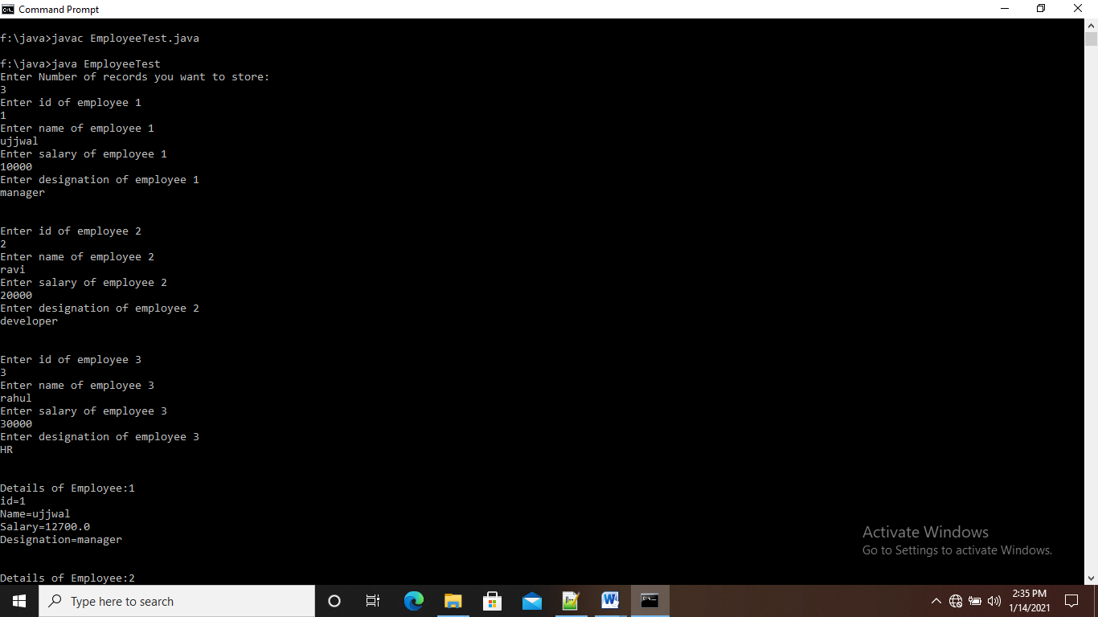

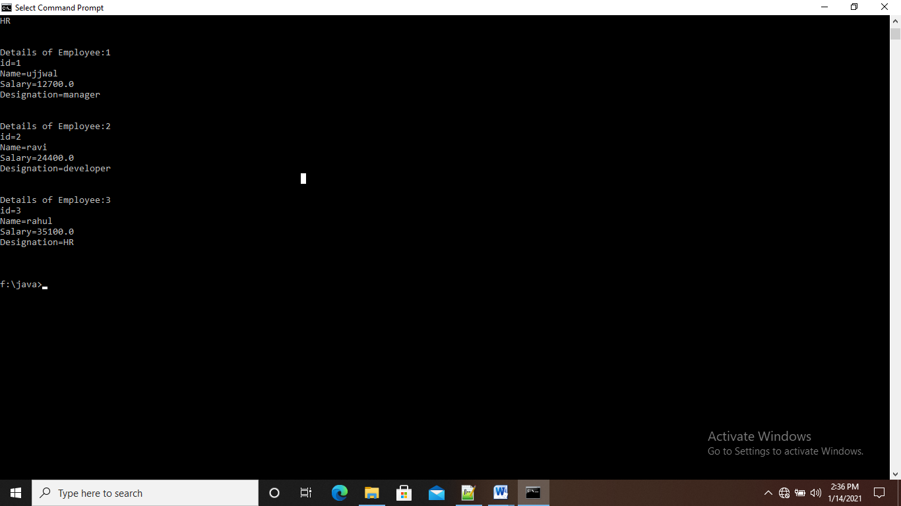

**Assignment 1**

do{

Online Examination

1:English , 2 : Math 3 : GK

switch() {

case 1

3 Q

case 2

3 Q

case 3

3 Q

}

Do want to continue ?

}while();

Result g_total > 70

Result + 10

Result>=90 selected else try next time.

**Solution:**

import java.util.Scanner;

public class OnlineExam

{

public static void main(String args[])

{

System.out.println("Online Examination System");

Scanner sc=new Scanner(System.in);

int choice;

int c=0,d=0,e=0,n=3,marks1=0,marks2=0,marks3=0;

do{

System.out.println("Press 1 for English \nPress 2 for Maths \nPress 3 for GK ");

choice=sc.nextInt();

switch(choice)

{

case 1:if(c==0)

{

System.out.println("Welcome to English Examination");

System.out.println("1.Please,stop.....so many mistakes.");

System.out.println("1. to make\n2. make\n3. making\n4. makes");

int p1=sc.nextInt();

if(p1==3)

{

marks1=marks1+10;

}

else{

System.out.println("Wrong Answer.");

}

System.out.println("2.The English.....English");

System.out.println("1. speak\n2. spoke\n3. spoken\n4. is spoken");

int p2=sc.nextInt();

if(p2==1)

{

marks1=marks1+10;

}

else{

System.out.println("Wrong Answer.");

}

System.out.println("3.The rain comes.....the clouds.");

System.out.println("1. in\n2. near\n3. from\n4. under");

int p3=sc.nextInt();

if(p3==3)

{

marks1=marks1+10;

}

else{

System.out.println("Wrong Answer.");

}

System.out.println("This Section Completed successfully...");

c++;

n--;

break;

}

else{

System.out.println("You have already done this section");

break;

}

case 2:if(d==0)

{

System.out.println("Welcome to Maths Examination");

System.out.println("1.Can we write 0 in the form of p/q?");

System.out.println("1. Yes\n2. No\n3. Cannot be explained\n4. None of the above");

int q1=sc.nextInt();

if(q1==1)

{

marks2=marks2+10;

}

else{

System.out.println("Wrong Answer.");

}

System.out.println("2.Every rational number is:");

System.out.println("1. Whole number\n2. Natural number\n3. Integer\n4. Real number");

int q2=sc.nextInt();

if(q2==4)

{

marks2=marks2+10;

}

else{

System.out.println("Wrong Answer.");

}

System.out.println("3.If the coordinates of a point are(0,-4),then it lies in:");

System.out.println("1. X-axis\n2. Y-axis\n3. At origin\n4. Between x-axis and y-axis");

int q3=sc.nextInt();

if(q3==2)

{

marks2=marks2+10;

}

else{

System.out.println("Wrong Answer.");

}

System.out.println("This Section Completed successfully...");

d++;

n--;

break;

}

else{

System.out.println("You have already done this section");

break;

}

case 3:if(e==0)

{

System.out.println("Welcome to GK Examination");

System.out.println("1.Which is longest river in the world?");

System.out.println("1. Ganga\n2. Nile\n3. Amazon\n4. Niger");

int r1=sc.nextInt();

if(r1==2)

{

marks3=marks3+10;

}

else{

System.out.println("Wrong Answer.");

}

System.out.println("2.Which is the biggest continent in the world?");

System.out.println("1. North America\n2. Aisa\n3. Africa\n4. Australia");

int r2=sc.nextInt();

if(r2==2)

{

marks3=marks3+10;

}

else{

System.out.println("Wrong Answer.");

}

System.out.println("3.Which is india's first super computer?");

System.out.println("1. Param8000\n2. param80000\n3. param800\n4. param8");

int r3=sc.nextInt();

if(r3==1)

{

marks3=marks3+10;

}

else{

System.out.println("Wrong Answer.");

}

System.out.println("This Section Completed successfully...");

e++;

n--;

break;

}

else{

System.out.println("You have already done this section");

break;

}

default:System.out.println("invalied choice...");

}

if(n!=0)

{

System.out.println("Do you want to continue with another section?\nPress 1 for YES \nPress 2 for NO ");

int ch=sc.nextInt();

switch(ch)

{

case 1:System.out.println("YES");

break;

case 2:System.out.println("NO");

if(c==0 || d==0 || e==0)

{

System.out.println("You have not completed the Exam...Please Complete");

}

break;

default:System.out.println("invalied choice...");

}

}

else{

System.out.println("Exam Completed");

System.out.println("Thank You");

}

}while(n!=0);

int result=0;

System.out.println("Marks in english="+marks1);

System.out.println("Marks in maths="+marks2);

System.out.println("Marks in GK="+marks3);

int totalmarks=marks1+marks2+marks3;

System.out.println("Total Marks="+totalmarks);

if(totalmarks>=70)

{

result=totalmarks+10;

System.out.println("Final Marks="+result);

}

if(result>=90)

{

System.out.println("Congratulations. You are Selected");

}

else{

System.out.println("Sorry, not passed. Please try next time");

}

}

}

**Output:**

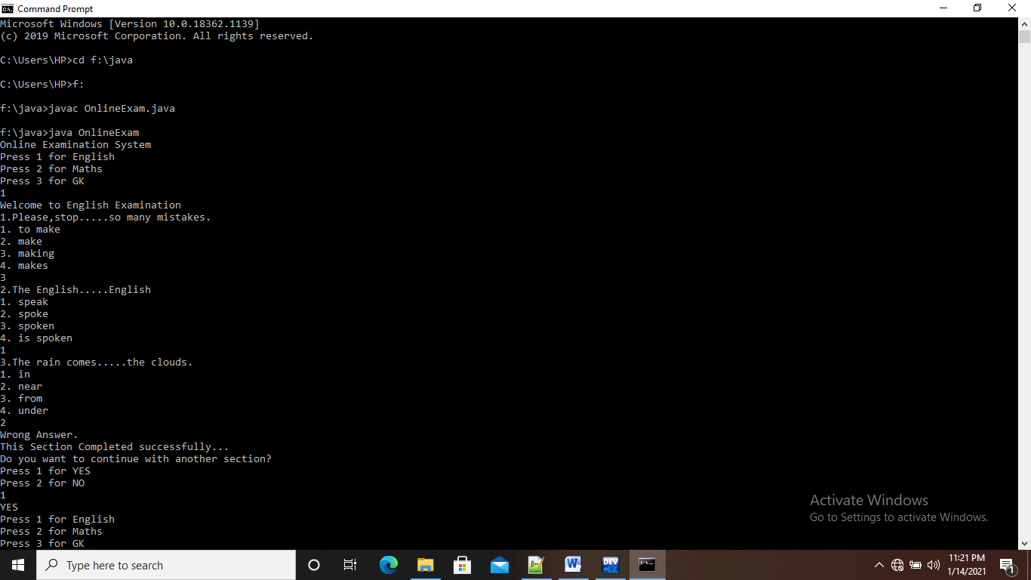

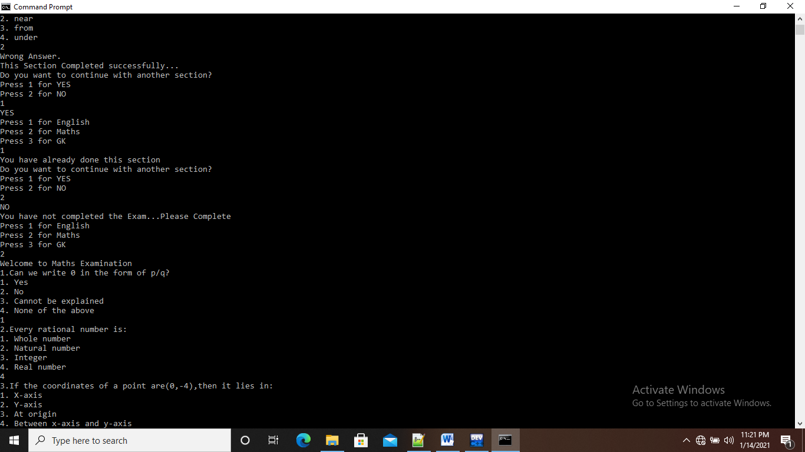

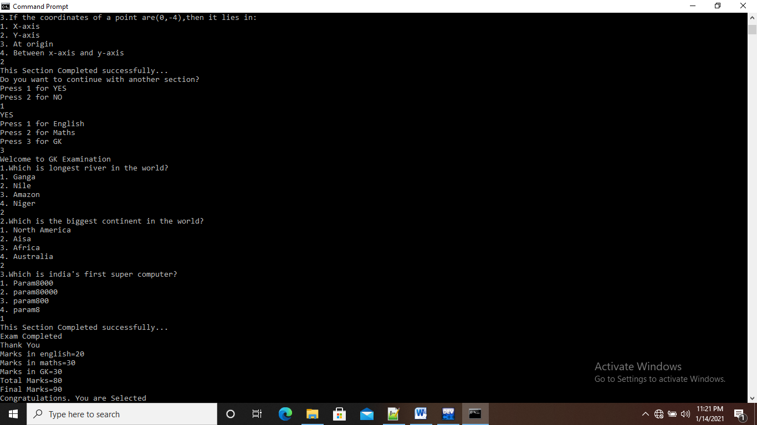

**Assignment 4**

Manager / Programmer is a Employee

Employee has a Address

class Employee { super class must be generic

id,name,salary

Scanner obj = new Scanner(System.in);

Address add = new Address();

methods

read() id,name,salary

, calSalary() : hra, da and pf

dislay()

}

class Manager extends Employee { sub must be specific

numberOfEmp : numbers

readMgr() numberOfEmp

add.readAdd();

disMgr();

numberOfEmp

add.disAdd();

}

class Programmer extends Employee{ sub must be specific

projectName: string

readPrg()

projectName

add.readAdd();

disPrg();

}

class Address {

city, state, pinCode

Scanner obj = new Scanner();

readAdd()

read city,state and pincode

disAdd();

city, state and pincode

}

EmployeeTest

Main Don’t create the Employee class object.

S.O.P(ManagerDetails);

Manager mgr

mgr.read() 3 details

mgr.readMgr() 1 own details, 3 address details

S.O.P(ProgramerDetails)

Programmer prg

prg.read()

prg.readPrg()

mgr.calSalary();

prg.calSalary()

Display Manager and Programmer details.

**Solution:**

import java.util.Scanner;

class Employee

{

int id;

String name;

float salary;

Scanner sc=new Scanner(System.in);

Address add=new Address();

void read()

{

System.out.println("Enter id:");

id=sc.nextInt();

sc.nextLine();

System.out.println("Enter Name:");

name=sc.nextLine();

System.out.println("Enter salary:");

salary=sc.nextFloat();

}

void calsalary()

{

float hra,da,pf;

hra=salary*0.1f;

da=salary*0.07f;

pf=salary*0.05f;

salary=salary+hra+da-pf;

}

void display()

{

System.out.println("\n");

System.out.println("Id="+id);

System.out.println("name="+name);

System.out.println("salary="+salary);

}

}

//..........................................................................

class Manager extends Employee

{

int number;

void readmgr()

{

System.out.println("Enter Number of Employee:");

number=sc.nextInt();

add.readadd();

}

void dismgr()

{

System.out.println("Number of Employee="+number);

add.disadd();

}

}

//.......................................................................

class Programmer extends Employee

{

String projectname;

void readprg()

{

sc.nextLine();

System.out.println("Enter name of project:");

projectname=sc.nextLine();

add.readadd();

}

void disprg()

{

System.out.println("Project="+projectname);

add.disadd();

}

}

//.......................................................................

class Address

{

String city,state;

int pincode;

Scanner obj=new Scanner(System.in);

void readadd()

{

System.out.println("Enter city:");

city=obj.nextLine();

System.out.println("Enter state:");

state=obj.nextLine();

System.out.println("Enter pincode:");

pincode=obj.nextInt();

}

void disadd()

{

System.out.println("city="+city);

System.out.println("state="+state);

System.out.println("pincode="+pincode);

}

}

//.......................................................................

class Employeetesting

{

public static void main(String args[])

{

System.out.println("Manager Details");

Manager mgr=new Manager();

mgr.read();

mgr.readmgr();

System.out.println("Programmer Details");

Programmer prg=new Programmer();

prg.read();

prg.readprg();

mgr.calsalary();

prg.calsalary();

mgr.display();

mgr.dismgr();

prg.display();

prg.disprg();

}

}

**Output:**

