A Project Report on

Behavioural Analysis of Internet Messaging
And Malicious activity
Detection.

Submitted in partial fulfillment of the requirements
in

Computer Science

by

Ujjwal Jain (17102027)
Bhavik Jain (17102058)
Rishabh Mehta (17102039)
Shrinath Suryawanshi (17102012)

Under the Guidance of

Prof. Brinal M. Colaco



Department of Computer Engineering

A.P. Shah Institute of Technology G.B.Road,Kasarvadavli, Thane(W), Mumbai-400615
UNIVERSITY OF MUMBAI

Academic Year 2020-2021

Approval Sheet

This Project Report entitled “Behavioral Analysis of Internet Messaging And Malicious activity Detection” Submitted by “Ujjwal Jain”(17102027),“Bhavik Jain”(17102058),“Rishabh Mehta”(17102039),“Shrinath Suryawanshi”(17102012) is approved for the partial fulfillment of the requirement in Computer Science Department from University of Mumbai .

Prof. Brinal M. Colaco
Guide

Prof. S.H.Malave
Head, Computer Engineering Department

Place:A.P.Shah Institute of Technology, Thane

Date:

CERTIFICATE

This is to certify that the project entitled “Behavioral Analysis of Internet Messaging And Malicious activity Detection” submitted by “Ujjwal Jain”(17102027),“Bhavik Jain”(17102058),“Rishabh Mehta”(17102039),“Shrinath Suryawanshi”(17102012) for the partial fulfillment of the requirement for award of a degree Bachelor of Engineering in Computer Science Department, to the University of Mumbai, is a bonafide work carried out during the academic year 2020-2021.

Prof. Brinal M. Colaco
Guide

Prof. S.H.Malave Dr. Uttam D.Kolekar
Head,Computer Engineering Department Principal

External Examiner

Place:A.P.Shah Institute of Technology, Thane Date:

Declaration

We declare that this written submission represents our ideas in our own words and where others’ ideas or words have been included, We have adequately cited and referenced the original sources. We also declare that We have adhered to all principles of academic honesty and integrity and have not misrepresented or fabricated or falsified any idea/data/fact/source in our submission. We understand that any violation of the above will be cause for disciplinary action by the Institute and can also evoke penal action from the sources which have thus not been properly cited or from whom proper permission has not been taken when needed.

———————————————

(Signature)

———————————————

(Ujjwal Jain, 17102027)
(Bhavik Jain, 17102058)
(Rishabh Mehta, 17102039)
(Shrinath Suryawanshi, 17102012)

Date:

Contents
1. Project conception and initiation

1.1 Abstract

With the outburst in the growth of the social networking, it is alarming how the youth could become a victim of social trapping and psychological depressions. Internet messaging which previously was meant for communication however turned out to have adverse effects
on youth and country. Increased exposure and misuse of “chatting” has become a common phenomenon. Internet messaging in social networking sites like Facebook, Whatsapp have also led to disastrous scenario where teenagers communicate through bawdy or explicit
messages, and prowlers trap opposite genders. In this paper the methodology for dealing with such type of messages is discussed. First, text messages are processed through the algorithm which would predict the behavior of both the communicating parties. Eventually it would
alarm if there is a malicious activity detected.

1.2 Objectives

In this era of technology, there are many pros and cons of this technology, one of the pros is chatting. But there are some cons like blackmailing, Cyber bullying, threat messages and many other Malicious activity.

So what our application will do?

It will store the messages in the group of 10-20 and compare them with threat messages database and if it matches 80% of them, it will send to the responsible guardian’s number which will be added during registration. By the use of this system, one can be saved from involving in illegal activities and from being a cyber victim.

1.3 Literature review

It considers one of the actual threats of the Internet of things related to the transmission of malicious messages between user. Methods of the transmitted data automatic verification and filtering by some set of features in Internet systems of things are analyze. It proposes an approach to the intelligent detection of unnatural conversation between user, which could minimize the likelihood of the implementation of threats.

The major problem in Instant Messengers, much of sensitive and personal information, disclosed through socio-engineered text messages for which solution is proposed but, detection of words using chatting technique in Instant Messengers is not yet done which is the motivating factor to carry out the work. Online criminal's now-a-days adapted technique along with text message and wraps out personal information leads to threat and hindrance for privacy.

Psychological health disorders pose a growing threat to society. Disorders such as Depression, Post-Traumatic Stress Disorder (PTSD), and mild Traumatic Brain Injury (mTBI), are often under-diagnosed and under-treated. Crisis hotlines are often the last resort for people who, from the lack of proper treatment, are considering suicide or intend to harm themselves or others.

Harassment by cyberbullies is a significant phenomenon on the social media. Existing works for cyberbullying detection have at least one of the following three bottlenecks. First, they target only one particular social media platform (SMP). Second, they address just one topic of cyberbullying. Third, they rely on carefully handcrafted features of the data. We show that deep learning based models can overcome all three bottlenecks. Knowledge learned by these models on one dataset can be transferred to other datasets. Our experiments provide several useful insights about cyberbullying detection. To the best of our knowledge, this is the first work that systematically analyzes cyberbullying detection on various topics across multiple SMPs using deep learning based models and transfer learning.

1.4 Problem Definition

An outburst of Social networking pages, without proper monitoring highly
endangers personal security especially of teens and youth who are highly exposed to
many inhumanely activities. They get addicted to internet Messaging over social
networking sites presenting serious threat of getting beguiled into extreme and even
horrendous acts like Trapping, girl-Trafficking, motivation to become extremists and other evils.

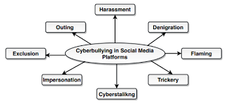

1.5 Scope

- Our Project proposes usage of behavioral analysis on messaged that are exchanged while people chat, followed by semantic analysis, scoring algorithm and a data mining technique to detect a malicious activity i.e., behavioral analysis is made on internet messages so as to detect any malicious activity.

- Extensive work done to analyze the behavior of the data to predict the positive or negative feedback using classification, which eventually can be used to predict the quality and response of people towards that particular thing or product.

1.6 Technology stack

- Python

Techniques :

- Latent Semantic Analysis
- Convolution Neural Network (CNN)

1.7 Benefits for environment and society

The idea of this project is concerned with the new generation as well as present generation, this system will be very helpful for both of the generation. It will be mainly helpful for the women’s around us. We know and have knowledge about the cyber crimes and threats given on Social media and the victim is not able to express due to many reasons. So our system will send alert notification to their responsible guardian on the behalf of victim. So they can get support from their guardians during tough times and we hope that our system will help in reducing Cyber crime rates.

2. Project Design

2.1 Proposed system

- As we are seeing on social media and news that many young adults are becoming the victim of blackmailing, cyber bullying and threats given on social media platforms
- So this problem encourages us to make this system as our system will compare the message retrieved from the online chatting with the already created database
- The main advantage of our system is that our system will detect the meaning of chats using the frequency of curse/abusive words used in that chat and it will alert the respected guardian that your child is in some trouble
- It will help in reducing suicide rates as victim is not able to tell their guardians about their problems in personal life
- Also victims are threatened for not involving their loved ones, so this system will help in that case
- This cyber-trapping which is very difficult to catch can be easily handled using our system

2.2 Design(flow of modules)

- Data Gathering:
- We had manually made the database by mutually chatting within ourselves
- Also we had taken the data from some online datasets available for free
- Some curse/abusive words and their synonyms from the online tools

- Preprocessing:
- We had removed Stop words from the chats
- Also we removed the emoji’s and extra characters
- All the data has been converted to lower case

- Algorithms Used (ML):
- Convolution Neural Network
- Latent Semantic Analysis

- Working of our System:

  - Text Classification using Convolution Neural Network (CNN)
- Initially we will perform text classification on already prepared dataset of sentences using CNN and we will create a CNN model
- High accuracy of this CNN model will be used in later stages for better prediction of malicious sentences

  - Extraction and Preprocessing of Data
- Initially we'll create 3 folders named flagged, non-flagged and highly flagged each having files containing sentences based on the usage of abusive/threat words.
- In 1st phase important part is input extraction from the chat, tokenization of text/messages, matching it with the already prepared files and frequency counting.

- Semantic analysis
- It will detect the meaning of the sentences using Latent semantic analysis (LSA).
- It will process the data in terms of meaning and to extract different emotion like Joy, sadness, anger, etc. From the given text which can be further use to detect the message as malicious.

- Frequency counting
  - This is the phase where actual score of the message will be predicted after going through two phases.
  - Frequency of each sentence will be predicted and then the cumulative score of the group of 20 messages will be Calculated and then it will be compared with the predefined threshold frequency, and if the frequency is greater than the threshold frequency then the message will be popped up as 'Malicious Activity detected' and if the frequency is lesser than the threshold frequency then message will be popped up as 'Malicious Activity not detected'

2.3 Class Diagram

- For Text Classification of already prepared dataset using CNN

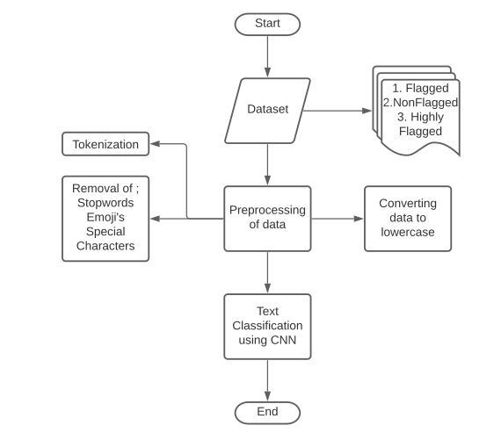

- For Malicious activity detection system

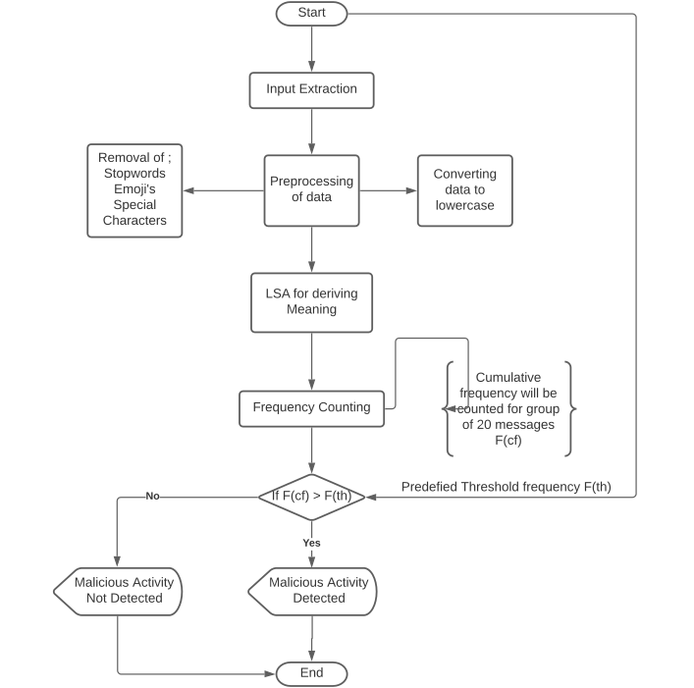

3. Planning for next semester

As of now we are trying to detect the malicious activity based on the already prepared set of abusive, curse and flirty words. Then these are categorized into three files named flagged , Non-flagged and highly-flagged based upon their general usage and frequency with which they can be used to signify an abusive and explicit meaning.

In the next semester we will add more data to our prepared set of words and also we’ll try to experiment it with the different algorithms for maintaining high accuracy and accurate prediction. We will also run this project on our local system as it will be easy to make it user friendly for alerting the output of our project i.e., the alert window which shows “The Malicious activity detected”.

4. References

[1] Behavioral analysis of internet messaging and malicious activity detection, K. Srividya, A. Mary Sowjanya, 2016 International Conference on Advances in Human Machine Interaction (HMI), Doddaballapur, India

[2] Deceptive phishing detection system: From audio and text messages in Instant Messengers using Data Mining approach, Mohammed Mahmood Ali and Lakshmi Rajamani, International Conference on Pattern Recognition, Informatics and Medical Engineering (PRIME-2012) , Tamilnadu, India

[3] Automatic search of the malicious messages in the internet of things systems on the example of an intelligent detection of the unnatural agents requests, Anastasia Iskhakova, Roman Meshcheryakov, 2017 Second Russia and Pacific Conference on Computer Technology and Applications (RPC), Vladivostok, Russia

[4] Automatic detection of psychological distress indicators and severity assessment in crisis hotline conversations, Maciej Pacula, Talya Meltzer, Michael Crystal, Amit Srivastava, Brian Marx, 2014 IEEE International Conference on Acoustics, Speech and Signal Processing (ICASSP), Florence, Italy

[5] Deep Learning for Detecting Cyberbullying Across Multiple Social Media Platforms, Sweta Agrawal, Amit Awekar, Accepted for ECIR 2018

