**PRACTICAL 2: Creating account, repository on Git hub and cloning repository in Git hub**

1. ***Creating Account :***

**Step 1**: Go to Git hub and click on sign up to create an account.

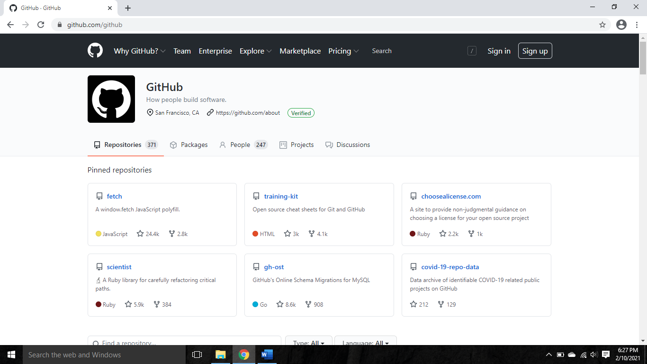

**Step 2**: fill the required information.

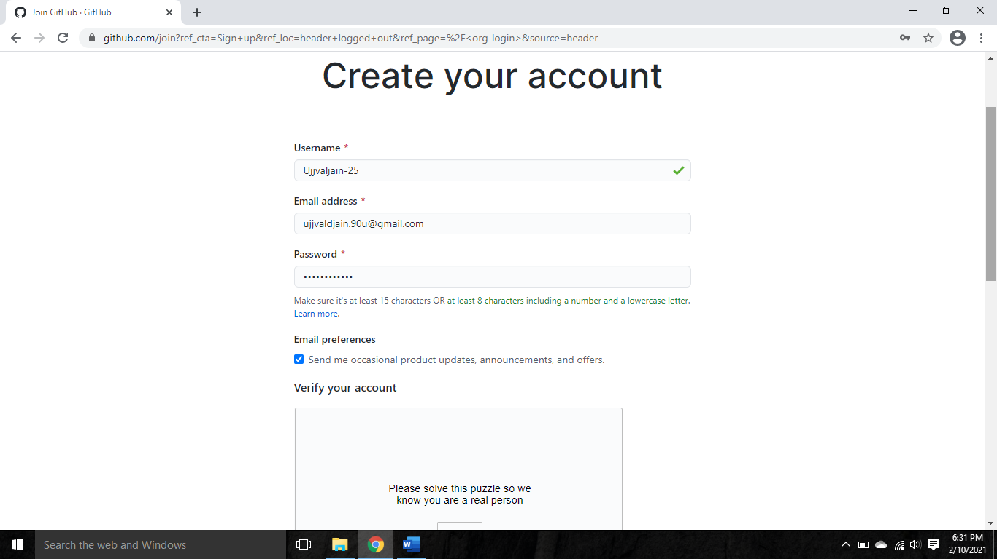

**Step 3** : Click on create account and then your account will be created.

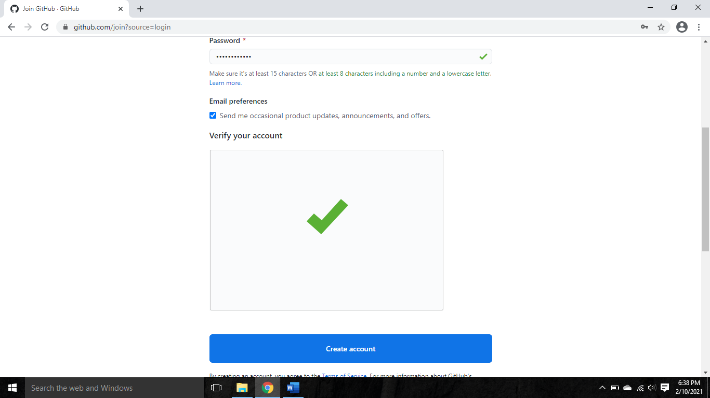

1. ***Creating Repository :***

**Step 1** : Click on + to create an repository.

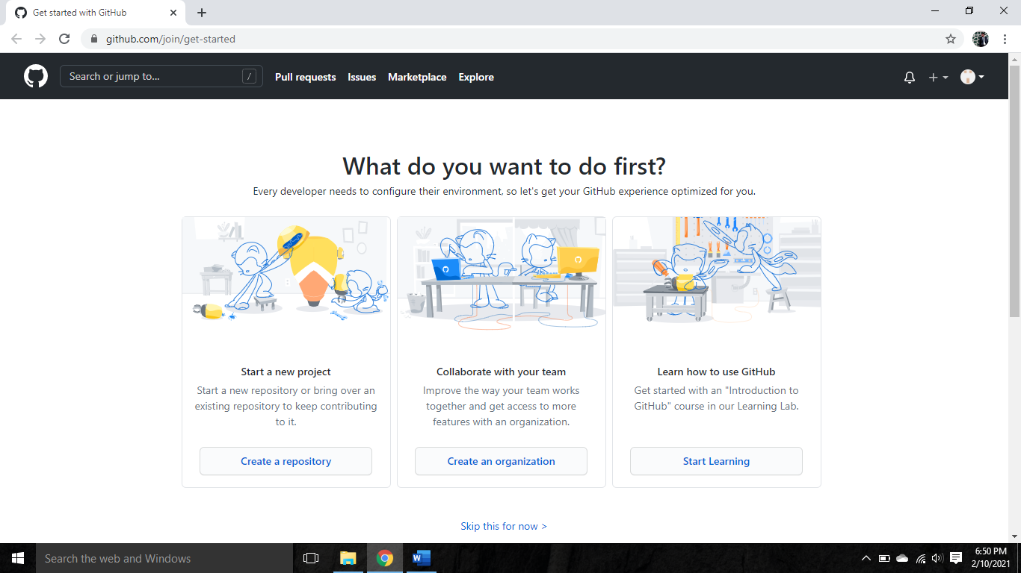

**Step 2** : Select new repository

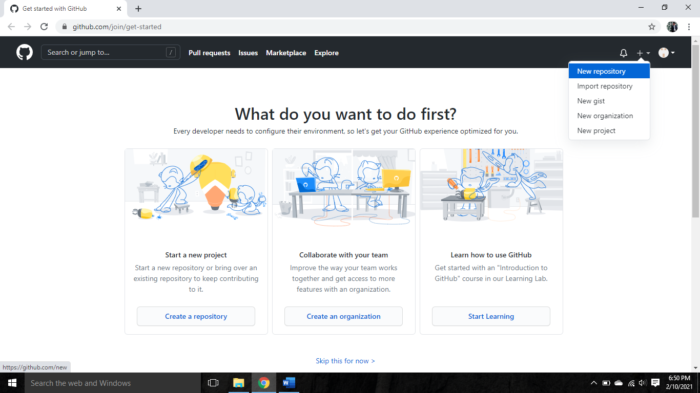

**Step 3** : Insert a name to your repository.

* ***Description***: It is optional, so if you want to describe something about your repository then fill the description field with necessary information
* ***Private***: If you want no one can access your repository then click on private button.
* ***Public***: If you want other people can access your repository then click on public button.

**Step 4** : click on create repository button then your repository will be created.

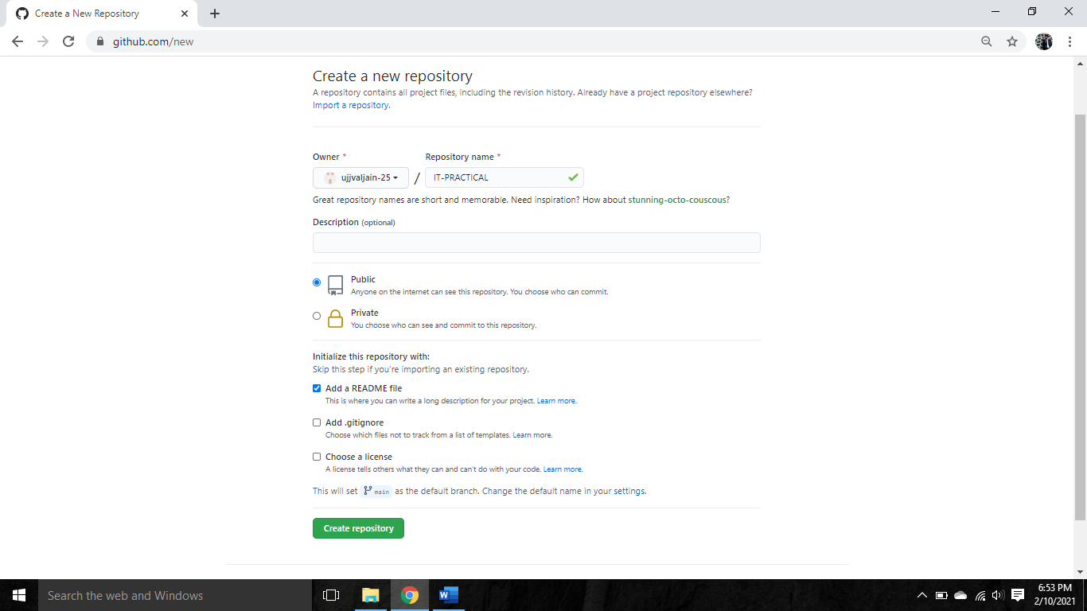

1. ***Cloning repository :***

**Step 1** : click on add file then select upload files.

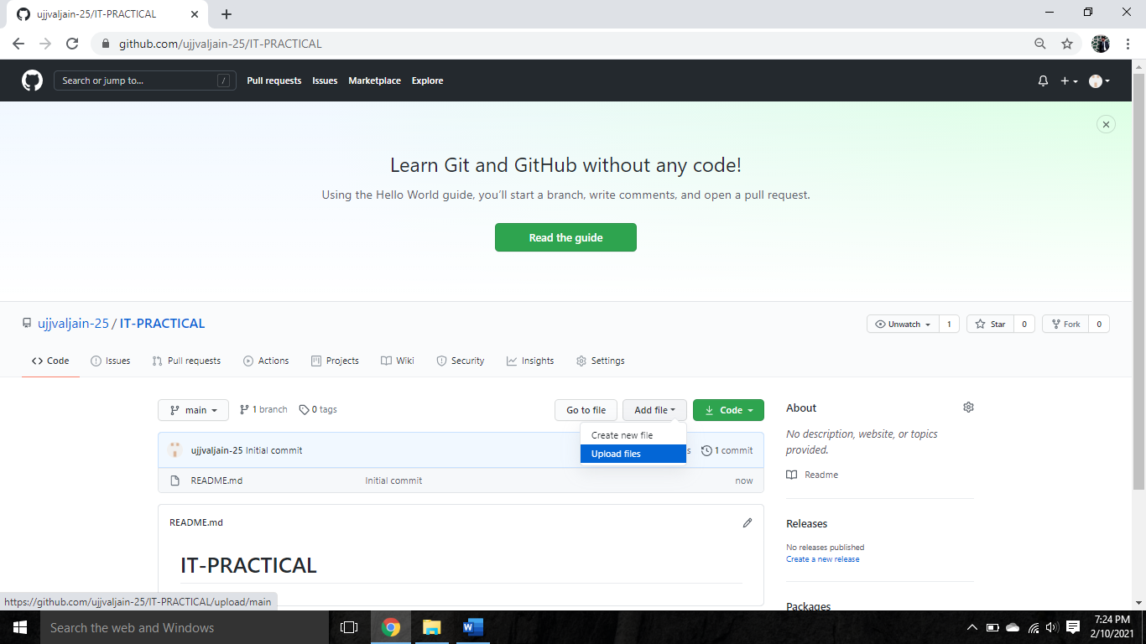

**Step 2** : click on choose your files to add your files to the repository.

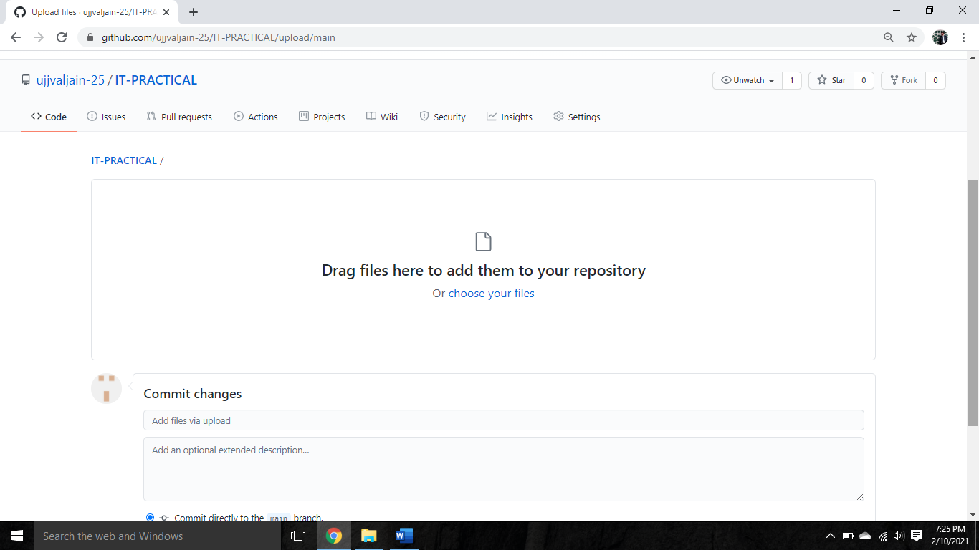

**Step 3** : select your file and then click on open to add your file.

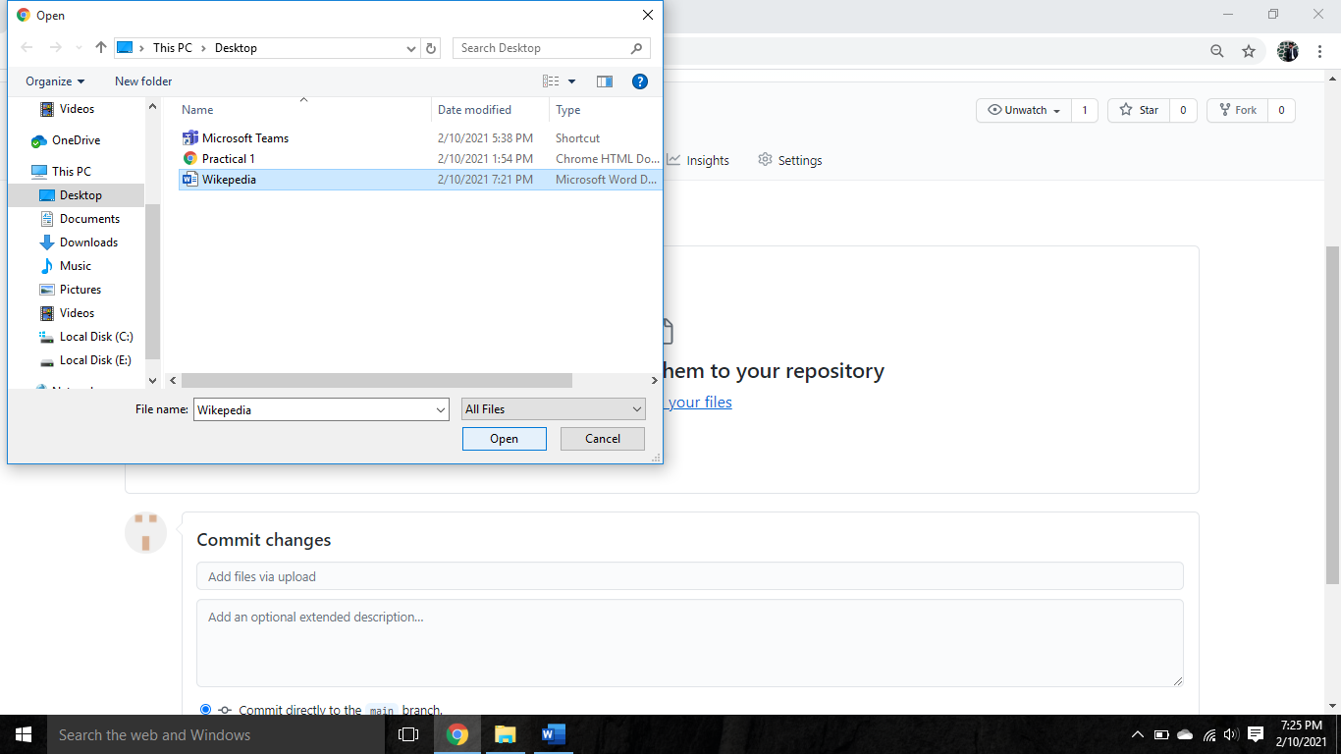

**Step 4** : click on commit changes then your file will get added to your repository.

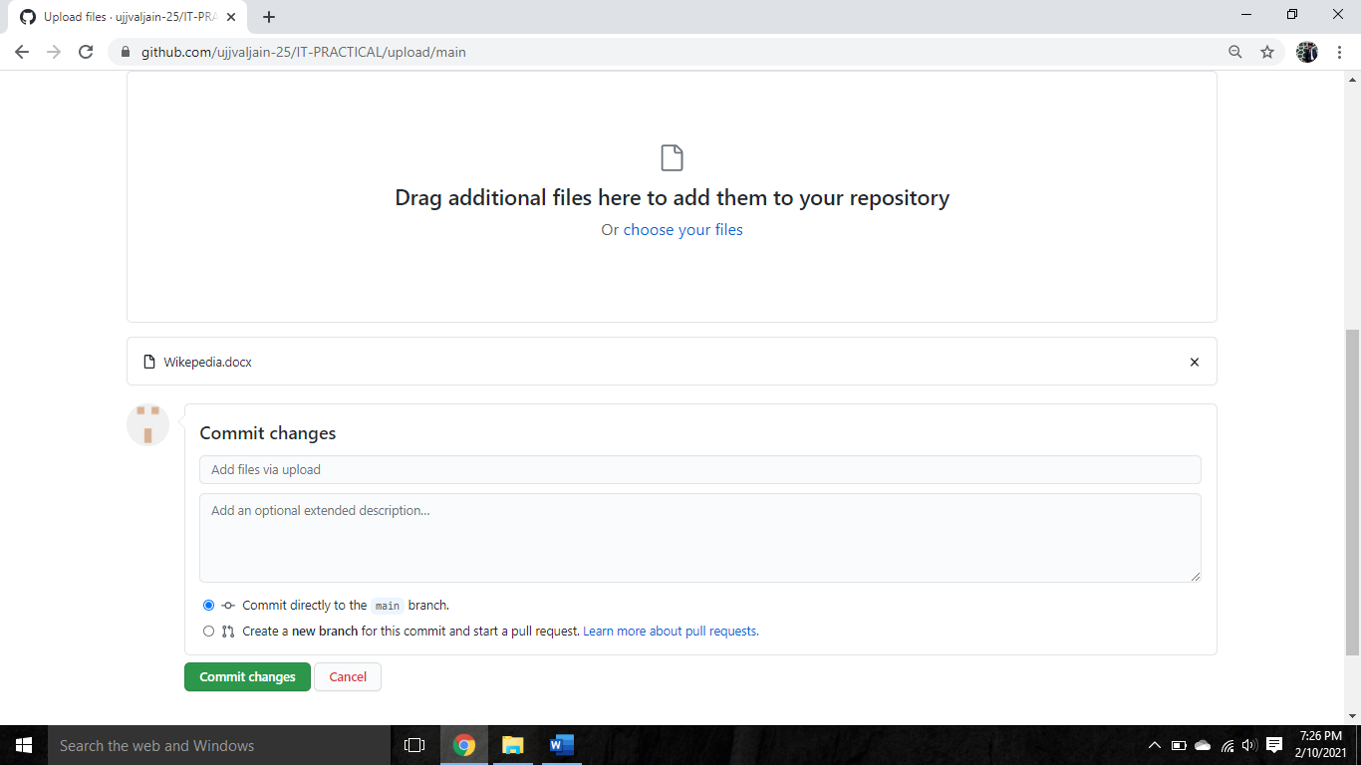

**Step 5** : click on the code button to get your repository link and copy the link

To share your repository.

