DEPARTMENT OF COMPUTER SCIENCE & ENGINEERING
ABES Engineering College, Ghaziabad
SOFTWARE REQUIREMENTS
SPECIFICATION (SRS)
Project Title: BankEase – NextGen Net Banking System
Standard Academic Compliance: IEEE Std 830-1998
————————————————————————————
SUBMITTED BY:  1. Ujjwal Upadhyay (Roll No: 2400320101205)  Degree: Bachelor of Technology (B.Tech)  Academic Year: 2026 - 2027 | UNDER THE GUIDANCE OF:  Prof. / Dr. ______________________________  Designation / Title: _____________________  Department of Computer Science & Engg.

Document Revision & Approval History
Version | Date | Description / Major Changes | Prepared By | Reviewed By
0.1 | 15-Sep-2026 | Initial Draft & Scope Definition | Project Team | Project Guide
1.0 | 30-Sep-2026 | Final 3rd Year Project SRS Baseline | Ujjwal Upadhyay | Project Guide / HOD

Guidance Note: This Software Requirements Specification follows the supplied IEEE Std 830-1998 academic template. Project-specific requirements below are derived from the implemented BankEase Angular + Spring Boot + MySQL application.

1. Introduction
1.1 Purpose
The purpose of this Software Requirements Specification (SRS) is to define the functional requirements, external interfaces, operating environment, security requirements, business rules, and design constraints of BankEase – NextGen Net Banking System. The document provides a common baseline for implementation, academic evaluation, testing, and future enhancement of the 3rd-year project.
1.2 Scope of the System
BankEase is a web-based net-banking application that provides authenticated customers with core personal banking workflows through an Angular frontend and a Spring Boot REST backend backed by MySQL. The system addresses the need for a centralized academic banking simulation in which account management, beneficiary management, fund transfer, bill payment, loans, investments, and administrative KYC/user controls can be performed through secure APIs and a responsive web interface.
- In-Scope Capabilities: User registration and login; JWT-based authentication; role-based access control; bank account creation and viewing; beneficiary management; fund transfers; bill payments; loan applications and admin decisions; investment product browsing, investment purchase and redemption; dashboard summaries; audit logging; validation; global exception handling; and CORS configuration.
- Out-of-Scope Boundaries: Real-world bank network integration, real payment gateway settlement, live KYC verification services, ATM/card processing, external core-banking systems, and production-grade regulatory compliance. The implemented project simulates banking operations within its own database.
- Expected Benefits: Provides a single web interface for academic demonstration of banking workflows, improves consistency through validation and transactional service logic, records security-relevant actions through audit logs, and demonstrates practical application of REST, JPA, JWT, RBAC, and relational database concepts.
1.3 Definitions, Acronyms, and Abbreviations
Category | Term / Acronym | Definition / Standard Context
Standard | SRS | Software Requirements Specification in the supplied IEEE Std 830-1998 academic format.
Application | BankEase | The implemented NextGen Net Banking web application.
Architecture | REST API | HTTP-based stateless API used by the Angular frontend to communicate with the Spring Boot backend.
Security | JWT | JSON Web Token used for stateless authentication; the token carries the authenticated identity and role.
Security | RBAC | Role-Based Access Control; the implemented roles are USER and ADMIN.
Database | JPA / Hibernate | Persistence layer used to map Java entities to the MySQL relational database.
Database | CRUD | Create, Read, Update and Delete operations performed on application resources.
Security | BCrypt | Password hashing mechanism configured through Spring Security's BCryptPasswordEncoder.
Frontend | Angular | Angular 20.3-based standalone-component frontend.
Backend | Spring Boot | Spring Boot 4.1.0 REST backend running on Java 21.
Banking | KYC | Know Your Customer status represented by PENDING, VERIFIED and REJECTED.
Banking | IFSC | Indian Financial System Code field stored with bank account/beneficiary information.
1.4 References
- IEEE Std 830-1998, IEEE Recommended Practice for Software Requirements Specifications (template basis supplied for this project).
- Project source code: BankEase_FullStack – Angular 20.3 frontend, Spring Boot 4.1.0 backend, MySQL persistence.
- Spring Security, Spring Data JPA, Hibernate, JJWT, Angular Router and Angular Forms – technologies represented by the project's declared dependencies and source code.
- Ian Sommerville, Software Engineering, 10th Edition, Pearson Education (reference listed in the supplied academic template).
1.5 Document Overview
The remainder of this SRS is organized as follows: Section 2 describes the product perspective, users, operating environment, constraints, assumptions, and dependencies. Section 3 defines functional requirements for authentication, accounts, beneficiaries, transfers, bills, loans, investments, dashboard reporting, auditing, and administration. Section 4 specifies user, hardware, software, and communication interfaces. Section 5 defines non-functional requirements covering security, reliability, usability, portability, maintainability, and performance verification. Section 6 presents the system context, use case, ER, and sequence models. Section 7 provides the academic review and sign-off section.
2. Overall Description
BankEase follows a multi-tier architecture consisting of a presentation tier (Angular 20.3 standalone components), an application/API tier (Spring Boot 4.1.0 with controllers, services, repositories, security and validation), and a relational persistence tier (MySQL accessed through Spring Data JPA/Hibernate). The frontend communicates with the backend through JSON REST endpoints. Authentication is stateless and uses a Bearer JWT. The backend also provides CORS configuration for the Angular development origin http://localhost:4200. No external banking or payment gateway is required by the implemented application.
The project is structured as a self-contained multi-tier system (comprising a presentation layer, an application/API logic tier, and a persistent database backend). It interfaces with external services (such as cloud storage or messaging gateways) strictly through secure, authenticated RESTful endpoints.
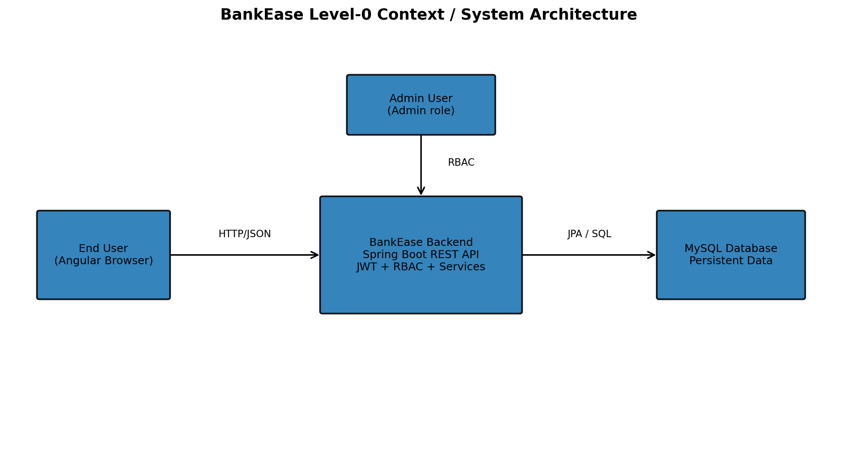
Figure 1. BankEase Level-0 Context / System Architecture

2.2 User Classes and Characteristics
The target software accommodates distinct user personas with varying access hierarchies:
User Role / Persona | Technical Proficiency | Core Responsibilities & Rights
Administrator | High | Reviews users, changes KYC status, enables/disables users, reviews pending loan applications, and records loan decisions. Admin endpoints are protected by the ADMIN role.
Registered Customer | Intermediate | Registers/logs in, views dashboard and accounts, creates accounts, manages beneficiaries, transfers funds, pays bills, applies for loans, and purchases/redeems investments.
Guest / Visitor | Basic | Can access public entry points such as registration/login and the public investment-product listing endpoint; authenticated resources require a valid session.
The application operates within the following software and hardware environments:
- Client Requirements: Modern browser capable of running Angular 20.3; the implemented frontend is responsive and is designed for standard desktop/laptop and mobile-sized viewports.
- Application Runtime: Java 21 for the backend; Spring Boot 4.1.0; Angular 20.3; TypeScript ~5.8.2; RxJS 7.8.2; and an Angular-compatible Node.js/npm environment.
- Database Storage Tier: MySQL using the MySQL Connector/J driver. The configured local development database is named bankease by default.
- Database Storage Tier: PostgreSQL 15 / MySQL 8.0 / MongoDB 6.0 Enterprise or community editions.
- Deployment Constraint: The project is designed for local/academic deployment; the frontend development origin is configured as http://localhost:4200 and the backend runs on port 8080 by default.
- Security Constraint: Passwords are encoded with BCrypt; APIs use stateless JWT authentication and ADMIN endpoints are protected by role-based authorization. JWT/database secrets are configurable through environment variables.
- Architecture Constraint: The implementation follows controller-service-repository separation, DTOs for API input/output, entity mappings for persistence, centralized exception handling, and a dedicated security layer.
- Modularity Standards: Adherence to Model-View-Controller (MVC) or modular REST service patterns to ensure clean separation of concerns.
- Assumptions: The user has network access to the running frontend/backend, the MySQL service is available, and application configuration values are correctly supplied.
- Dependencies: MySQL database; Java 21 runtime/JDK; Maven for backend dependency management; Angular CLI/npm dependencies for the frontend; and browser support for the Angular application. No third-party banking API is required.
- Dependencies: Continuous availability of third-party public APIs (e.g., Google OAuth 2.0, Geocoding service, or external model repository).
Requirements are categorized by functional subsystem modules with unique identifiers (FR-x.x). Priority is expressed as High, Medium, or Low for academic implementation planning.
3.1 Module 1: Authentication, Authorization and Session Management
3.2 Module 2: Banking Operations – Accounts, Beneficiaries, Transfers and Bills
Req ID | Feature Description | Input / Validation Rule | Priority
FR-1.1 | User Registration | Accept first name, last name, email, password and optional phone number. Email must be valid and unique; password length is 8–100 characters; phone, when supplied, must match the configured 10-digit Indian mobile pattern. | High
FR-1.2 | Secure Login | Authenticate using email and password. Credentials are verified through Spring Security and BCrypt. Successful login returns a Bearer JWT and user session details. | High
FR-1.3 | JWT Token Management | Generate a signed HS256 JWT containing the user's role. Configured default token expiration is 86,400,000 ms (24 hours). | High
FR-1.4 | Role-Based Authorization | Permit authenticated users to access protected resources; restrict /api/admin/** to ADMIN users; allow public access only to explicitly permitted authentication/public endpoints. | High
FR-1.5 | 401/403 Handling | Return application-specific error responses through AuthenticationEntryPoint and AccessDeniedHandler for unauthenticated and unauthorized requests. | High
FR-1.6 | Frontend Session Guard | Use Angular route guards and an HTTP interceptor to protect authenticated routes and attach the JWT as a Bearer Authorization header. | High
FR-1.7 | Audit Authentication Events | Record successful and failed login attempts and registration events in AuditLog. | Medium
3.3 Module 3: Loans, Investments, Dashboard and Administrative Control
Req ID | Feature Description | Input / Validation Rule | Priority
FR-2.1 | Bank Account Creation | Create Savings or Current accounts with an optional initial deposit. Account numbers are generated by the backend and must remain unique. | High
FR-2.2 | Account Viewing | Authenticated users can list their own accounts and retrieve an individual account only when it belongs to the current user. | High
FR-2.3 | Beneficiary Management | Create, list and delete beneficiaries. Beneficiary information includes name, account number, IFSC, bank name and optional nickname. | High
FR-2.4 | Fund Transfer | Transfer funds from an authenticated user's account to an active beneficiary. The source account must belong to the user, be active, have sufficient balance, and the user's KYC status must be VERIFIED. | High
FR-2.5 | Transfer Mode Rules | Support IMPS, NEFT and RTGS. RTGS requires at least ₹2,00,000; IMPS is limited to ₹5,00,000 per transaction. The account also enforces a ₹2,00,000 daily transfer limit. | High
FR-2.6 | Transactional Balance Update | Debit the source account atomically and, when the destination account exists internally and is active, credit the destination account. Record a successful transfer and audit event. | High
FR-2.7 | Bill Payment | Debit an active customer account for a bill payment after ownership and balance validation. Store biller, category, consumer number, amount, status and reference number. | High
FR-2.8 | Transaction History | Provide recent transfer and bill-payment history for the authenticated user. | Medium
3.3 Module 3: Reporting, Visualization & Administrative Control
Req ID | Feature Description | Input / Validation Rule | Priority
FR-3.1 | Loan Application | Allow customers to apply for Personal, Home, Education or Vehicle loans. Requested amount must be at least ₹10,000 and tenure must be 6–360 months. | High
FR-3.2 | Loan Decision | Allow ADMIN users to review pending loans and approve/reject them. Approval requires an interest rate; EMI is calculated by the backend. | High
FR-3.3 | Investment Product Catalogue | Expose active investment products such as Fixed Deposit, Mutual Fund and Bond products. The product catalogue is publicly readable. | Medium
FR-3.4 | Investment Purchase | Validate product activity, minimum investment, account ownership and sufficient balance; debit the funding account and create an ACTIVE investment. | High
FR-3.5 | Investment Redemption | Allow the owner to redeem an active investment and credit its current value back to the original funding account. | High
FR-3.6 | Customer Dashboard | Display account balance, investment value, transfer count, recent transfers and quick links to banking modules. | Medium
FR-3.7 | User/KYC Administration | Allow ADMIN users to list users, change KYC status, and enable/disable user accounts. | High
FR-3.8 | Audit Logging | Record important business events including transfers, bill payments, loan applications/decisions, investment purchase/redemption and account-status changes. | Medium
FR-3.9 | Validation & Exception Handling | Validate request DTOs and convert business/resource/security errors into consistent API error responses through the global exception handling layer. | High

Implemented REST Endpoint Summary

Module | Representative Endpoints | Access
Authentication | POST /api/auth/register; POST /api/auth/login; GET /api/auth/health | Public
Accounts | POST /api/accounts; GET /api/accounts; GET /api/accounts/{id} | Authenticated USER
Beneficiaries | POST /api/beneficiaries; GET /api/beneficiaries; DELETE /api/beneficiaries/{id} | Authenticated USER
Transfers | POST /api/transfers; GET /api/transfers | Authenticated USER + KYC rule
Bills | POST /api/bill-payments; GET /api/bill-payments | Authenticated USER
Loans | POST /api/loans; GET /api/loans | Authenticated USER
Investments | GET /api/investments/products; POST /api/investments; GET /api/investments; POST /api/investments/{id}/redeem | Products public; other operations authenticated
Administration | GET /api/admin/users; PATCH /api/admin/users/{id}/kyc; PATCH /api/admin/users/{id}/enabled; GET /api/admin/loans/pending; PATCH /api/admin/loans/{id}/decision | ADMIN only
4. External Interface Requirements
The Angular frontend provides standalone pages for Login, Registration, Dashboard, Accounts, Beneficiaries, Transfers, Bills, Loans, Investments and an Admin console. Navigation is protected through route guards. Forms use Angular Forms, and API requests are sent through a centralized ApiService. Error and loading states are represented by shared UI components.
The interface will follow standard UX usability best practices (clean navigation bar, breadcrumbs, modal validation dialogs). All forms must provide immediate visual feedback (success banners or inline error alerts under erroneous fields).
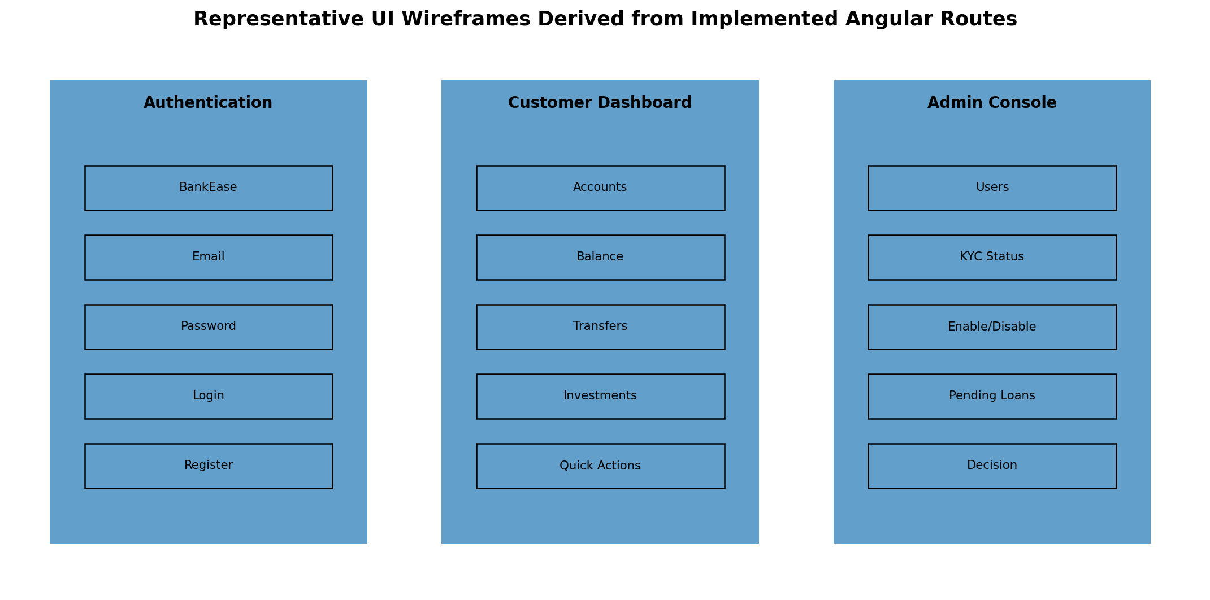
Figure 2. Representative UI Wireframes derived from implemented Angular routes

The application does not require specialized hardware. It can be operated using standard keyboard, mouse/touch input, display, and network connectivity.
Standard Deployment: A desktop/laptop or mobile device capable of running a modern web browser is sufficient.
- Embedded / IoT Interfaces: Not applicable to the implemented BankEase system.
- Embedded / IoT Variants (if applicable): Microcontroller I/O interfaces (e.g., ESP32 GPIO, I2C, SPI sensors, USB UART serial communications).
Relational Database Connector: Spring Data JPA/Hibernate with MySQL Connector/J. Java entity classes represent User, Role, BankAccount, Beneficiary, FundTransfer, BillPayment, LoanApplication, Investment, InvestmentProduct and AuditLog.
- Frontend/Backend Interface: Angular HttpClient communicates with Spring Boot REST controllers using JSON. No external cloud-storage, geocoding, OAuth, or commercial banking integration is implemented.
- External Cloud Utilities: Amazon Web Services (S3 bucket for document storage) / Cloudinary for image optimization.
4.4 Communication Interfaces
- Data Serialization: API request and response payloads use JSON over HTTP. Authorization uses the HTTP Authorization header with the Bearer JWT scheme. The current development configuration uses HTTP on localhost; HTTPS/TLS is a deployment concern rather than an implemented local requirement.
- Data Serialization: All payload bodies exchanged using standard UTF-8 encoded application/json format.
5. Non-Functional Requirements (NFRs)
Attribute | Target Metric / Standard | Verification & Testing Method
5.1 Security | Passwords must not be stored in plain text; BCrypt is used for password encoding. Protected APIs require JWT authentication and ADMIN endpoints require ADMIN role. | Code review of SecurityConfig/AuthService; authentication and authorization tests.
5.2 Data Integrity | Money-moving operations and investment purchase/redemption use transactional service methods. Account ownership and balance checks must pass before state changes. | Service/API tests with valid, invalid, insufficient-balance and unauthorized-owner cases.
5.3 Reliability | Business failures should be rolled back by transactional boundaries and surfaced as consistent error responses. Audit events are persisted for major business operations. | Negative-path testing and database state verification after failed requests.
5.4 Usability | Provide clear navigation, loading states, empty states, status indicators and error messages for the major customer workflows. | Manual UI testing of all implemented Angular routes.
5.5 Maintainability | Maintain separation of controller, service, repository, DTO, entity, security, mapper and exception packages; use centralized ApiService and Angular shared UI components. | Code-structure review and static inspection.
5.6 Portability | Frontend should run in a modern browser; backend requires Java 21 and MySQL. The application uses configurable database/JWT environment properties. | Build verification and execution on the stated development environment.
5.7 Performance | No fixed production SLA is implemented in the source. Academic performance should be measured under representative concurrent requests before deployment. | JMeter/Apache Benchmark or equivalent load test; record measured results in the project report.
The models below describe the implemented static structure and dynamic behavior of BankEase. They are derived from the project's controllers, services, security components, routes and JPA entities. The diagrams are academic analysis models and are not substitutes for the executable source code.
University evaluation rubrics require standard graphical analysis models illustrating the dynamic and static behavior of the application:
Diagram Type | Objective & Scope | Deliverable Format
Use Case Diagram | Maps Guest, Customer and Administrator actors to registration/login, account management, beneficiary management, transfers, bills, loans, investments, dashboard and administrative workflows. | UML-style use-case model (Figure 3).
Data Flow / Context Diagram | Shows Angular client interaction with the Spring Boot REST API and MySQL persistence boundary. | Level-0 context/system architecture model (Figure 1).
Entity-Relationship Diagram | Shows the major persistent entities and their principal associations through User, Role, BankAccount, Beneficiary, FundTransfer, BillPayment, LoanApplication, Investment, InvestmentProduct and AuditLog. | Crow's Foot-inspired relational model (Figure 4).
Sequence Diagram | Shows the chronological request flow for a fund transfer from Angular UI through controller/service to the database and back. | UML-style sequence model (Figure 5).
This Software Requirements Specification has been prepared from the implemented BankEase project source and the supplied 3rd-year SRS academic template. It is intended for academic review, requirements baseline, system design discussion, and project evaluation. Names, roll numbers, and supervisor details not present in the project source are intentionally left for the project team to complete.
Figure 3. BankEase Use Case Model
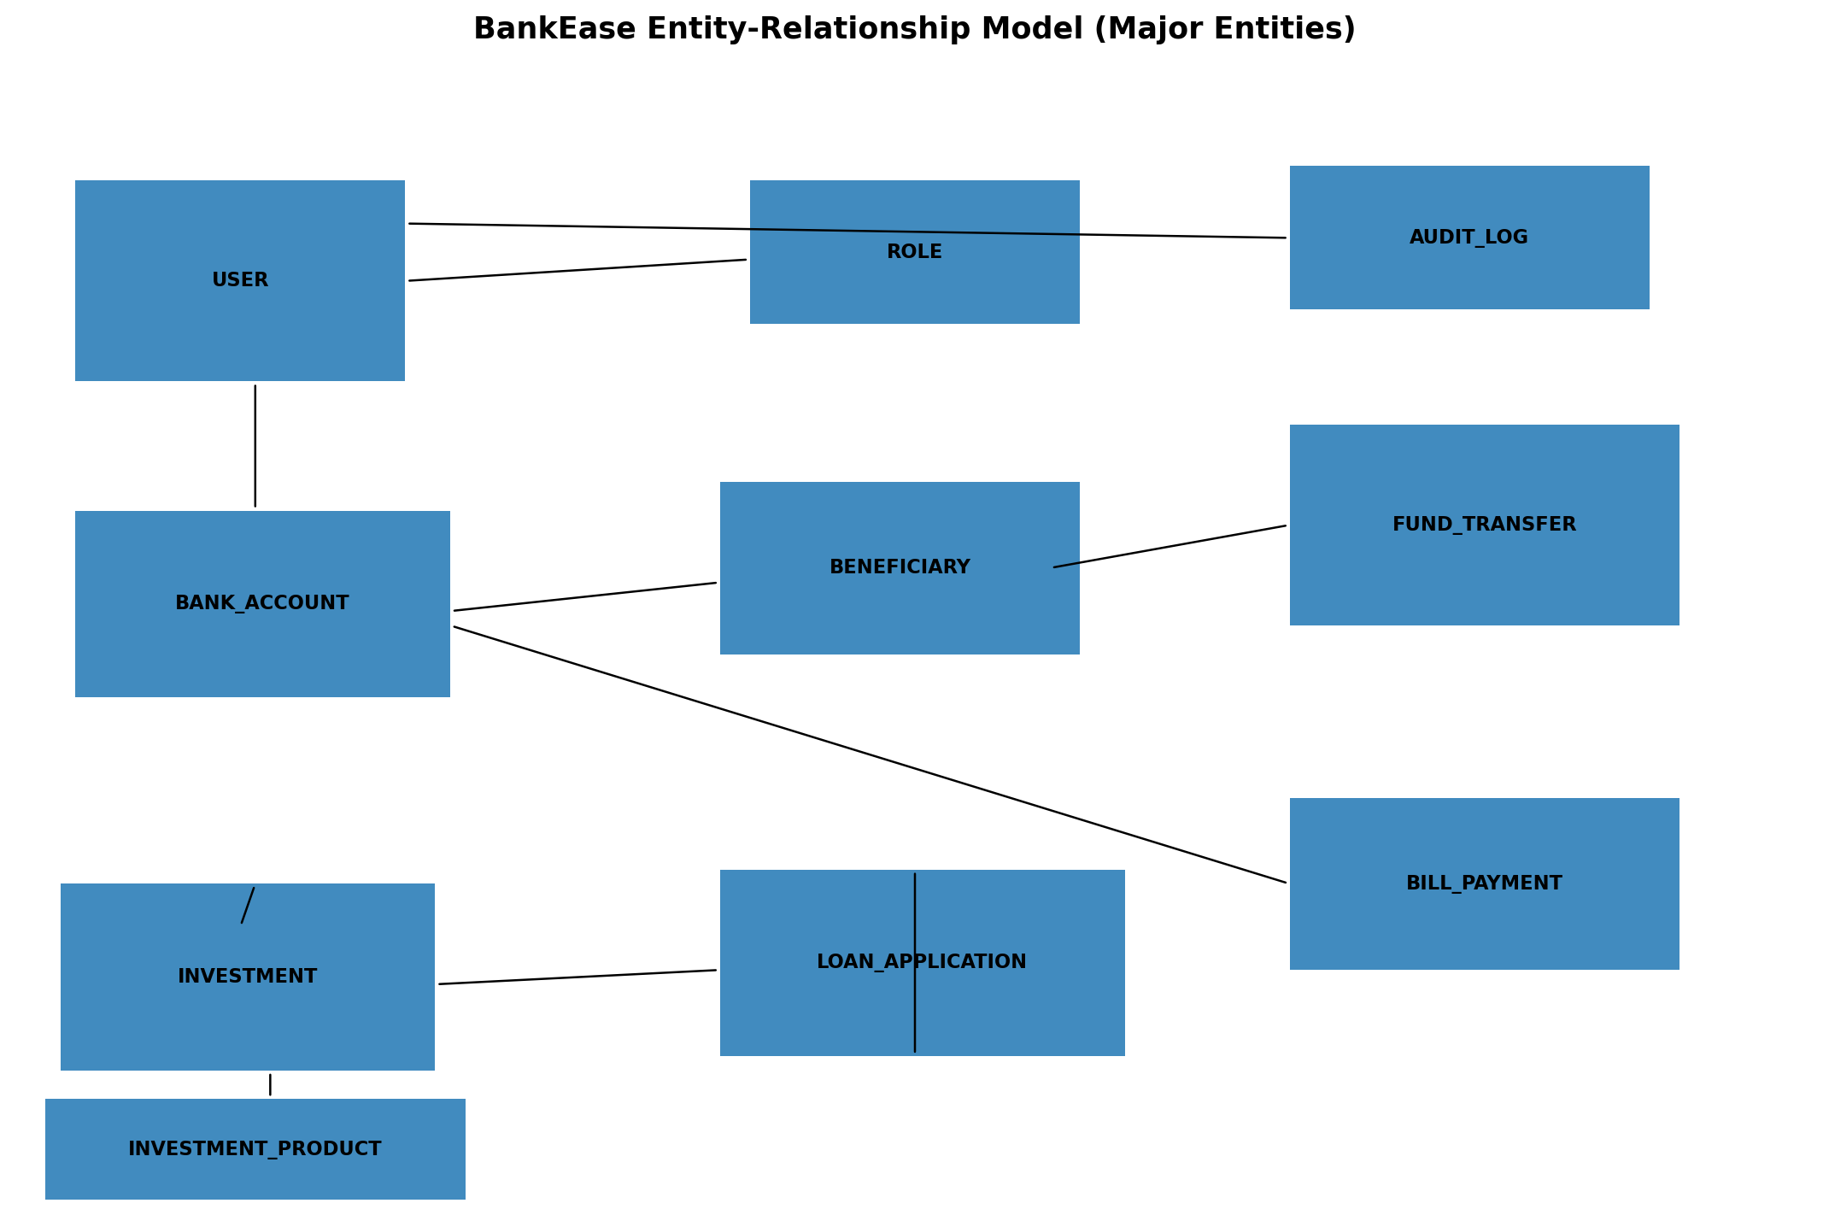
Figure 4. BankEase Entity-Relationship Model
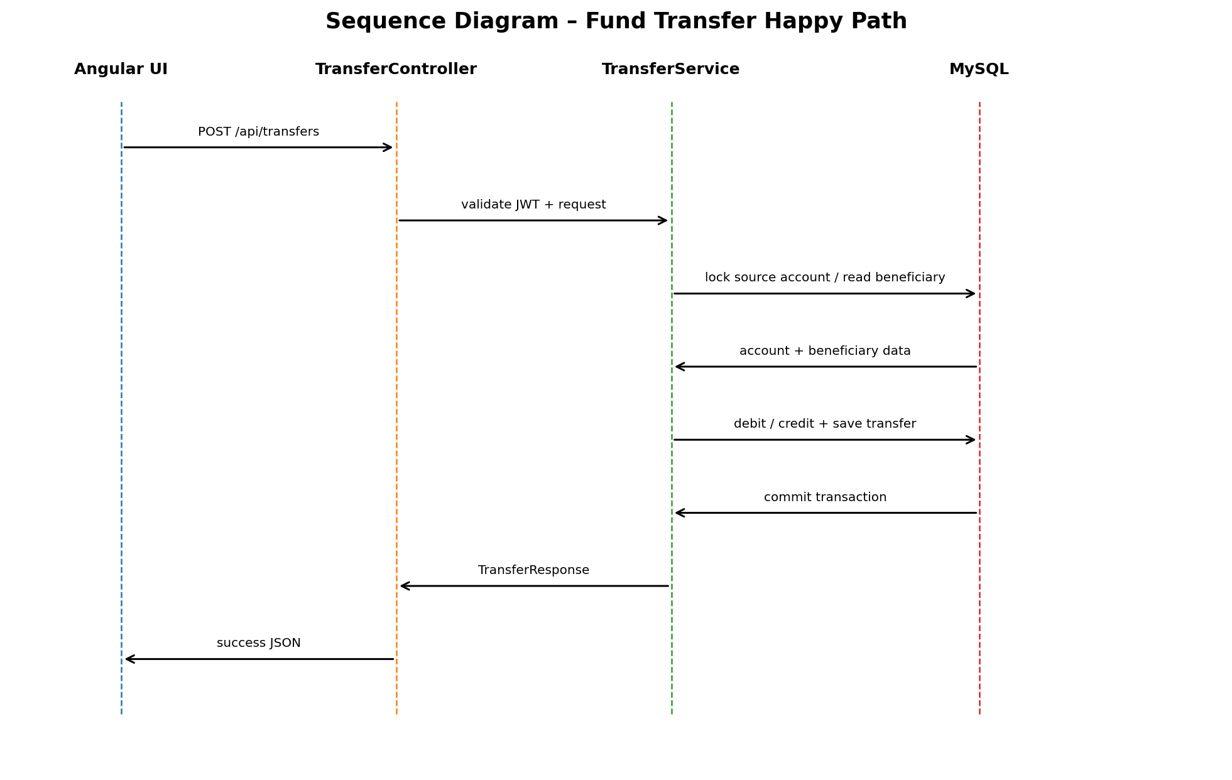
Figure 5. Fund Transfer Sequence Diagram
7. Academic Review & Sign-Off
This Software Requirements Specification document has been submitted and reviewed by the academic supervisory panel:
Project Coordinator / Guide | Internal Examiner | Head of Department (HOD)
Signature: __________________  Date: __________________ | Signature: __________________  Date: __________________ | Signature: __________________  Date: __________________

