**Documentation**

**CSE-112**

**Computer Organization**

**UJJWAL BHAN-2019282,Sec-B**

**Assumption**

-Input address should be of 16 bits.If the length of address is less or greater than 16 then the program will leave the that instruction.

-The instructions should contain only 1 or 2 elements(in case of two they should be separated by a comma) ,If instruction contains more than two elements then the program will leave that instruction.

-The address should be in binary form, if not then the program will leave that instruction.

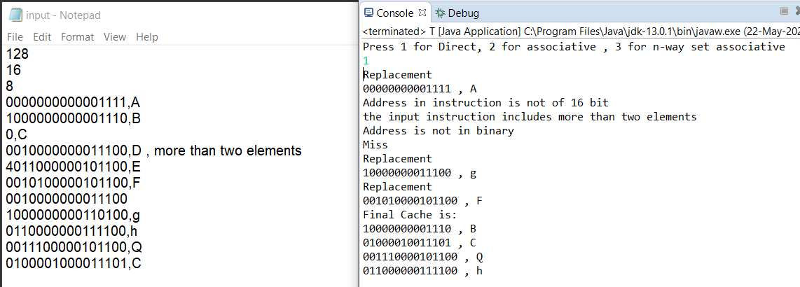

-Cache size , no. Of blocks and no. Of lines should be in the power of 2 otherwise the program will terminate.

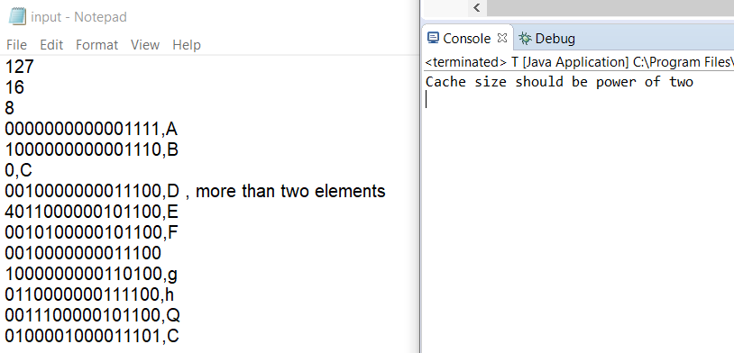

- N(in case of n-way associative mapping)

-should be in power of two

-not equal to 0

-should not be greater than the no. Of lines

otherwise the program will not proceed.

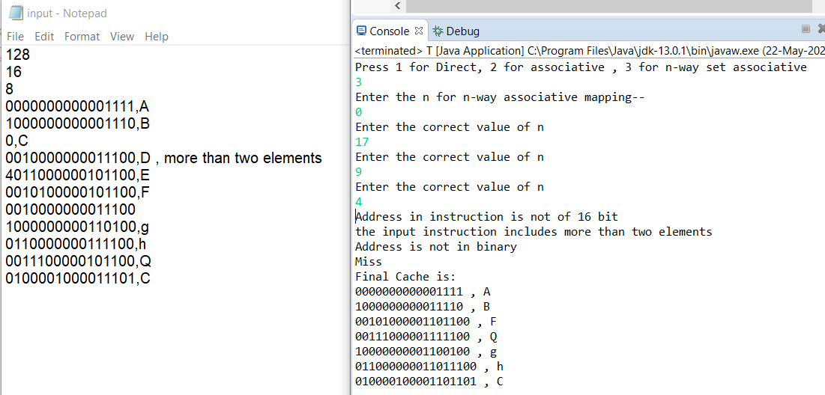

**Design**

-The program contains three functions-

- boolean ispowtwo(int) which returns true if the integer is power of 2

-int powtwo(int)- returns the power of 2

-int dec(string)-converts the string of binary number in decimal

-The program take input from a file ("C:\\Users\\Ujjwal\\Desktop\\input.txt")as well from scanner for choice and for n(in case of n-way associative mapping).

-In associative mapping and n-way associative block replacement is done randomly using random function.

-For Cache 2-D string array is used.

-In case of block replacement the program shows all the replaced data with the address.

-No main memory is used.

-Once the block is replaced it’s data cannot be restored,in the given below output A cannot be restored

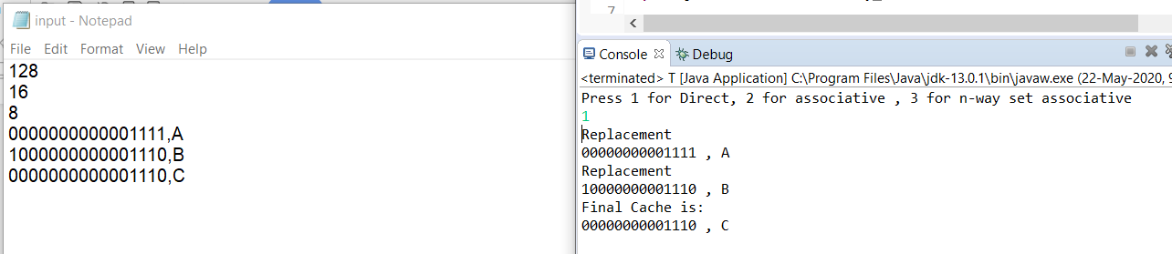

**Input File**

First line -Cache Size

Second Line- No. of blocks

Third Line- No. Of lines

After this each line consist of instructions:

For Read-Address

For Write-Address,Data

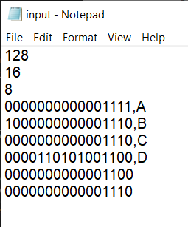

**Sample Input-Output**

1.For Direct Mapping

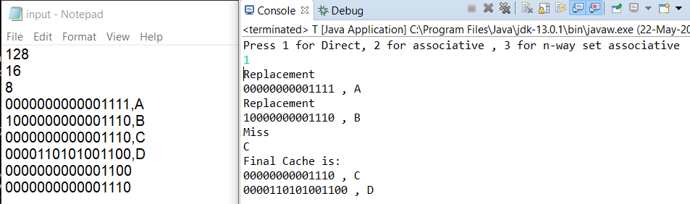

1. For associative mapping

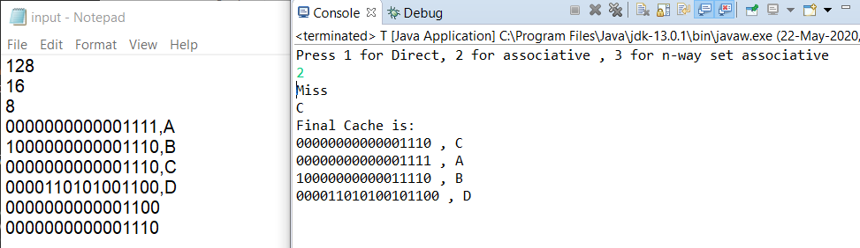

1. For n-way associative mapping

