

FULL CORPORATE OFFER FOR FROZEN CHICKEN PAWS

Date: {{date}} RON/FCO/APR/2026/1377

To
{{buyer_company}}

91/55-56 Moo 10, Khlong Nueng Pathum Thani 12120 Thailand {{buyer_email}}
{{buyer_phone}}

Dear {{buyer_name}},

We, Ronsons Trading FZ- LLC, hereby formally confirm our intent and capability to supply Frozen Chicken Paws, to ACE IMPORT & EXPORTS, THAILAND. We affirm that our company is fully prepared, willing, and able to sell the product strictly in accordance with the specifications, quantities, pricing, and commercial terms outlined in this Full Corporate Offer (FCO). This declaration is issued with full corporate authority and complete responsibility on behalf of our company.

QUANITY & PRICING FOR YEARLY CONTRACT

Contract Quantity | {{contract_quantity}}
Price | {{price}}
Monthly Shipment Value | $ 7,803,000.00 USD
Annual Contract Value | $ 93,636,000.00 USD
Contract Duration | 12 Months
Loading Capacity | Approx. 1,350 cartons per 40ft HC container
Annual Contract Quantity | 2,295 MT x 12 Months ( 27,540 MT ) +/- 5%
Loading Port | Santos Port, Brazil / TBD
Destination Port | CIF Shanghai Port, China
Delivery Time | After Loaded at Port of Loading 40-45 Days

1



PRODUCT SPECIFICATION

CATEGORY | SPECIFICATION
Product Name | {{product_name}}
Grade | Grade A
Origin | Brazil
Origin / Certification | Certified for entry into Mainland China
Processing | Fresh slaughtered, cooled down and frozen immediately after slaughter
Appearance |   No feathers, no skin with nails; outer yellow skin off; white color, no ammonia burns
Odor | No bad smell
Bones | Broken bones not more than 2%
Blood / Blood Stains | No excessive blood or blood stains
Moisture Content | Less than 2%
Damage | No damage
Chicken Paw Pad | Retained
Weight per Piece | 35 gm and up
Length per Piece | 9–12 cm
Packaging | Poly bags
Inner Packing | 5 × 4 kg per bag or 2 × 10 kg per bag
Carton Weight | 20 kg per carton
Freezing Temperature | Blasted at −20°C
Storage Temperature | −18°C
Transportation Temperature | −10°C to −15°C
Freezing Process | BQF
Shelf Life | 12 months from production date
Packaging | Packed in poly bags 20kg/ bag in carton, Net weight of 20kg/ carton
- The shipment shall begin seller’s Bank, after the co  - The Date of bill of Lading  - Seller is responsible for al  - Not later than 72 hours fr the vessel’s sailing date a  - All port of loading charges of the buyer. | PRODUCT DISCHARGE  within 15-20 days after receipt and confirmation of the payment instrument in ntract is signed.  shall be considered the date of delivery.  l supervision, fees and/ or levies at the port of loading.  om the completion of loading, the seller’s agent shall email the buyer and inform nd the expected time of arrival at the port of destination.  are for the account of the seller and all port of discharge charges are for the account  2



COMMERCIAL TERMS

For the Monthly/Yearly Contract Buyer will open an irrevocable, operative, and transferable DLC (MT700) for the value of one month shipment quantity against the proforma invoice & SPA, issued and confirmed by world top 25/50 Banks. Upon completion of loading and issuance of the Bill of Lading, the Seller shall provide copies of the commercial invoice, Bill of Lading, Packing List, and other relevant shipping documents to the Buyer. The Buyer shall remit 100% payment immediately upon confirmation of the above mentioned shipping documents. Payment shall be effected via MT103 / TT bank-to-bank SWIFT transfer. Release of the original Bill of Lading and full set of original shipping documents shall be made only after confirmation of full payment through normal banking channels.

PAYMENT VIA TELEGRAPHIC TRANSFER (TT/MT103)
The Buyer shall effect payment for monthly contract shipments by way of Telegraphic Transfer (TT/MT103) upon receipt of confirmation from the Seller's nominated bank via SWIFT that the original shipping documents have been duly submitted and are held in custody by the bank. The Seller shall, prior to such confirmation, provide the Buyer with scanned/digital copies of all relevant shipping documents for advance review and verification. The Buyer will still be providing DLC MT 700 as a security financial instrument for contract shipments.

DOCUMENTARY LETTER OF CREDIT (DLC/MT700)
The DLC/MT700 shall serve as a supporting financial instrument for the purpose of providing transactional assurance and security to both parties. For the avoidance of doubt, the DLC shall not constitute the primary mode of payment. Actual settlement for each shipment shall be effected exclusively via TT/MT103.

TELEX RELEASE

The Seller shall arrange telex release of the cargo upon receipt of full payment, unless otherwise mutually agreed.



PRODUCT DOCUMENTATION

A full set of the following documents which will be legitimate for shipment from Brazil will be presented.
- Full set of clean on – board marine bill of lading made out to order and blank endorsed, 1/3 clearly marked “Freight Prepaid” in 1 original
- Commercial Invoice issued by the seller indicating the contract number, DLC number, Description of the goods, gross / net weights of the goods in 1 Original.
- Packaging list 1 originals showing contract no., seal no., container no., gross / net weight, B/L no., date. Quantity loaded and loading port.

- Certificate of origin issued by the relevant authority of the country of origin of Brazil in 1 original
- Certificate of Quality and quantity issued by CCIC Brazil, 1 original
- Veterinary health certificate issued by veterinary office for the record of China entry- Exit inspection and quarantine in 1 originals
- Insurance policy/ certificate in 1 original for 110% of the invoice value, covering ocean marine transportation all risk.
- Commodity bilingual English- Chinese label samples in 1 original.
- Slaughterhouse SIF certificate in 1 copy
- Export / shipper certificate of GACC Registration in 1 Copy

PROCEDURES
- The Buyer issues the LOI (Letter of Intent) to the Seller.
- The Seller issues the FCO to the Buyer. Upon acceptance of the FCO, with sign and seal.
- The Buyer issued ICPO.
- The seller issues SPA.
- The buyer provides POF by BCL.
- Once the SPA is signed and sealed seller will issue Proforma Invoice.
- The Seller sends a Proforma Invoice for each monthly shipment value to the Buyer. After signing the SPA and Proforma Invoice, the Buyer’s bank issues the payment to the Seller’s bank in accordance with the contract payment terms.
- The Seller arranges CCIC Brazil inspection for both quality and quantity at the Seller’s expense, completes the shipment, and submits the shipping documents to the Buyer’s bank as per the SPA payment terms to collect payment from the Buyer’s bank at sight.
- The Seller allows the Buyer or the Buyer’s appointed agent to witness the loading at the loading warehouse, at the Buyer’s expense.
- 100% payment at sight by TT-MT103 upon receipt of original shipping documents at loading port, the Buyer is responsible for customs clearance and unloading of the product at the destination. Any penalties resulting from delayed unloading shall be borne by the Buyer. The Buyer shall notify the Seller in writing of the clearing agents’ name at the time of payment acceptance by the seller’s bank.
- Upon receipt of original shipping documents, the Buyer is responsible for customs clearance and unloading of the product at the destination. Any penalties resulting from delayed unloading shall be borne by the Buyer. The Buyer shall notify the Seller in writing of the clearing agent’s name at the time of payment acceptance by the Seller’s bank.



SELLER DETAILS |  | SELLER BANKING DETAILS
Company Name | Ronsons Trading FZ-LLC | Bank Name | MASHREQ
Address | Compass Building, Al Shohada Road, Al Hamara, Industrial Zone-FZ, Ras Al Khaimah,  United Arab Emirates | Address | Beside AI Hooth Hypermarket-AI Muntasir RD- AI Nakheel-Ras AI Khaimah- United Arab Emirates
Contact Person | Mr. Hirdey Batth | Account Name | RONSONS TRADING FZ-LLC.
Email | ceo@ronsonstrading.com | Account Number | 019101772389
Website | www.ronsonstrading.com | IBAN | AE380330000019101772389
WhatsApp | +1 (604) 613-2109  +971 50 838 0262 | Swift Code | BOMLAEAD


BUYER COMPANY INFORMATION

Company Name | ACE IMPORT & EXPORTS, THAILAND
Address | 91/55-56 Moo 10, Khlong Nueng Pathum Thani 12120 Thailand
Contact Person | Mr. John
Email Address | sreeaecimportexport@gmail.com
Country | Thailand
Phone No. | +66 84 119 7027, +91 93476 02855

BUYER BANK INFORMATION

Bank Name
Bank Address
Bank Swift Code
Account Name
Account Number
Bank Charges: All banking Charges from Buyer’s Bank shall be borne by the buyer, and all banking charges incurred at Seller’s Financier’s Bank will be borne by the Seller Financier’s.
Note: No contact with the Seller’s or Buyer’s bank(s) shall be made without the explicit written permission of the Seller or Buyer. In the event that an alternate bank account is to be used, the Seller and Buyer shall notify each other in writing of the new bank coordinates. Both parties are required to inform each other in advance before forwarding any financial instructions or correspondence to the bank.



Please Note: A final SPA will be signed between End Seller and ACE IMPORT & EXPORTS, THAILAND once this FCO is accepted, signed and sealed by the buyer.

VALIDITY OF OFFER
This FCO remains valid until Monday, 20th April 2026– 5:00 PM (MIDDLE EAST GULF TIME)

AUTHORIZED SIGNATURES



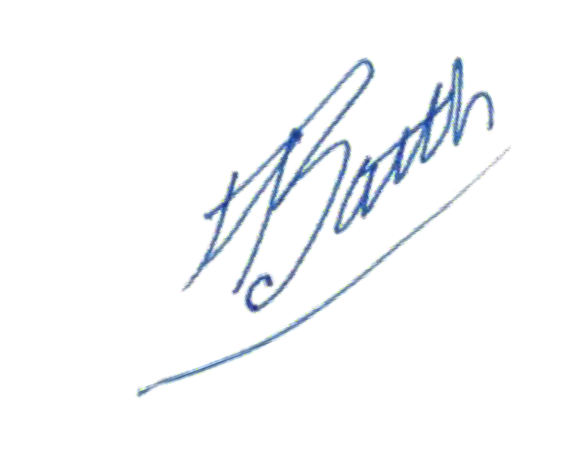
FOR AND ON BEHALF OF RONSONS TRADING FZ- LLC (SELLER)

Mr. Hirdey Batth
Chief Executive Officer Date: 14th April 2026

FOR AND ON BEHALF OF ACE IMPORT & EXPORTS, THAILAND (BUYER)

_________________________ Mr. John
Date:

