Analyze Flights data

Ujjwal

December 31, 2017

load(file=".RData")

load(file=“.RData”)

## R Markdown

This is an R Markdown document. Markdown is a simple formatting syntax for authoring HTML, PDF, and MS Word documents. For more details on using R Markdown see <http://rmarkdown.rstudio.com>.

When you click the **Knit** button a document will be generated that includes both content as well as the output of any embedded R code chunks within the document. You can embed an R code chunk like this:

## Date DayOfWeek DepTime ArrTime   
## Length:1047901 Min. :1.00 Min. : 1 Min. : 1   
## Class :character 1st Qu.:2.00 1st Qu.: 946 1st Qu.:1117   
## Mode :character Median :4.00 Median :1345 Median :1520   
## Mean :3.97 Mean :1368 Mean :1492   
## 3rd Qu.:6.00 3rd Qu.:1750 3rd Qu.:1917   
## Max. :7.00 Max. :2400 Max. :2400   
## NA's :14505 NA's :17285   
## ActualElapsedTime ArrDelay DepDelay Origin   
## Min. :-310.0 Min. :-1302.000 Min. :-1345.00 ORD : 57263   
## 1st Qu.: 58.0 1st Qu.: -3.000 1st Qu.: 0.00 ATL : 47616   
## Median : 82.0 Median : 3.000 Median : 0.00 LAX : 38480   
## Mean : 100.1 Mean : 8.211 Mean : 6.99 DFW : 35349   
## 3rd Qu.: 127.0 3rd Qu.: 13.000 3rd Qu.: 6.00 DEN : 35231   
## Max. :1654.0 Max. : 1033.000 Max. : 1439.00 SFO : 31281   
## (Other):802681   
## Dest Distance Delayed   
## ORD : 57791 Min. : 0.0 Min. :0.00   
## ATL : 47887 1st Qu.: 248.0 1st Qu.:0.00   
## LAX : 38507 Median : 414.0 Median :0.00   
## DEN : 35792 Mean : 590.8 Mean :0.13   
## DFW : 35792 3rd Qu.: 783.0 3rd Qu.:0.00   
## STL : 31620 Max. :4983.0 Max. :1.00   
## (Other):800512

## Including Plots

You can also embed plots, for example:

plot(pressure)

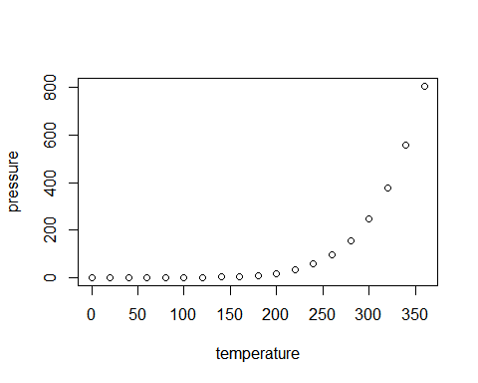

Note that the echo = FALSE parameter was added to the code chunk to prevent printing of the R code that generated the plot.