Mini project

Topic college management system

1914071 ujjwal bana

1914113 ritik gupta

1914121 suyash srivastav

This project “**College Management System**” provides us a simple interface for maintainance of student information.

It can be used by educational institutes or colleges to maintain the records of students easily. Achieving this objective is difficult using a manual system as the information is scattered, can be redundant and collecting relevant information may be very time consuming. All these problems are solved using this project. Throughout the project the focus has been on presenting information in an easy and intelligible manner

**Purpose:**

The objective of Student information System is to allow the administrator of any organization to edit and find out the personal details of a student and allows the student to keep up to date his profile .It’ll also facilitate keeping all the records of students, such as their id, name, mailing address, phone number, DOB etc. So all the information about an student will be available in a few seconds.

**Login module**: Login module will help in authentication of user accounts .Users who have valid login id and password can only login into their respective accounts.

**Search module**: Suppose there are hundreds of students and from this we have to search a particular student and we know the name of the student .In manual system it is a tedious task though we know the name of the student, but using this module we can easily search the student by specifying the name of the student in the search criteria. Thus this module will help the administrator in searching the student with various criteria easily

**Various information is stored in the database**

Student roll

Student password

Student name

Student DOB

Student mailing address

Gender

Contact no

Class

Grade

Remark

**An admin can**

1. **Search for student**
2. **Edit an student**
3. **Delete a student**
4. **Add a student**
5. **See teacher**

**A STUDENT CAN**

**See his/her marks**

**Edit profile**

**See profile**

**Can see their marks in all exams**

**Can see time-table**

Snapshot of pages

HOME PAGE

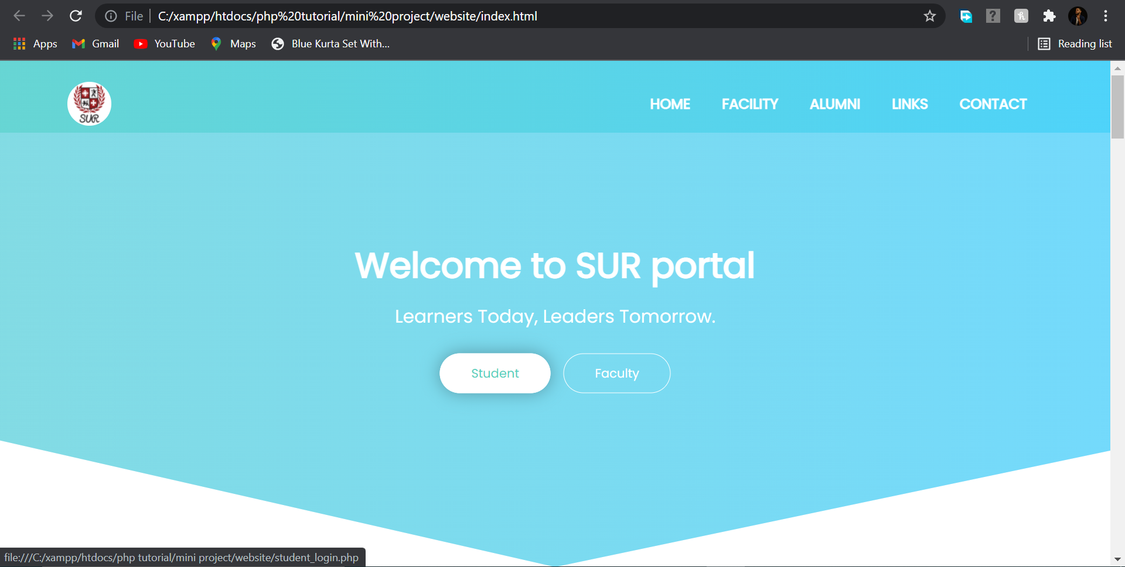

COURSES OFFERED

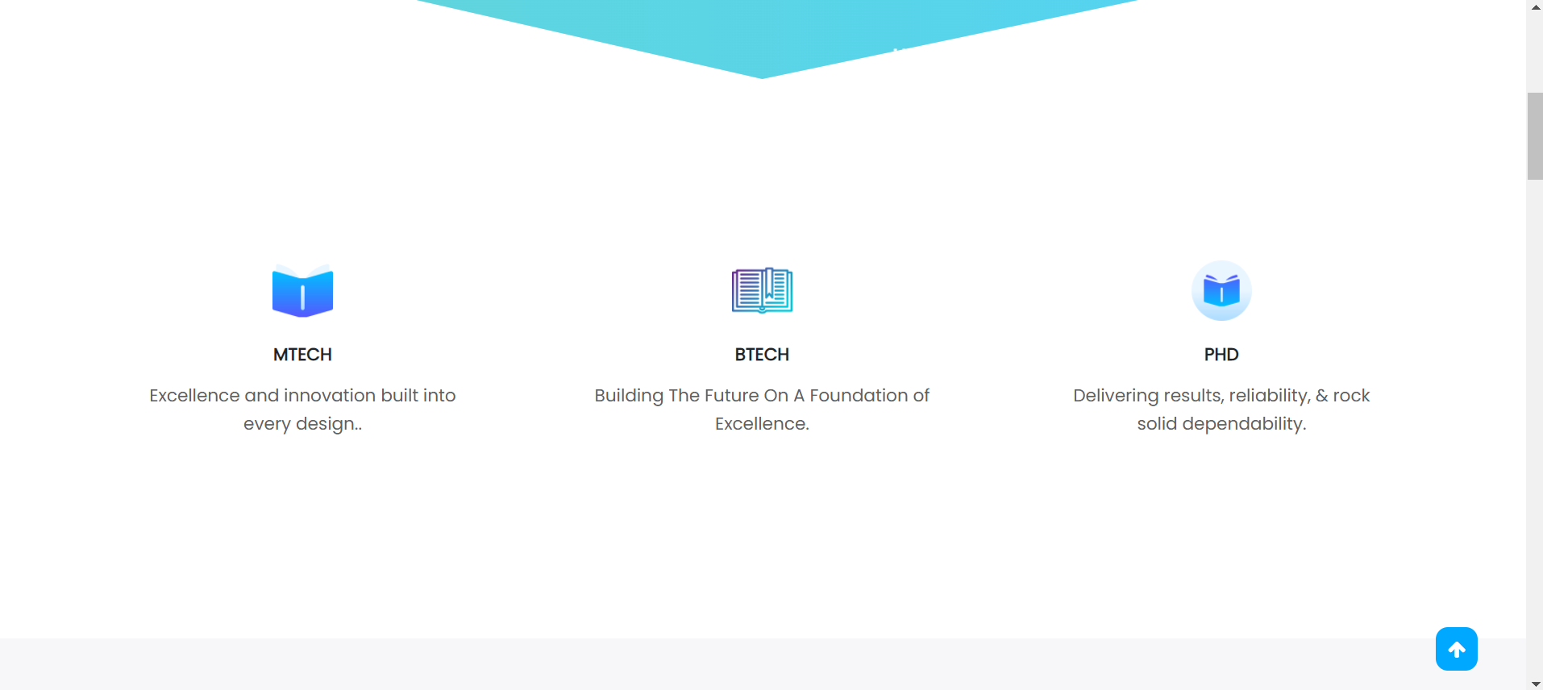

FACILITY OFFERED

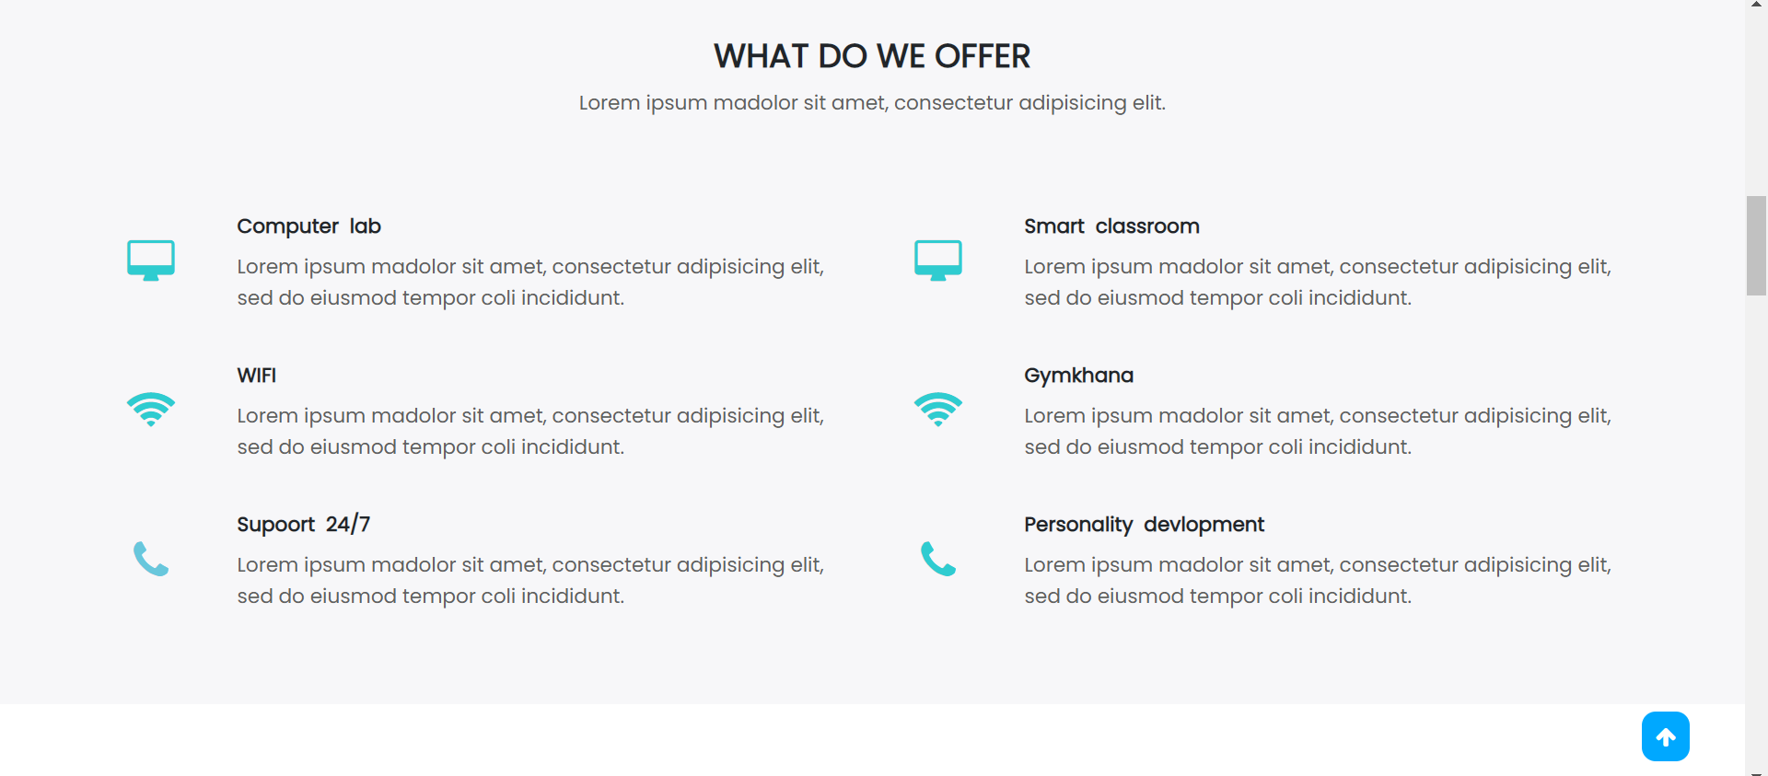

COLLEGE RANKING

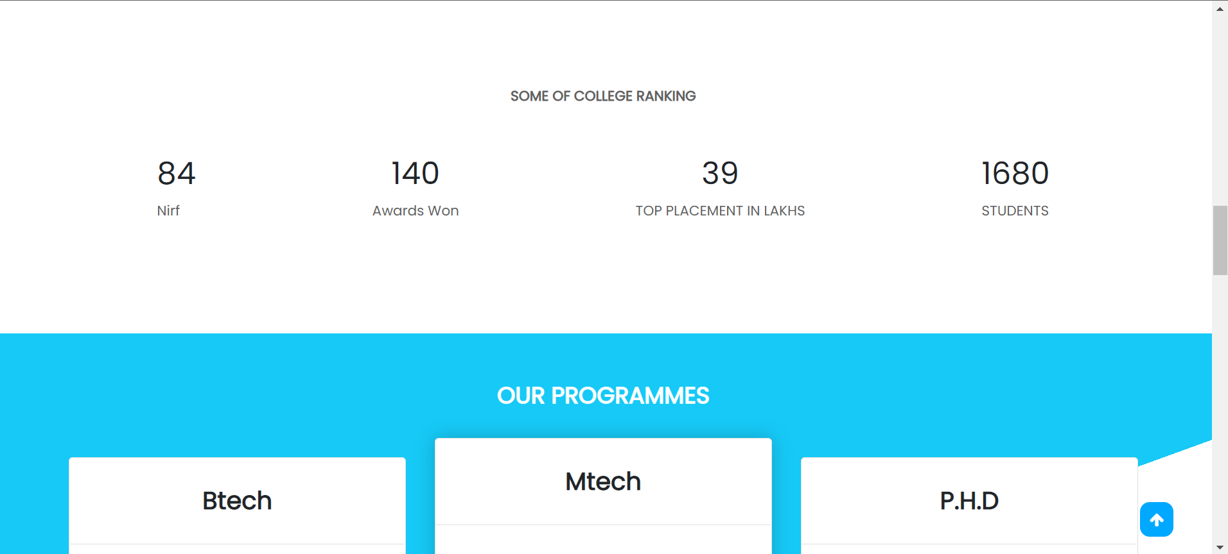

SYLLABUS

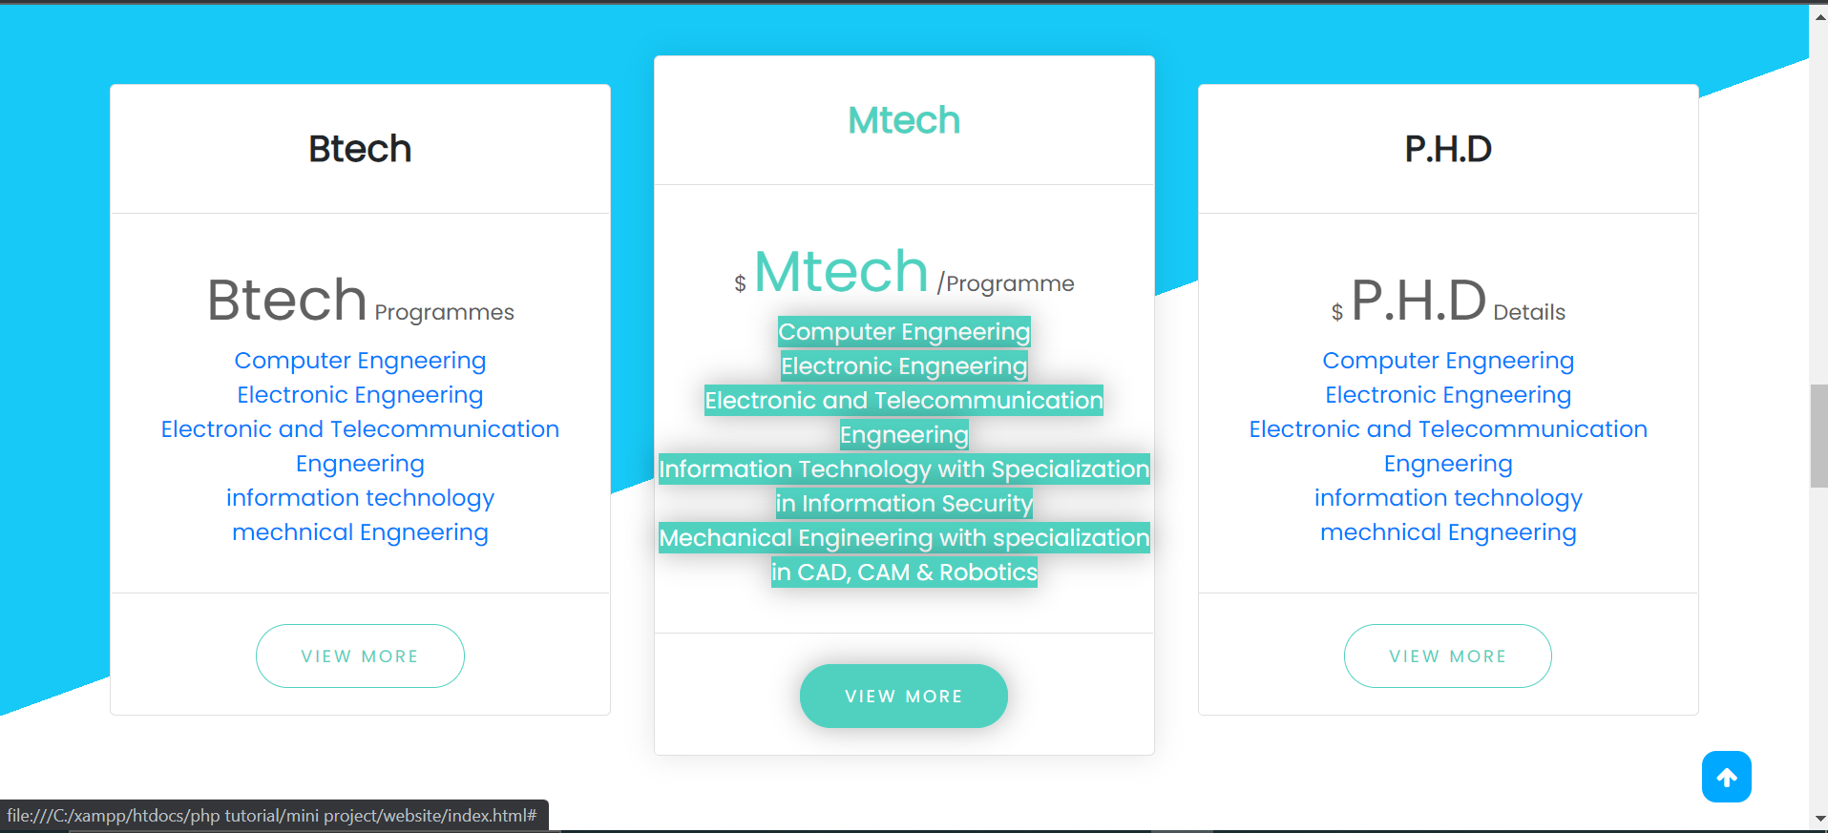

ALUMNI REVIEW

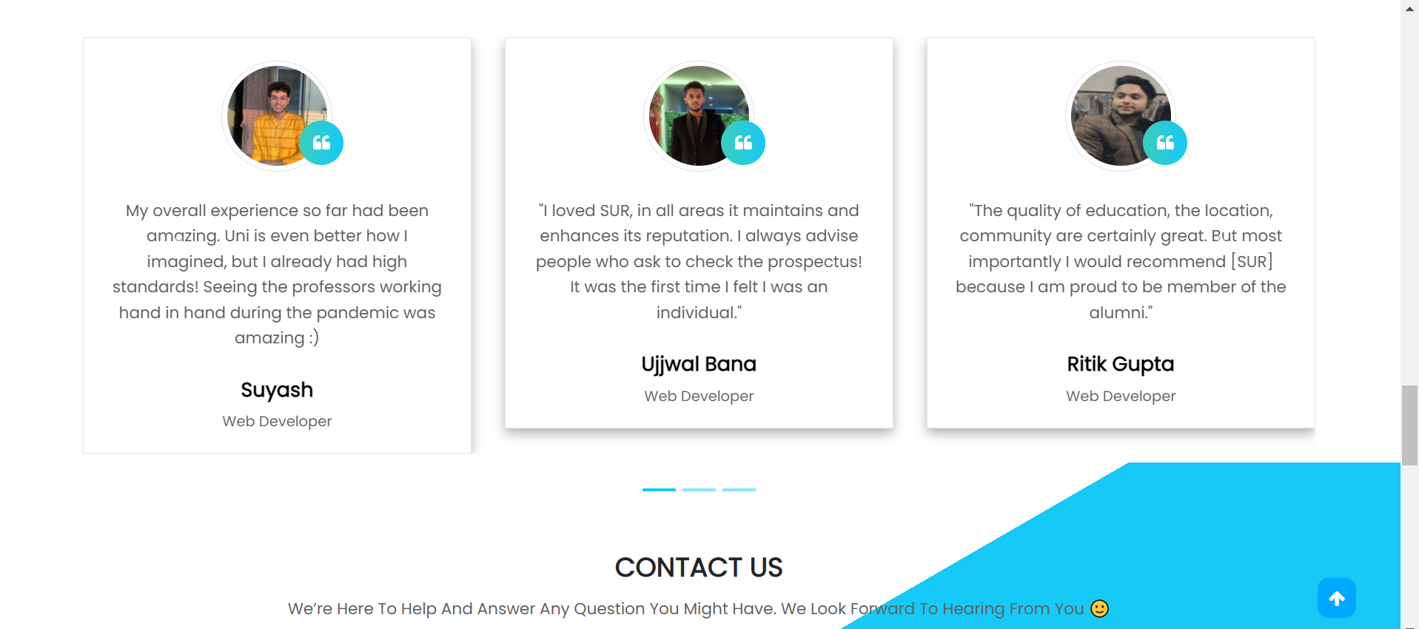

CONTACT US

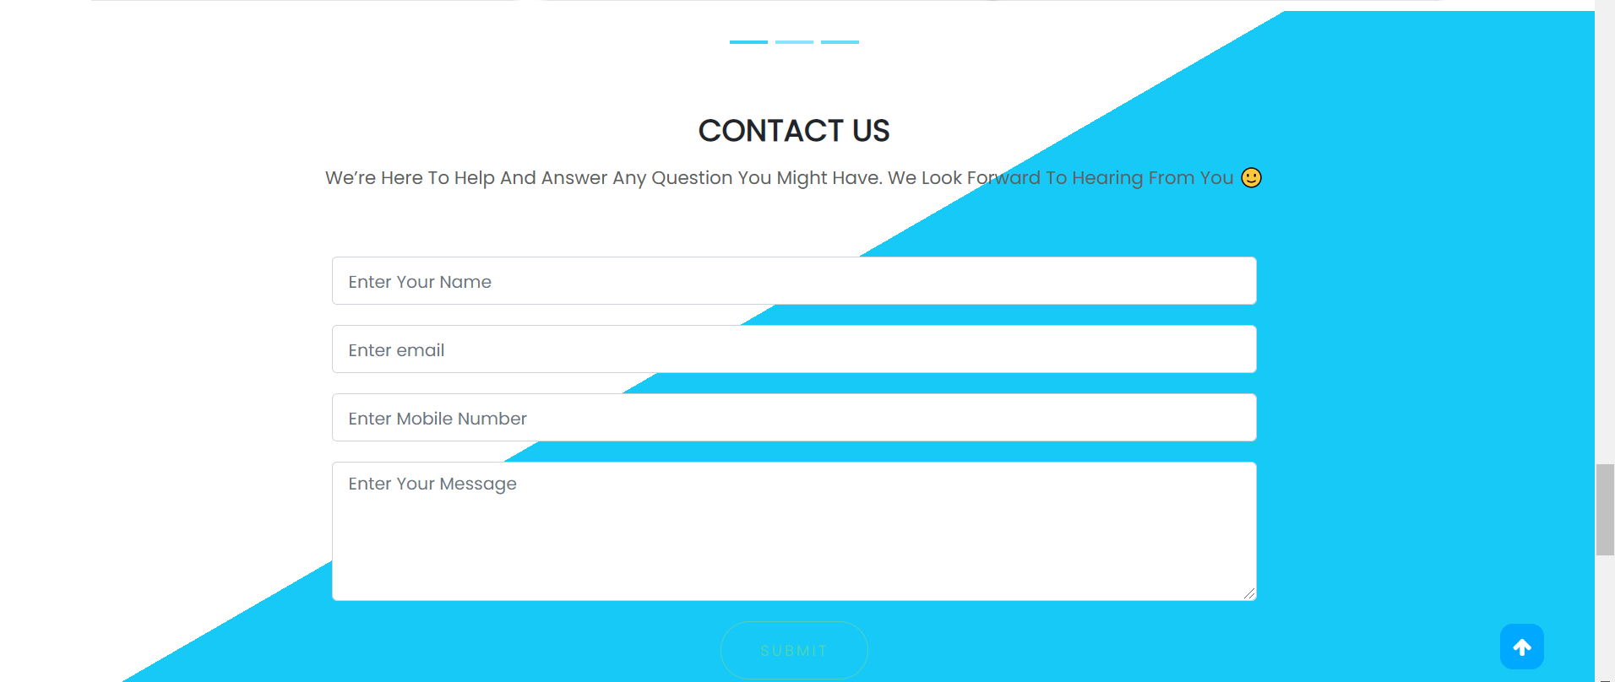

NEWSLETTER AND FOOTER

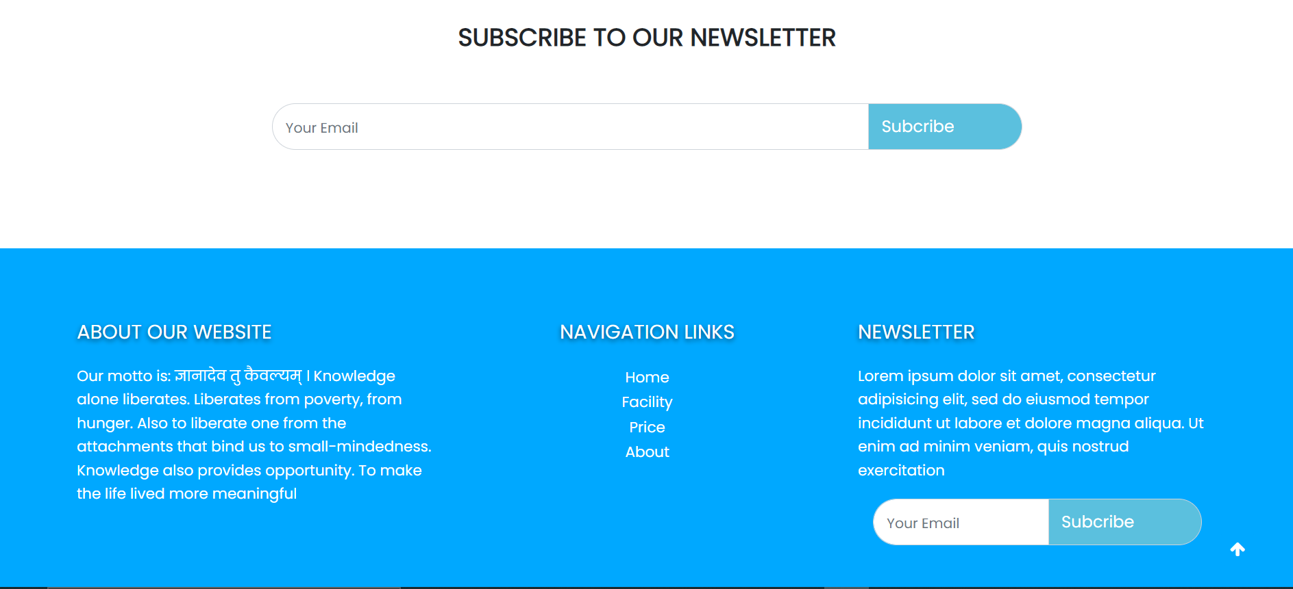

ADMIN PORTAL

LOGIN PAGE

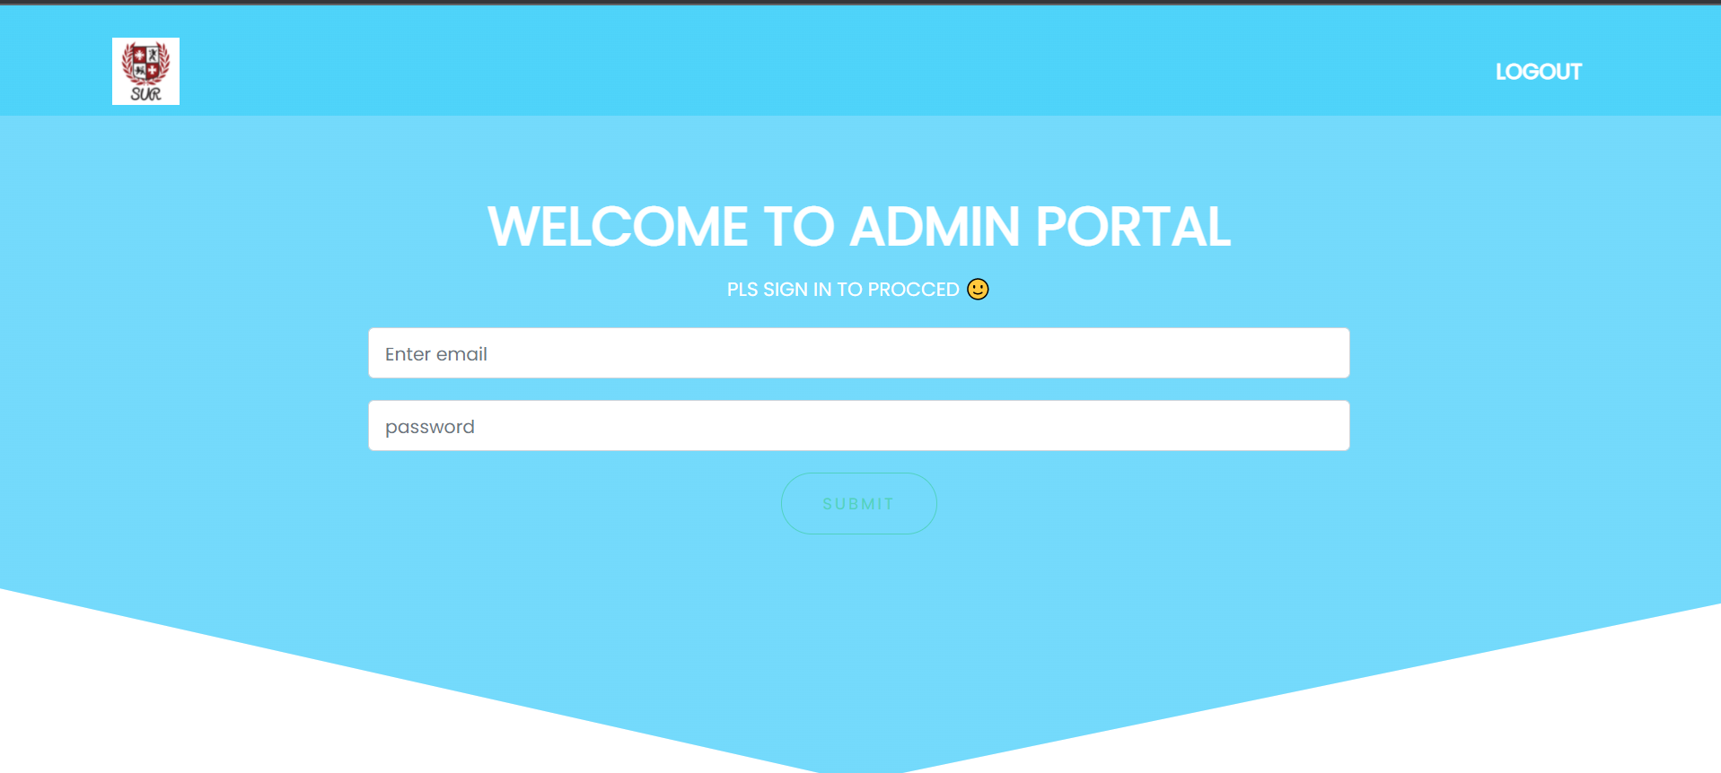

ADMIN DASHBOARD

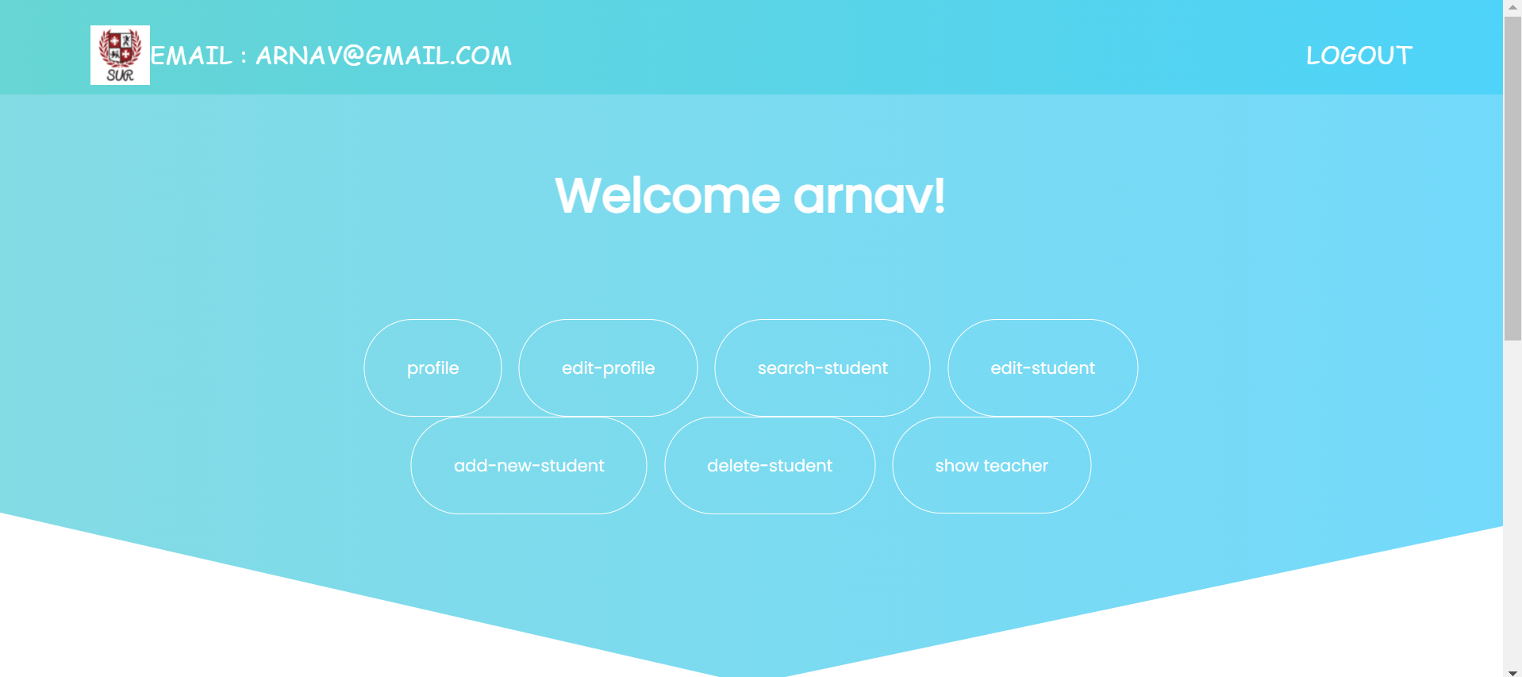

PROFILE PAGE

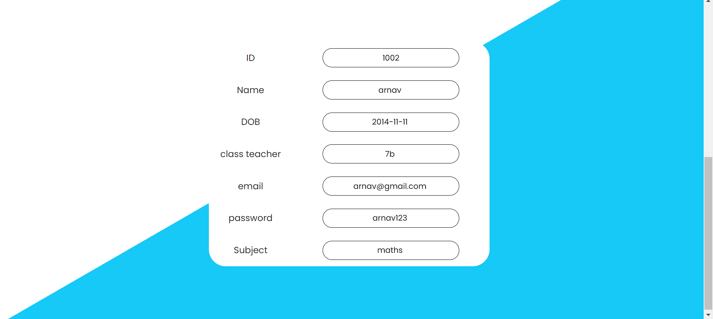

EDIT PROFILE

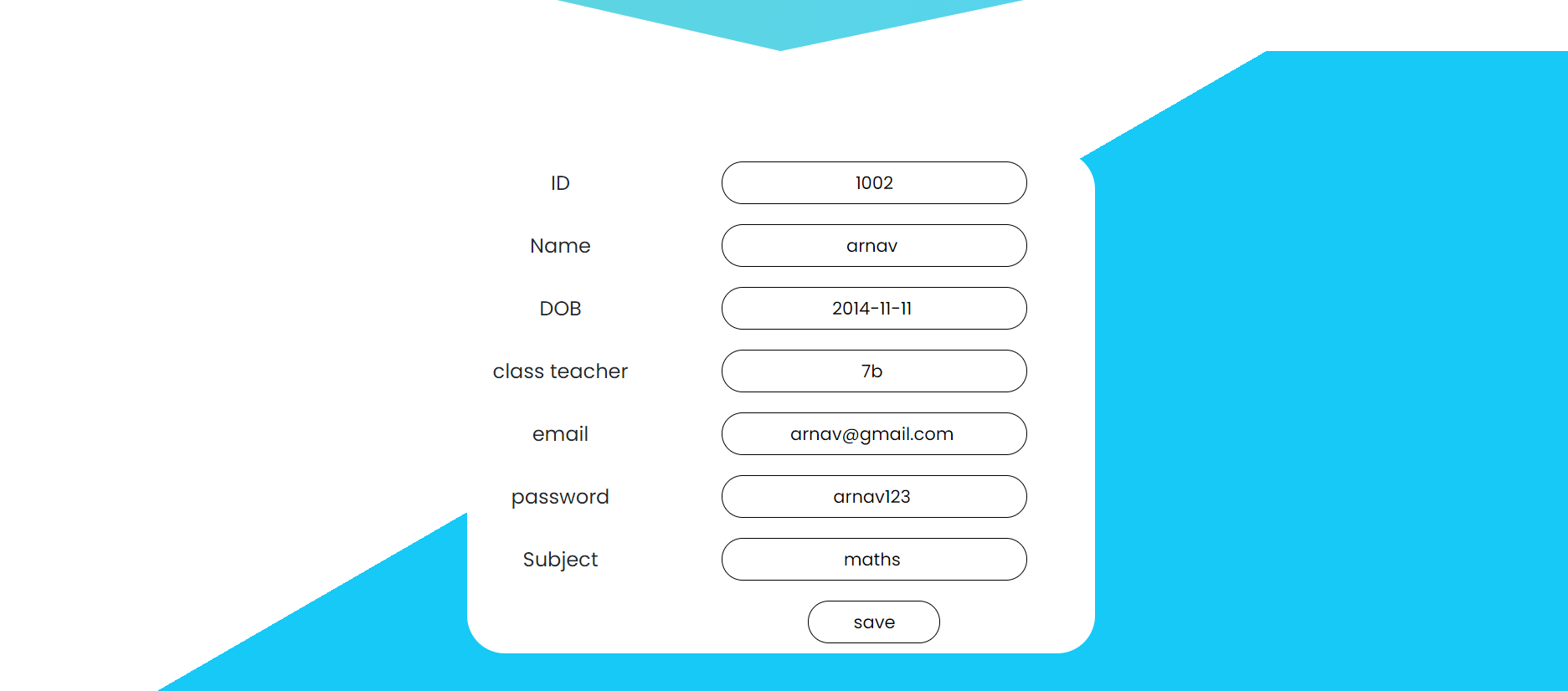

SEARCH STUDENT

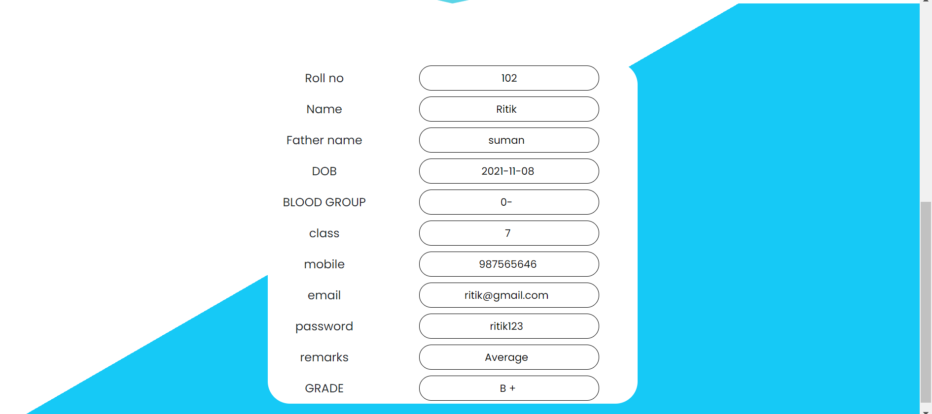

EDIT STUDENT

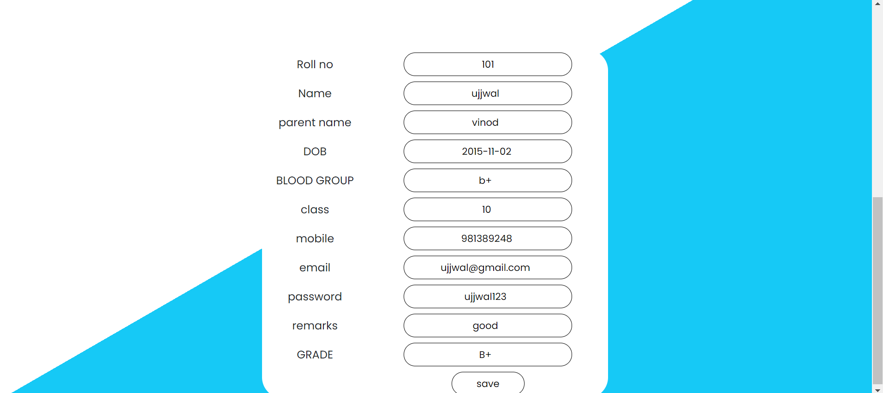

ADD A STUDENT

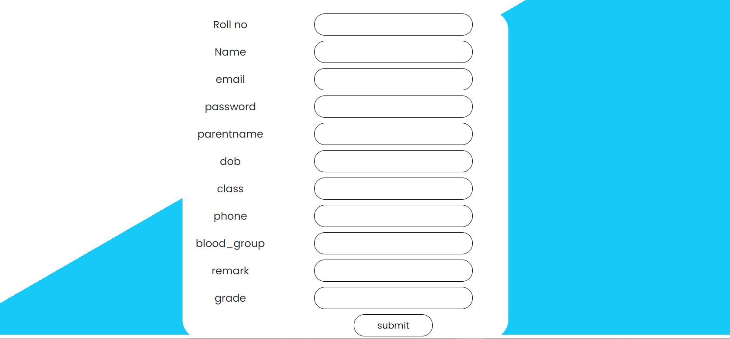

DELETE A STUDENT

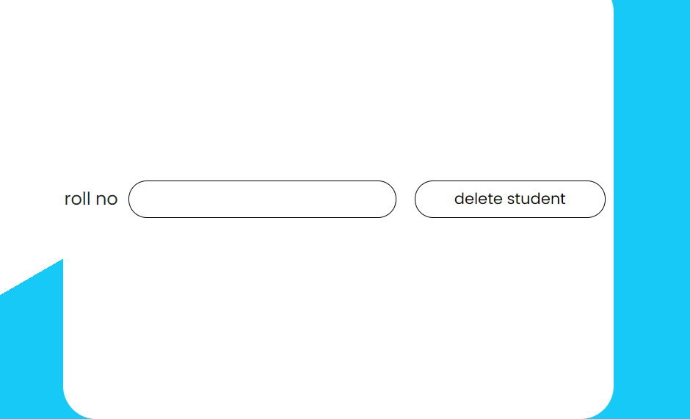

SHOW TEACHER

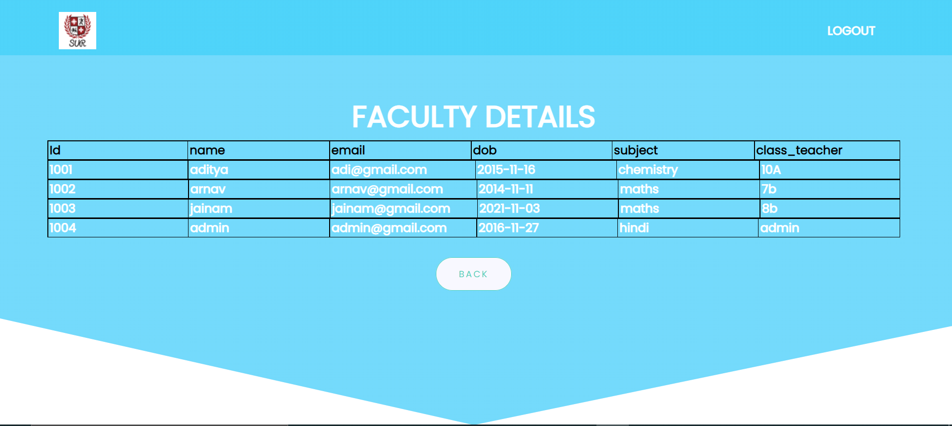

STUDENT PORTAL

STUDENT LOGIN

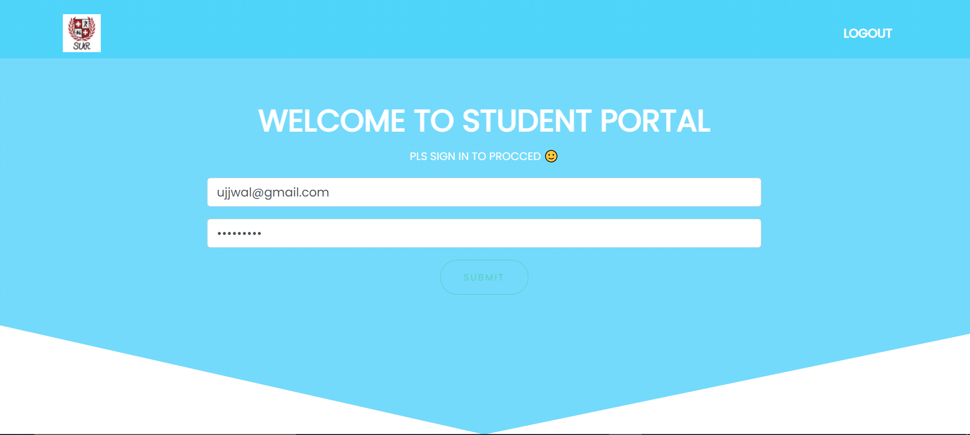

STUDENT DASHBOARD

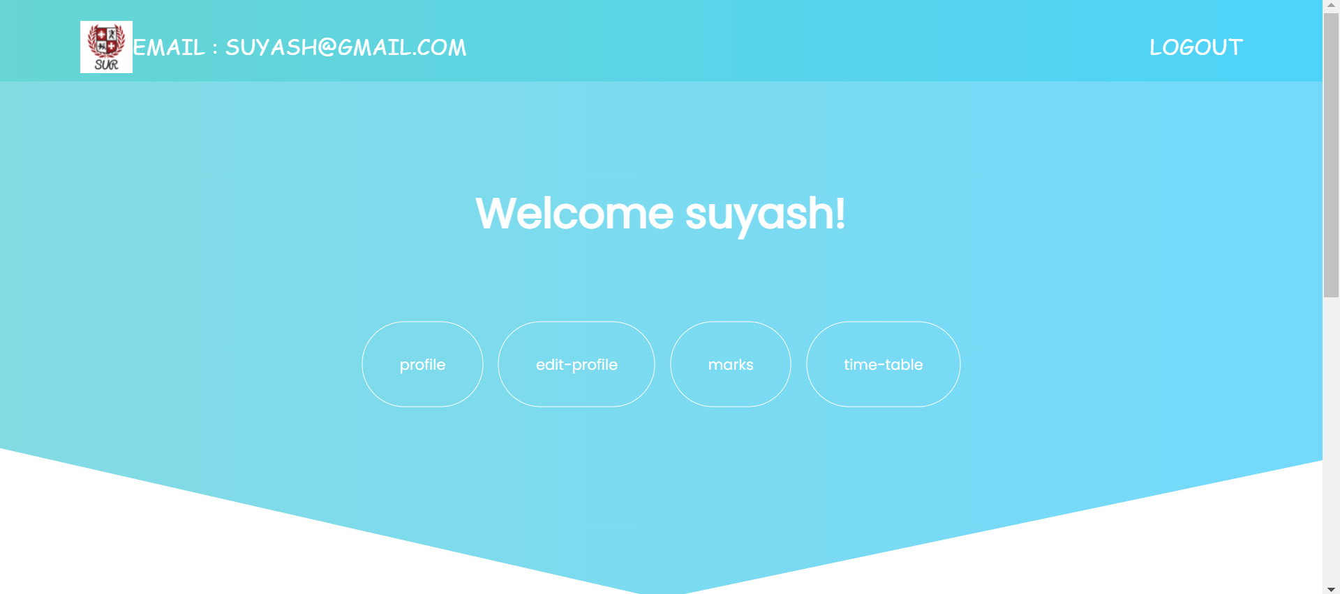

PROFILE PAGE AND EDIT PAGE ARE SAME AS IN ADMIN PORTAL

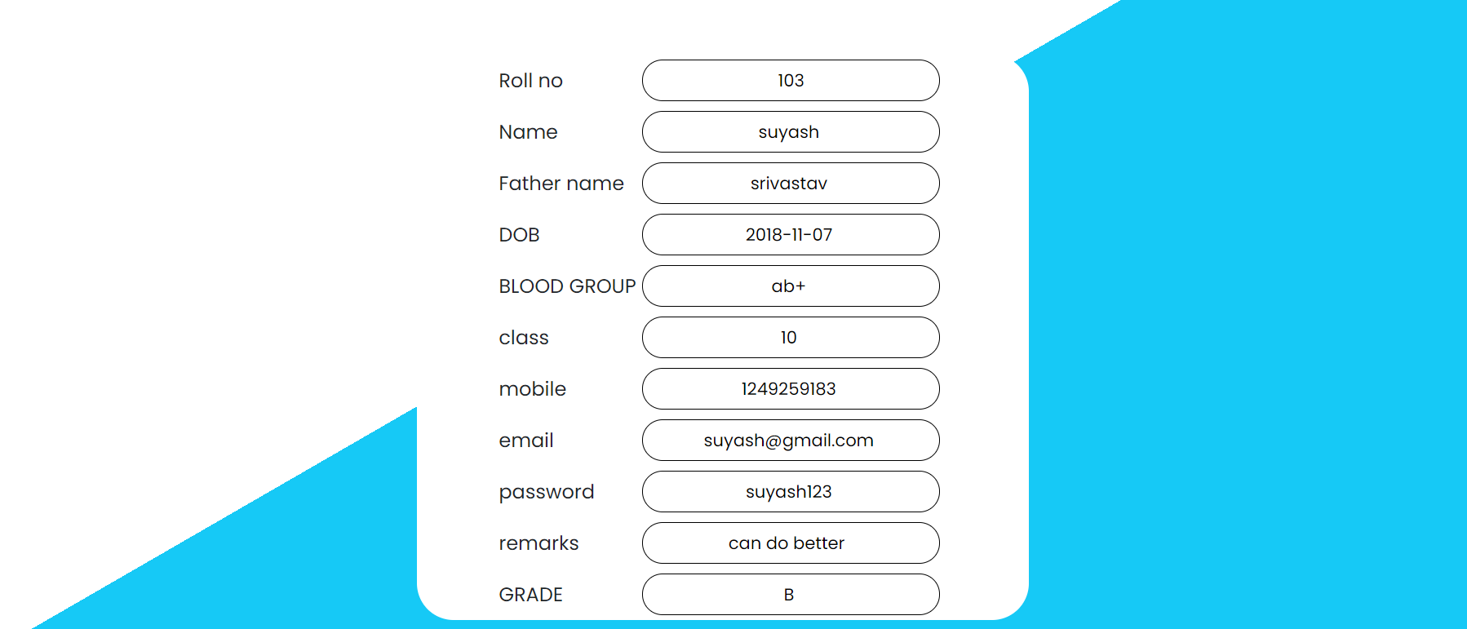

MARKS

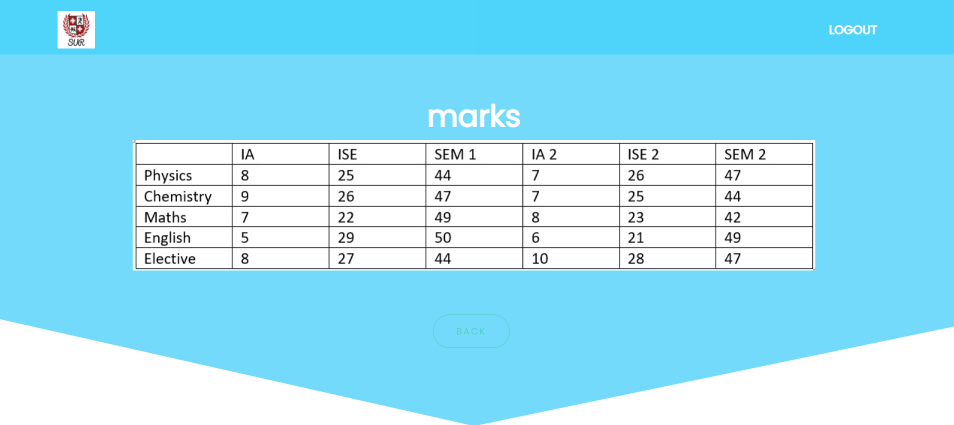

THANK YOU