University of Texas at Arlington

CSE 3330 Database Project 1

By

Shishir Pathak

Ujjwal Bajagain

This document contains Screen shots of some of the codes used in the CSE 3330 Database project.

To review the entire source code please visit https://github.com/ujjwalbgn/cse3330

**Tools Used:**

Database: SQlite3

Programming Language: python

Version Control: Git (GitHub link: **https://github.com/ujjwalbgn/cse3330**)

To recreate the program please follow the README.md associated with this program.

The data was copied to the python script where those data were inserted into the inserted functions which inserted the data into the tables.

Creating Tables:

Function to create table

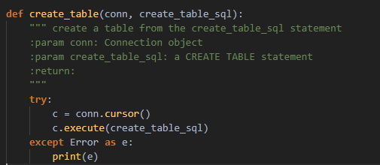

Query for creating table and passing the query into the create table function: 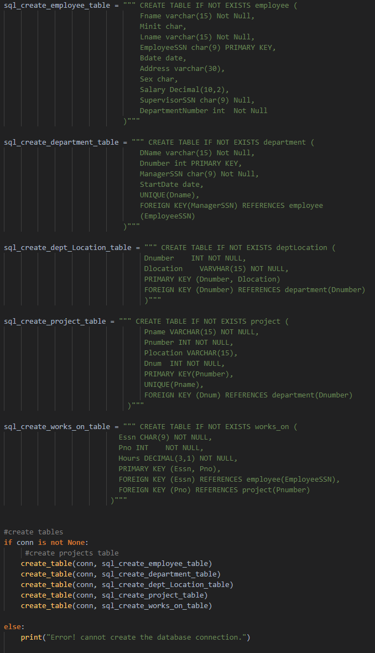

Inserting Data into Tables:

Some of the Inset Functions:

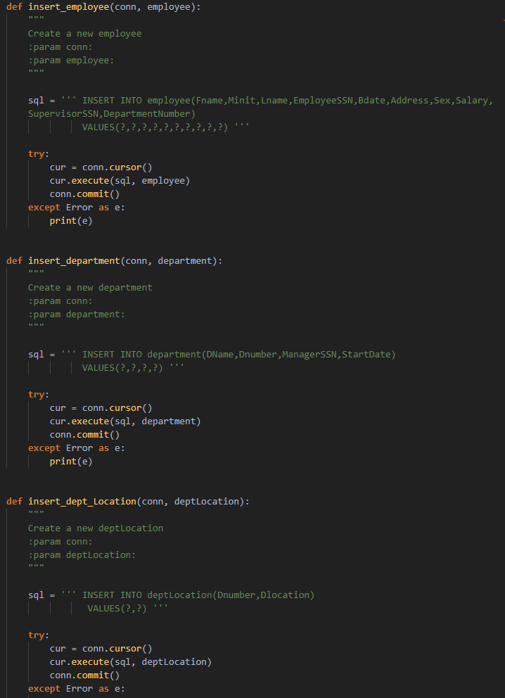

Passing Data into Insert Function:

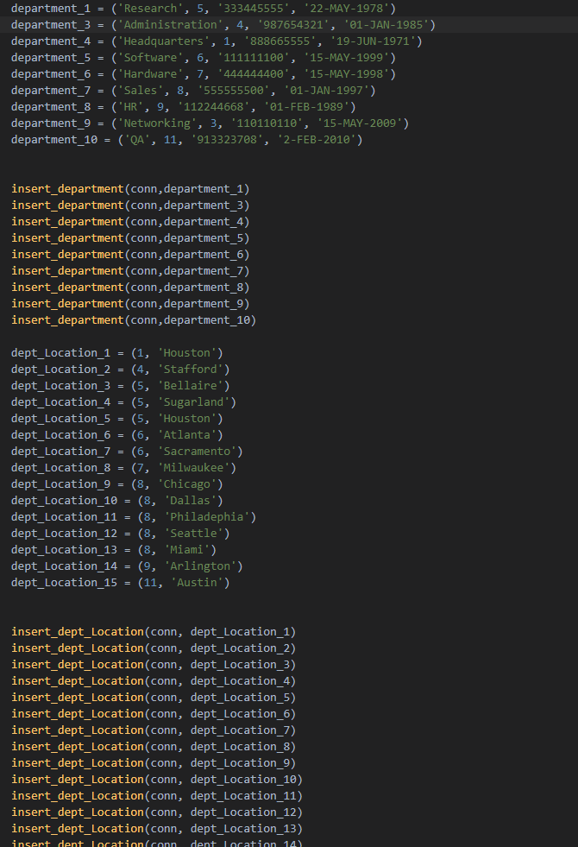

Using department name, and retrieve all the names and salaries of all employees who work

in that department.

Function that runs the query:

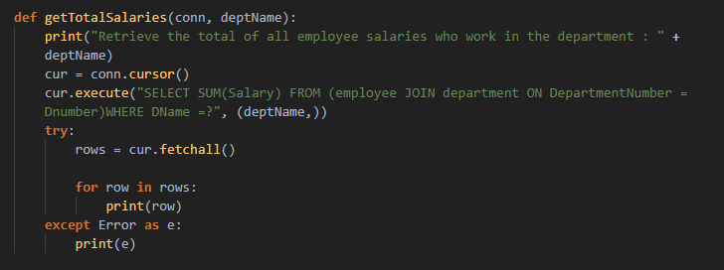

Running the Function:

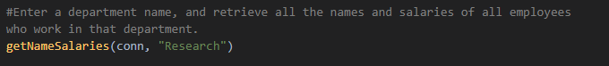

Result:

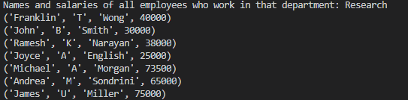

Using employee last name and first name and retrieve a list of projects names/hours per week that the employee works on

Function that runs the query:

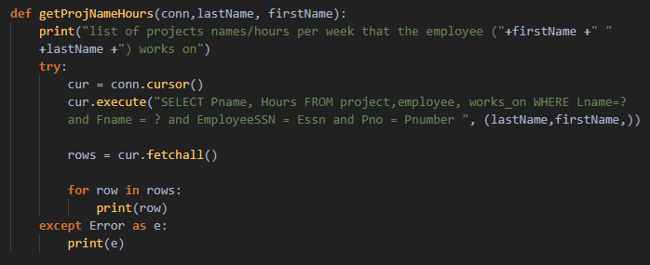

Pass Last Name and First name into the function

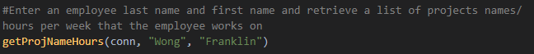

Result

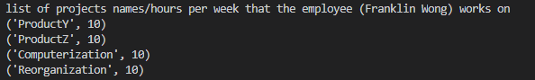

Enter a department name and retrieve the total of all employee salaries who work in the department

Function that runs the query:

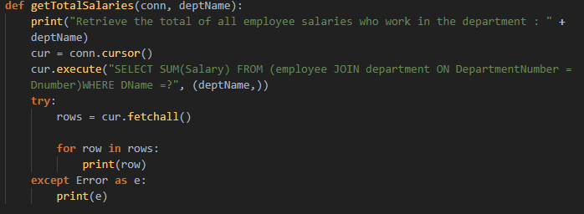

Passing department name into the function:

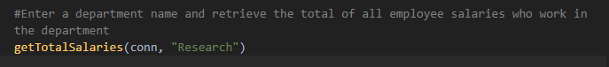

Result:



For each department, retrieve the department name and the number (count) of employees who work in that department. Order the result by number of employees in descending order

Function that runs the query:

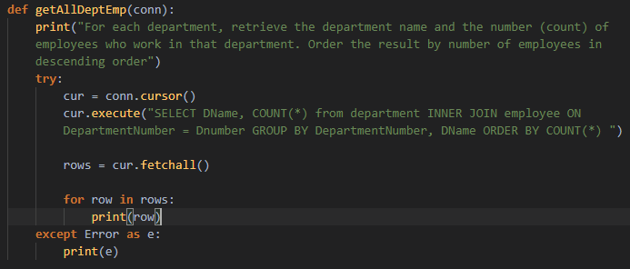

Calling the function:

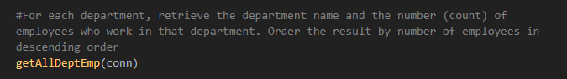

Result:

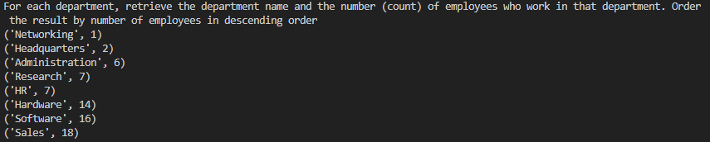

For each employee who is a supervisor, retrieve the employee first and last name and number (count) of employees that are supervised. Order the result in descending order.

Function that runs the query:

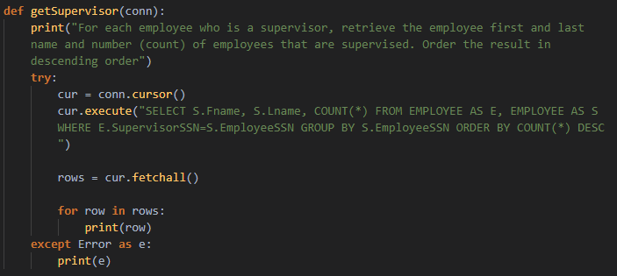

Calling the function:

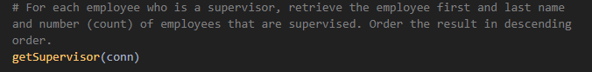

Result 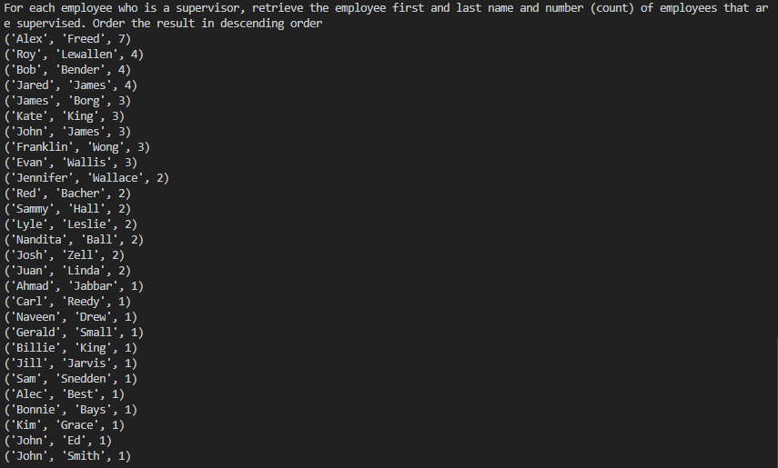

Our group have two members.

Shishir Pathak worked on insertion and creation of tables while Ujjwal Bajagain assisted with creation of tables however, focused mostly on querying the data. We worked closely as a team. We used GitHub as version control.