|  |  |  |  |  |  |  |  |  |  |  |
| --- | --- | --- | --- | --- | --- | --- | --- | --- | --- | --- |
|  |  | **MUNGI ENGINEERS PVT LTD B12** | | | |  |  | **ORIGINAL FOR RECIPIENT** | | |
|  |  |  |  |  |  |  |
|  |  | B-12, PHASE-IICHAKAN INDUSTRIAL AREA, CHAKAN - 410501 | | | | |  |  |  |  |
|  |  | **C.I.N. : U28910MH2004PTC146663** | | | |
|  |  |  | Tel. : / | Fax : | |  |
|  |  |  |  | **PAN No. :**AAECM0828M | | |  |
|  |  |  |  |  |  |  |  |
|  | E-mail:corporate.marketing@mungiindia.com | | | Website : www.mungigroup.com | | |  |  |  |  |
|  |  |  |  | **TAX INVOICE** | |  |  |  |  |  |
|  |  | |  |  |  | | |  |  |  |
|  | **GSTIN Number :** | | 27AAECM0828M1Z9 |  | **Vendor Code :** | | | M73521 |  |  |
|  | **Transportation Mode :** | | BY ROAD TEMPO |  | **Invoice Number :** | | | **1926002121** | |  |
|  | **Place of Supply :** | | PUNE |  | **Invoice Date :** | | | **15/04/2019** |  |  |
|  | **Commodities :** | | M.V. PARTS |  | **Date & Time of Supply :** 15/04/2019 | | | | 7:50:43 am | |
|  | **HSN / SAC Code No. :** | | 87081090 |  | **Vehicle No :** |  |  | MH-14-EM-9205 | |  |
|  | **Tax Is Payable On Reverse Charge : No** | | |  | **L.R. No :** |  |  |  |  |  |
|  |  |  |  |  | **Order No. & Date :** | | | 1510193639 | 24/04/2018 | |
|  |  | | |  |  | | | | | |
|  | **Details of Receipient (Billed to)** | | |  | **Details of Consignee (Shipped to Address of delivery)** | | | | | |
|  | TATA MOTORS LIMITED | |  |  | TATA MOTORS LIMITED | | |  |  |  |
|  | PASSENGER CAR BUSINESS UNIT, | | |  | PASSENGER CAR BUSINESS UNIT, | | | |  |  |
|  | SECTOR NO.15&15A, PCMTDA, CHIKHALI, | | |  | SECTOR NO.15&15A,,PCMTDA, CHIKHALI, | | | | |  |
|  | DIST PUNE,410501 | |  |  | DIST PUNE,410501 | | |  |  |  |
|  | MAHARASHTRA | | 27 |  | MAHARASHTRA | | | 27 |  |  |
|  | GSTIN : 27AAACT2727Q1ZW | | |  | GSTIN : 27AAACT2727Q1ZW | | | |  |  |
|  | |  |  |  |  |  | |  |  |  |
| **Sr. No.** | | **Part No.** | **Name of Goods** | **Qty Unit** | | **Rate Rs.** | | **Total** | **Disc.** | **Value Rs.** |
|  | 1 | 2853 2651 0123 | TOP COVER COMPLETE ASSY | 150.00 NOS | | 1231.13 | | 184669.50 | 0.00 | 184669.50 |

|  |  |
| --- | --- |
|  | BASIC VALUE |
|  | DISCOUNTED VALUE |
|  | TRANSACTION VALUE |
|  | CGST |
|  | SGST |
|  | SUB TOTAL |
| 9076745717 | ROUNDING |



|  |  |  |  |
| --- | --- | --- | --- |
|  |  |  | 184669.50 |
|  |  |  | 184669.50 |
|  |  |  | 184669.50 |
| @ | 14.00 | % | 25853.73 |
| @ | 14.00 | % | 25853.73 |
|  |  |  | 236376.96 |
|  |  |  | 0.04 |

|  |  |
| --- | --- |
| **INVOICE TOTAL Rs.** | **236377.00** |

**TOTAL INVOICE VALUE (IN WORDS) Rs. :** Two Lac Thirty Six Thousand Three Hundred Seventy Seven Only.

**TOTAL GST Amt. (IN WORDS) Rs.** Fifty One Thousand Seven Hundred Seven paise Fourty Six Only.

**Electronic Reference Number** 241098140283 **Date & Time of Removal :** 15/04/2019 7:50:43 am

**Certified that the particulars given herein above are true and correct and the amount indicated in this invoice represents the price actually charges by us and that there is no additional consideration following directly or indirectly from such sales over & above what has been Declared.**

**I/We hereby certify that my/our registration certificate under the GSTIN Act. 2017 is in force on the date on wich the supply of the goods specified in this Tax Invoice is made by me/us and that the transaction of sale covered by this tax Invoice has been effected by me/us and it shall be accounted for in the turnover of sale while filling of return and the due tax, if any, payable on the sale has been paid or shall be paid.**

**All Transactions are Subject to Mumbai Jurisdiction. E. & O.E.**

**FOR MUNGI ENGINEERS PVT LTD B12**

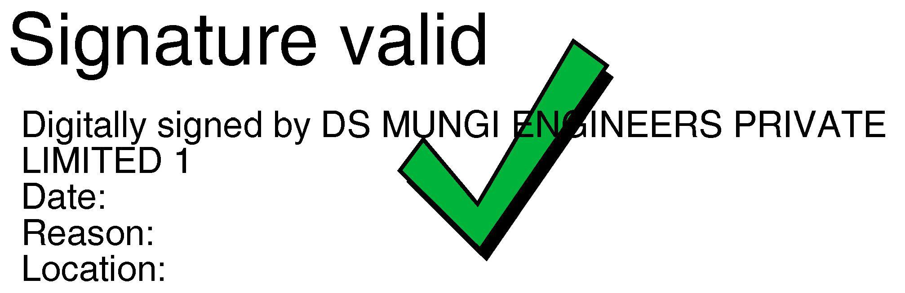

15-04-2019 9:52:51

PUNE

**Receiver's Stamp & Signature** **Authorized Signatory**

**Regd. Office : Unit No. 132, 1st Floor, Hubtown Solaris, N.S. Phadake Marg, Opp Teli Galli, Andheri (E) Mumbai - 400069. Maharashtra, INDIA.**