Complaint Resolution System

Table of Contents
1. Introduction
1.1 Purpose
1.2 Document conventions
1.3 Intended Audience
1.4 Project Scope

2. Overall Description
2.1 Product Perspective
2.2 Product Features
2.3 User Classes and Characterstics
2.4 Operating Environment

3. System Features
3.1 Description and priority
3.2 Stimulus/Response Sequence

4. External Interface Requirements
4.1 User Interfaces
4.2 Hardware Interfaces
4.3 Software Interfaces
4.4 Communications Interfaces

5. Non-Fuctional Requirements
5.1 Performance Requirements
5.2 Safety Requirements
5.3 Security Requirements
5.4 Software Quality Attributes

1. INTRODUCTION

1.1 PURPOSE
The purpose of this document is to build complaint resolution system for stock trading company.

1.2 DOCUMENT CONVENTIONS
This document uses the following conventions.

CSR Customer Service Representative
DB Database

1.3 INTENDED AUDIENCE
This project is a prototype for the complaint resolution system and it is restricted within the organization . This project is useful for the customer support team and as well as to the customers.

1.4 PROJECT SCOPE
The purpose of the complaint resolution system is to ease customer issues and to create a convenient and easy-to-use application for customer and support team, trying to resolve complaints. The system is based on a relational database with its complaint registartion and resolution function. Above all, we hope to provide a comfortable user experience along with the best resolution available.

2. DESCRIPTION

2.1 PRODUCT PERSPECTIVE
A distributed database system stores the following information.
- Customer description:It includes customer Acc.No, name, address, phone number and email Id. This information may be used for keeping the records of the customer for any other kind of information.
- Complaint Log: It includes the customer Account Number, randomly generated unique request Id, catagory of the complaint and description.
- Issue table: It includes Request id, Customer Account Number, customer email Id, complaint status, complaint description and comments.

2.2 PRODUCT FEATURES
The major features of complaint resolution system as shown in below flow chart.
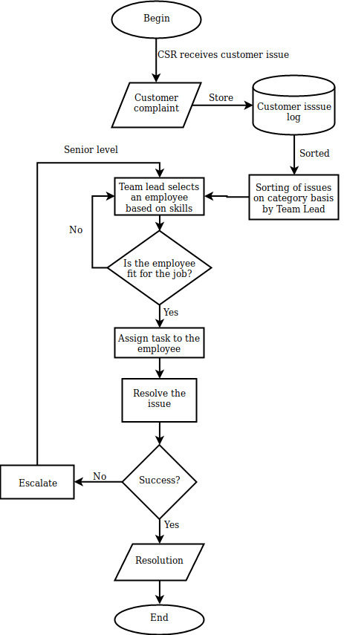

2.3 USER CLASS and CHARACTERISTICS
Users of the system should be able to retrieve the complaint information given by the customer based on the complaint log details. Whenever there is an issue on the customer end, it’s reported to customer service representative who then catagorizes the complains based on predefined list of catagories.This entire complaint log is dynamically pushed on to the support team lead. Support team has multilevel of employees, based on the skill and experience. The support team lead assigns all complaints to concerned employees based on the complaint catagory.
The Support Engineer tries to resolve that complaint. In case of failure the complaint is escalated to higher level engineer,this process keeps on repeating until the complaint is resolved.
The system will support two types of user privileges, Customer, and Employees. Customers will have access to customer functions, and the employees will have access to both customer and employee functions. The customer should be able to do the following functions:
- Complaint submission
- Status tracking
The Employee should have following management functionalities:
- CSR FUNCTIONS
• Genarating unique request id.
• Catagorizing the complaint.
- SUPPORT TEAM LEAD FUNCTIONS
• assigning the task to concerned employee.
• reassigning the task in case of failure.

2.4 OPERATING ENVIRONMENT
Operating environment for the compliaint resolution system is as listed below.
- Database
- Operating system:Windows/Linux
- Database: mysql
- Platform:Java

3. SYSTEM FEATURES

3.1 DESCRIPTION and PRIORITY
The complaint resolution system maintains information on customers including their complaints, progress report,and the resolution provided by the concerned support team. Of course, this project has a high priority because it is very difficult to manage large amount of customer complaints.

3.2 STIMULUS/RESPONSE SEQUENCES
  - Complaint registration.
  - Task assignment.
  - Task Completion.

4. EXTERNAL INTERFACE REQUIREMENTS

4.1 USER INTERFACES
- Front-end software: HTML,CSS and Javascript.
- Back-end software: Java,Sql.

4.2 SOFTWARE INTERFACES
Following are the software used for the Complaint resolution system.
Software used | Description
Operating system | We have chosen Windows, Linux and MAC as the project is cross platform compatible.
Database | To save the complaint records we have chosen SQL database.
Java | To implement the project we have chosen Java implemented using Eclipse.

4.3 COMMUNICATION INTERFACES
This project supports all types of web browsers.

5. NONFUNCTIONAL REQUIREMENTS

5.1 PERFORMANCE REQUIREMENTS
The steps involved to perform the implementation of customer database are as listed below.

A) E-R DIAGRAM
The E-R Diagram constitutes a technique for representing the logical structure of a database in a pictorial manner. This analysis is then used to organize data as a relation, normalizing relation and finally obtaining a relation database.
- ENTITIES: Which specify distinct real-world items in an application.
- PROPERTIES/ATTRIBUTES: Which specify properties of an entity and relationships.
- RELATIONSHIPS: Which connect entities and represent meaningful dependencies between them.
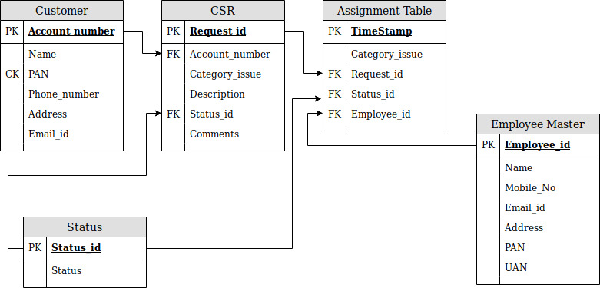
^{ER diagram for the database}
B) NORMALIZATION:
The basic objective of normalization is to reduce redundancy which means that information is to be stored only once. Storing information several times leads to wastage of storage space and increase in the total size of the data stored.
If a database is not properly designed it can give rise to modification anomalies. Modification anomalies arise when data is added to, changed or deleted from a database table. Similarly, in traditional databases as well as improperly designed relational databases, data redundancy can be a problem. These can be eliminated by normalizing a database.
Normalization is the process of breaking down a table into smaller tables. So that each table deals with a single theme. There are three different kinds of modifications of anomalies and formulated the first, second and third normal forms (3NF) is considered sufficient for most practical purposes. It should be considered only after a thorough analysis and complete understanding of its implications.
5.2 SAFETY REQUIREMENTS
If there is extensive damage to a wide portion of the database due to catastrophic failure, such as a disk crash, the recovery method restores a past copy of the database that was backed up to archival storage (typically tape) and reconstructs a more current state by reapplying or redoing the operations of committed transactions from the backed up log, up to the time of failure.
5.3 SECURITY REQUIREMENTS
Security systems need database storage just like many other applications. However, the special requirements of the security market mean that vendors must choose their database partner carefully.
5.4 SOFTWARE QUALITY ATTRIBUTES
- AVAILABILITY: The flight should be available on the specified date and specified time as many customers are doing advance reservations.
- CORRECTNESS: The flight should reach start from correct start terminal and should reach the correct destination.
- MAINTAINABILITY: The administrators and flight in chargers should maintain correct schedules of flights.
- USABILITY: The flight schedules should satisfy a maximum number of customers needs.

