I have used a sequential Convolutional Neural Network to train my model to classify Fashion_MNIST dataset. The data set has been divided into training data set (Shape-(60000,28,28)) and test data (Shape-(10000,28,28)). Further training dataset has been divided into training(55000,28,28) and validation dataset(5000,28,28). I have used 20 epochs and batch size= 100 to train my model.

a)**Graph of training loss vs number of epochs while training:**

* 1. Training loss- 0.2207
  2. Validataion loss- 0.2043
  3. Test loss- 0.2255

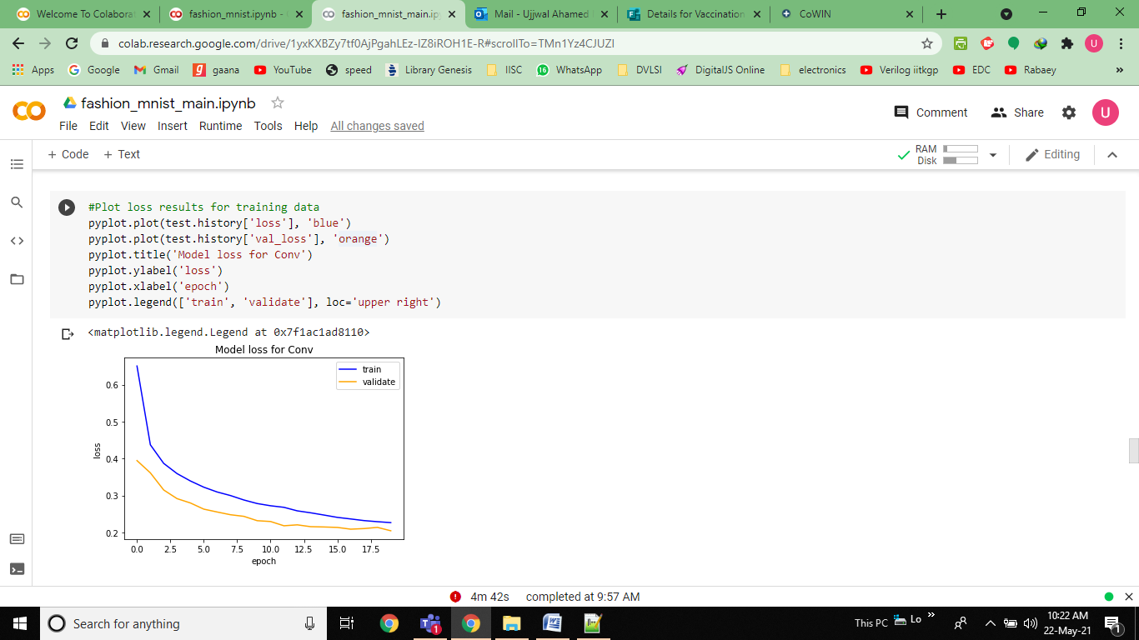

**Observation:** loss is decreasing with increase in number of epochs and eventually getting saturated. So it does not imply that more epochs mean less loss. Sometimes increasing number of epochs after a certain limit may over fit the model.

**Graph of Model accuracy vs number of epochs while training:**

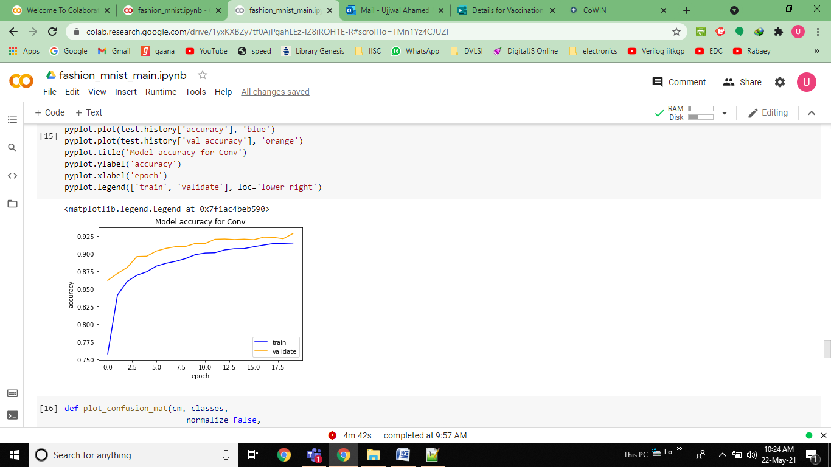

**b) Classification accuracy:**

i) Training accuracy= 0.9162

ii) Validation accuracy= 0.9282

iii) Test accuracy= 0.9182

**c) Confusion matrix:**

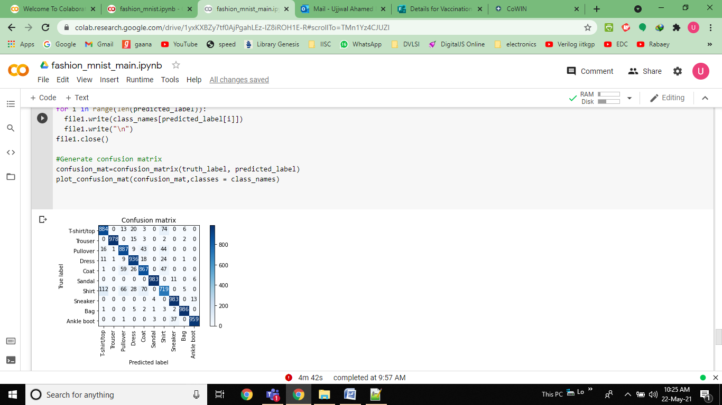

**Classification report:**

precision recall f1-score support

T-shirt/top 0.92 0.71 0.80 1000

Trouser 0.96 0.98 0.97 1000

Pullover 0.97 0.48 0.65 1000

Dress 0.90 0.89 0.90 1000

Coat 0.71 0.91 0.80 1000

Sandal 0.96 0.99 0.97 1000

Shirt 0.57 0.81 0.67 1000

Sneaker 0.97 0.94 0.95 1000

Bag 0.97 0.98 0.98 1000

Ankle boot 0.97 0.97 0.97 1000

accuracy 0.87 10000

macro avg 0.89 0.87 0.87 10000

weighted avg 0.89 0.87 0.87 10000