Login:

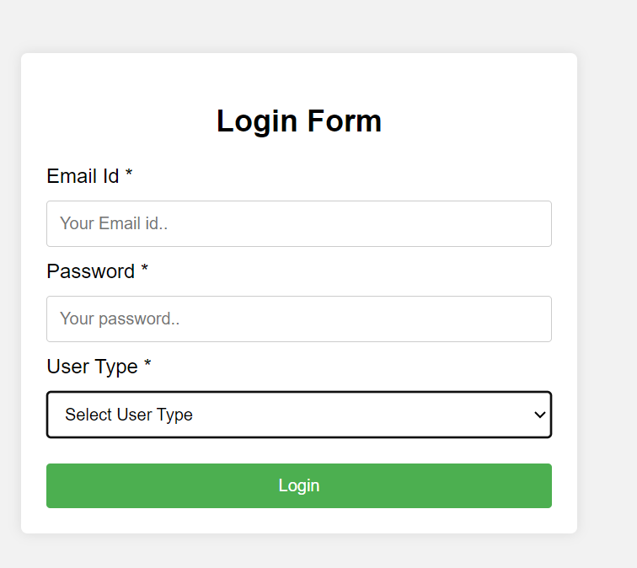

## Admin

**Admin Home screen:**

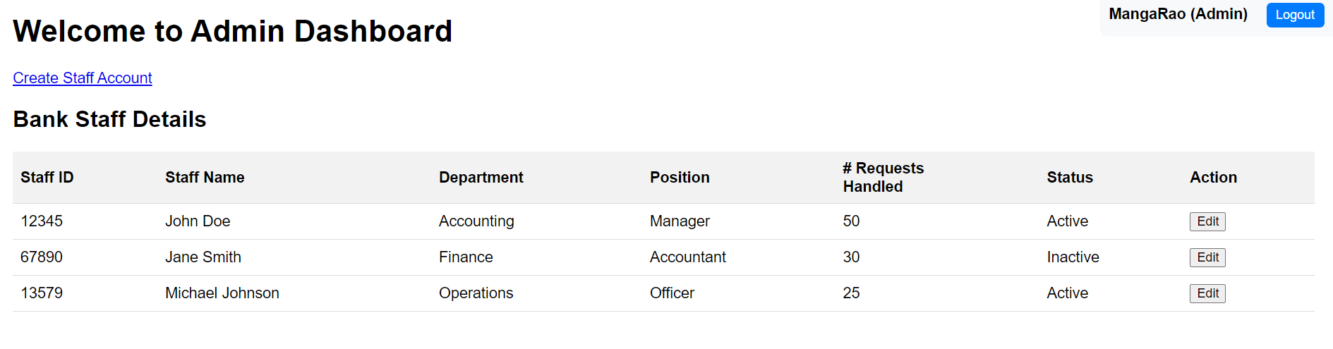

**Create Staff Account:**

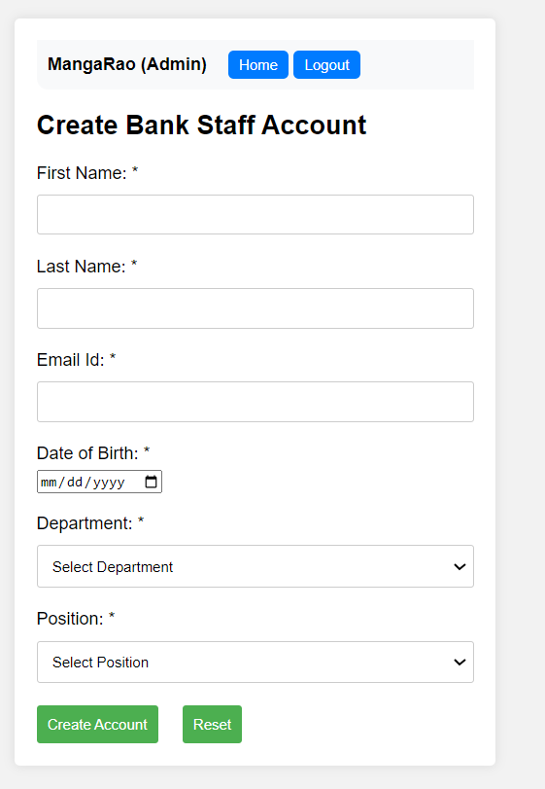

**Update Staff Account:**

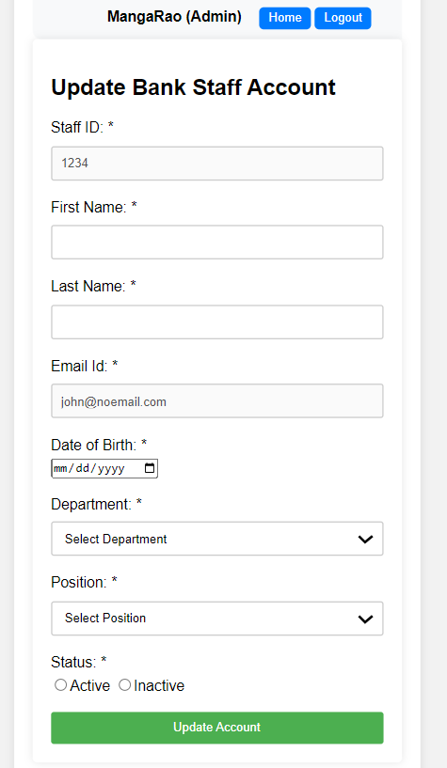

## **Staff**

**Staff Home screen:**

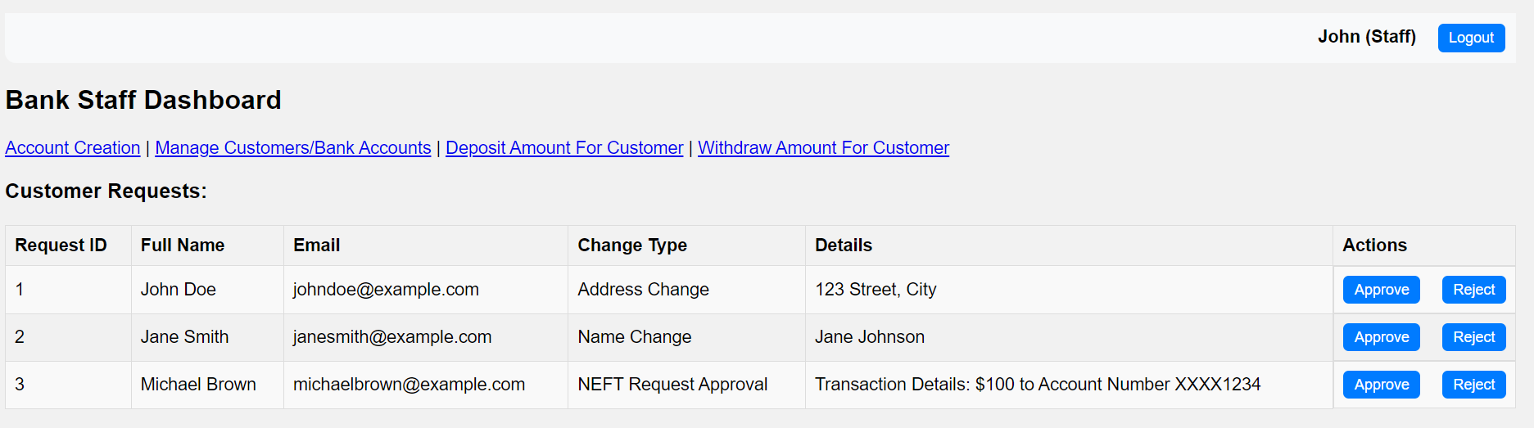

**Create Bank Account screen:**

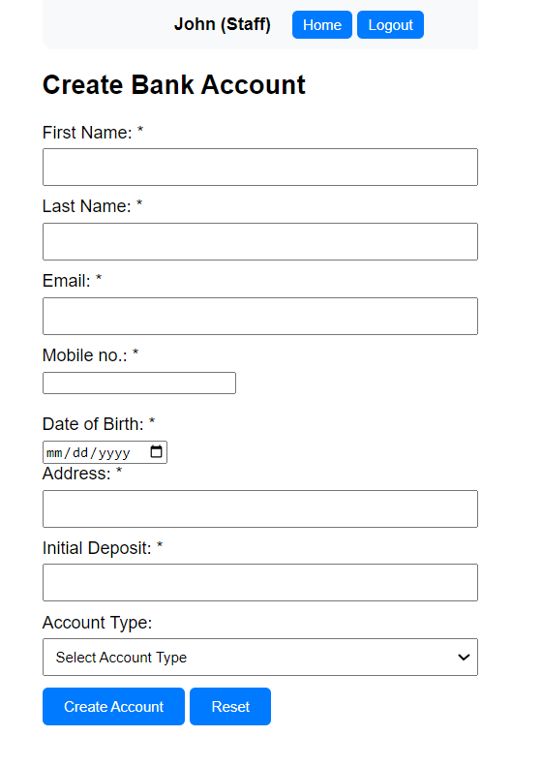

**Manage Bank Account Report screen:**

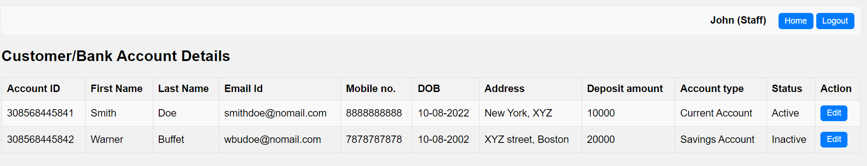

**Edit Bank Account Details:**

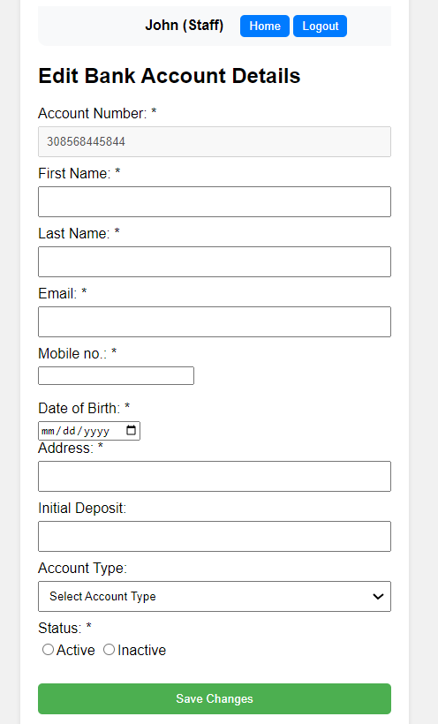

**Deposit Money:**

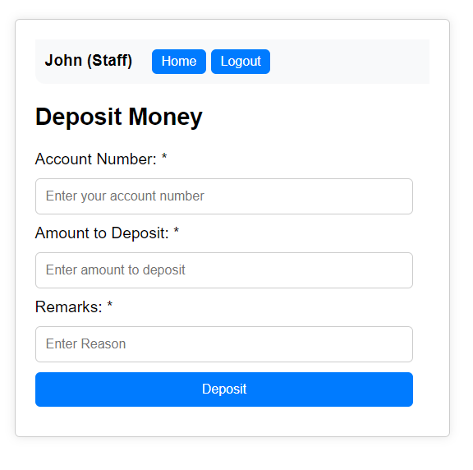

**Withdraw money:**

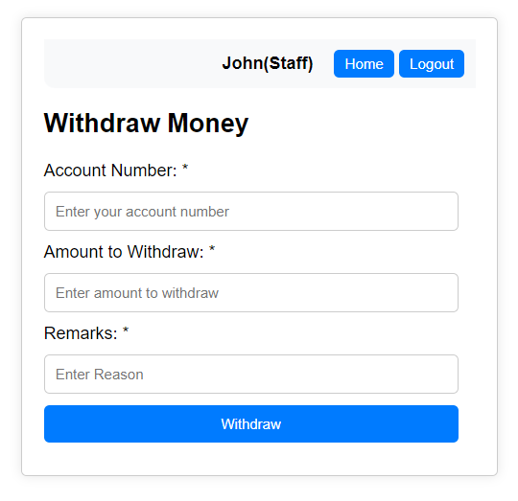

## **Customer:**

**Customer Home screen:**

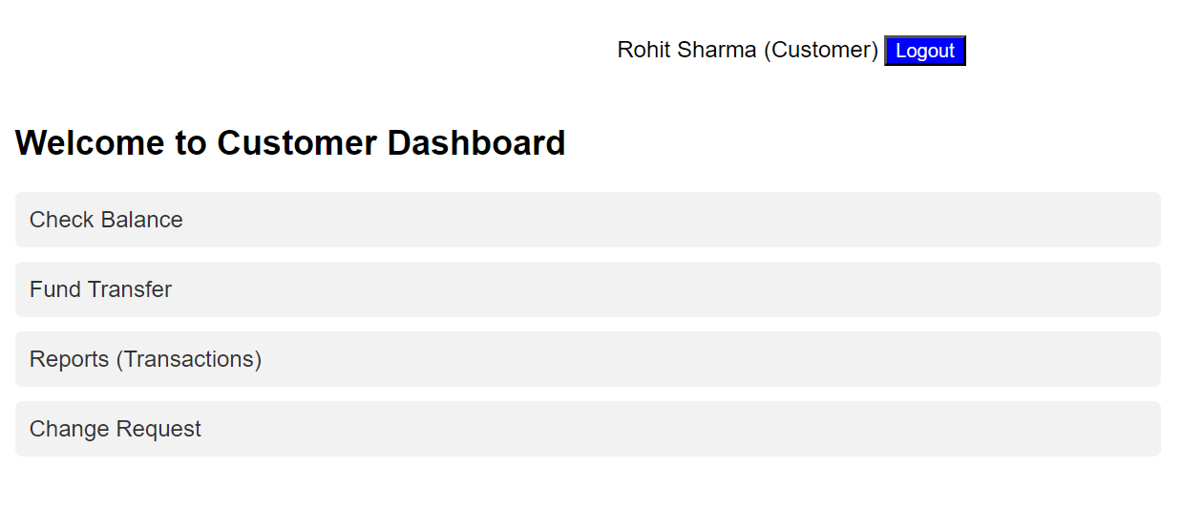

**Balance Details:**

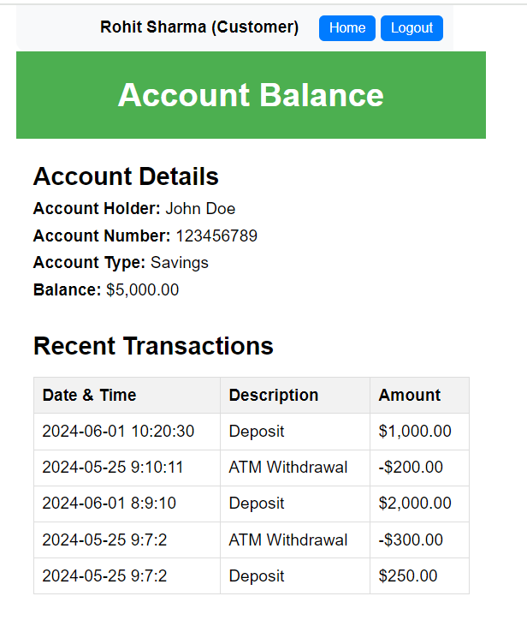

**Fund Transfer:**

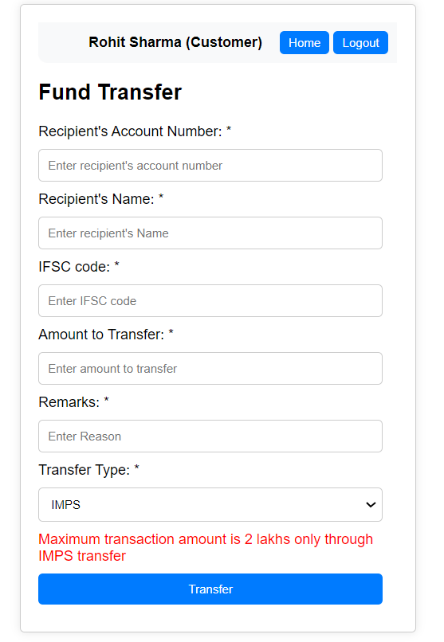

**Transactions Report:**

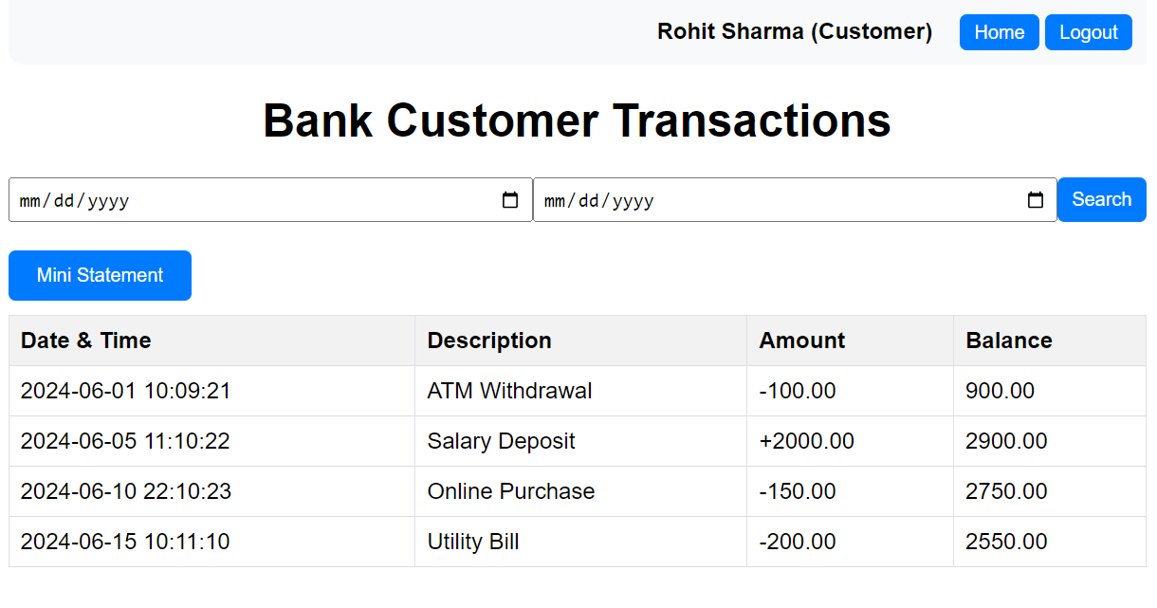

**Change Request:**

