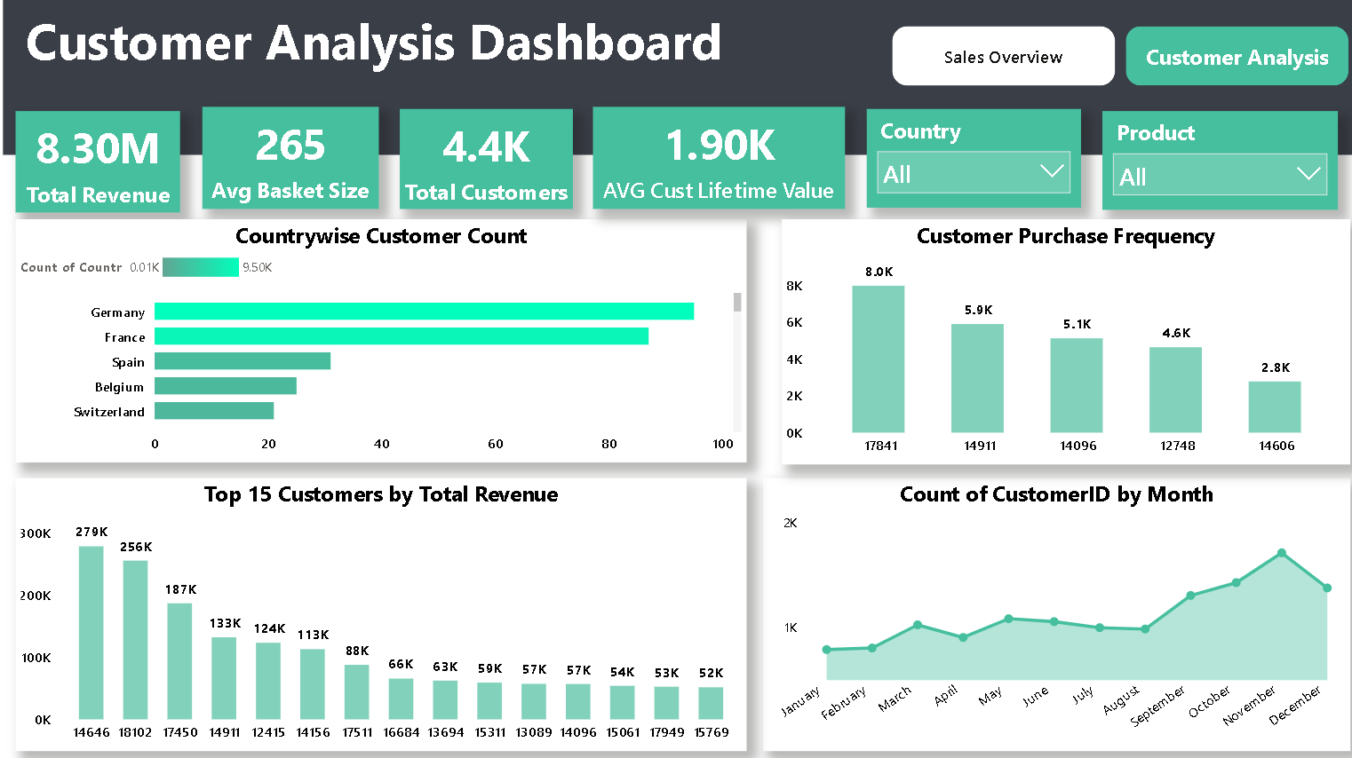

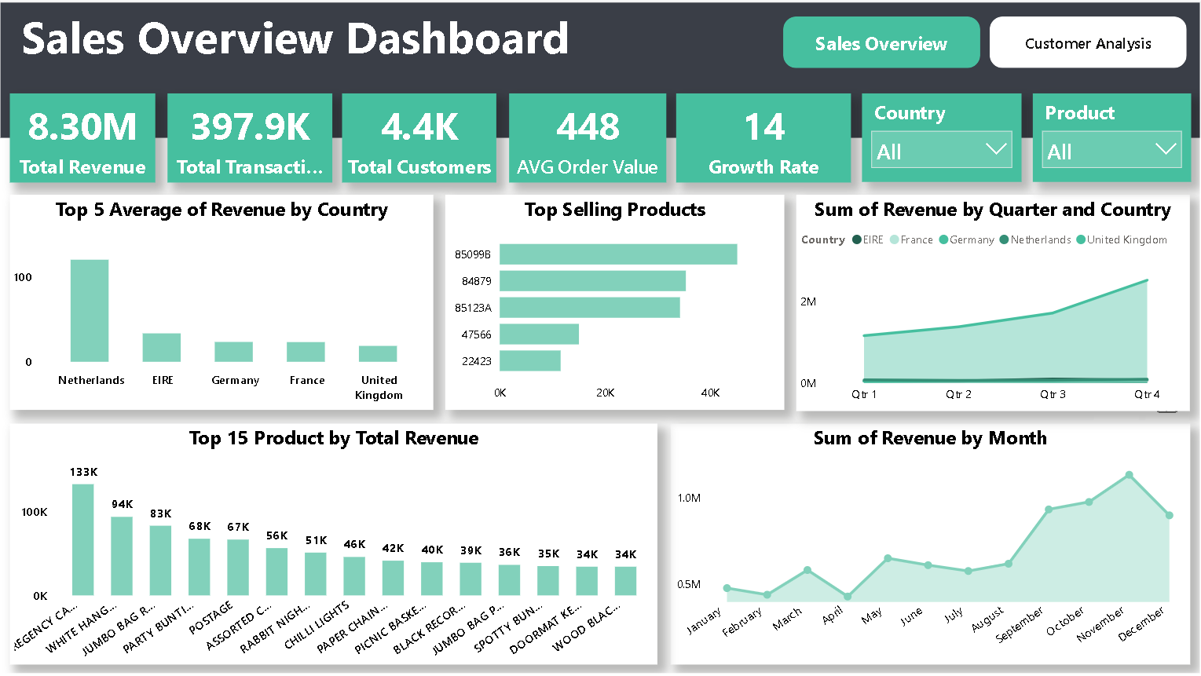

****Introduction****  
This project focuses on analyzing company sales performance and customer behavior through two connected dashboards: Sales Overview and Customer Analysis. The goal was to provide leadership and sales teams with a clear, interactive view of revenue trends, top products, and customer engagement.

## ****Insights Shown in the Dashboards****

****Sales Overview****

****Total Revenue Performance:**** Revenue of ****8.3M**** across nearly ****398Ktransactions**** and ****4.4K customers****.

****Top Markets:**** The Netherlands contributes the highest average revenue, followed by EIRE, Germany, France, and the UK.

****Best-Selling Products:**** Key SKUs like 85099B, 84879, and 85123A drive strong sales volumes

.

****Product Revenue Leaders:**** Items like Regency C. and White Hanging Heart generate the highest sales.

****Seasonality & Growth:**** Revenue trends rise sharply in Q4, with December being the strongest month — useful for planning stock and marketing campaigns.

****Customer Analysis****

****Customer Demographics:**** Germany and France have the largest customer bases, with strong representation also from Spain, Belgium, and Switzerland.

****Customer Lifetime Value:**** Average CLV stands at ****1.9K****, highlighting valuable repeat buyers.

****Top Customers:**** A handful of customers (IDs 14646, 18102, 17450) contribute disproportionately high revenue.

****Purchase Frequency:**** Most active customers make between 5–8K purchases, offering insight into loyalty and engagement.

****Monthly Growth:**** Customer acquisition accelerates toward the end of the year, peaking in November–December.

## ****Key Features & Highlights****

****Dual Dashboards:**** Seamless navigation between Sales Overview and Customer Analysis for different business perspectives.

****Dynamic KPIs:**** Key metrics (Revenue, Transactions, Order Value, CLV) update instantly based on slicer selections.

****Country & Product Filters:**** Flexible analysis across geographies and product categories.

****Interactive Visuals:**** Line charts reveal seasonal patterns; bar charts highlight top performers; tables provide granular breakdowns.

****User-Friendly Design:**** A clean, consistent layout with high-contrast KPIs ensures clarity even for non-technical users

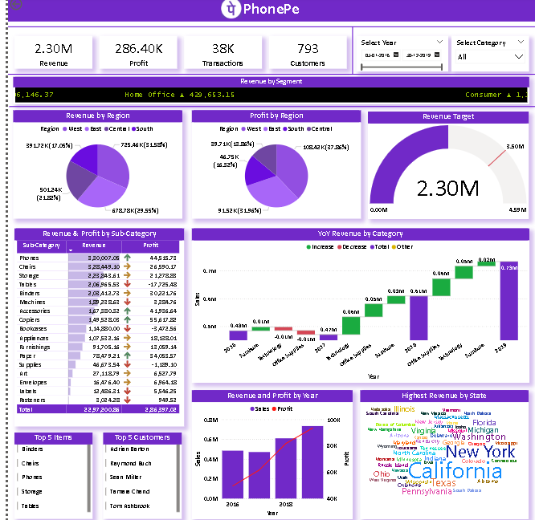

**Overall Performance Summary**

**1 Overall Performance Summary**

Total **Revenue:** ₹2.30M

**Profit:** ₹286.40K

**Transactions:** 38K

**Customers:** 793  
👉 This shows a healthy revenue per customer ratio of nearly ₹2,900, indicating strong customer monetization.

**2 Revenue Segmentation**

**3 Home Office Segment:** ₹429.65K (highest revenue)

**Consumer Segment:** ₹1.11M  
👉 The “Home Office” segment is the most profitable, suggesting that targeting home-based professionals yields better margins.

**4 Regional Performance**

**South Region** leads with ₹678.3K revenue (≈30%)

**East Region** has the lowest with ₹391.2K (≈17%)  
👉 Southern states are the key revenue drivers — expansion in East can be an untapped growth opportunity.

**5 Profit Distribution by Region**

**South Central Region** contributes **37% of total profit**, the highest among all regions.  
👉 Focusing marketing spend here could yield higher ROI due to strong profitability.

**6 Category-Wise Growth (YoY)**

**Technology-related categories (Phones, Machines, Chairs)** show consistent **year-over-year growth.**

**Office Supplies** had a slight dip, indicating saturation.  
👉 Diversifying product lines beyond traditional office supplies is crucial for sustained growth.

**7 Top Performing Sub-Categories**

**Phones:** ₹320.0K revenue, ₹46.5K profit

**Chairs:** ₹289.4K revenue  
👉 Phones and Chairs are revenue anchors — focusing on bulk discounts or combo offers here can maximize profit.

**8 State-Wise Revenue**

**California** dominates in revenue, followed by **New York** and **Texas.**  
👉 High-tech and high-income states are driving performance — expansion strategy should prioritize these markets.

**9 Revenue Target Achievement**

Achieved **2.30M** out of **3.5M target (≈66%)**.  
👉 Current performance is strong but requires ~34% more to hit full target — suggests potential to improve conversion rate.

**Year-over-Year Revenue & Profit Trend**

Clear **upward trend from 2016 to 2018** in both sales and profit.  
👉 Business has been scaling effectively — indicates sustainable growth and strong market acceptance.

**10 Customer Insights**

**Top 5 Customers:** Adrian Barton, Raymond Rich, Sean Miller, Tamara Chand, Tom Ashbrook  
👉 A few key customers drive significant sales — implementing a loyalty or referral program could amplify customer retention.

### 🔹 “From the analysis, I observed that our top 30% of regions and customers contribute to over 70% of total revenue — applying the 80/20 Pareto principle here can help optimize marketing and resource allocation.”

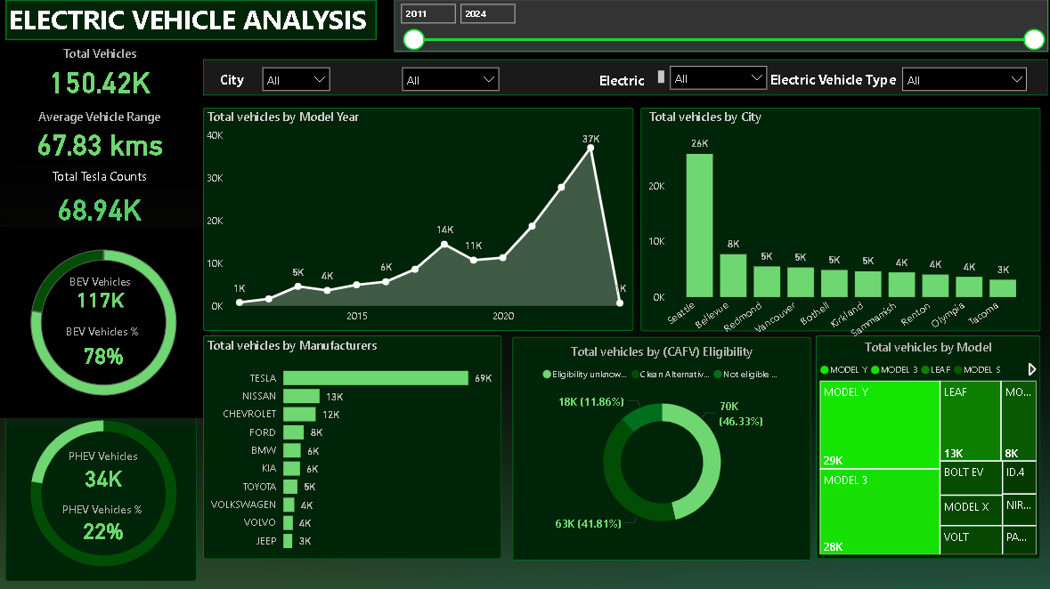

**1 Overall Market Overview**

Total Electric Vehicles: **150.42K**

Out of which, **78% are BEVs (Battery Electric Vehicles)** and **22% are PHEVs (Plug-in Hybrid Electric Vehicles)**.  
👉 This indicates a strong consumer shift toward fully electric vehicles.

**2 Average Vehicle Range**

The **average range is 67.83 km per charge**, which reflects moderate performance suitable for urban use.  
👉 Future focus should be on improving battery efficiency and range to boost adoption.

**3 Tesla’s Market Dominance**

**Tesla alone accounts for 68.94K vehicles (~46% of the total market)**.  
👉 Tesla continues to dominate the EV segment, setting benchmarks for innovation and performance.

**4 Top Manufacturers**

After Tesla, **Nissan (13K)** and **Chevrolet (12K)** are the next key players, followed by Ford and BMW.  
👉 The market has a strong top-3 concentration — strategic partnerships or incentives could help other brands catch up.

**5 Year-Wise Growth Trend (2011–2024)**

EV registrations show exponential growth after **2017**, peaking at **37K in 2022**.  
👉 Government incentives and consumer awareness after 2018 clearly accelerated EV adoption.

**6 City-Wise Vehicle Distribution**

**Seattle** leads with **26K EVs**, followed by **Bellevue (8K)** and **Redmond (5K)**.  
👉 Seattle emerges as the EV capital — infrastructure investments here are paying off.

**7CAFV (Clean Alternative Fuel Vehicle) Eligibility**

46.33% of vehicles are **“Not Eligible”** for CAFV benefits, while 41.81% are eligible.  
👉 There’s still untapped potential for policy-based adoption incentives.

**8 Top Performing Models**

**Model Y (29K)** and **Model 3 (28K)** lead by a huge margin, together covering ~38% of the total EV market.  
👉 Compact and mid-range models are driving EV sales — showing customer preference for affordability and range balance.

**9 Brand Penetration Insights**

While **Tesla** leads, emerging brands like **Kia, Toyota, and Volkswagen** have started gaining small but consistent market presence.  
👉 Indicates diversification and competition in the EV ecosystem.

**10 Regional Insights for Expansion**

**High adoption in urban cities** like Seattle and Bellevue highlights good charging infrastructure.

Smaller cities like Olympia and Tacoma show emerging potential.  
👉 Focusing on Tier-2 cities could be the next growth strategy.

“From my Electric Vehicle Analysis dashboard, I observed that the EV market is rapidly expanding, with over **150,000 total vehicles** recorded between 2011 and 2024. **Battery Electric Vehicles dominate 78%** of the market, showing a clear preference for zero-emission options. **Tesla alone contributes nearly half of the total market share**, led by **Model Y and Model 3**, which together represent about 38% of all EVs.

Interestingly, **Seattle emerges as the top-performing city**, while year-wise growth highlights a massive spike after 2017, mainly due to improved policies and infrastructure. However, around **46% of vehicles remain ineligible for clean fuel incentives**, indicating policy gaps and opportunities for improvement.

Overall, the insights emphasize Tesla’s dominance, the effectiveness of infrastructure in key cities, and the untapped potential for policy-driven EV expansion.”

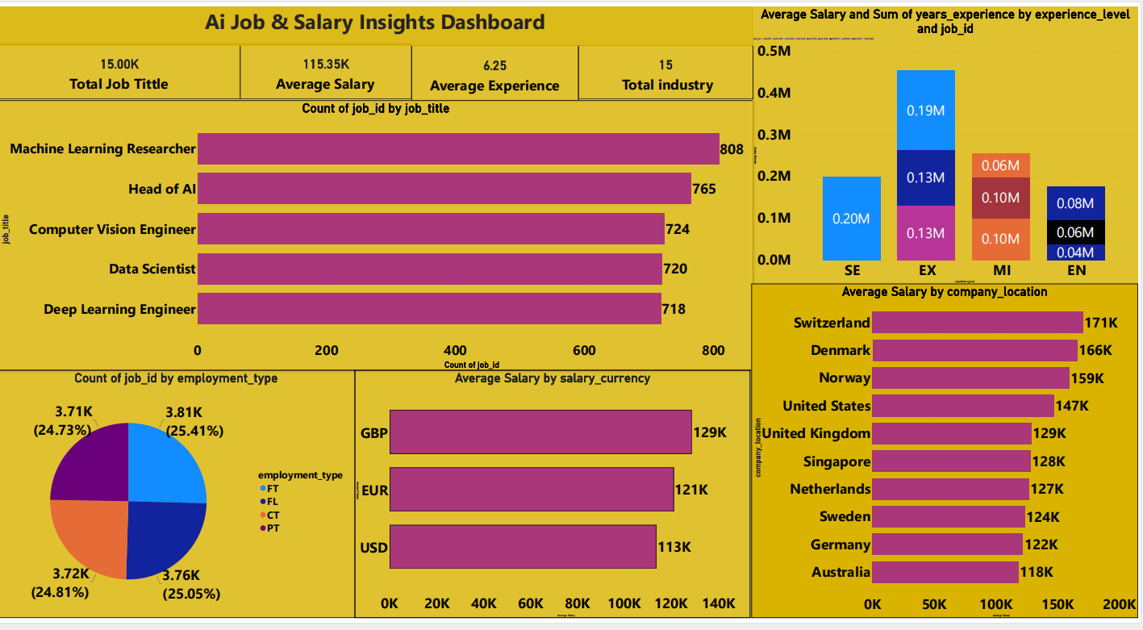

****1Machine Learning Dominates****

Machine Learning Researchers hold the highest number of job positions (808), showing how strongly the AI job market revolves around machine learning expertise.

**2Attractive Global Average Salary**  
The average salary across all AI roles is **$115.35K**, reflecting the high value and demand for AI professionals worldwide.

**3 Switzerland Leads in Pay**  
Among all countries, **Switzerland offers the highest average AI salary at $171K**, followed by Denmark ($166K) and Norway ($159K). This highlights Europe as a hub for premium AI roles.

**4 AI Leadership Roles Pay Exceptionally Well**  
Positions like **Head of AI** and **Machine Learning Researcher** not only dominate in numbers but also in salary potential, indicating that leadership and deep research roles command top compensation.

**5 Balanced Employment Types**  
The distribution of employment types (FT, FL, CT, PT) is almost even, showing that the AI industry offers flexible job opportunities — not limited to full-time roles.

**6 Experience Level Impacts Salary Significantly**  
Experienced professionals (EX) earn around **$0.19M annually**, while mid-level (MI) professionals earn **$0.10M**. This proves that expertise and experience strongly influence pay growth in AI careers.

**7 AI Industry Diversity**  
With **15 different industries** represented, AI skills are not confined to tech companies — they’re spreading across sectors like healthcare, finance, and manufacturing.

**8 Global Currency Comparison**  
AI professionals paid in **GBP** earn the most on average ($129K), followed by **EUR ($121K)** and **USD ($113K)**, reflecting regional differences in salary scales and cost of living adjustments.

**9 Average Experience Requirement**  
The average experience level of **6.25 years** shows that AI jobs generally demand skilled professionals with strong technical and analytical backgrounds.

**10 Data Scientist Roles Remain Core**  
Despite newer job titles, **Data Scientist** roles still maintain a high presence (720 jobs), confirming their ongoing importance as the foundation of AI-driven decision-making.