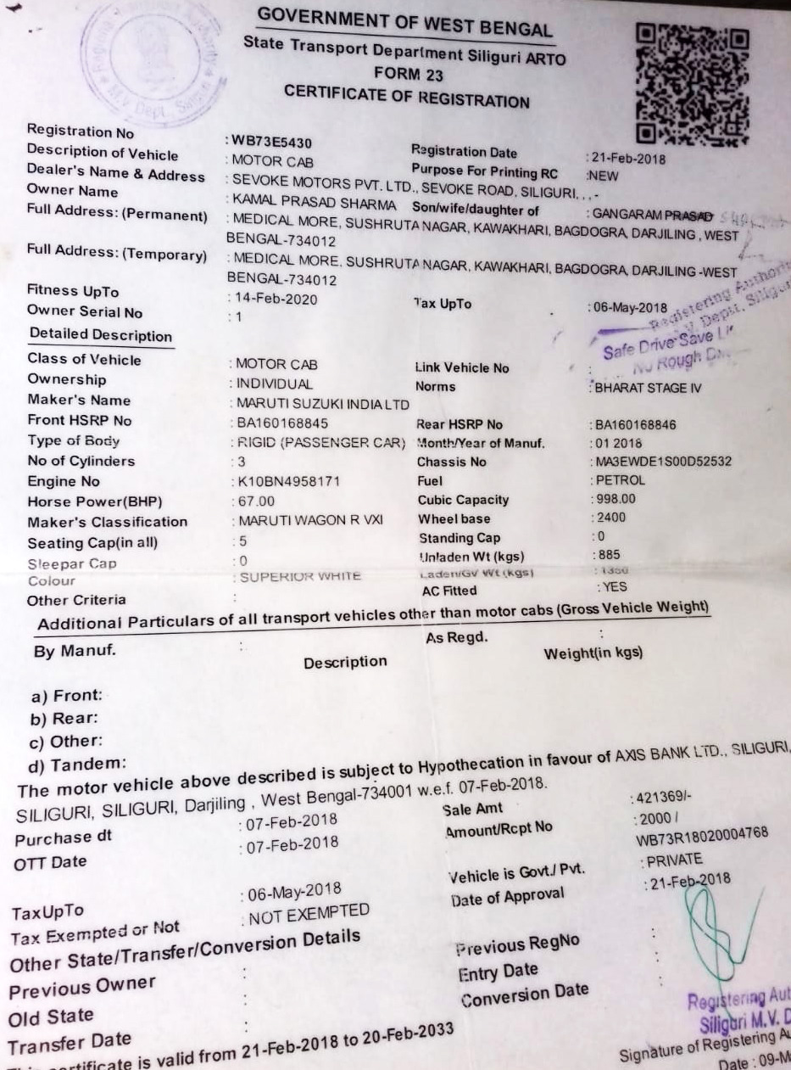

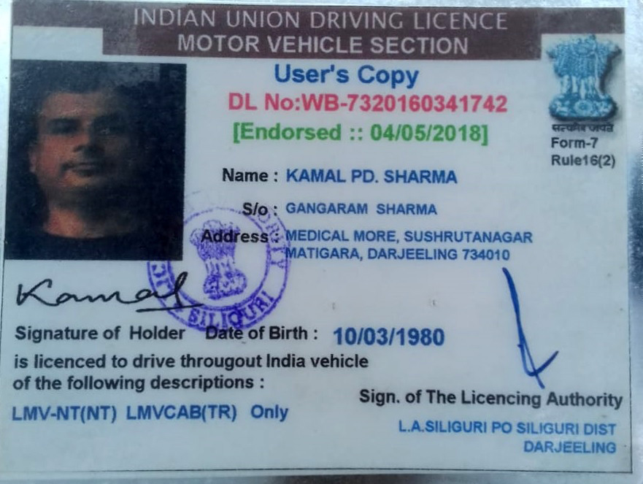

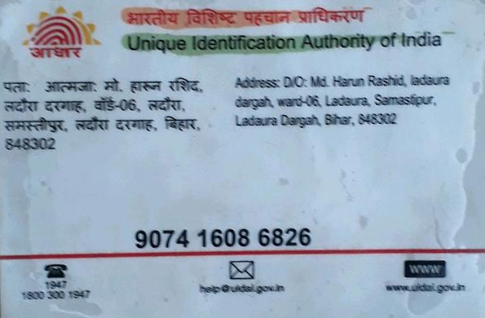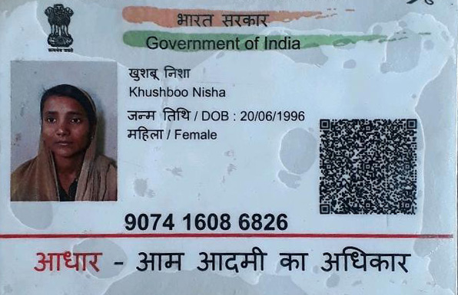

**BUS Details:**

Bus No.: **BR - 063PD – 0625**

Bus Counter Mob. No.: **+91 99326 53019**

From: **Siliguri Junction** To **Samastipur**