WEEK 1 TASK
Planning and Strategy for Automotive Programming Innovation
Project Plan: AutoBridge
A No-Code Learning and Simulation Platform for Automotive Software & Cybersecurity
Field | Details
Course | Programming for Non-Programmers
Task | Week 1 – Planning and Strategy
Project Domain | Automotive Programming / Vehicle Software
Proposed Project | AutoBridge
Primary Audience | Non-programmers, beginners, students and cross-functional automotive teams
Data Policy | Public resources only; no proprietary/internal datasets
Planned Effort | 34 hours
Document Status | Project planning report / Week 1 submission
GitHub URL | Replace with the actual project repository before submission

1. Executive Summary
AutoBridge is a proposed beginner-friendly application that helps non-programmers understand how software controls modern vehicles and how automotive software should be tested and protected. The idea responds to the shift toward connected vehicles, software-defined features, over-the-air (OTA) updates, automated driving functions, and increasingly software-dependent safety systems.
The platform would use visual building blocks instead of requiring users to write code. A learner could select a vehicle feature such as braking assistance, lighting, battery monitoring, or an infotainment function; connect simple logic blocks; run a safe simulation; view the data flow; generate a test scenario; and receive a plain-language explanation of the result. A cybersecurity module would allow the learner to examine simplified risks around network access, authentication, firmware integrity, and OTA updates without interacting with a real vehicle.
The project is based on public resources. NHTSA publishes vehicle-cybersecurity guidance and research, including anomaly detection and firmware/OTA update security. UNECE provides UN Regulation No. 155 on vehicle cybersecurity and UN Regulation No. 156 on software-update management. Open-source projects such as Autoware show how public automotive software ecosystems can support learning. These sources provide a realistic foundation without confidential OEM data.
The Week 1 plan allocates 34 hours across research, problem definition, concept selection, requirements, architecture, workflow design, risk planning, documentation, and review. The intended output is a clear project blueprint that can later be converted into a small working prototype and public GitHub repository.

2. Introduction and Background
Automotive programming is no longer limited to a small number of engine-control programs. Modern vehicles contain electronic control units (ECUs), sensors, communication interfaces, software services and connected features. This creates opportunities for new software products, but also a learning barrier for students and non-programmers who need to understand the relationship between software, vehicle functions, safety and cybersecurity.
NHTSA describes vehicle cybersecurity as protection of automotive electronic systems, communication networks, control algorithms, software, users and data from malicious attacks, damage, unauthorized access or manipulation. NHTSA also highlights wireless access paths, safety-critical electronic functions and software-designed features as important areas to monitor.
UNECE UN Regulation No. 155 addresses vehicle cybersecurity and cybersecurity management, while UN Regulation No. 156 addresses software updates and software-update management systems. These developments show that software and cybersecurity are important parts of vehicle engineering and lifecycle management.

3. Research: Current Trends and Challenges

3.1 Current trends
- Connected vehicles: Wi-Fi, cellular and Bluetooth connectivity increase digital interfaces in vehicles.
- Software-defined features: more vehicle functionality can be changed, enhanced or managed through software.
- Over-the-air updates: software and firmware can be updated remotely, creating benefits but also requiring secure update processes.
- Advanced driver-assistance and automated driving: software increasingly participates in perception, planning, control and safety functions.
- Open-source automotive development: Autoware provides public software, documentation and community-driven learning opportunities.
- Cyber-resilience: modern guidance emphasizes prevention, detection, response, recovery and continuous improvement.

3.2 Key challenges
- Automotive software terminology can be difficult for non-programmers.
- Real vehicle systems are expensive and potentially unsafe for beginner experimentation.
- Vehicle software is interconnected, so a software change can affect another function.
- OTA mechanisms must protect update integrity and resist unauthorized or unsafe changes.
- Cybersecurity concepts such as authentication, attack surfaces, firmware integrity and risk assessment are difficult to learn only from theory.
- Public resources are available but distributed across regulations, government guidance, open-source documentation and technical publications.
NHTSA's public research identifies anomaly-based intrusion detection and firmware/OTA update security as active research areas. Its 2022 best practices recommend maintaining OTA update integrity and protecting update mechanisms from risks such as compromised servers, insider threats and protocol vulnerabilities.

4. Problem Statement
There is a gap between introductory programming education and the complex software environment of modern vehicles. A non-programmer may understand a basic programming concept but still struggle to see how that concept maps to an ECU, sensor, vehicle function, software update, test case or cybersecurity control.
Core problem: How can a beginner understand and safely contribute to automotive programming concepts without needing access to a real vehicle, proprietary software, or confidential datasets?

5. Conceptualization and Selected Innovation

5.1 Proposed solution: AutoBridge
AutoBridge is a visual learning and simulation platform for automotive programming. It converts selected automotive software concepts into guided, no-code activities. Users work with blocks such as Sensor Input, Condition, Vehicle Function, Network Message, Security Check, Software Version, Update Approval and Test Result.

5.2 Why this concept was selected
- Directly supports the course goal of helping non-programmers understand programming concepts.
- It can use public documentation and simulated data instead of proprietary vehicle data.
- It creates a safe environment for learning without controlling a real vehicle.
- It connects programming, software testing and cybersecurity in one automotive context.
- It has a clear path from educational prototype to a larger training or developer-assistance platform.

5.3 Core innovation
The innovation is the combination of visual programming, explainable automotive workflows, basic cybersecurity/rule checks, test-scenario generation and an OTA update learning module. Each technical result is translated into beginner-friendly language.

6. Project Objectives
- Create a clear visual model of selected automotive software functions.
- Allow a non-programmer to build simple logic using blocks rather than source code.
- Explain the relationship between sensors, software logic, vehicle functions and test results.
- Provide a safe simulation of an automotive software-update workflow.
- Introduce basic cybersecurity concepts such as authentication, integrity and attack-surface awareness.
- Generate simple test scenarios and readable results.
- Use only public resources and synthetic/simulated data.
- Produce a prototype-ready technical and project plan that can be developed further on GitHub.

7. Scope of the Proposed Project

7.1 In scope
- Visual no-code automotive logic builder.
- Synthetic vehicle signals and simulated ECU states.
- Basic rule engine for simple safety and cybersecurity checks.
- OTA update lifecycle simulation: available → verified → approved → installed → tested.
- Beginner explanations and glossary.
- Test-scenario generator.
- Dashboard showing inputs, decisions, alerts and outcomes.
- Public documentation and source-code repository for the prototype.

7.2 Out of scope
- Direct connection to or control of a real vehicle.
- Real ECU flashing or firmware modification.
- Use of confidential OEM data.
- Real-world penetration testing against vehicles or external systems.
- Claims that the prototype is a certified automotive safety or cybersecurity product.
- Replacement of professional automotive engineering standards or regulatory compliance processes.

8. Target Users and Stakeholders
Stakeholder | Need | Expected benefit
Non-programming students | Understand automotive programming concepts | Visual learning and guided practice
Programming beginners | Connect basic logic with vehicle functions | Hands-on simulation without real hardware
Automotive project teams | Explain system behavior to mixed-skill members | Common visual language
Teachers/trainers | Demonstrate automotive software workflows | Reusable classroom scenarios
Future developers | Move from visual logic to code concepts | Foundation for deeper programming
Project evaluator | See research, planning and innovation | Measurable deliverables and documented methodology

9. Methodology
- Research: collect public automotive software, cybersecurity and open-source resources.
- Problem framing: identify the learning and safety gap for non-programmers.
- Ideation: generate several possible concepts and compare feasibility, usefulness, originality and public-data availability.
- Requirements: define user stories, core functions, constraints and success measures.
- System design: create architecture and workflow diagrams.
- Prototype planning: identify modules, tools, data structures and test cases.
- Risk planning: identify technical, safety, scope, data and schedule risks with mitigation actions.
- Documentation: assemble the project plan and references.
- Review: check clarity, completeness, source traceability and alignment with the task.

10. Functional and Non-Functional Requirements

10.1 Functional requirements
ID | Requirement | Priority
FR-01 | User can select a simulated vehicle function. | High
FR-02 | User can connect visual logic blocks. | High
FR-03 | System can run synthetic input scenarios. | High
FR-04 | System displays the state/result of the simulated function. | High
FR-05 | System generates a basic test scenario. | Medium
FR-06 | System checks simple cybersecurity/update rules. | High
FR-07 | System simulates an OTA update lifecycle. | High
FR-08 | System explains results in plain language. | High
FR-09 | System exports a simple project/test report. | Medium

10.2 Non-functional requirements
- Safety: simulation only; no real vehicle control.
- Usability: first-time users should understand the basic workflow with minimal technical vocabulary.
- Transparency: each rule/result should have an explanation.
- Maintainability: modules should be separated so new vehicle functions can be added later.
- Portability: prototype should run on a normal student laptop.
- Data privacy: use synthetic data and public resources only.
- Traceability: research claims should point to public references.

11. Workflow Diagram
The workflow shows how a beginner moves from public knowledge to a simulated automotive software task, then receives a result and repeats the learning cycle.
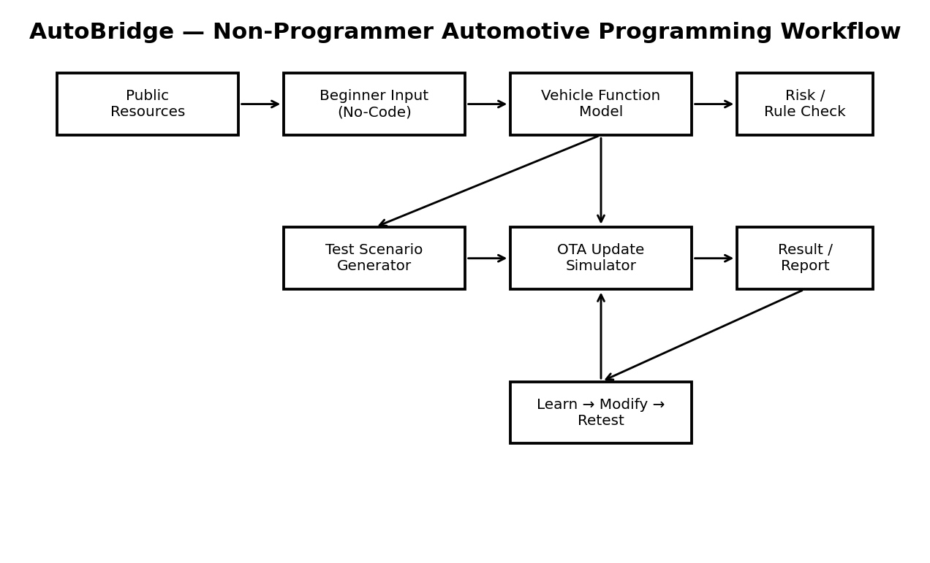
Figure 1. Proposed AutoBridge learning and simulation workflow.

12. Proposed System Architecture
The architecture separates the user interface, application logic, simulation layer and public-resource layer. This makes the project easier to understand, test and extend.
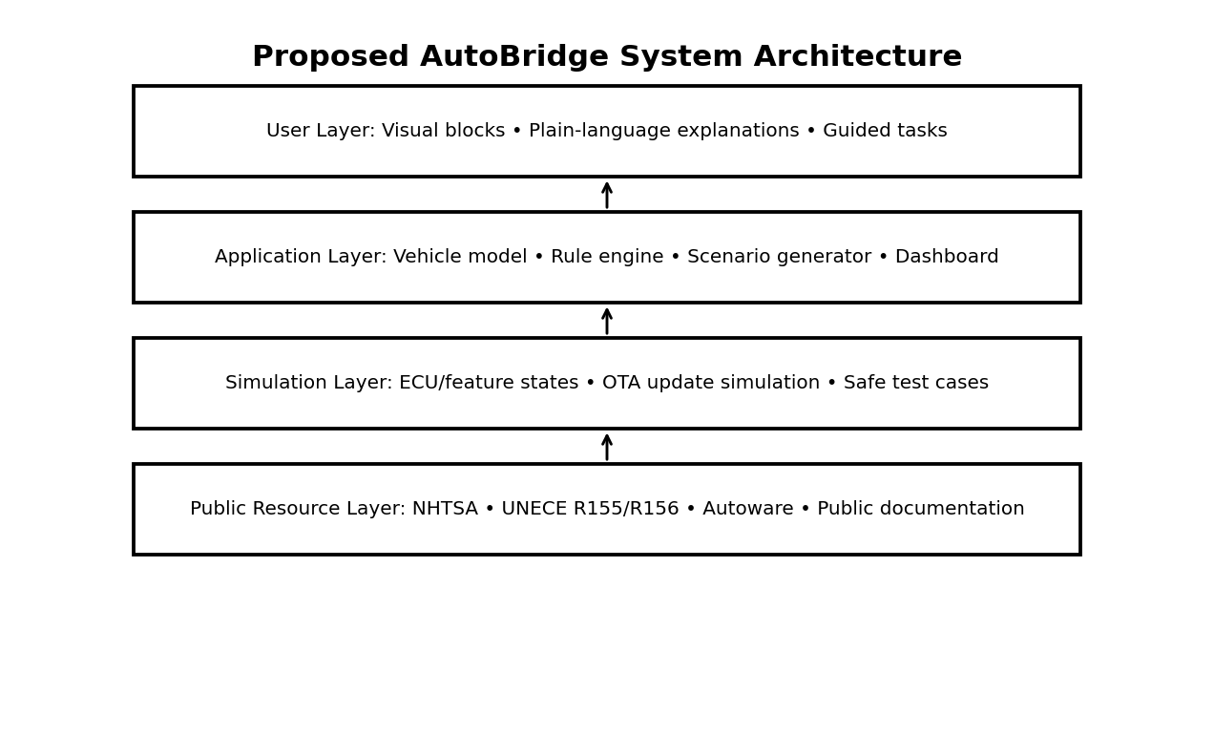
Figure 2. High-level AutoBridge architecture.

13. Example User Scenario
Scenario: a learner wants to understand a simplified battery-temperature monitoring feature.
- Select Battery Temperature Monitoring.
- Display a synthetic temperature signal.
- Connect Sensor → Compare → Warning → Log Event blocks.
- Run normal, warning and abnormal input cases.
- View how the logic changes the simulated vehicle-state output.
- Open the security tab and see why update authentication and software integrity matter.
- Generate a small test report listing inputs, expected results, actual results and observations.

14. Detailed 34-Hour Work Plan and Timeline
The task is planned as approximately 34 hours of structured work. The schedule demonstrates substantial research, design and documentation effort.
Stage | Activity | Hours | Output
1 | Research scope and keywords | 2 | Research log + source list
2 | Automotive trend research | 3 | Trend/challenge summary
3 | Public resource review | 3 | NHTSA/UNECE/open-source notes
4 | Problem definition | 2 | Problem statement + user needs
5 | Idea brainstorming | 2 | 3–5 candidate concepts
6 | Concept selection | 2 | Selection rationale + scope
7 | User stories & requirements | 3 | FR/NFR list
8 | System architecture | 3 | Architecture diagram
9 | Workflow & process design | 2 | Workflow diagram
10 | Risk management planning | 2 | Risk register + mitigations
11 | Resource & milestone planning | 2 | Resource matrix + milestones
12 | Report drafting | 3 | Full report draft
13 | Review, editing & quality check | 2 | Final DOCX + checklist
TOTAL |  | 34

15. Milestones and Acceptance Criteria
Milestone | Target | Acceptance criteria
M1 – Research complete | End of research stage | At least 5 relevant public sources reviewed and summarized
M2 – Concept frozen | After ideation | Problem, users, scope and value proposition defined
M3 – Design complete | After architecture | Workflow and architecture diagrams completed
M4 – Risk plan complete | Before documentation | Major risks have mitigations and residual-risk notes
M5 – Report complete | Final stage | All required sections, references and diagrams included
M6 – Prototype-ready | Project handoff | Requirements are clear enough to begin implementation

16. Resource Allocation

16.1 Human resources
Role | Main responsibility | Hours
Project lead | Planning, scope, integration and final review | 8
Research lead | Public-source research and evidence notes | 7
UX/content lead | Non-programmer explanations and workflow design | 5
Technical design lead | Architecture, simulation logic and requirements | 8
QA/documentation lead | Risk review, editing and submission quality | 6
Total |  | 34

16.2 Technology resources
- Student laptop/desktop.
- VS Code or another code editor.
- A web interface or lightweight Python application for later implementation.
- Git and GitHub for version control and public documentation.
- Python/JavaScript or another beginner-friendly implementation language.
- Public documentation from NHTSA, UNECE and open-source automotive projects.
- Synthetic JSON/CSV data generated specifically for the simulator.

17. Risk Management
ID | Risk | Likelihood | Impact | Mitigation
R1 | Scope becomes too large | High | High | Freeze MVP to 3–4 vehicle functions; postpone advanced features.
R2 | Automotive terminology becomes too technical | Medium | High | Use glossary, diagrams and plain-language explanations.
R3 | Public sources are misunderstood | Medium | High | Prefer official sources and clearly label interpretations.
R4 | Prototype connects to real vehicle systems | Low | Very High | Simulation-only design; no real ECU/control interface.
R5 | OTA/security topic becomes unsafe or overly technical | Medium | High | Use defensive educational simulations only; no real attack instructions.
R6 | Insufficient development time | Medium | High | Prioritize workflow, simulator core and documentation.
R7 | Data availability problem | Low | Medium | Generate synthetic signals and use public documentation.
R8 | GitHub submission is incomplete | Medium | High | Create repository structure early and verify link before submission.
R9 | Diagram/report formatting issues | Medium | Medium | Run final document checklist and visual review.

18. Evaluation and Success Metrics
Metric | Target / indicator
Beginner usability | A new user can complete one basic simulation with guided instructions.
Learning clarity | Each major result includes a plain-language explanation.
Research quality | Core claims are traceable to official/public sources.
Innovation | Platform combines visual programming, simulation, testing and security awareness.
Safety | No real-vehicle control or real firmware flashing is required.
Reproducibility | Scenarios use synthetic/publicly documented inputs.
Documentation quality | Required sections, timeline, risks and diagrams are present.
Prototype readiness | Requirements and architecture are clear enough for implementation.

19. Expected Deliverables
- Week 1 project-plan DOCX.
- Executive summary and project concept.
- Research summary based on public resources.
- Requirements and scope document.
- System architecture diagram.
- End-to-end workflow diagram.
- 34-hour project timeline.
- Milestone and acceptance criteria table.
- Risk register and mitigation plan.
- Resource allocation plan.
- Prototype-ready module structure.
- Public GitHub repository for later technical implementation (actual URL to be inserted before submission).

20. Future Prototype Roadmap
Phase | Future work | Output
1 | Build visual interface and 3 basic blocks | Clickable MVP
2 | Add synthetic vehicle signals | Simulation engine
3 | Add test-case generator | Automated beginner test scenarios
4 | Add OTA update lifecycle | Update simulator
5 | Add cybersecurity/rule explanations | Learning security module
6 | Add report export and GitHub documentation | Public prototype
7 | User testing with students | Usability findings and improvements

21. How Non-Programmers Can Contribute
- Requirement contribution: describe user needs in plain language.
- UX contribution: design visual flows and explanations.
- Testing contribution: create expected-input/expected-output scenarios.
- Documentation contribution: convert technical behavior into learner-friendly explanations.
- Domain contribution: identify realistic vehicle features and workflows.
- Research contribution: summarize public regulations and guidance.
- Quality contribution: check whether the interface and explanations are understandable.
- Programming contribution: gradually convert visual logic into code as skills improve.

22. Conclusion
AutoBridge provides a practical strategy for connecting non-programming education with the increasingly software-driven automotive sector. The concept focuses on a real learning gap: beginners need a way to understand vehicle software, testing and cybersecurity without the cost, safety concerns and confidentiality barriers associated with real vehicle systems.
The project is aligned with public developments in connected vehicles, cybersecurity, OTA software updates and open-source autonomous-driving software. Synthetic data and simulation keep the initial project accessible and safe. The 34-hour plan establishes a realistic sequence from research to requirements, architecture, risk management and documentation. The next step would be to implement the minimum viable prototype and publish the source and documentation through the project's actual GitHub repository.

23. Public References and Research Sources
NHTSA — Vehicle Cybersecurity
https://www.nhtsa.gov/research/vehicle-cybersecurity
NHTSA — Auto-ISAC Cybersecurity Summit Keynote
https://www.nhtsa.gov/speeches-presentations/auto-isac-cybersecurity-summit-keynote-0
UNECE — UN Regulation No. 155
https://unece.org/transport/documents/2021/03/standards/un-regulation-no-155-cyber-security-and-cyber-security
UNECE — UN Regulation No. 156
https://unece.org/transport/documents/2021/03/standards/un-regulation-no-156-software-update-and-software-update
NHTSA — Cybersecurity Best Practices for the Safety of Modern Vehicles (2022)
https://www.nhtsa.gov/sites/nhtsa.gov/files/2022-09/cybersecurity-best-practices-safety-modern-vehicles-2022-tag.pdf
NHTSA — Cybersecurity of Firmware Updates
https://www.nhtsa.gov/sites/nhtsa.gov/files/documents/cybersecurity_of_firmware_updates_oct2020.pdf
Autoware Foundation — Autoware Overview
https://autoware.org/autoware-overview/
NHTSA — Automated Vehicle Safety
https://www.nhtsa.gov/vehicle-safety/automated-vehicle-safety

24. Final Submission Checklist
- DOCX opens correctly and diagrams are visible.
- Executive summary is included.
- Research uses public sources only.
- Introduction, methodology, timeline, risk analysis and conclusion are present.
- Workflow and architecture diagrams are present.
- 34-hour work plan is documented.
- Actual GitHub repository URL is inserted if the project is submitted as technical work.
- 200+ word submission description is pasted into the task portal.
- Final document is checked for spelling, formatting and consistency.

