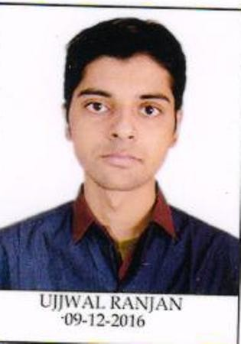**UJJWAL RANJAN | 17MA20043** MATHEMATICS & COMPUTING (M.Sc. 5Y)

|  |  |  |  |
| --- | --- | --- | --- |
| **EDUCATION** | | | |
| **Year** | **Degree/Exam** | **Institute** | **CGPA/Marks** |
| 2022 | M.SC(5YR) | IIT Kharagpur | 7.95 / 10 |
| 2016 | All India Senior School Certificate Examination | Resonance International School | 88.4% |
| 2014 | All India Senior School Certificate Examination | Resonance International School | 10 / 10 |
| **COURSEWORK INFORMATION** | | | |

Design And Analysis Of Algorithms(theory+lab),Object Oriented Systems Design(theory+lab),Soft computing,Operation Research (thoery+lab),Discrete Mathematics,Probability And Statistics, Switching And Finite Automata

**Ongoing-**Computer Organisation And Architecture,Systems Programming,Machine Learning Foundations And Applications,Linear Algebra For AI and ML

**SKILLS AND EXPERTISE**

**Programming Language Expert**: C,C++ **Familiar**: Python

**Libraries** - Panda,Numpy,Matplotlib,Scikit-Learn,STL(C++)

**COMPETITION/CONFERENCE**

# Google Code Jam|2020

•Qualified for Round 1 and secured a rank of 2563 in round 1A of Google Code Jam,2020 out of more than 32000 participants.

# Competitive Programming

•A peak rating of **1643** on **Codeforces** (@ujj_wal).

**AWARDS AND ACHIEVEMENTS**

•Secured **All India Rank 1305** in **Joint Entrance Examination Advance 2017** among 200000+ students.

•Secured **All India Rank 125** during 2016 ,in National Level Science Talent search Examination **(N.S.T.S.E.)** conducted by Unified Council .

•Secured **All India Rank 1** in mathematics and overall **All India Rank 1180** during 2014 in National Level Science Talent search Examination **(N.S.T.S.E.)** conducted by Unified Council .

•Secured **International Rank 195** and **2012** in International mathematics olympiad and **International Rank 122** and **537** in national science olympiad conducted by **Science Olympiad Foundation** in year-2013,2014.

**PROJECTS**

# Development of Desktop Application for Graph Editor|Course Project| Advisor :Prof.Bodhayan Roy|Aug-2019-Nov-2019

•Developed a desktop application of Graph Editor in Python, a tool for drawing and working with the graphs

•Created a GUI using **PYQT5** tools and **QT Designer**, on which a graph can be drawn with its nodes and edges

•Implemented addition, deletion, colouring and moving of Vertices and Edges and opening and saving the graph

•Implemented algorithms for Graph optimization problems on maximum matching,minimum vertex cover,maximum independent sets

# Machine Learning Based Inventory Management System and Sales Prediction|course project| Advisor :Prof.S.K.Barai|Feb 2019-April 2019

•Applied different regression models on data-set of previous year restaurant sales.

•The Multi Layer **Perceptron** (Neural Network) was concluded to train the data-set.

# Development of a Simple working web application blog writer|(self)

•Developed a simple blog writer using **Django** framework,Html,Css.

**EXTRA CURRICULAR ACTIVITIES**

•Member of the organizing team of **KHOJ**- AZAD Hall's treasure hunt competition for freshers.

•Participated in Disaster management Training Program and Cleanliness Drive Organised by NSO Health and Fitness,IIT Kharagpur.

•Was ranked 2nd in **Inter Hall Case Study** IIT Kharagpur during 2019.

•Contributed in winning Sports General Championship 2017-18 for Azad hall,by participating in **Chess.**

!self declaration by the student