**UJJWAL RANJAN | 17MA20043** MATHEMATICS & COMPUTING (M.Sc. 5Y)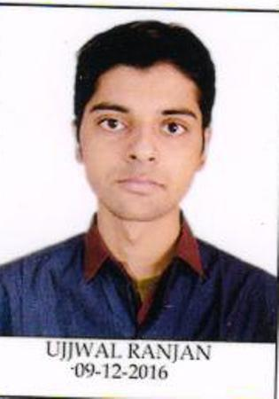

|  |  |  |  |
| --- | --- | --- | --- |
| **EDUCATION** | | | |
| **Year** | **Degree/Exam** | **Institute** | **CGPA/Marks** |
| 2022 | M.SC(5YR) | IIT Kharagpur | 7.95 / 10 |
| 2016 | All India Senior School Certificate Examination | Resonance International School | 88.4% |
| 2014 | All India Senior School Certificate Examination | Resonance International School | 10 / 10 |
| **COURSEWORK INFORMATION** | | | |
| Programming and data structure,Design and analysis of algorithm,Object oriented programming,Machine learning foundation and application,Neural networks and deep learning,Improving deep neural networks:hyperparameter tuning,regularization and optimization,Structuring machine learning projects. | | | |
| **SKILLS AND EXPERTISE** | | | |
| **Programming Languages-**  **Expert:**c,c++ **Familiar:**html,css,javascript,python  **Libraries-**panda,numpy,scikit-learn,matplotlib,opencv | | | |
| **COMPETITION/CONFERENCE** | | | |
| Google Code Jam|2020 •Qualified for Round 1 and secured a rank of 2563 in round 1A of Google Code Jam,2020 out of more than 32000 participants. Competitive Programming •A peak rating of **1643** on **Codeforces** (@ujj_wal). | | | |
| AWARDS AND ACHIEVEMENTS | | | |
| •Secured **All India Rank 1305** in **Joint Entrance Examination Advance 2017** among 200000+ students.  •Secured **All India Rank 125** during 2016 ,in National Level Science Talent search Examination **(N.S.T.S.E.)** conducted by the Unified Council .  •Secured **All India Rank 1** in mathematics and overall **All India Rank 1180** during 2014 in National Level Science Talent search Examination **(N.S.T.S.E.)** conducted by the Unified Council .  •Recipient of Innovation of Science Pursuit for Inspire Research(INSPIRE) Scholarship.  •Secured **International Rank 195** and **2012** in International mathematics olympiad and **International Rank 122** and **537** in national science olympiad conducted by **Science Olympiad Foundation** in year-2013,2014. | | | |
| **PROJECTS** | | | |
| **VIS-GRAPH**  •Developed a desktop application graph editor,tool to draw and analyse graphs.  •Prominent graph algorithm integrated like shortest path problem,graph planarity check,maximum matching,minimum vertex cover,maximum independent sets.  •Implemented addition, deletion, colouring and moving of Vertices and Edges, opening and saving the graph  •Documentation done using prominent UML diagrams  **Technology used**-python(backend),pyqt5(frontend),staruml  **INVENTORY**  •Was solely responsible for building a Deep Neural Networks model(from scratch) to create inventory management system giving over 88% accuracy.  •Used the last 3 years of sales data for a restaurant as training data, so as to identify the sales pattern of each season.  •Implemented dropout normalisation to reduce overfitting,Adam optimization algorithms for parameter update.  **Technology used**-Python,pandas,Numpy  **Web-app**  •Developed blog writer using django framework(backend),HTML,CSS,Javascript(frontend)  •Cloned various websites like netflix ,apple using HTML,CSS,Javascript | | | |
| **EXTRA CURRICULAR ACTIVITIES** | | | |
| •Member of the organizing team of **KHOJ**- AZAD Hall's treasure hunt competition for freshers.  •Participated in Disaster management Training Program and Cleanliness Drive Organised by NSO Health and Fitness,IIT Kharagpur.  •Was ranked 2nd in **Inter Hall Case Study** IIT Kharagpur during 2019.  •Contributed in winning Sports General Championship 2017-18 for Azad hall,by participating in **Chess.** | | | |

# 