**IIT MANDI CS-207 APPLIED DATABASE PRACTICUM FALL 2019**

ASSIGNMENT 2: Understanding PHP and JSON

(In groups of 3-5 students containing B. Tech. 2nd years)

**Dr. Varun Dutt Due: Before 12:00 NOON on September 2nd, 2019**

**Readings:**

* Class notes and slides from week 2
* Activity 2 on Moodle

**Objectives:**

* Understand how PHP works
* Understand how JSON works.

**Submission:**

Each group will make one single submission.

Please submit as a zipped file, the following documents:

* + HTML file and CSS stylesheet with proper filenames
  + A PHP file with the code
  + Any supplementary material that have been provided.

**Assignment:**

Q1. Create a contact form similar to the one attached below using HTML, CSS and PHP

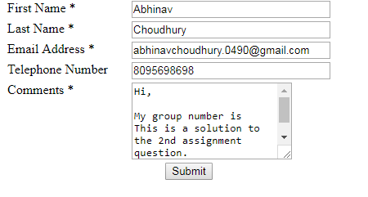

Please enter your details in the text boxes.

The following things should be present in the webpage:

1. The webpage should be structured like a contact form containing your First name, Last name, email address and Phone number and a comment.

The comment box should contain the following text:

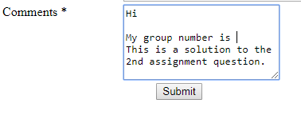

1. The form should send the above mail from your email address mail to [abhinavchoudhury.04@gmail.com](mailto:abhinavchoudhury.04@gmail.com).

Sample mail output:

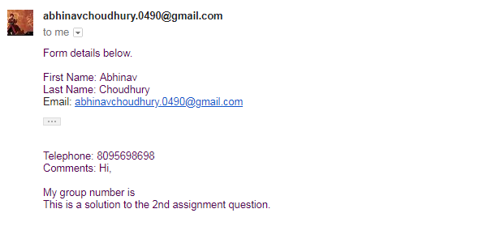

Hint: **Setting up your mail server in XAMPP**

In C:\xampp\php\php.ini find extension=php_openssl.dll and remove the semicolon from the beginning of that line to make SSL working for gmail for localhost.

In php.ini file find [mail function] and change

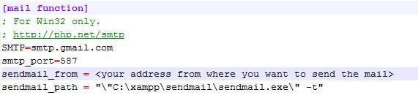

Now Open C:\xampp\sendmail\sendmail.ini. Replace all the existing code in sendmail.ini with following code

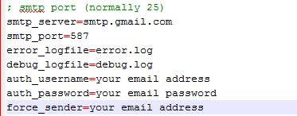

For more information, please see the following link: [How to configure XAMPP for mail](https://stackoverflow.com/questions/15965376/how-to-configure-xampp-to-send-mail-from-localhost)

Q6. **[Optional Bonus]**.

Download the JSON file wizard.json from Moodle and decode the data and print it in the following format using PHP.

