Practical-4
AIM-ER diagram relations schema
create database company;
1.create table factory
CREATE TABLE FACTORY (
city VARCHAR(20) PRIMARY KEY,
THROUGHPUT BIGINT(20),
MANEGER_ID VARCHAR(20),
FOREIGN KEY(MANEGER_ID) REFERENCES FACTORY(CITY)
);

2.create table employee
CREATE TABLE EMPLOYEE (
ID BIGINT(20) PRIMARY KEY,
NAME VARCHAR(20),
POSITION VARCHAR(20),
PAYRATE BIGINT(10),
PAYTYPE VARCHAR(20),
SUPERVISOR_ID BIGINT(20),
CITY VARCHAR(20),
FOREIGN KEY(SUPERVISOR_ID) REFERENCES EMPLOYEE(ID),
FOREIGN KEY(CITY) REFERENCES FACTORY(CITY)
);
3.create table Assemblyline
CREATE TABLE ASSEMBLYLINE(
AT_NUMBER BIGINT(10),CITY VARCHAR(20) PRIMARY KEY,
AT_THROUGHPUT BIGINT(10),
FOREIGN KEY(CITY) REFERENCES FACTORY(CITY)
);
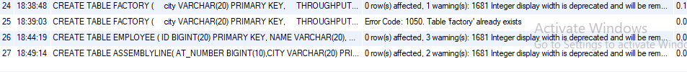

4.create part table
CREATE TABLE PART(
PART_NUMBER BIGINT(10) PRIMARY KEY,
DESCRIPTION VARCHAR(20)
);
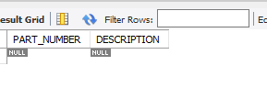
5.vendor table
CREATE TABLE VENDOR(
NAME VARCHAR(20),
EMAIL VARCHAR(30),
PHONE BIGINT(10));
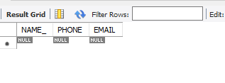
6.part_vendor table
CREATE TABLE PART_VENDOR(
PART_NUMBER BIGINT(10),
NAME VARCHAR(20),
FOREIGN KEY(PART_NUMBER) REFERENCES EMPLOYEE,
FOREIGN KEY(NAME) REFERENCES VENDOR);
