**PRACTICAL - 5**

**AIM-Calculate and display the total no of students enrolled in followingsubjects from student table.**

**1.create table student_info**

CREATE TABLE STUDENT_INFO(STUDENTID BIGINT(10),

NAME VARCHAR(10),

SUBJECT VARCHAR(20),

);



**2.Insert details**

INSERT INTO STUDENT_INFO(STUDENTID,

NAME,

SUBJECT)VALUES

(1,'UJJWAL','MATHS'),

(2,'AIM','SCI'),

(3,'RIYA','PHY');



**3. display total no of students enrolled in maths-**

SELECT COUNT(SUBJECT) FROM STUDENT_INFO WHERE SUBJECT='MATHS';

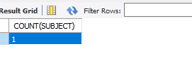

**que 2 -write queries to implement following function**

**(i)Grouping fun**

SELECT SUBJECT, COUNT(SUBJECT)

FROM STUDENT_INFO

GROUP BY SUBJECT

ORDER BY SUBJECT;

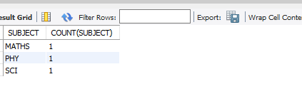

**(ii)Mathematical function**

ALTER TABLE STUDENT_INFO ADD COLUMN MARKS VARCHAR(10);

INSERT INTO STUDENT_INFO(STUDENTID,

NAME,

SUBJECT,

MARKS)VALUES

(1,'ANJALI','MATHS',20),

(2,'AIM','SCI',30),

(3,'RIYA','PHY',40);

SELECT SUM(MARKS) FROM STUDENT_INFO WHERE SUBJECT='MATHS';

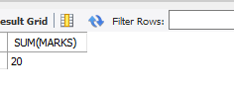

**(iii) Character function**

SELECT * FROM Student_info WHERE NAME LIKE 'A%';

