Practical-6

Aim: Create an employee(empid,name,dept) and account(empid,salary) define empid as the primary key in employee also the foreign key from accounts, dept as not null also check salary>0 and display the name of all employees having salary greater than 10000.

1. Create employee and account table

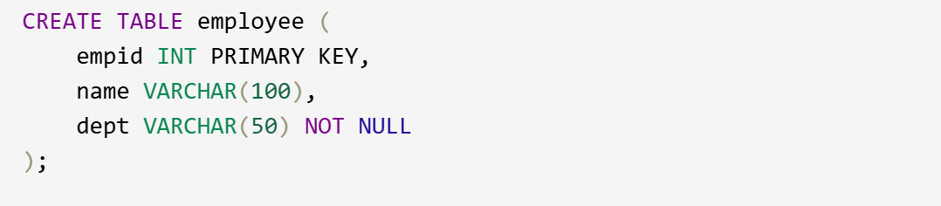

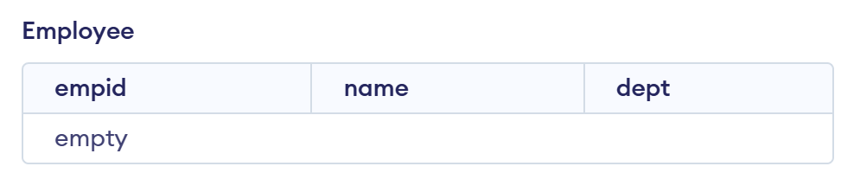

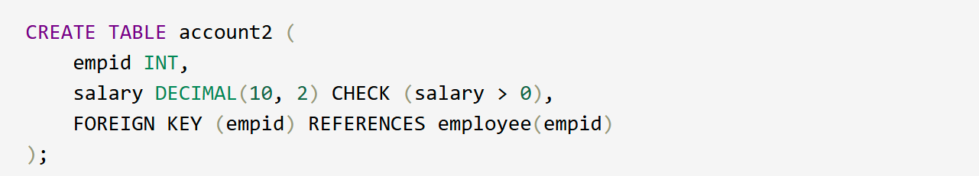

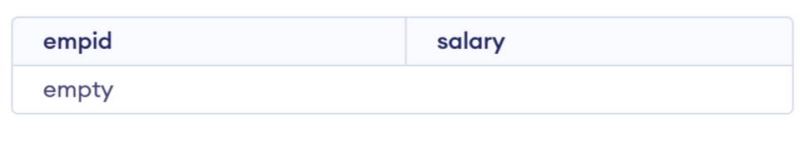

2. Insert 5 rows

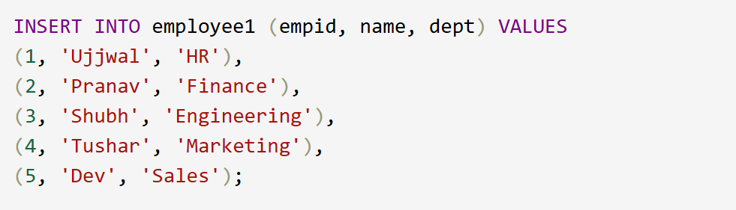

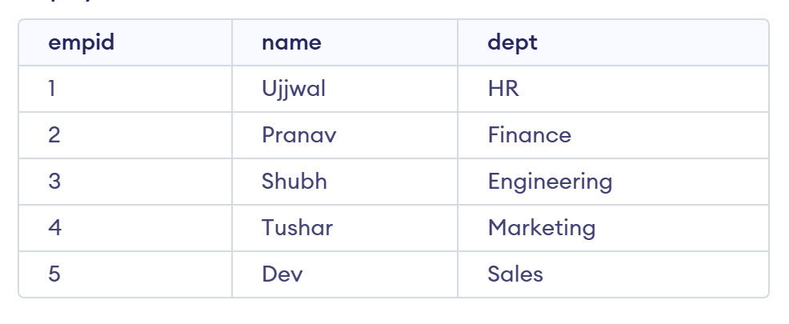

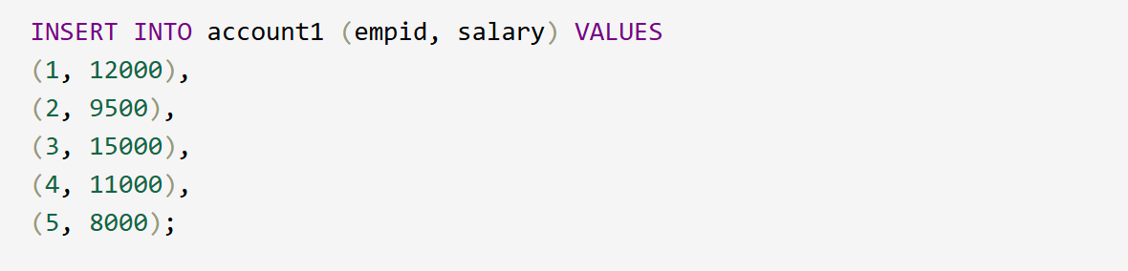

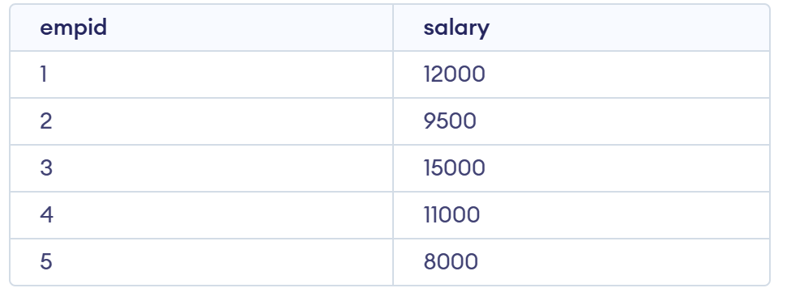

3. Run the query to check salary>10000

