Practical-7

Aim: To create employee table and run the following subqueries

1. Create table employee

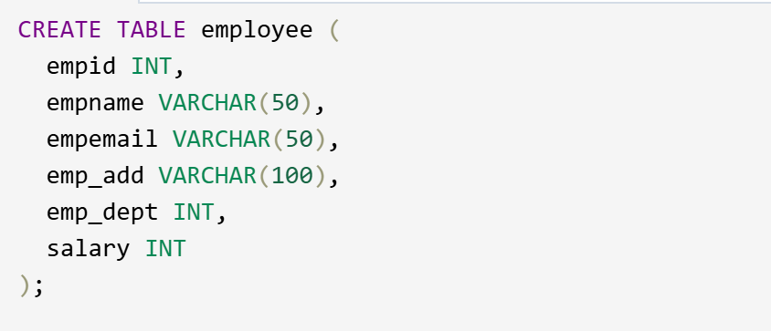

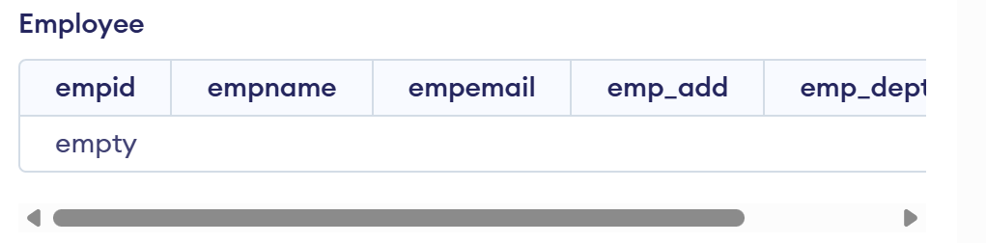

2. Insert 10 entries

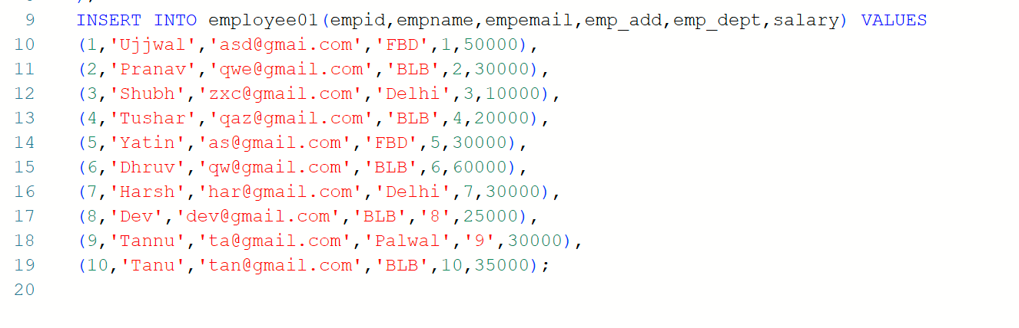

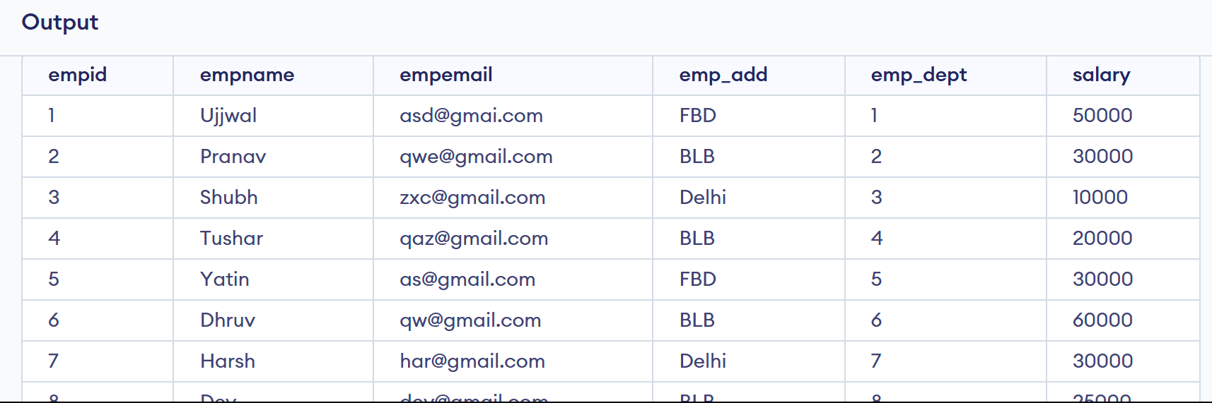

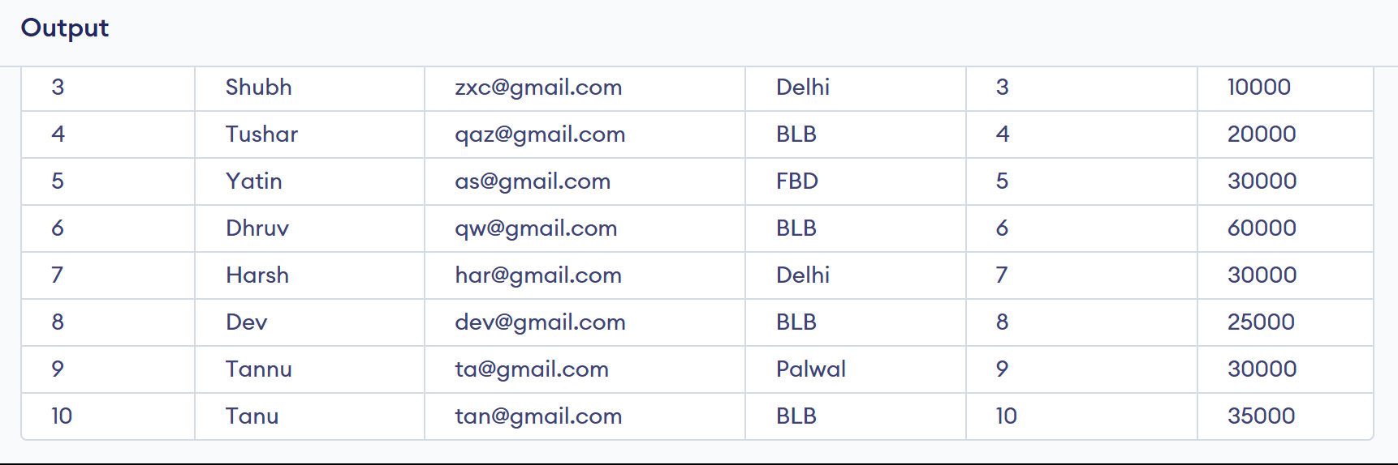

3. Select empname,empid,emp_add where salary>(select salary from employee where empname=’Harsh’)

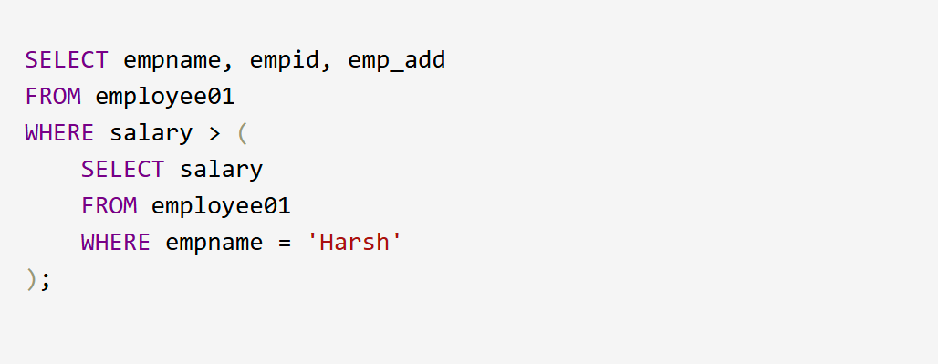

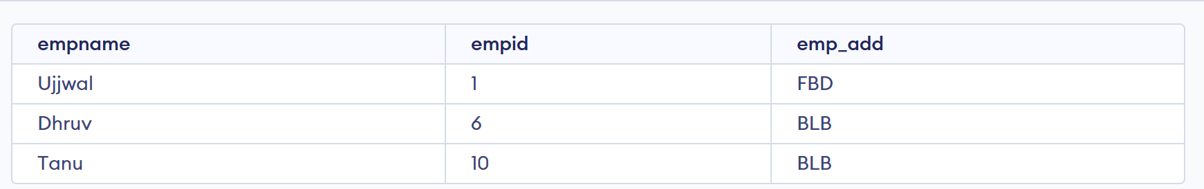

4. Select empname,empid from employee where salary< any(select salary from employee where emp_dept=10)

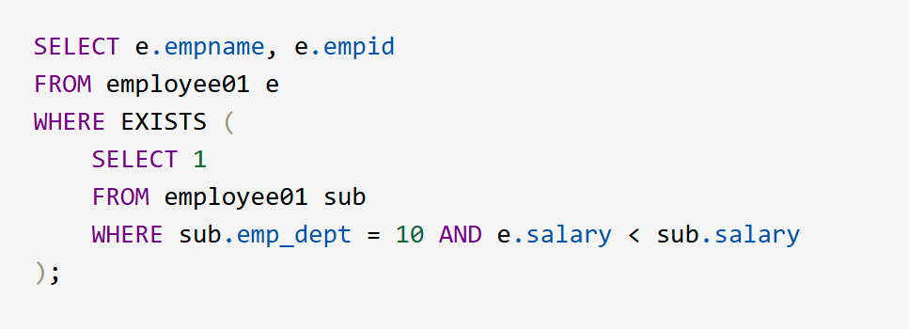

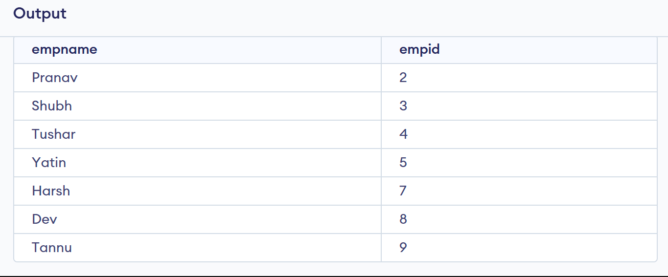

5. Select * from employee x where x.salary>(select avg(salary) from employee where emp_dept=x.emp_dept)

