Practical-8

Aim: Implement the grouping group by, order by and run the following queries-

1. Create table customer



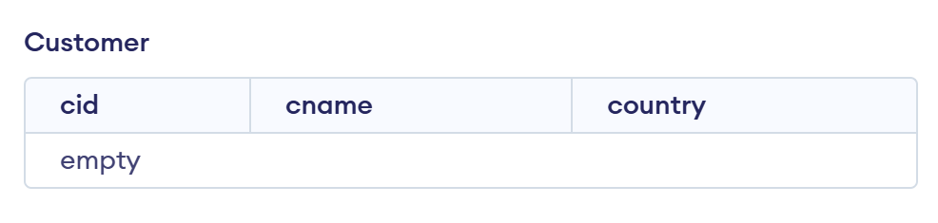

2. Insert 10 entries

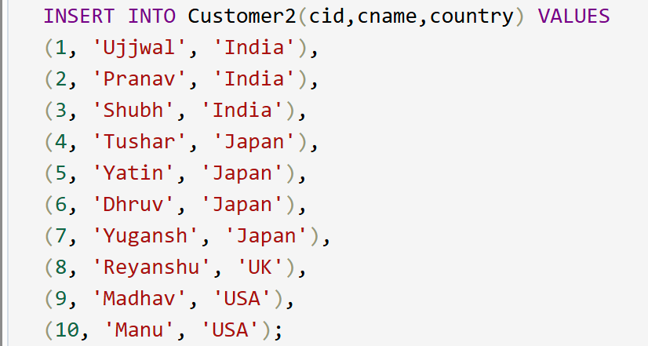

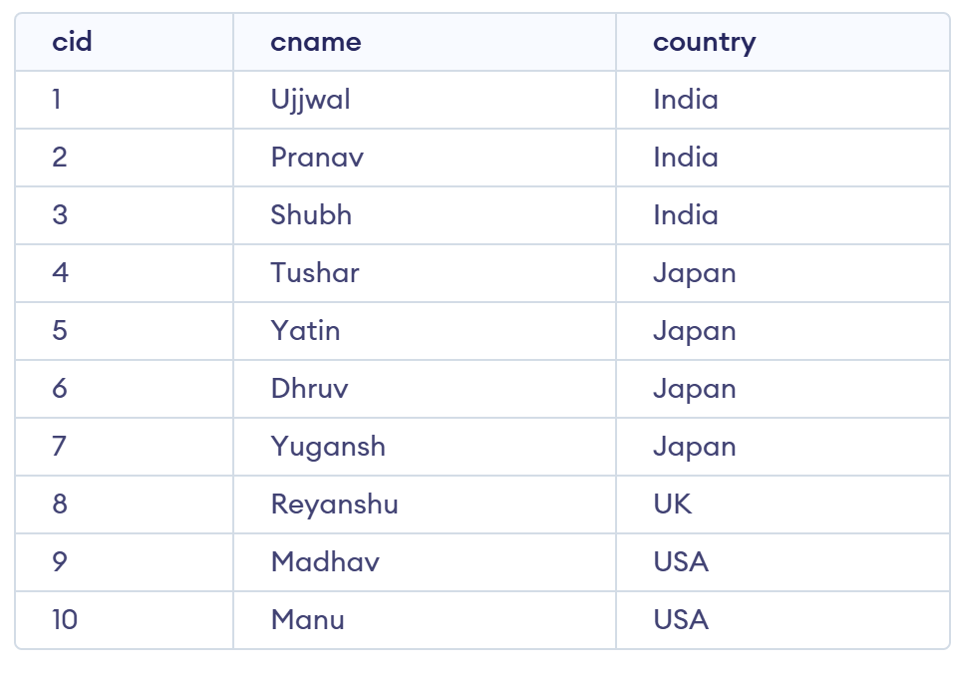

3. Select count(cid), country from customer group by country

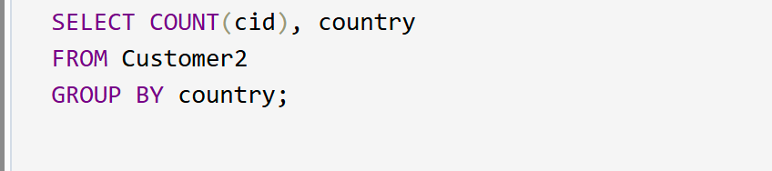

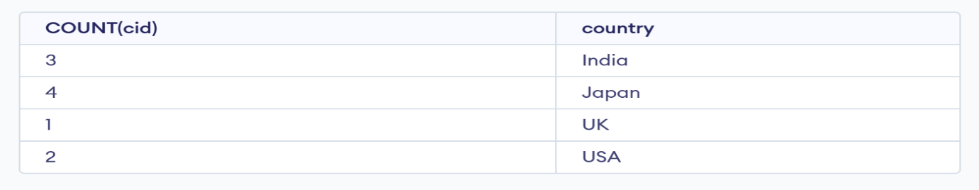

4. Select count(cid), country from customer group by having count(cid)>3

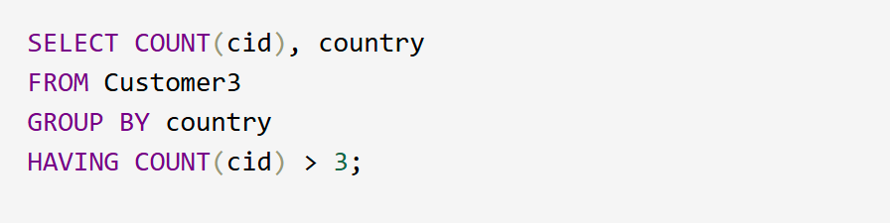

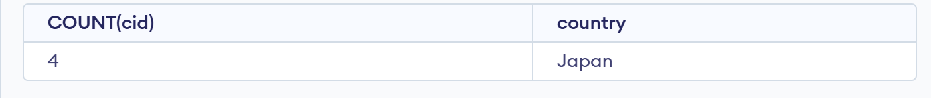

5. Select cid(name from customer order by cid asc)

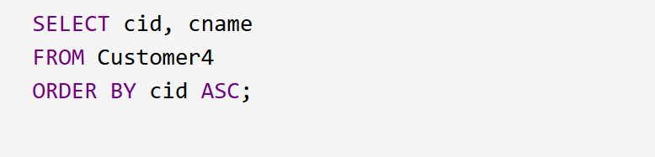

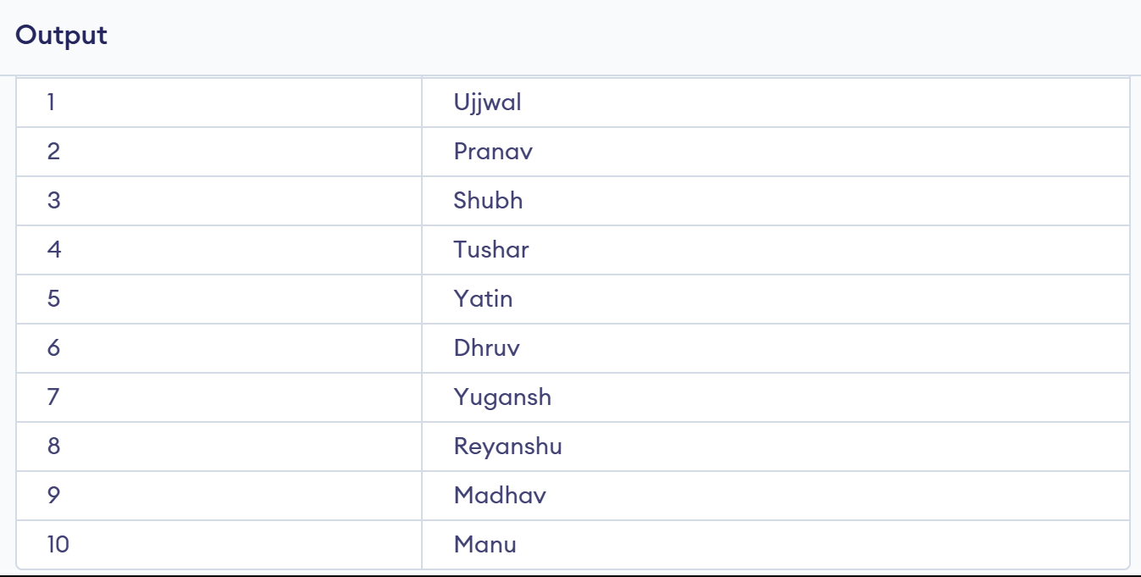

6. Select cid(name from customer group cid desc)

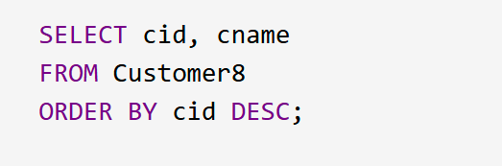

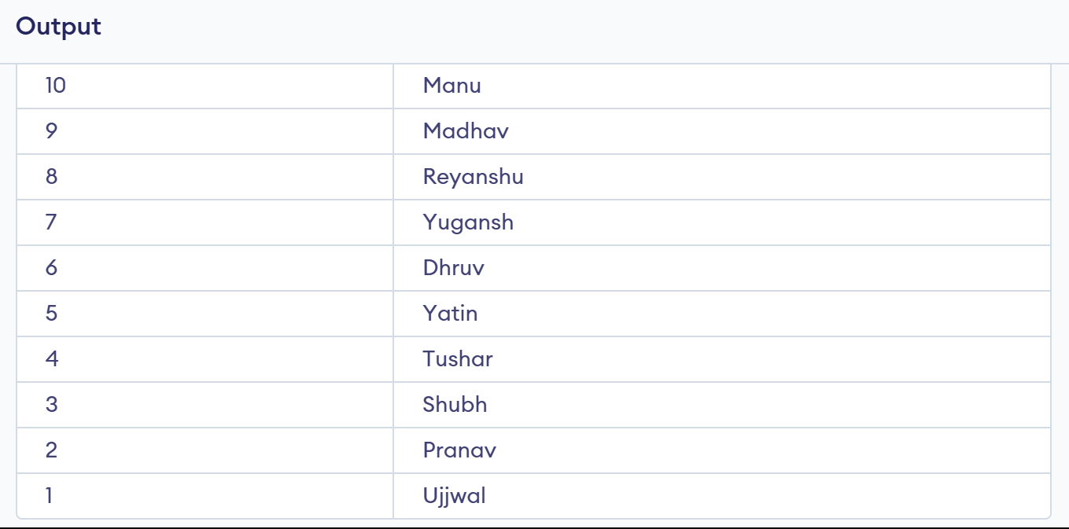

7. Select cid(cname from customer order by cid asc, cname desc)

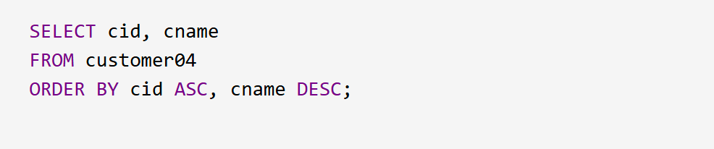

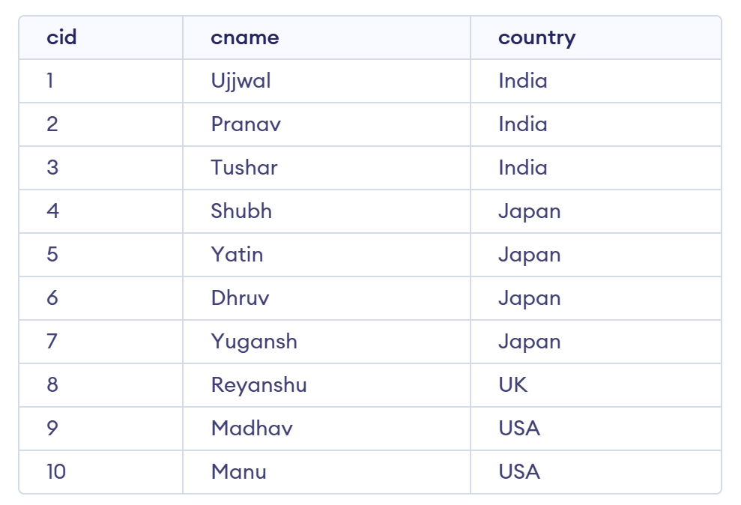

8. Create view custview as select \* from customer



