Practical-9

Aim: To perform Left join, Right join, Inner join, Left join where B.key is NULL, Right join where A.key is NULL, Full join where A.key or B.key is NULL, Full outer join

1. Create customer and order table

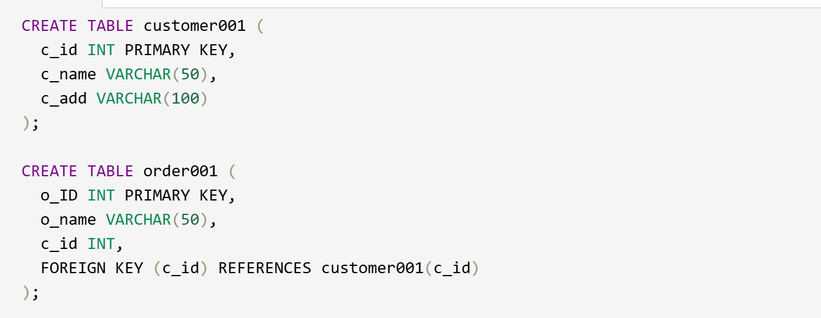

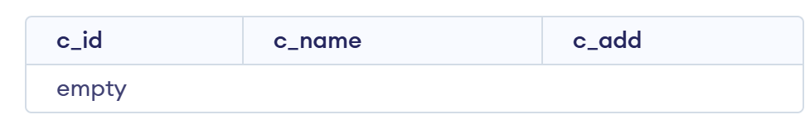

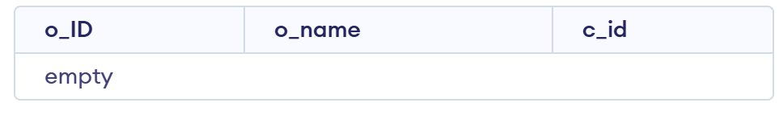

2. Insert 5 rows in both tables

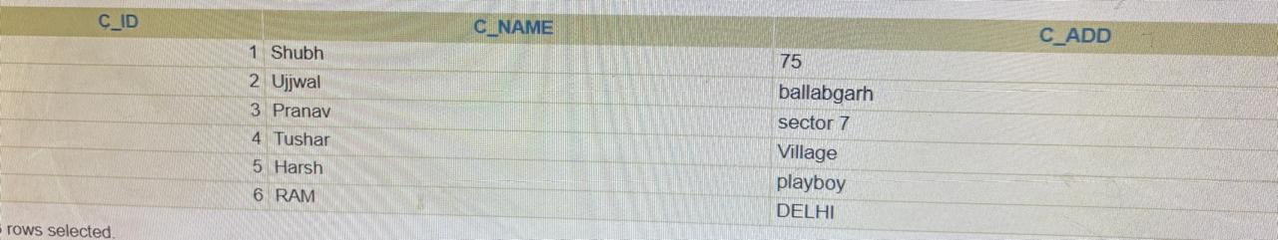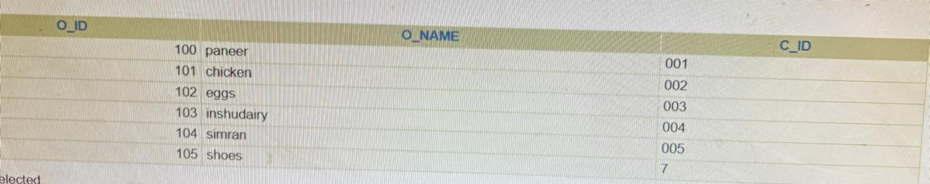

3. Perform query for left join

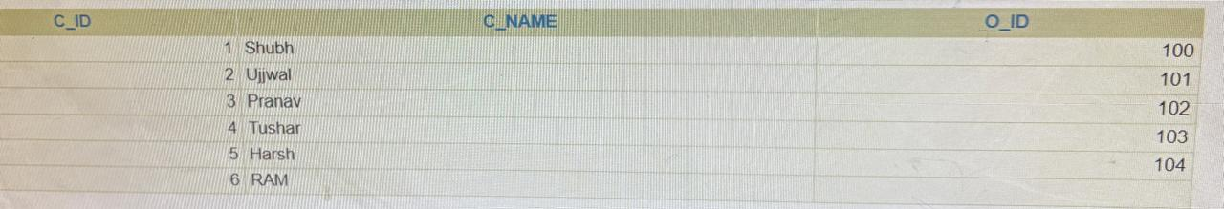

4. Perform right join

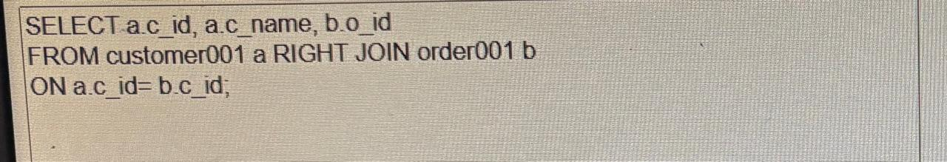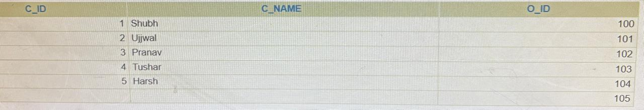

5. Perform inner join

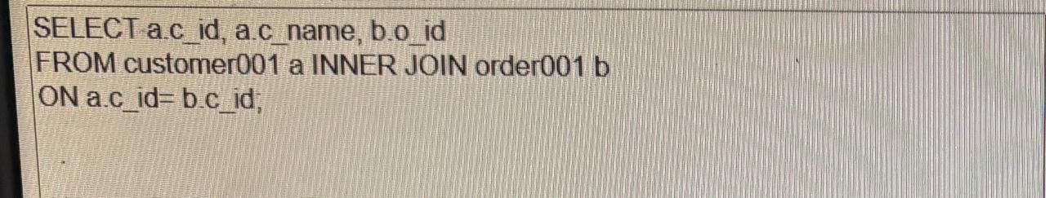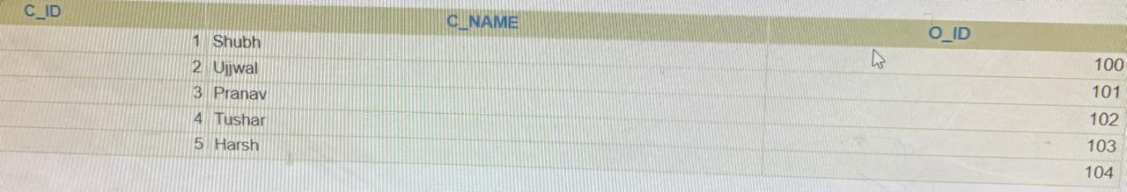

6. Perform Left join where B.key is NULL

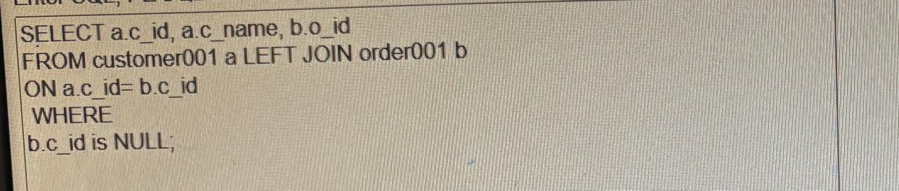 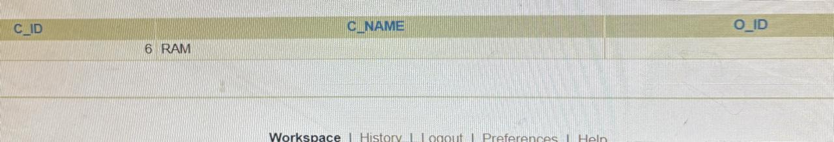

7. Perform Right join where A.key is NULL

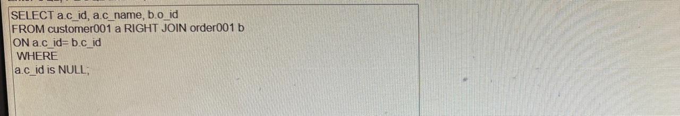 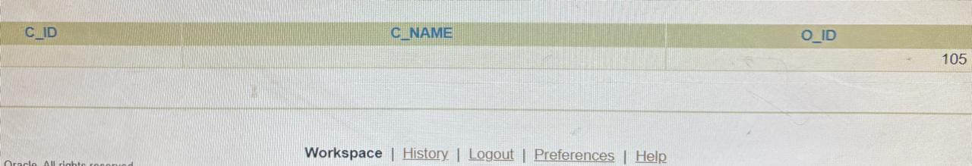

8. Perform Full join where A.key or B.key is NULL

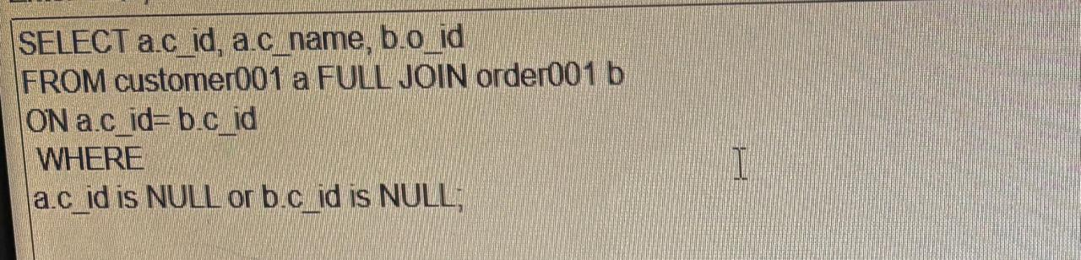

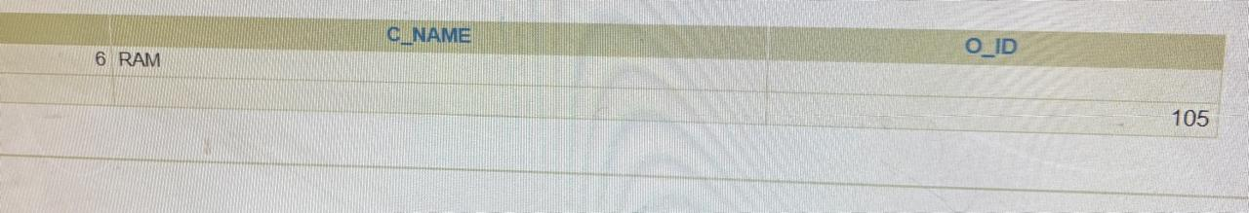

9. Perform full outer join

