* Github Link : <https://ujkim98.github.io/Multimedia_for_Education/home.html>

Dear Professor.

I found that ‘Menu4 - Coordinate’ was not working well in Chrome and Internet Explorer as I designed. However, it worked well in Microsoft Edge. So if you don’t mind, would you please open above link in Microsoft Edge, sir?

Nevertheless, in case of not working well in your computer, I insert another link that shows video which ‘Menu4 – Coordinate’ worked well in my computer.

Also, when you first open it, Microsoft Edge will automatically block scripts of my pages, so would you please allow it, sir?

Thank you, professor.

* Video Link : <https://ujkim98.github.io/Multimedia_for_Education/Sample_of_Coordinate.mp4>

**<Final Project Report>**

2018313285 Computer Education Ujin Kim

I chose ‘Learning Math easily’ for my final project topic. Considering that I want to be a teacher and I was not that good at math when I was a student, I ended up choosing this topic. Targets for this website will be elementary school students. To be honest, even though getting out of “Teaching by rote” is important and it may help students to think creatively, Korean middle school and high school students are too busy to learn creatively by using multi-media like my website. Unlike piteous students who have to devote themselves to Korean SAT, elementary school students still have a lot of time until Korean SAT, also they are more interested in and receive more effect when they are taught by multi-media because they are young.

I think numbers and figures are basic, but also major part in math. However, young elementary school students do not fully understand about it. For example, when they just think or imagine about various calculations using numbers or different properties of weird figures, they can be confused and may not get it intuitively. So I hope my future students to easily deal with numbers and figures using visual aids in my website.

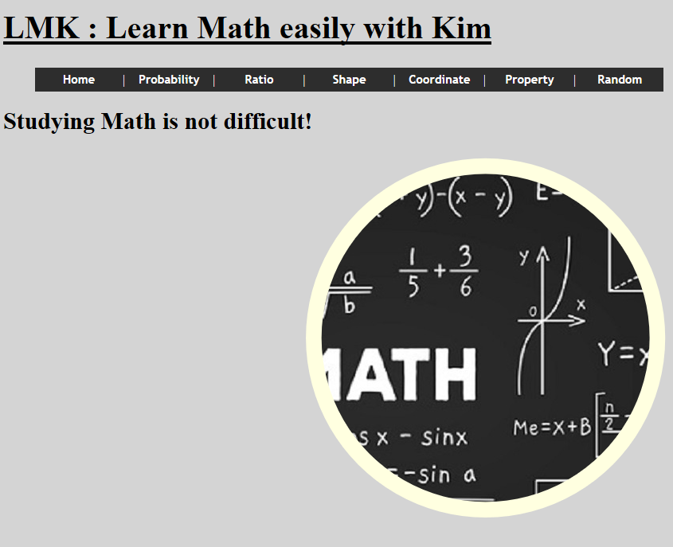Then, from now on, I will introduce my website in terms of design, contents, and user convenience. **Firstly**, let’s me talk about design. Concept of my website is ‘Simple’. Considering that its purpose is teaching students, too many pictures or decorations may disturb students. Instead, I placed adequate numbers of pictures and decorations to the extent of not hurting student’s concentration. In addition, I used black & white or brown tone’s colors throughout all pages to look calm and clean.

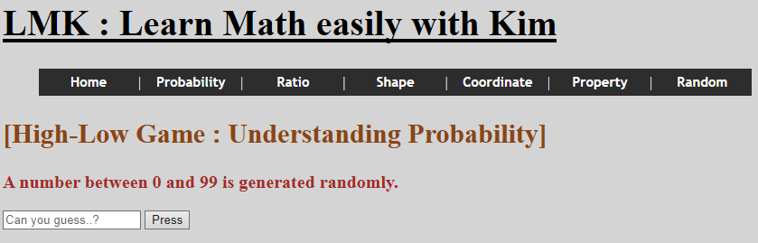**Secondly**, and most importantly, the contents that the website has. There are 6 sections to study. **First section** is probability. When students enter ‘Probability’ page, random number between 0 and 99 is generated automatically. Students have to write down his or her guessing number. Whether it is right or not, ‘count’ will increase. If it is wrong, messages that let students to adjust the number will come out and if it is right, total count and guessing probability will be alerted. When we do it again at the same page, random number is same, but count is refreshed. However, when we refresh the page and do it again, both random number and count are refreshed. Because the count is provided, students can easily and interestingly understand the idea of probability by playing ‘High-Low Game’.

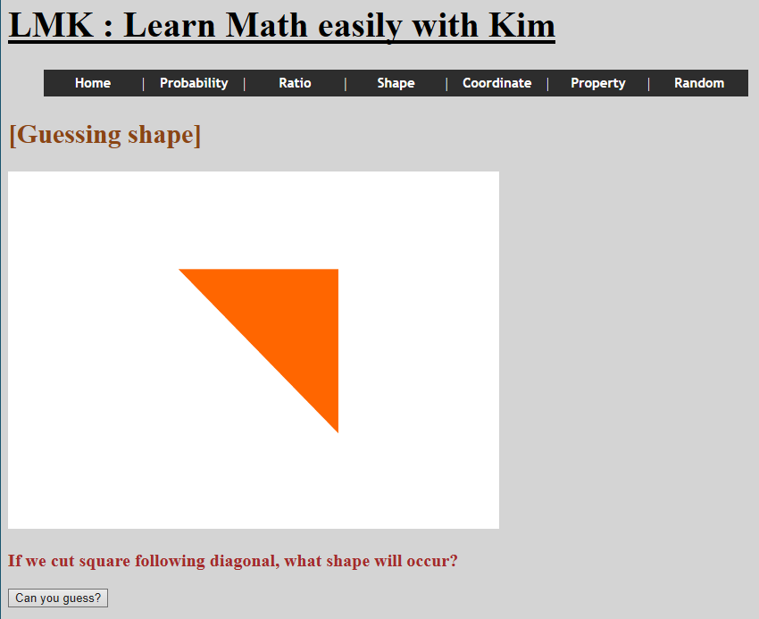**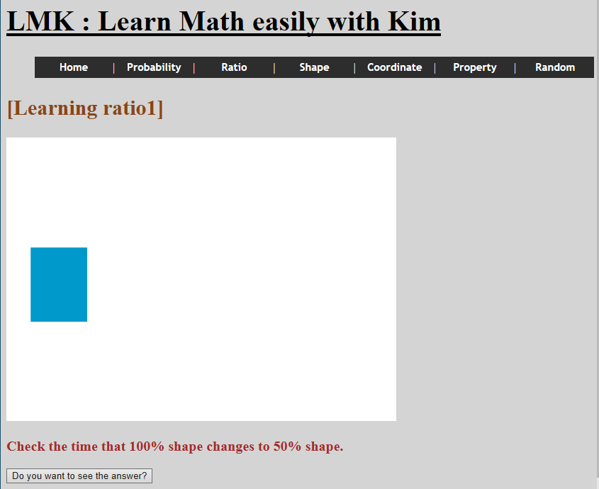Second section** is ratio. There are 2 figures that are made with Flash. At first, students check the time that first figure changes from 100% to 50% and then compare with the answer. Next, students check the time that second figure changes from 50% to 0% and then compare with the answer. Because students studied ratio(5s : -50% = Xs : -100%) while looking at animation of changing figure, they can intuitively get notion of it.

**Third section** is shape. There is square made with Flash. If we cut it following diagonal, it will become right angle isosceles triangle. However, young elementary school students may have trouble with imagining accurate figure, so in this case, studying with animation which is kind of visual aid will be helpful. Also, like second section, answer is shown as pop-up style and it disappears when we press ‘OK’ button. So it is more suitable for reviewing the section than non-pop-up style.

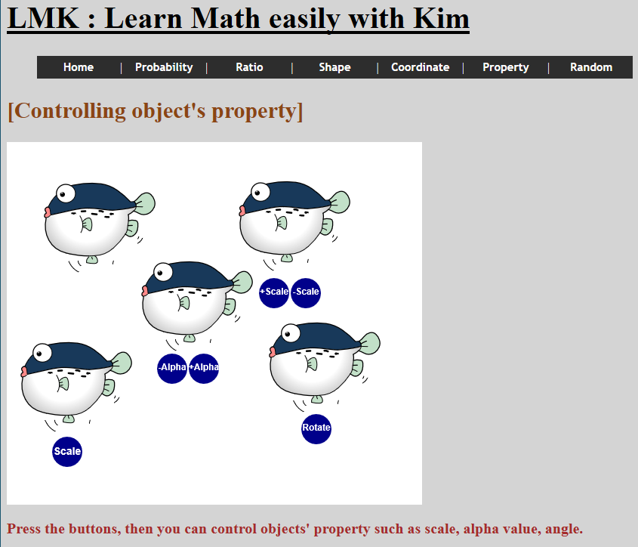**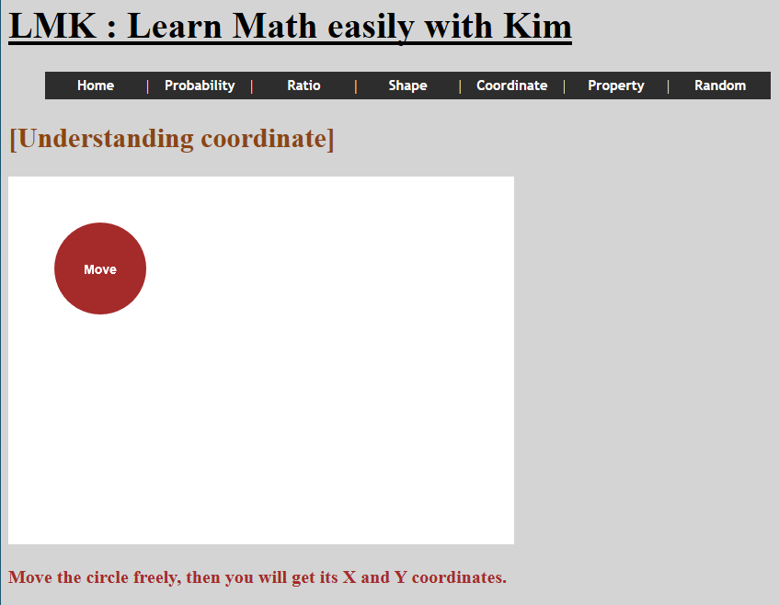Fourth section** is coordinate. Students drag circle to anywhere in canvas. Every time the circle moves, it alerts its current position with X-coordinate and Y-coordinate. Young students who only know one-dimension will become familiar with two-dimensional system while he or she is actually moving the figure in two-dimension.

**Fifth section** is property. In this section, students deal with diverse properties of object. If we press ‘Scale’ button, fish keep heading back and forth. If we press ‘–, + Alpha’ button, fish’s alpha value is repeatedly being changed. If we press ‘+, – Scale’ button, the size of fish is getting bigger and smaller. Finally, if we press ‘Rotate’ button, fish is being rotated as 45 degrees per each press. Because objects are not just simple figures but funny looking fishes, they can stimulate curiosity of students and can teach conception of scale, alpha and rotation naturally.

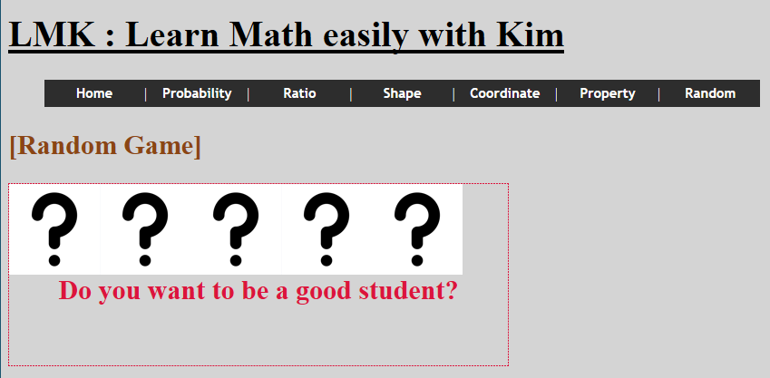**Last section** is random. There are 5 covered cards. If students open the card, it will be ‘Good’ card or ‘Bad’ card. The game ends when all of 3 ‘Good’ Cards are founded, and guessing accuracy is provided. By random game, students can understand probability unaffectedly and joyfully.

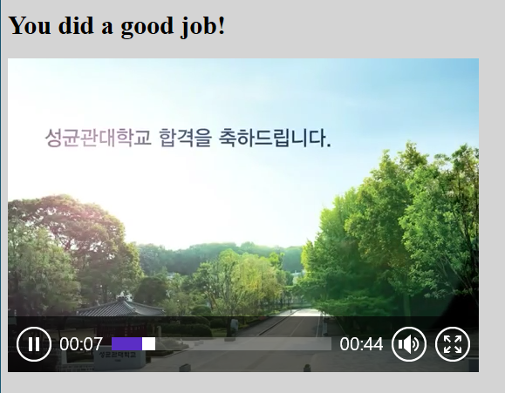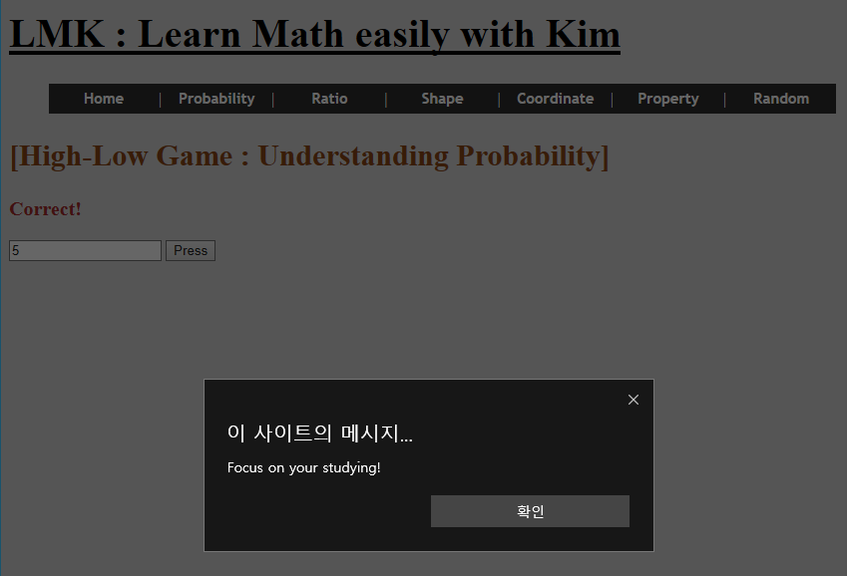**Lastly**, I will talk about functions that contribute to user convenience. At first, black colored menu bar helps students to easily and quickly find contents for studying. In anywhere, students can move to ‘Home’ page or different section pages by using it. Also, when we put mouse cursor on menu, its color is changed so we can easily know where we are pointing at. In addition, the mask effect that can be founded on ‘Home’ page catches students’ attention and makes them to arouse interest in subjects that we are going to handle soon. Besides, except ‘Home page’, in all other studying pages like ‘Probability’, ‘Ratio’ and so on, alerting messages come out once a minute to make students keep focusing on their studying. Finally, when students finish all sections from ‘Probability’ to ‘Random’, congratulation video is played automatically to compliment and encourage students to keep study hard if students want to enter SKKU in the distant future.

I did not had experience about html and java script before, so it was quite difficult to handle them at first. However, I think I made decent website by myself, and I am proud of it. With this project as a momentum, I want to become a teacher who helps students to study easily and interestingly by using various types of multi-media at the future.