Prosocial Personality and Cognitive Buffers for Partners of Manic Individuals
Marc Weintraub
University of California, Berkeley

Abstract
An extensive amount of research examines the ill effects of bipolar disorder for romantic relationships (e.g. Miklowitz & Johnson, 2009; Lam, Donaldson, Brown, & Malliaris, 2005), but little research has examined whether there are some people who can better cope with their partners who suffer from bipolar disorder, especially during the manic phase of the disorder. This paper attempts to fill that gap by examining how romantic partners of individuals higher in manic symptoms (measured with the ASRM; Altman, Hedeker, Pederson, & Davis, 1997) can experience greater satisfaction with their relationships. Specifically, this study investigates whether people who are higher in agreeableness and reappraisal tendencies report less declines in relationship satisfaction as well as engage in greater behavioral indicators of relationship quality—namely, touch and laughter—relative to people lower in these traits. Results from sixty-three couples in romantic relationships provide initial evidence that agreeableness and the tendency to reappraise are indeed important traits that help romantic partners of individuals with mania experience greater satisfaction and engage in more touch and laughter behaviors in comparison to partners lower in these tendencies. These findings suggest the dispositional and cognitive buffers that can safeguard against the ill effects of a partner with manic symptoms and demonstrate the importance of prosocial research in understanding manic and bipolar relationships.

Introduction
Romantic relationships are one of the most important social connections that we make in our lives; however, maintaining these relationships is not easy. When a couple is faced with a partner’s psychological disorder, relationship stress can be exacerbated. In the case of bipolar disorder, researchers have discovered that a romantic partner suffering from a manic episode often creates increased financial, emotional, and social problems for the relationship (e.g. Hunt, 2004; Steele, Maruyama, & Galynker, 2010; Lam et al., 2005).
This paper focuses on mania, which is typically researched within the context of bipolar disorder—a disorder that includes episodes of both mania and depression. The symptoms of a manic episode in the Diagnostic and Statistical Manual (IV-TR) include elevated or irritable mood. Additional symptoms include increases in goal-directed activity or physical restlessness, unusual talkativeness or rapid speech, flight of ideas, decreased need for sleep, inflated self-esteem, distractibility, and excessive involvement in pleasurable activities. These symptoms can vary from a euphoric mental state to an irritable and aggressive state (Moreno & Andrade, 2010). While a manic episode can become stressful for many people around the manic individual, a reduced need for sleep and an inflated self-esteem can make the individual with mania feel elated and confident (Braun, Daigneault, Gaudelet & Guimond, 2008).

Mania and Intimate Relationships
Currently, little research explores the role mania may play in romantic relationships. Most of the literature regarding bipolar disorder views the disorder in its entirety, and fails to distinguish depression from mania in the examination of its subjects, leaving the diametrically different effects the two poles of bipolar disorder (i.e. depression and mania) have on bipolar individuals unaddressed (e.g. Rosa et al., 2008). This means of investigating bipolar disorder provides an unclear understanding of the specific aspects of the experiments’ results that can be attributed to the particular symptoms of bipolar disorder. For example, the literature cited in this paper has only examined patients with bipolar I disorder, a condition characterized by one or more manic episodes, and possibly one or more depressive episodes. Consequently, the results of many studies investigating the effects of bipolar disorder on relationships include findings that may be attributable to mania or depression, or both. While investigating bipolar disorder in its entirety certainly has its strengths, exploring the nuances of the disorder can greatly expand the current literature by providing more specific insight into the particular workings of each distinct episode. Due to the fact that mania is considerably understudied, the present study seeks to understand whether certain characteristics can help those in relationships with partners who suffer from mania better cope with their manic partners. Specifically, the present study examines whether prosocial tendencies can buffer partners of individuals who suffer from mania against experiencing decreased relationship quality.
The current literature on bipolar I disorder notes that there is added stress in relationships with manic people (Hunt, 2004), but some partners of individuals who suffer from mania may have traits or coping mechanisms that may potentially shield them from the stresses of manic symptoms. Financial issues, for example, are major concerns that are closely connected to bipolar disorder (Rosa et al., 2008) and influence satisfaction in romantic relationships. Across studies, researchers have found that people experiencing manic episodes often have unwise spending patterns and increased desire to partake in pleasurable activities such as drug use (Kulkarni et al., 2008), behaviors that create financial and emotional difficulties for families (Lam et al., 2005; Rosa et al., 2008). Although an individual experiencing a manic episode may view the mania as pleasurable, the negative effects of the disorder are detrimental to both the diagnosed individuals and the people around them (Moreno & Andrade, 2010). Mania puts an emotional strain on romantic relationships; one study found that a little over 50% of spouses tend to feel overwhelmed with their bipolar partners, and 65% felt miserable and conflicted about staying with their partner (Lam et al., 2005). The emotional toll becomes so taxing that about 53% of spouses said they would have not married had they known beforehand of their partner’s illness (Targum, Dibble, Davenport & Gershon, 1981). In light of the difficulties of mania, some studies have started to examine methods that can help couples cope with bipolar episodes. These practices include better communication, problem solving, and decreased expressed emotion, a variable that is measured by criticism and hostility (Miklowitz & Johnson, 2009). Therapists attempt to teach these beneficial strategies to the individuals, couples, and families. While these therapies have been found to be rather successful, they still are in their beginning stages.
The difficulties confronting couples in which one partner experiences manic episodes are detrimental to the health of such relationships. The present study focuses on whether certain dispositional and cognitive tendencies of the non-manic partners can help buffer the non-manic against decreased satisfaction in a relationship with a partner who suffers from mania.

Can a Partner’s Prosocial Orientation be a Buffer?
To examine the prosocial behaviors of individuals who rate higher on manic symptoms, positive psychology was applied in the present study. This positive psychology framework focuses on factors that contribute to an individual’s health, happiness, and ability to cope with life circumstances (Gillham & Seligman, 1999). In the context of this study, positive psychology pertains to the prosocial, internal and external characteristics that help individuals experience greater levels of relationship satisfaction (i.e. increased levels of agreeableness and reappraisal, described below). Specifically, the question of whether certain individual personality differences and cognitive responses can help buffer people against the ill effects of a partner who suffers from mania is examined. Since some potentially problematic behaviors of partners who suffer from mania are related to the non-manic partner’s inability to sympathize with their partners (a dispositional component; Lam et al., 2005) and control their own emotions (a cognitive component; Miklowitz & Johnson, 2009). This paper will examine both prosocial dispositions and prosocial cognitive tendencies that may assist couples in better coping with partners who suffer from mania. The present study examines whether being more agreeable (John, Donahue, & Kentle, 1991) and having a stronger tendency to reappraise emotional situations (Gross & John, 2003) help people better cope with partners who suffer from mania, relative to people who are less agreeable and engage in less reappraising.
The first point of examination, agreeableness, refers to prosocial traits such as compassion, kindness, and sympathy (John et al., 1991). Research has shown that for most couples, those who are more agreeable tend to be more accommodating of their partner, especially during stressful times (Perunovic & Holmes, 2008). Furthermore, higher levels of agreeableness predict more commitment and willingness to deal with problems in a relationship (Urbaniak & Kilmann, 2006). Overall, this prosocial disposition seems to make the individual more flexible, understanding, and proficient in resolving problems. Thus, it is hypothesized that people who are more agreeable will be less adversely affected in relationships with partners who are higher in manic symptoms than those who are less agreeable.
The present study’s hypothesis is that people who have a greater tendency to reappraise, meaning that they tend to mentally move away from the issue at hand and think through a problem during times of stress (Gross & John, 2003), will experience fewer negative effects in relationships with manic partners than those who reappraise less. Partners of individuals higher in manic symptoms may experience more stressors and negative situations than people whose partners have less or not mania (Hoover & Fitzgerald, 1981). For example, the non-manic partner may be dealing with a partner who is engaged in several difficult behaviors, such as increased irritability, a lower libido, substance use, and frivolous money spending (e.g., Moreno & Andrade, 2010; Lam et al., 2010; Kulnari et al., 2008). Those who are able to deal with these situations by reappraising their partner’s negative behaviors and emotions may be better equipped to cope and interact with a partner who has mania (e.g. by re-evaluating the situation before reacting) than those who do not have such tendencies. In this way, reappraising will benefit both partners and can be seen as a prosocial tendency that can counteract the stress of manic relationships. In sum, the present study hypothesizes that people who are more agreeable and who reappraise more experience higher quality relationships with manic partners than individuals who are less agreeable and reappraise less.
Using data from 63 couples, the present study examined whether people who had greater prosocial tendencies were better able to cope with partners with mania. That is, the present study tested whether people in relationships with partners who are more manic, more agreeable, and had a greater tendency to reappraise were more satisfied with their manic partners, compared to those who were less agreeable and reappraised less. The present study also examined whether people in relationships with partners who rated higher in mania, touched and laughed more during their interactions were more satisfied with their relationship, relative to people who touched and laughed less.
The present study extended prior findings in three important ways. First, prior research has focused on the broad spectrum of bipolar disorder, whereas the present study focused only on mania, allowing the specific episode of mania to be an isolated and uniquely educational piece to learn from (i.e., higher levels of cheerfulness, talkativeness, sleepiness, activeness, and self-confidence). Second, researchers have previously focused on ways in which manic symptoms negatively impact relationships while this study examined the prosocial ways in which people with partners with mania can make the relationship more satisfying (i.e., through agreeableness and reappraisal). Finally, previous research on the role of mania in romantic relationships (which primarily focused on self-reported relationship quality) is extended by including behavioral indices of relationship quality—namely touch and laughter.

Method

Participants
Sixty-three heterosexual couples in romantic relationships were recruited from the San Francisco Bay Area using advertisements on Craigslist.org and paper flyers. The participants comprised a diverse range of ethnic backgrounds in which 52% were European or European-American, 20% were Chinese or Chinese-American, 8% were African or African-American, 5% were Mexican or Mexican-American, and 15% were of other races/ethnicities. The mean age among participants was 28 years (SD = 6.7; Range = 18 - 60). On average, the couples had been in their relationships for a little over two years (SD = 24.4; Range = 2 months to almost 8 years) and about half (48%) were cohabiting.

Procedure
After both partners had agreed to participate in the study, each partner was sent a link to a secure website where he or she completed demographics as well as questions assessing his or her personality and relationship quality, including measures of manic symptoms, agreeableness, reappraisal tendencies, and relationship satisfaction. The couples then arrived at the lab and participated in several videotaped interactions. The couples discussed three different topics, with each being the “speaker” and the “listener” for a total of six conversations. Each partner was asked to think of a time when they had made a sacrifice for their partner, a time during which they had felt a lot of love for their partner, and a time when they had experienced a great deal of suffering. These three conversation topics, each ranging from 51 seconds to 8 minutes 22 seconds with a mean conversation time of 3 minutes 37 seconds (SD = 1 minute, 10 seconds), were chosen to evoke emotional sentiments from both partners, with the intent of fostering behavioral responses (such as touching and laughing). The order of speaking was decided randomly by randomly flipping a coin. Each person was paid $30 dollars as compensation for participating in the laboratory portion of the study. Within the laboratory setting, each partner was seated in a chair that was facing the other partner, allowing the couples the opportunity to touch each other. There were two small cameras mounted on the wall about 6 feet above the ground. Each camera was angled directly in front of the respective participant, allowing for a full frontal recording. The cameras were visible to the participants and captured images from the top of their heads to their laps. Research assistants controlled the cameras from an adjacent room where they could hear the conversations and communicate to the participants through an intercom.

Background Measures

Mania
Mania was measured using the Altman Self-Report Mania Scale (ASRM; Altman, Hedeker, Pederson, & Davis, 1997), a self-report inventory with five items. This scale exhibited good reliability, α = .79, and scale items rated the severity of the following five symptoms within the past week: cheerfulness (“I feel happier and more cheerful than usual”), inflated self-confidence (“I feel more self- confident than usual”), sleepiness (“I can go all day or night without any sleep and still not feel tired”), talkativeness (I talk constantly and cannot be interrupted”), and excessive activity level (“I am constantly active or on the go all the time”). The items were measured on a 5-point scale that assessed the level of the symptoms. For example, cheerfulness scores ranged from 0 (I do not feel more cheerful than usual) to 4 (I feel much more cheerful than usual). The five items are summed to create a composite score that can range from 0 (not at all manic) to 20 (most severe manic symptoms). The ASRM is highly correlated with both clinical interviews and self-report levels of mania (Altman, Hedeker, Pederson, & Davis, 2001).

Agreeableness
Agreeableness was measured with the Agreeableness subscale of the Big Five Inventory (BFI; John et al., 1991), and, in this sample, it was highly reliable with α = .77. This subscale includes nine items such as “I sympathize with other’s feelings” and “I make people feel at ease.” The items were measured on a 5-point Likert Scale and ranged from 0 (strongly disagree) to 4 (strongly agree).

Reappraisal
Reappraisal was measured using the Emotion Regulation Questionnaire, (ERG; Gross & John, 2003), and the scale was highly reliable, with α = .83. The ERG measures reappraisal with six items that assess overall reappraisal tendencies (e.g. “I control my emotions by changing the way I think about the situation I’m in”), as well as reappraisal in both positive (e.g. “when I want to feel more positive emotion, I change the way I’m thinking about the situation”), and negative (e.g. “when I want to feel less negative emotion, I change the way I’m thinking about the situation”) situations. Reappraisal was measured on a 5-point Likert Scale, and ranged from 0 (strongly disagree) to 4 (strongly agree).

Relationship Satisfaction
Relationship satisfaction was measured with the full questionnaire from Rusbult, Martz, & Agnew, which includes five items such as “I feel satisfied with our relationship” (1998). Satisfaction was measured on a 7-point Likert Scale and ranged from 0 (strongly disagree) to 6 (strongly agree). In this study, α = .89.

Measuring Relationship Quality
Relationship satisfaction is a global measure of how people feel about their relationship (i.e., how satisfied they feel with their partner and their relationship at the present time; Rusbult, Martz, & Agnew, 1998) and has been associated with long-term relationship outcomes (Wieselquist, Rusbult, Foster, & Agnew, 1999). In this research, the present study examined both self-reports and behavioral indicators of relationship quality. The present study investigated whether prosocial tendencies of people with partners with mania influenced their self-reported relationship satisfaction, as well as their frequency of touch and laughter during interactions with their partners.
Touch and laughter are two behaviors that are closely linked with relationship quality. Touch has been found to play an important role in interpersonal relationships, and Montagu goes so far as to say that “touch and love are indivisible” (1971). A study examining stress found that cortisol levels and heart rates were lower as a result of being touched by one’s partner (Ditzen et al., 2007). Further, an individual’s reactivity to stress is reduced by the touch of one’s partner, while increases in the levels of oxytocin (the “pair bonding hormone”) have been found after couples hug (Whitcher & Fisher, 1979; Light, Grewen & Amico, 2005). The benefits of touch seem to be universal, especially within romantic relationships, and touch is correlated with greater relationship satisfaction (Gulledge, Gulledge, & Stahmann, 2003).
Laughter is another important indicator of relationship quality. Dinkmeyer and Carlson (1984) explain that the reason humor is so important in relationships is that it strengthens positive emotions and promotes a creative way for couples to bond and work together. In fact, one of the best ways to index marital happiness is through laughter (Farley, 1979). In addition, humor has been found to be a necessary component for long-term relationships, and is one of the two major characteristics of happily married older couples (Bluemnfeld & Alpern, 1986; Carstensen, Gottman, & Levenson, 1995). Taken together, these two distinct measures of relationship quality help fully capture the influence of people’s prosocial tendencies when dealing with partners with mania.

Observer Ratings of Touch and Laughter
Fourteen of the 63 couples could not be included in the behavioral analyses because of audio malfunctions during the interactions, leaving 49 couples with coded touch and laughter data.

Touch Frequency
Two independent coders rated how frequently each person touched his or her partner during each conversation. The three conversations were broken down into five-second intervals and the coders rated whether or not (1) a touch had occurred during each increment. Coders had good reliability, with only 4% disagreement with regards to overall touching. For each partner, the total amount of touches was created by summing the number of times a touch had occurred across all 6 conversations.

Laugh Frequency
Two independent coders reviewed the videotapes and noted whenever a laugh occurred during each conversation by marking down the start time. A third coder then reviewed each start time that was marked by only one of the two original coders. The third coder made the final decision as to whether or not the participant in the video laughed at those noted times. This procedure ensured that two coders agreed upon the laughs identified before they were finalized as laughs. Coders were instructed to look for laughter sounds, exhalations, smiles, and body shakes. For each partner, laughter was the sum of the number of laughs for each partner in each of the 6 conversations.

Results
To interpret the results, the data were analyzed using mixed models in PASW 18.0. Since this study included both members of dating couples and violated assumptions of independence, mixed models analysis was necessary as it treats the dyad rather than the individual as the unit of analysis. In addition, the present study used the Actor-Partner Interdependence Model (APIM; Kenny, Kashy & Cook, 2006) to analyze the data. This model assesses the interdependence that exists between members of a couple by taking into account both actor effects and partner effects. For example, an actor effect of mania on relationship satisfaction would examine whether one’s own manic symptoms influence one’s own relationship satisfaction while controlling for one’s partner’s manic symptoms. A partner effect of mania on relationship satisfaction would examine whether one’s partner’s manic symptoms influence one’s own relationship satisfaction while controlling for one’s own manic symptoms.
Overall, the average score for mania was 5.67 (SD = 4.08) and scores ranged from 0 to 18 (out of 20). Men and women did not differ significantly in their levels of manic symptoms (Men’s M = 6.10, Women’s M = 5.25), t(124) = 1.16, ns. There was also no significant correlation between partners’ mania, r = .11, ns. The present study also examined whether people who were more manic, or who had partners who were more manic, were less satisfied and if they touched and laughed less with their partner (Table 1). The only significant finding reveals that people with partners who exhibit more manic symptoms touched their partners more than people with less manic partners.
The present study examined whether this lack of association between one partner’s mania and the other person’s relationship quality could be due to the fact that people’s prosocial tendencies moderate this association. For each of these analyses, relationship quality was regressed (measured as satisfaction, touch or laughter) onto standardized actor agreeableness (reappraisal), standardized partner mania, and their interaction term.

Relationship Satisfaction
First, it was assessed whether people who were more agreeable and/or reappraised more reported feeling greater satisfaction levels in their relationships with partners who displayed more manic symptoms, relative to people who were less agreeable and reappraised. In other words, for people who were less agreeable and reappraised less it was hypothesized that relationship satisfaction would decline as partner mania increased. However, the hypothesis also stated that people who were more agreeable and reappraised more should not experience this same decline in satisfaction. There was a main effect for agreeableness such that people who were more agreeable were more satisfied in their relationships, B = .16, p < .05. However, as predicted, this effect is qualified by the predicted interaction between actor agreeableness and partner mania, B = .13, p < .05. This interaction suggests that for people who are less agreeable (i.e., 1 SD below the mean) the more manic their partners were, the less satisfied they were with their relationships (Figure 1). In contrast, when people were higher in agreeableness (i.e., 1 SD above the mean), partners’ mania was not associated with a decline in satisfaction. Specifically looking at people whose partners were higher in manic symptoms, the more agreeable the people were, the more satisfied they were with their relationships.
A similar pattern was shown for people’s tendency to reappraise. People who were more likely to reappraise were more satisfied with their relationships than those who reappraised less, B = .18, p < .01. This effect was qualified by a significant interaction between actor reappraisal and partner mania (B = .14, p < .05; shown in Figure 2), which suggested that for people with a lower tendency to reappraise, satisfaction declined as the degree of their partner’s manic symptoms increased. In contrast, for those with a higher tendency to reappraise, partner mania was not associated with a decline in satisfaction. In other words, for individuals in relationships with partners who have more mania, a greater tendency to reappraise was associated with greater relationship satisfaction relative to people who were less likely to reappraise.

Behavioral Indicators of Relationship Quality
Both touch and laughter scores indicate a strong positive skew, therefore prior to analysis, these variables were transformed using a log transformation.

Frequency of Touch
A comparable pattern was shown for people’s tendency to touch, as was found in the cases of reappraisal and agreeableness. Individuals who reappraised more were more likely to touch their partners than those who reappraised less, B = .21, p < .05. This effect was qualified by a marginally significant interaction between actor reappraisal and partner mania (B = .07, p = .07; shown in Figure 3), suggesting that for people in romantic relationships with more manic partners, a greater tendency to reappraise was associated with more touch. The results for agreeableness moderating the association between actor touch and partner mania were not significant; however, the values did trend in a similar direction as reappraisal.

Frequency of Laughter
As predicted, there was a significant interaction between actor agreeableness and partner mania, (B = .05, p < .05; shown in Figure 4), suggesting that for people in relationships with more manic partners, more agreeable disposition is associated with more laughter. Similarly, a significant interaction exists between actor reappraisal and partner mania (B = .04, p < .05, shown in Figure 5). This interaction suggests that for people in relationships with more manic partners, a greater tendency to reappraise was associated with more frequent laughter as they interacted with their partners. That is, when examining these more objective indicators of relationship quality, we still find the same buffering effects for people who are more agreeable and reappraise more.

Table 1 – Actor and Partner Mania Predicting Relationship Quality
Actor’s... | Actor Mania | Partner Mania
Self-Report Measure  Satisfaction | .11 | .03
Observation in Lab  Touch  Laughter | .10  .04 | .21*  .01
Note: * = p < .05

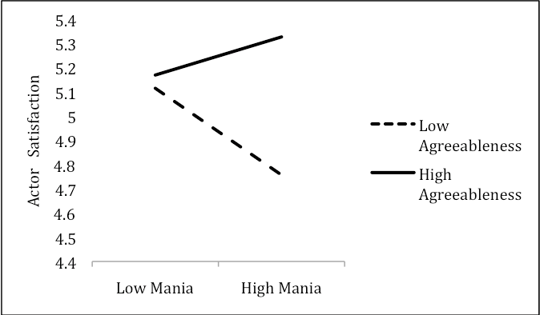Figure 1. Actor’s Agreeableness Moderates the Association between Partner Mania and Actor Satisfaction

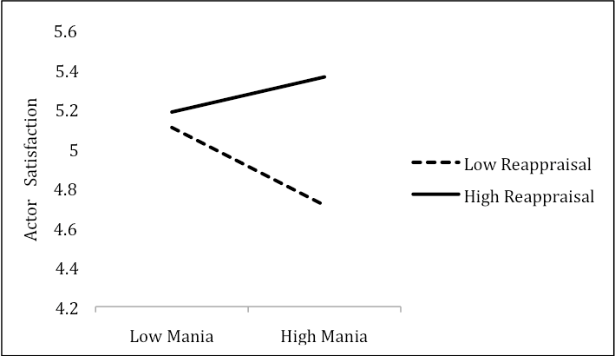Figure 2. Actor’s Reappraisal Moderates the Association between Partner Mania and Actor Satisfaction
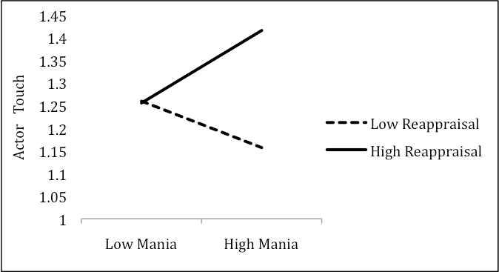Figure 3. Actor’s Reappraisal Moderates the Association between Partner Mania and Actor Touch (marginal significance)

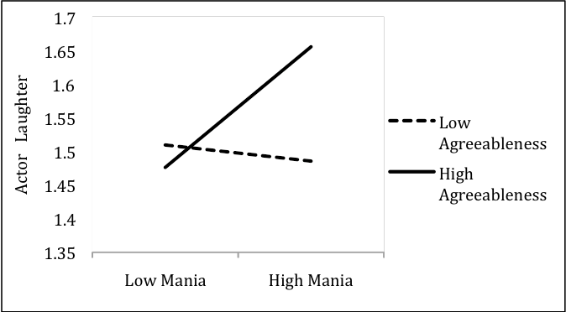Figure 4. Actor’s Agreeableness Moderates the Association between Partner Mania and Actor Laughter
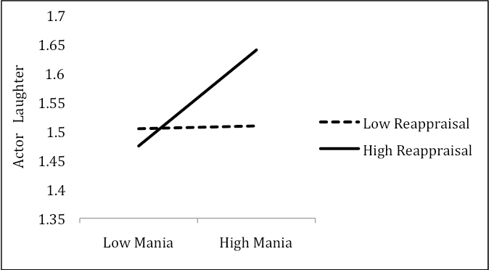Figure 5. Actor’s Reappraisal Moderates the Association between Partner Mania and Actor’s Laughter

Discussion
Findings from the present study support the original hypothesis and show that for people who are romantically involved with individuals possessing manic symptoms, being higher in agreeableness and having a greater tendency to reappraise functions as a buffer against the potentially negative effects of manic symptoms on relationships. In particular, these people report feeling more satisfied and actually engage in more touch and laughter as they converse with their partners. That is, being sympathetic, compassionate, and deeply caring for one’s partner (agreeableness) and having the cognitive inclination to reconfigure one’s attitudes and emotions during times of stress seem to be invaluable for these potentially problematic relationships. Together, these results provide initial evidence that people who have more prosocial tendencies (in this case, are more agreeable and reappraise more) are more satisfied in their relationships with partners who exhibit more manic symptoms, relative to people who possess less prosocial tendencies.

Implications
These results illustrate that people with higher levels of agreeableness, reappraisal, touch, and laughter can better cope with partners with mania. The undesirable effects of mania shown in previous literature (e.g. Lam et al., 2005; Hunt, 2004; Kulkarni et al., 2008) may only be applicable to certain people, as this research shows that mania’s stresses can be moderated. In fact, it appears that there is potential for greater happiness in dealing with manic symptoms within romantic relationships. People who are more agreeable and reappraise more seem to do well in these relationships, since their relationship satisfaction and frequency of touch and laughter are greater than for those who are less agreeable and reappraise less. On the other hand, those who do not have these prosocial tendencies seem to struggle with partners who display more mania as their relationship satisfaction, touch, and laughter decrease. Furthermore, the behaviors of touch and laughter provide insight about the actions that people who are more agreeable and reappraise more engage in. People who are more agreeable and reappraise more engage in greater behavioral indicators of relationship quality when they have partners who are higher in manic symptoms. Rather than ignoring or exacerbating their partner’s stress, individuals with more prosocial tendencies are able to connect with their partners through increased touch and laughter. This reveals that engaging in these prosocial tendencies are very important when dating a partner with manic symptoms, and are linked to experiencing a more rewarding relationship. An interesting aside, however, is the data from the present study that seem to suggest that for individuals who are not romantically involved with manic partners, these prosocial tendencies have a lesser effect on relationship quality. As displayed in the interaction figures, cognitive reappraisal and agreeableness are correlated with virtually identical levels of relationship satisfaction. However, as one’s partner’s manic symptoms increase, the prosocial tendencies seem to really play a role in relationship satisfaction and cause the non-manic partner to become more satisfied with their partner who exhibits manic symptoms. With this aside, these findings have implications both for our understanding of manic relationships, and when prosocial tendencies influence relationship quality.
In the present study, sub-clinical mania was examined in an effort to reveal the nuances of less severe levels of mania, and to shed light on trends that pertain to the entirety of the manic spectrum. Although the participants in the present study were not clinically diagnosed with mania, the present research shows that the sub-clinical levels of mania still affect the quality of romantic relationships. While the DSM creates rigid and defining criteria for disorders, such rigid criteria may not be equally applied to individuals across situations. In the case of this research, there is a full range of severity within the manic spectrum, and the same may be true for other mood disorders as well as any other psychological disorder. Therefore, these findings reveal the importance of studying the entire spectrum of a disorder. By examining all levels of disorders, a more complete picture of disorders can be captured, and studying different angles of the same disorder can help triangulate the specific aspects of the pathology. Being below the threshold of a clinical diagnosis does not mean that there are no ill effects on people’s relationships, and, clearly, studying this population can provide insightful information.
Additionally, these findings could be useful for therapeutic settings. Although it is clear that the findings here are correlative, they still may be important for therapists in understanding that a correlation between high reappraisal and increased relationship satisfaction with a partner who exhibits manic symptoms does exist. Since reappraisal is a cognitive process and is thus a partly acquired behavior, individuals can possibly learn to reappraise, and thereby be better equipped to handle the possible negative outcomes of manic behavior. If a couple face problems stemming from having a partner with mania, the non-manic partner can be taught to take a step back during stressful situations, calm themselves down, and reappraise the situation, rather than reacting immediately or suppressing their emotions. This way, individuals with romantic partners who display manic symptoms can alter the way in which they assess situations with their partners and potentially benefit from this new perspective (just as Beck (1967) and Seligman (1967) have proposed with their cognitive models for other mood disorders).

Limitations and Future Directions
Although this study has important implications, it also has several limitations. One of the limitations of the study is concerned with the assessment of mania. The Altman Self-Rating Mania scale has been found to have external clinical validity (Altman et al., 2001), but this study examined a population that was sub-clinical. This sample gave us key information about a largely unstudied population, making it more difficult to generalize the results to people experiencing clinical mania. A future study may aim to replicate these findings in a clinical sample, thereby adding to this new body of knowledge.
As noted previously, the findings from this study suggest that even sub-clinical levels of mania have important implications for relationship quality. People are not just manic or not manic. While there are boundaries between clinical and sub-clinical populations, the problems do not just surface once the boundary is crossed. Thus, future research should work not just with clinical mania but also with people experiencing less severe manic symptoms and examine their experiences with the world and their interpersonal relationships. Additionally, it is very important to understand the manic spectrum at its various levels of severity, rather than just looking at the on/off, clinical/non-clinical distinction. This perspective gives credence to examining sub-clinical populations and should be further pursued in connection with clinical research. The DSM has strict guidelines for what falls into a diagnosis, which inevitably excludes people who may be slightly subthreshold of the disorder. Mapping the full spectra of various disorders will be a more comprehensive means of ensuring that the conclusions based on clinical groups are related to those drawn from sub-clinical populations.
Another limitation is the correlational nature of this study. Without conducting an experiment where we assign people to be agreeable and reappraise in varying degrees, we cannot assert whether these prosocial tendencies actually bring about the buffering effect discussed in the paper. Although it could be difficult to manipulate trait variables such as agreeableness, there are examples of previous research that has successfully manipulated reappraisal tendencies (Richards & Gross, 2000). Future research should, therefore, look at the most efficacious way to manipulate reappraisal. This would help clinicians to train their clients on how best to adjust to the potential difficulties of relationships with manic partners. Researchers could also look at whether manipulating other aspects of prosociality (e.g., being more compassionate) produces the same beneficial effects. These studies would be a crucial first step in creating interventions.
Finally, the full bipolar disorder should be studied to discover if these same prosocial tendencies aid those with a depressed loved one or if there are other prosocial traits that better address the problems of depression. Agreeableness and reappraisal, while potentially not very useful for all relationships (as this study’s data show), are extremely helpful in manic relationships, and it would be logical for this trend to follow a similar pattern for relationships involving a individual with depression. Additionally, these and other potential prosocial tendencies should be examined in the context of other disorders, for they are likely to make a beneficial impact.
Even with the limitations of this study, the findings are compelling and shed light upon the importance of prosocial tendencies, especially when faced with serious stressors such as having a partner with mania. Not everyone suffers equally from the stress of a manic relationship, as there are some who seem to handle these relationships better than others. This research highlights several individual differences that seem to help people better cope with their partners who exhibit mania symptoms, thus underscoring the potential benefits of being more agreeable and having a greater tendency to reappraise.

Acknowledgements
I would like to thank Amie Gordon for all her extraordinary help with editing, running analyses, and guiding me through this entire process. I would also like to thank Dacher Keltner for his comments, suggestions, and encouragement throughout this process. Finally, I would like to thank Alex Kogan for helping me get this project started and for his continued support along the way.

References
Altman, E. G., Hedeker, D., Peterson, J. L., & Davis, J. M. (1997). The Altman Self-Rating Mania Scale. Biological Psychiatry, 42, 948–955.
Altman, E. G., Hedeker, D., Peterson, J. L., & Davis, J. M. (2001). A Comparative Evaluation of Three Self-Rating Scales for Acute Mania. Biological Psychiatry, 50, 468–471.
American Psychiatric Association. (2000). Diagnostic and Statistical Manual of Mental Disorders, Text Revision: DSM-IV-TR. Washington, DC.
Angst, J., Gamma, A., Benazzi, F., Ajdacic, V., Eich, D., & Rossler, W. (2003). Toward a re-definition of subthreshold bipolarity: Epidemiology and proposed criteria for bipolar-II, minor bipolar disorders and hypomania. Journal of Affective Disorders, 73, 133–146.
Blumenfeld, E., & Alpern, L. (1986). The Smile Connection: How to Use Humor in Dealing with People. Atlanta, GA: Prentice Hall.
Braun, C. M. J., Daigneault, R., Gaudelet, S., & Guimond, A. (2008). Diagnostic and statistical manual of mental disorders, fourth edition symptoms of mania: Which one(s) result(s) more often from right than left hemisphere lesions? Comprehensive Psychiatry, 49(5), 441–459.
Carstensen, L., Gottman, J., & Levenson, R. (1995). Emotional behavior in long-term marriage. Psychology and Aging, 10(1), 140–149.
Coryell, W., Scheftner,W., Keller, M., Endicott, J., Maser, J., & Klerman, G.L. (1993). The enduring psychosocial consequences of mania and depression. American Journal of Psychiatry, 150, 720–727.
Dinkmeyer, D., & Carlson, J. (1984). Time For a Better Marriage. Circle Pines, MN: American Guidance Service.
Ditzen, B., Neumman, I., Bodenmann, G., vonDawans, B., Turner, R.A., Ehlert, U., Heinrichs, M., 2007. Effects of different kinds of couple interaction on cortisol and heart rate responses to stress in women. Psychoneuroendocrinology, 32, 565–574.
Farley, F. H., & Peterson, J. M. (1979). Identifying a distressed marriage from the interactions between spouses: A structural analysis. Family Therapy, 6(3), 119–122.
Gillham, J.E., & Seligman, M.E.P. (1999). Footsteps on the road to positive psychology. Behaviour Research and Therapy, 37, S163–S173.
Goodwin, F.K., & Jamison, K.R. (2007). Manic-Depressive Illness: Bipolar Disorders and Recurrent Depression, 2nd ed. Oxford University Press, New York.
Gross, J.J., & John, O.P. (2003) Individual differences in two emotion regulation processes: implications for affect, relationships, and wellbeing. Journal Personality of Social Psychology, 85, 348–362.
Gulledge, A.K., Gulledge, M.H., & Stahmann, R.F. (2003). Romantic physical affection types and relationship satisfaction. American Journal of Family Therapy, 31, 233–242.
Hoover, C. F. & Fitzgerald, R. G. (1981). Marital conflict of manic-depressive patients. Archives of General Psychiatry, 38(1), 65–67.
Horesh, N., & Fennig, S. (2000). Perception of spouses and relation ships: A matched control study of patients with severe affective disorder in remission and their spouses. Journal of Nervous and Mental Disease, 188(7), 463–466.
Hunt, T. K. (2004). Manic depression and marriage: Perceptions of marital partners on the interrelationships. ProQuest Information & Learning. Dissertation Abstracts International: Section B: The Sciences and Engineering, 65.
John, O. P., Donahue, E. M., & Kentle, R. L. (1991). The Big Five Inventory: Versions 4a and 54 (Tech. Rep.). Berkeley, CA: Institute of Personality and Social Research, University of California, Berkeley.
Kessler, R. C., McGonagle, K. A., Zhao, S., Nelson, C. B., Hughes, M., Eshleman, S., & Kendler, K. S. (1994). Lifetime and 12-month Prevalence of DSM-III-R Psychiatric Disorders in the United States: Results from the National Comorbidity Survey. Archives of General Psychiatry, 51, 8–19.
Kulkarni, J., Berk, M., Fitzgerald, P. B., de Castella, A. R., Montgomery, W., Kelin, K., Brnabic, A., Granger, R. E., & Dodd, S. (2008). The Bipolar Comprehensive Outcomes Study (BCOS): Baseline Findings of an Australian Cohort Study. Journal of Affective Disorders, 107(1-3), 135–144.
Lam, D., Donaldson, C., Brown, Y., & Malliaris, Y. (2005). Burden and Marital and Sexual Satisfaction in the Partners of Bipolar Patients. Bipolar Disorder, 7, 431–440.
Levkovitz, V., Fennig, S., Horesh, N., Barak, V., & Treves, I. (2000). Perception of Ill Spouse and Dyadic Relationship in Couples with Affective Disorder and Those Without. Journal of Affective Disorders. 58, 237–240.
Light, K., Grewen, K., & Amico, J., 2005. More Frequent Partner Hugs and Higher Oxytocin Levels are Linked to Lower Blood Pressure and Heart Rate in Premenopausal Women. Biological Psychology, 69, 5–21.
Miklowitz, D. J., & Johnson, S. L. (2009). Social and Familial Factors in the Course of Bipolar Disorder: Basic Processes and Relevant Interventions. Clinical Psychology: Science and Practice, 16(2), 281–296.
Montagu, A. (1971). Touching: the Human Significance of the Skin. New York: Columbia University Press.
Moreno, D. H., & Andrade, L. H. (2010). Latent Class Analysis of Manic and Depressive Symptoms in a Population-Based Sample in São Paulo, Brazil. Journal of Affective Disorders, 123(1-3), 208–215.
Perunovic, M., & Holmes, J. G. (2008). Automatic Accommodation: The Role of Personality. Personal Relationships, 15(1), 57–70.
Richards, J. M., & Gross, J. J. (2000). Emotion Regulation and Memory: The Cognitive Costs of Keeping One’s Cool. Journal of Personality and Social Psychology, 79, 410–424.
Rosa, A. R., Franco, C., Martínez-Aran, A., Sánchez-Moreno, J., Reinares, M., Salamero, M., Arango, C., Ayuso-Mateos, J. L., Kapczinski, F., & Vieta, E. (2008). Functional impairment in patients with remitted bipolar disorder. Psychotherapy and Psychosomatics, 77(6), 390–392.
Rusbult, C. E., Martz, J. M., & Agnew, C. R. (1998). The investment model scale: Measuring commitment level, satisfaction level, quality of alternatives, and investment size. Personal Relationships, 5, 357–391.
Steele, A., Maruyama, N., & Galynker, I. (2010). Psychiatric Symptoms in Caregivers of Patients with Bipolar Disorder: A Review. Journal of Affective Disorders, 121(1–2), 10–21.
Targum, S. D., Dibble, E. D., Davenport, Y. B., & Gershon, E. S. (1981). The family attitudes questionnaire: Patients’ and spouses’ views of bipolar illness. Archives of General Psychiatry, 38(5), 562–568.
Urbaniak, G. C., & Kilmann, P. R. (2006). Niceness and dating success: A further test of the nice guy stereotype. Sex Roles, 55(3–4), 209–224.
Vieta, E., Cieza, A., Stucki, G., Chatterji, S., Nieto, M., Sanchez-Moreno, J., Jaeger, J., Grunze, H., & Ayuso-Mateos, J.L. (2007). Developing core sets for persons with bipolar disorder based on the International Classification of Functioning, Disability and Health. Bipolar Disorder, 9, 16–24.
Wieselquist, J., Rusbult, C. E., Foster, C. A., & Agnew, C. R. (1999). Commitment, prorelationship behavior, and trust in close relationships. Journal of Personality and Social Psychology, 77, 942–966.
Whitcher, S.J. & Fisher, J.D. (1979). Multidimensional reaction to therapeutic touch in a hospital setting. Journal of Personality and Social Psychology, 37, 87–96.
Zarate, C. A., Jr., Tohen, M., Land, M., & Cavanagh, S. (2000). Functional impairment and cognition in bipolar disorder. Psychiatric Quarterly. Special Issue: The Twelfth Annual New York State Office of Mental Health Research Conference, 71(4), 309–329.

